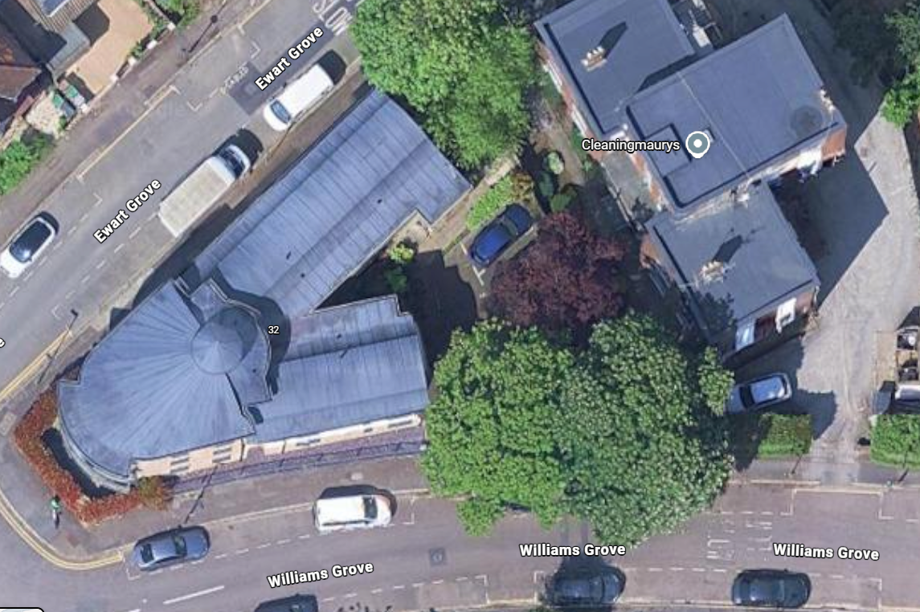
T1: Tree Type - Horse chestnut (Aesculus hippocastanum)
Approx. Diameter at 1.5m - 0.6m
Approx. Height - 14m
Approx. Crown Spread Diameter - 13m
Location - See map
Service - Crown Reduction
Work Required - Reduce height by up to 3m and lateral spread on all sides by up to 2m
Reason - Upon inspection tree does have a pocket of decay at the base approx 0.3m opening and approx 0.5m deep with some occlusion wood present. Given the proximity to houses, road amd public footpath reduction recommended to take weight out of the crown and retain tree for the future.

Number – G2
Tree Type - Horse chestnut (Aesculus hippocastanum)
Approx. Diameter at 1.5m - 0.6m
Approx. Height - 14m
Approx. Crown Spread Diameter - 13m
Location - See map
Service - Cut back
Work Required - Reduce lateral limbs growing towards Mowbray court back giving 2-3m clearance
Reason - As per clients specification / to provide clearance from the building
T2
T1

