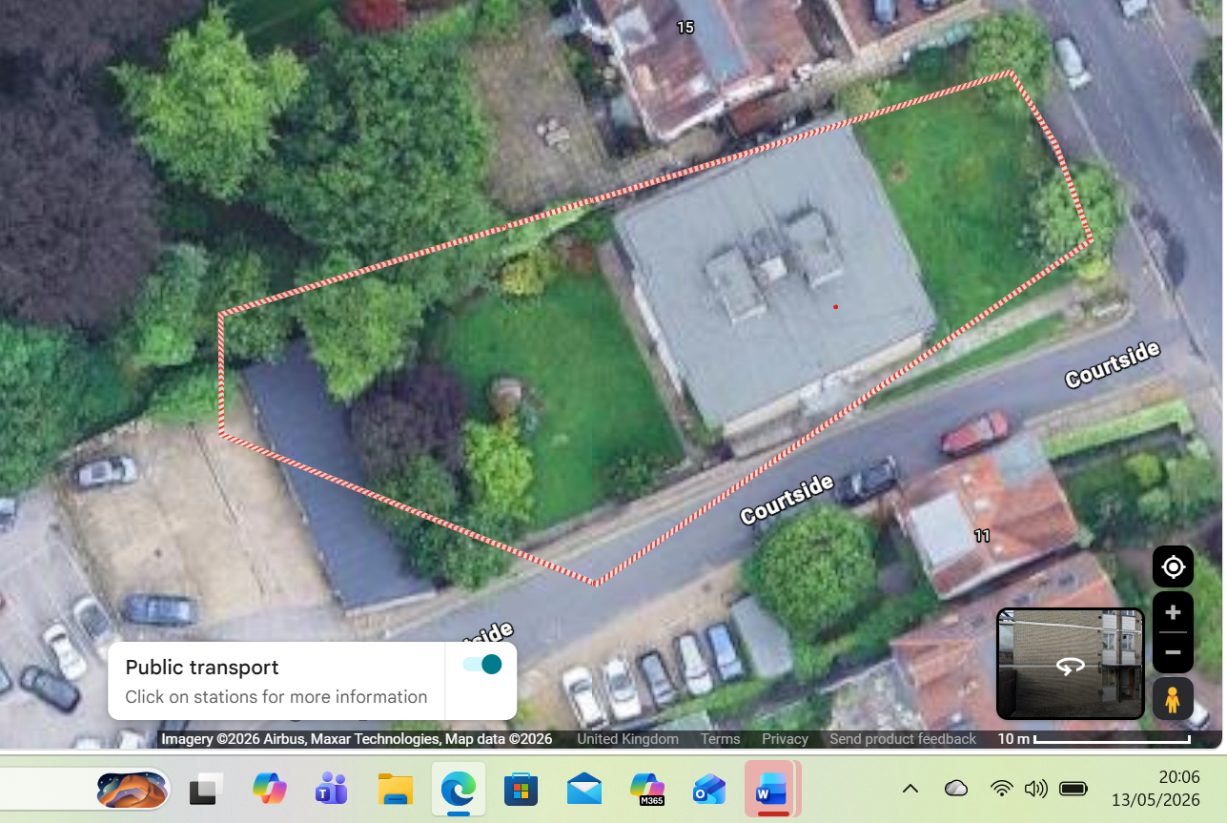
T5 Cherry
T3 Purple Plum
T4 Beech
T2 Holm Oak
T1 Holm Oak

