Formation Design and Build
To: | Adam Silverwood
From: | Matthew Ashley
Date: | 13/05/2026
Re: | Ashley Road Depot – Condition 49b

Dear Adam,
Further to the Carbon Management response in relation to the discharge of Condition 49(b), we write to provide the requested clarification and confirm the actions being taken to address the two outstanding points raised.
We note that the Council has reviewed the submitted site photographs of the finished roofs to Blocks B1, B2, B3, C1 and C2, and has requested further confirmation regarding the planting specification, substrate depths and biodiverse habitat measures. We can confirm that the living and blue roof works have been installed in accordance with the details approved under Condition 49(a), including the specified substrate build-ups, planting requirements and biodiversity measures.
The actions raised by the Council are responded to as follows:
No. | Council Action | Applicant Response / Action
1 | Confirm in writing that the living roofs have been installed as per the approved specification and proposed substrate depths discharged under Condition 49(a). | We confirm that the living roofs have been installed in accordance with the approved Condition 49(a) details. This includes the approved substrate build-up, substrate depths, planting specification and roof arrangement. The submitted photographs show the roof areas following installation and preparation to receive the approved planting mix and plug plants.
2 | Submit site photographs demonstrating that the biodiverse habitat measures, including features such as sand piles, have been installed. | Additional roof photographs are provided below to demonstrate the biodiversity measures installed across the living roof areas. These include photographic evidence of the biodiverse habitat features, including sand piles / habitat zones where applicable, in accordance with the approved living roof specification.
We trust the above, together with the accompanying photographic evidence, addresses the two outstanding actions raised within the Carbon Management response. On this basis, we respectfully request that Condition 49(b) is now discharged.
Evidence item | Photograph
1 | 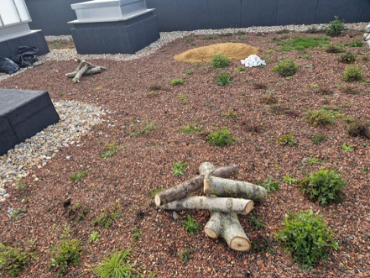
2 | 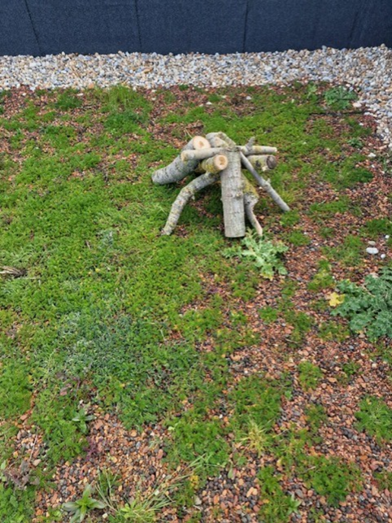
3 | 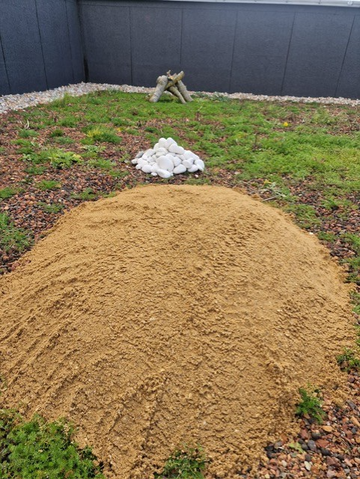
4 | 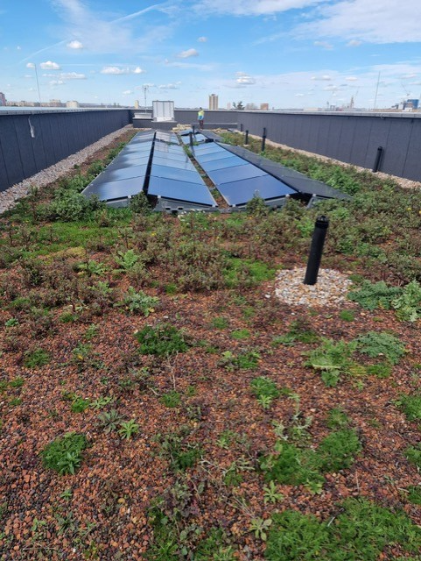
5 | 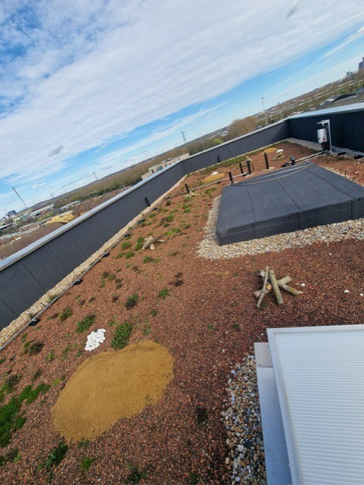
6 | 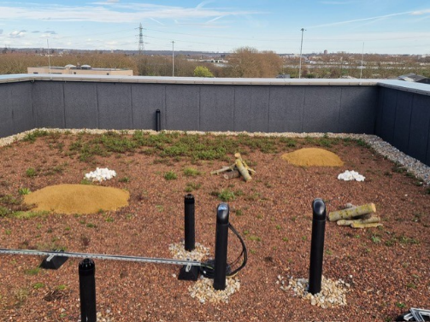
7 | 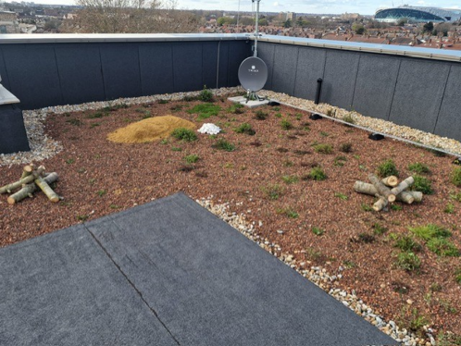
8 | 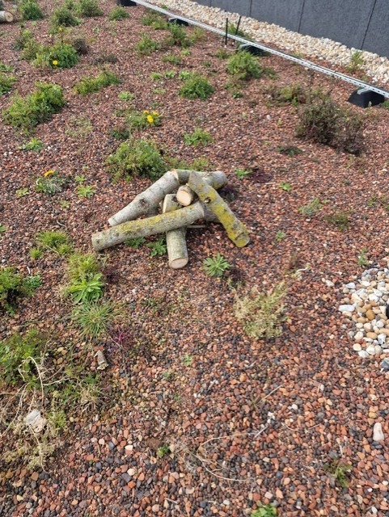
9 | 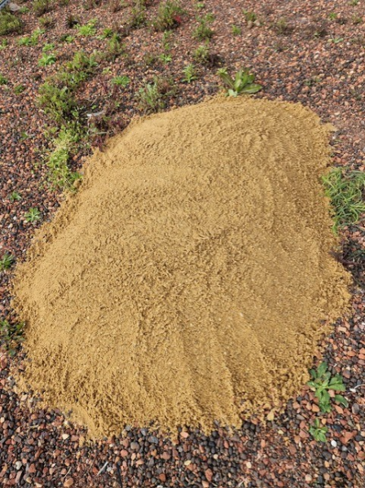
10 | 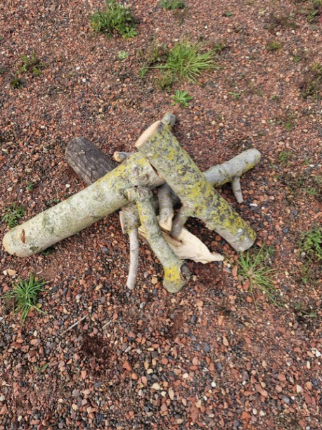
11 | 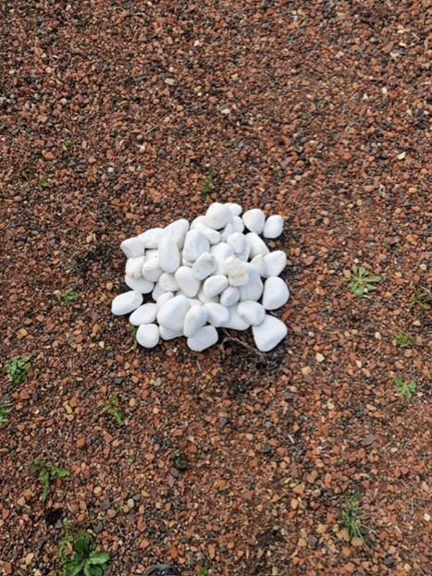
12 | 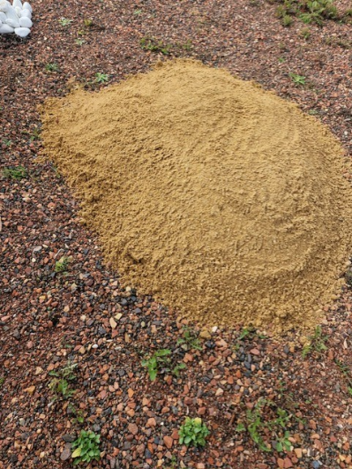
13 | 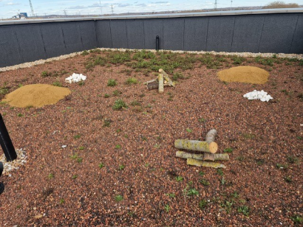

Yours sincerely,

