

SITE PHOTOGRAPHS

Project Description – Single Storey Rear Extension
Property Address – 39 Curzon Road, N10 2RB

REAR ELEVATION PHOTOGRAPHS

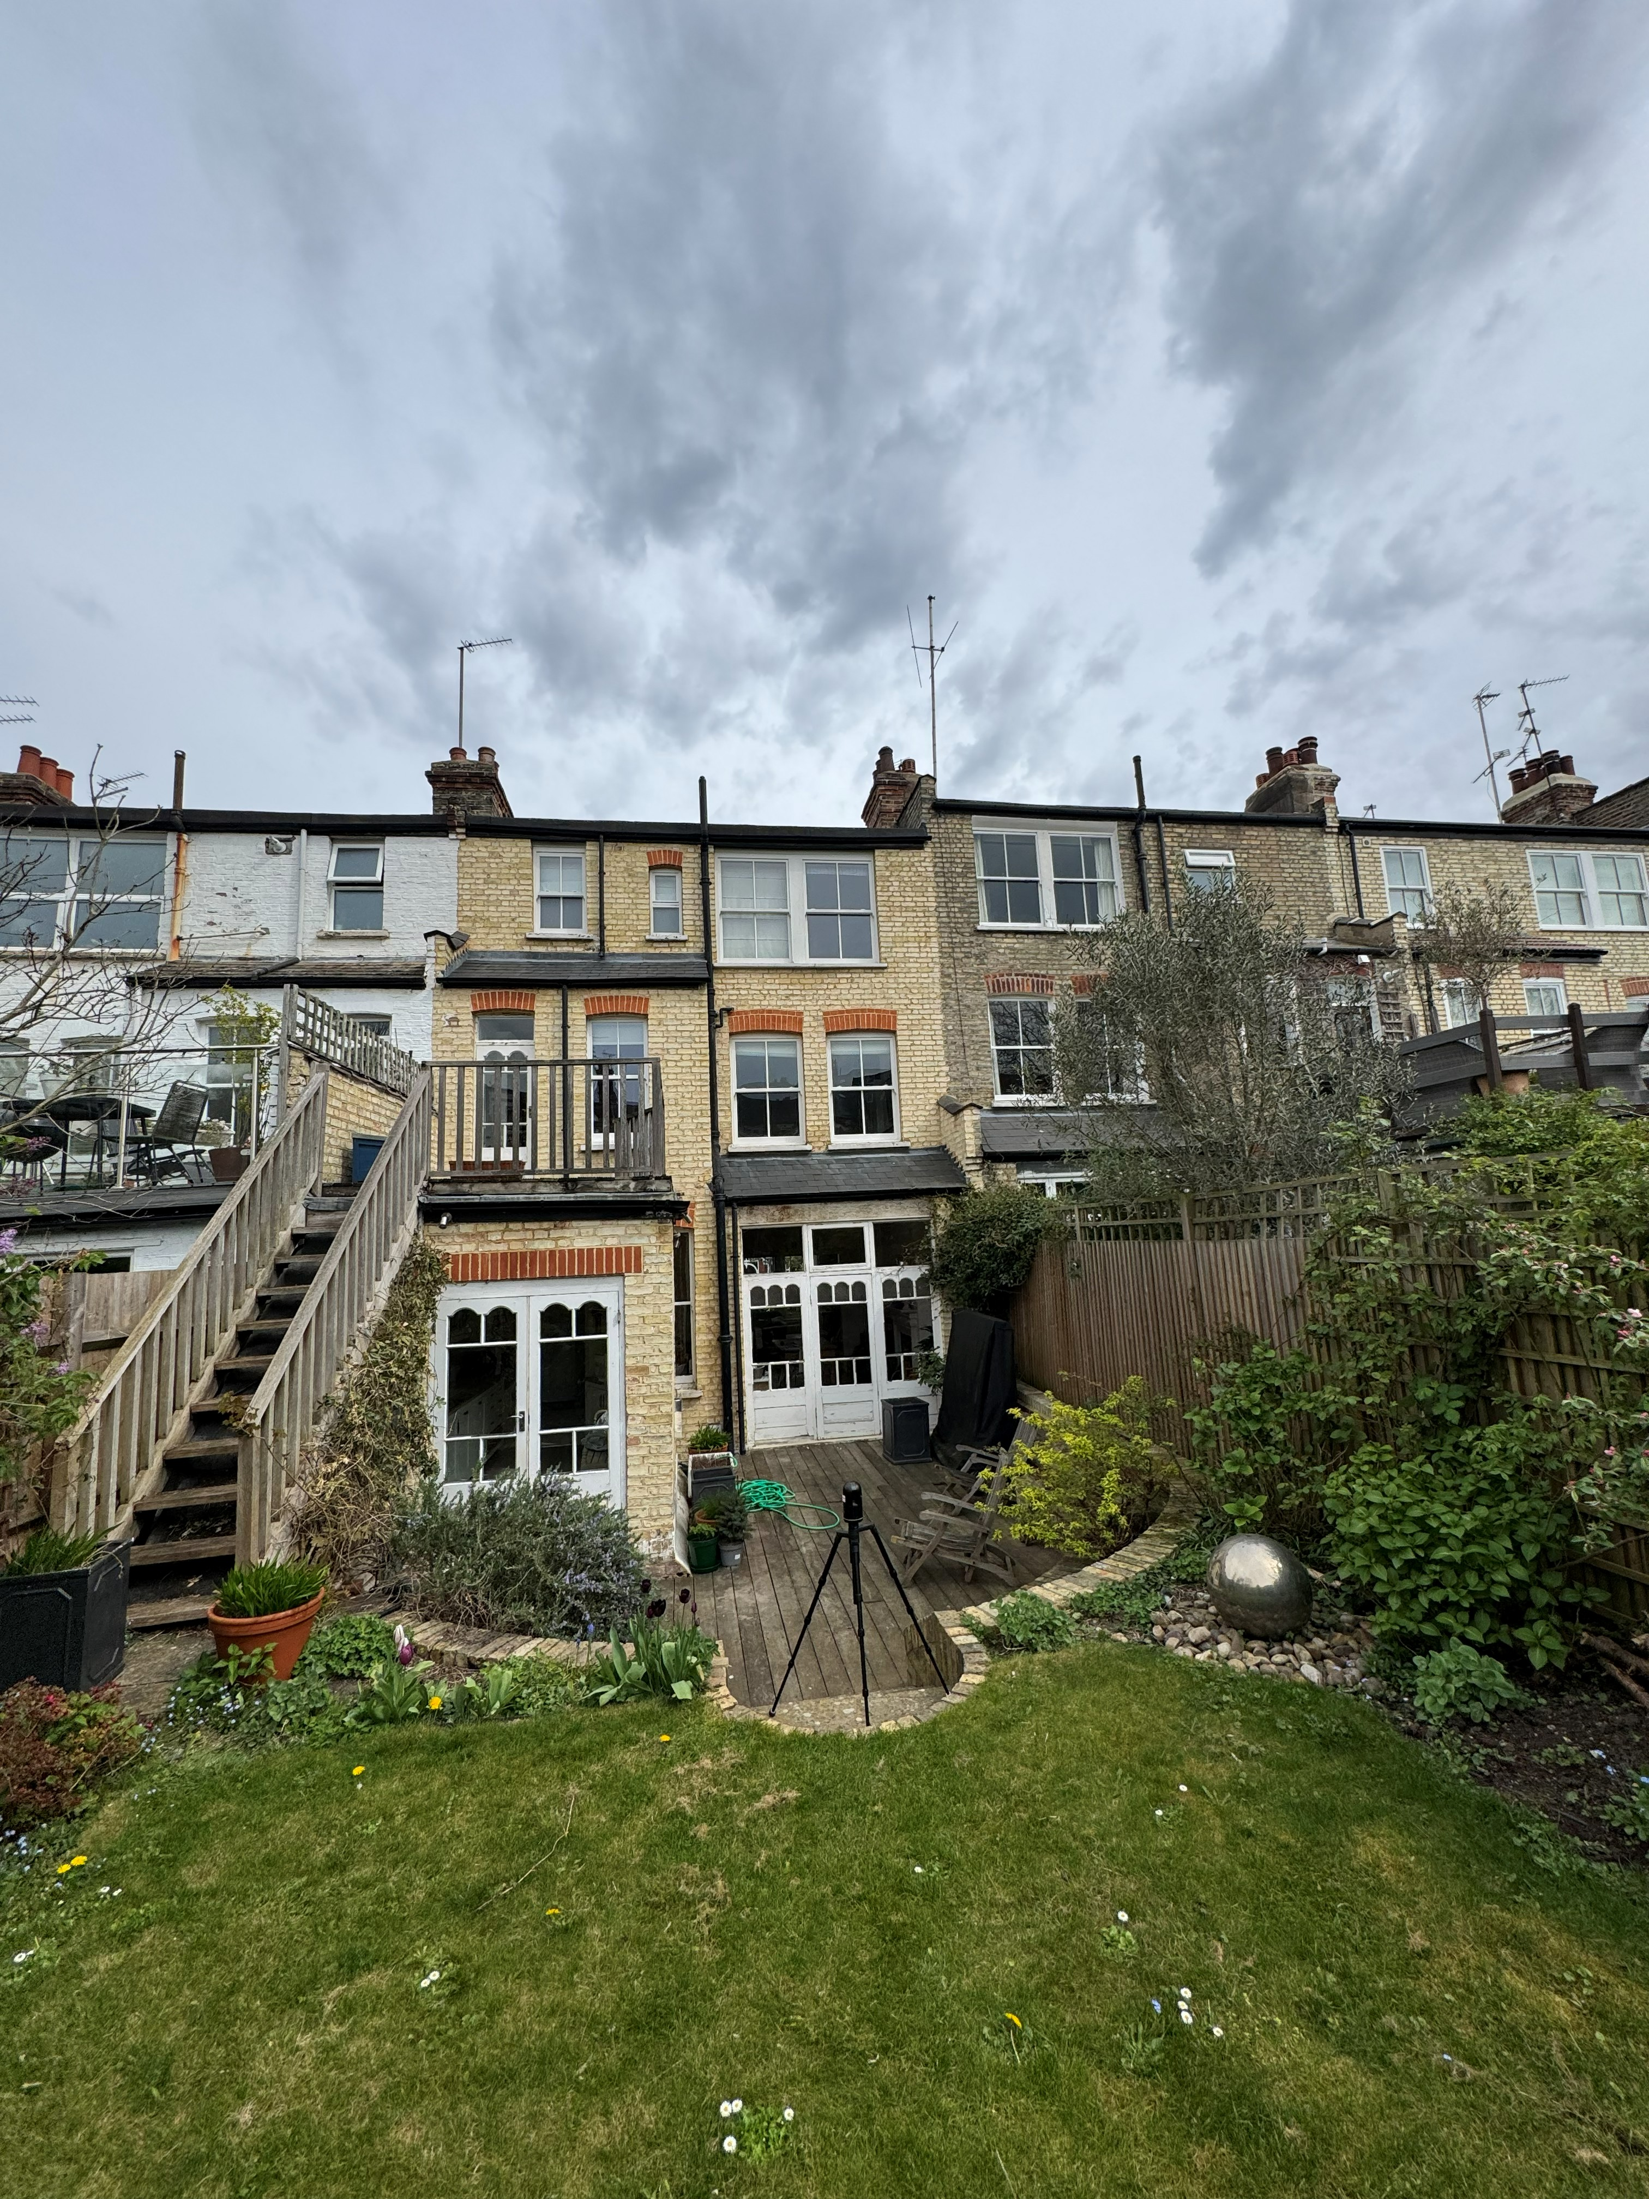

FRONT ELEVATION PHOTOGRAPHS

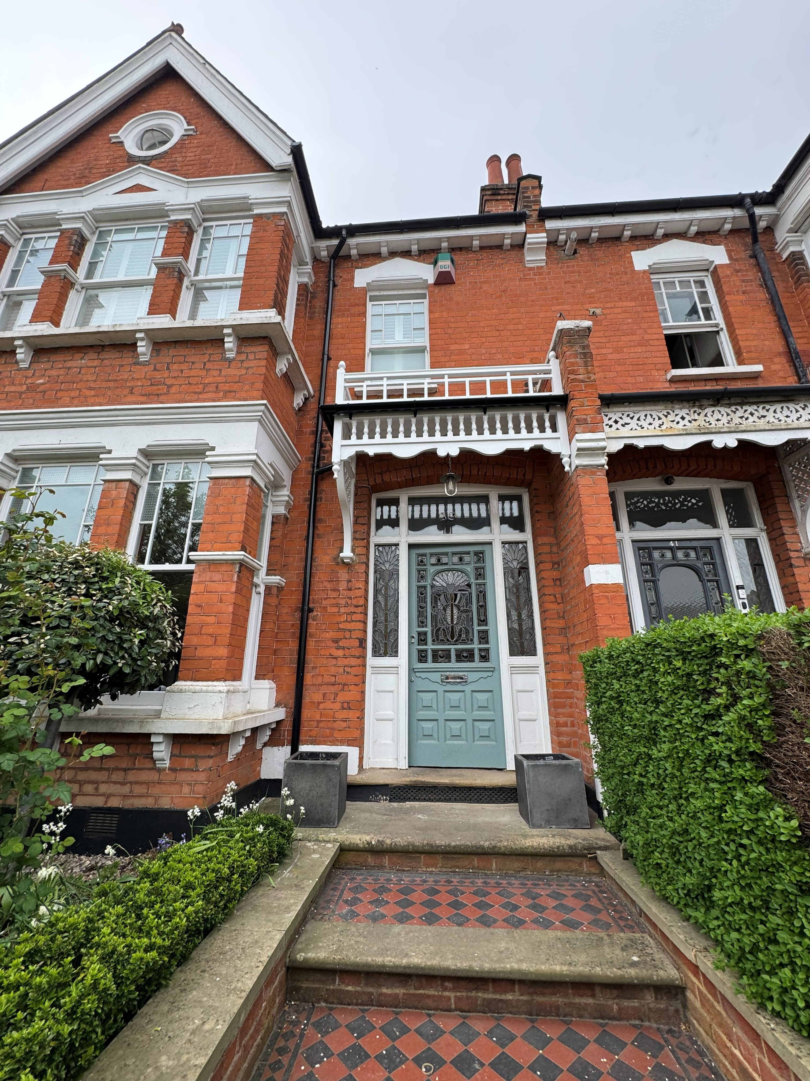


The Art of Building Ltd 45 Maplewell Road Woodhouse Eaves Leicestershire
LE12 8RG

www.taob.co.uk
T. 01509 891 105
E . info@taob.co.uk
VAT Registration No. 797787140
Reg. in England & Wales No. 4775259

