

SITE PHOTOGRAPHS

Single Storey Rear Extension

54 Blake Road, N11 2AH

REAR ELEVATION PHOTOGRAPHS

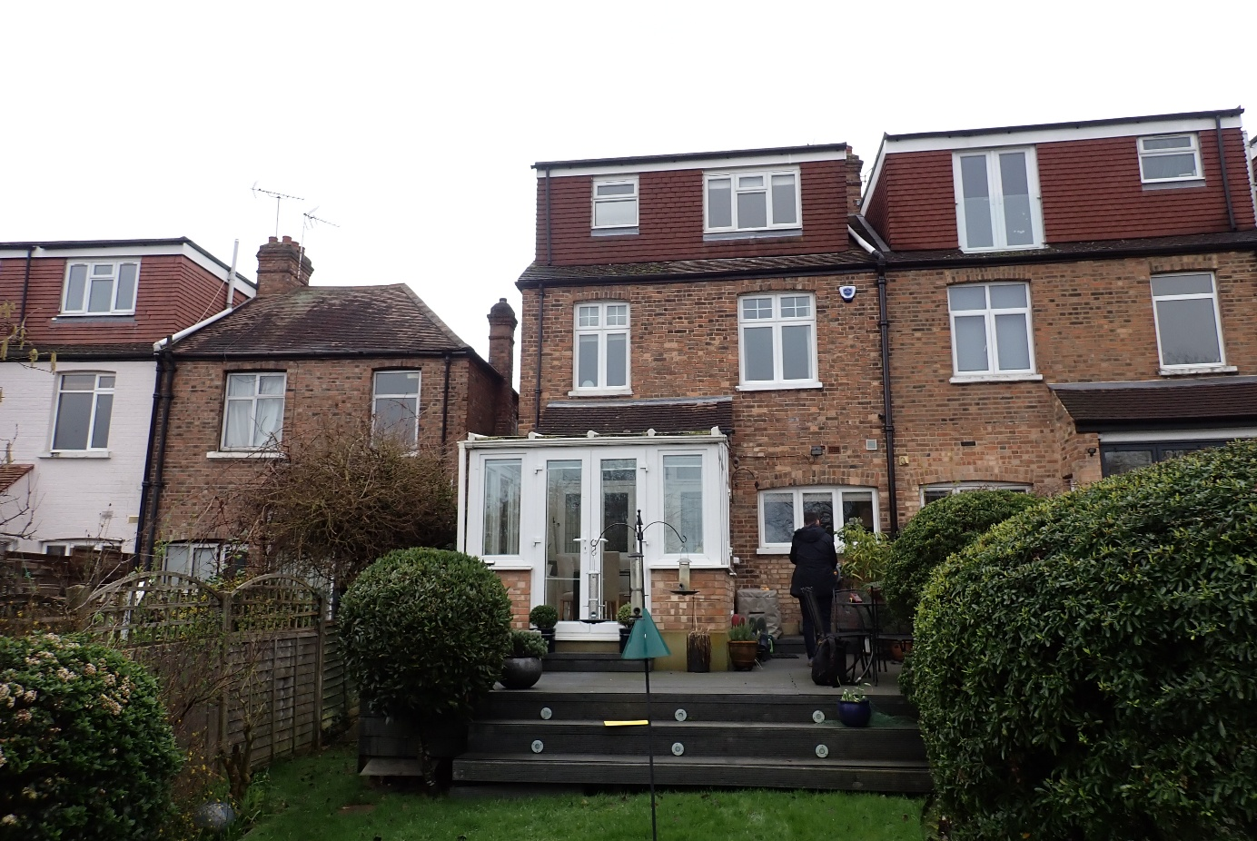

FRONT ELEVATION PHOTOGRAPHS

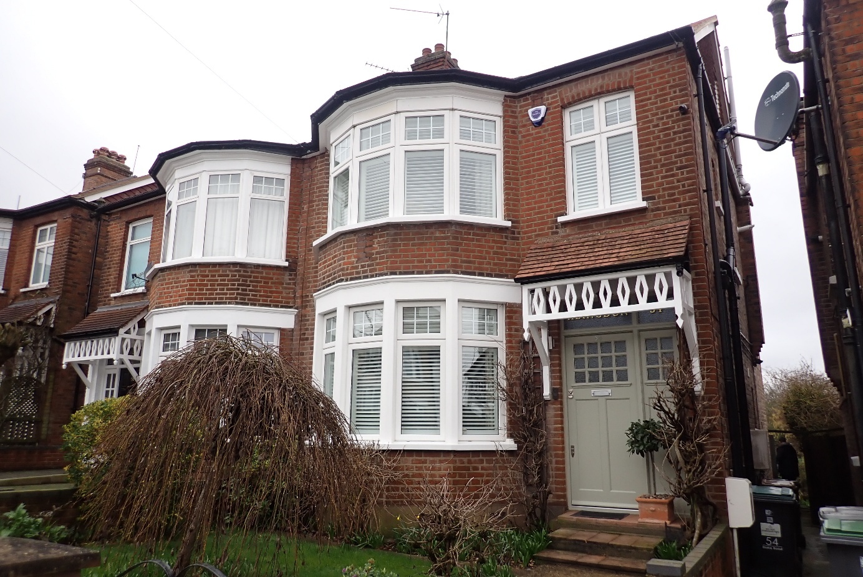


The Art of Building Ltd 45 Maplewell Road Woodhouse Eaves Leicestershire
LE12 8RG

www.taob.co.uk
T. 01509 891 105
E . info@taob.co.uk
VAT Registration No. 797787140
Reg. in England & Wales No. 4775259

