Construction Environmental and Demolition Management Plan

Project: Supported Living Development
Site Address: Barbara Hucklesbury Close, London N22 6PQ
Planning Application Reference: HGY/2022/0859
Client / Developer: London Borough of Haringey
Principal Contractor: Aspire Commercial Contractors Ltd
Document Purpose: Condition 14 discharge support document
Status: Draft for Silver DCC / Haringey review

Planning Condition 14 Compliance Matrix
This matrix has been placed at the front of the document so that Silver DCC and Haringey can directly identify where each element of Condition 14 is addressed. Items marked TBC are matters requiring confirmation from the Client, Haringey or the relevant specialist before final submission.
Condition ref | Requirement | Document response / action | Section reference | Status
14(a) | DEMP/CEMP shall include a CLP and AQDMP. | This document is structured as a combined CEMP / DEMP. The CLP is contained in Section 6 and the AQDMP is contained in Section 7. | Sections 1.2, 6 and 7 | Included
14(b)(i) | Construction method statement identifying the stages and details of how works will be undertaken. | A demolition and construction works overview is included. A separate detailed CMS is to be submitted to discharge Condition 19. | Section 5 and separate CMS | Included / separate CMS
14(b)(ii) | Working hours unless otherwise agreed: 08:00-18:00 Monday-Friday and 08:00-13:00 Saturday. | Working hours and delivery restrictions are set out including peak-period avoidance. | Section 4 and 6.5 | Included
14(b)(iii) | Details of plant and machinery used during demolition and construction. | Indicative plant categories are listed. Final specialist plant registers will be held on site and updated as works progress. | Section 5.5 and 7.5 | Included / to update
14(b)(iv) | Details of an Unexploded Ordnance Survey. | PCI identifies a moderate bomb risk and potential elevated UXO risk. UXO controls are included pending confirmation of final survey status. | Section 3.4 and 8.3 | Included / confirm
14(b)(v) | Waste management strategy. | Waste segregation, licensed carriers, transfer notes, hazardous waste controls and material re-use are set out. | Section 9 | Included
14(b)(vi) | Community engagement arrangements. | Resident liaison, newsletters, advance notice, complaints process and emergency contact arrangements are included. | Section 10 | Included
14(b)(vii) | Details of any acoustic hoarding. | Hoarding and acoustic screening approach is set out. Acoustic hoarding will be reviewed where noisy works create unacceptable impacts. | Section 11.3 | Included
14(b)(viii) | Temporary drainage strategy and performance specification to control surface water runoff and Pollution Prevention Plan. | Temporary drainage, runoff control, silt protection, drain protection, spill response and fuel/chemical controls are included. | Section 12 | Included
14(b)(ix) | Details of external lighting. | Temporary lighting controls are included to avoid glare and light spill into neighbouring homes. | Section 13 | Included
14(b)(x) | Other standard environmental management and control measures. | Standard controls for dust, noise, vibration, waste, pollution, ecology, lighting, traffic and emergency incidents are included. | Sections 7 to 16 | Included
14(c) | CLP to be in accordance with TfL Construction Logistics Plan Guidance July 2017. | The CLP section addresses TfL-style logistics controls including access, routes, delivery management, staff travel and consolidation where practicable. | Section 6 | Included
14(c)(i) | Monitoring and joint working arrangements where appropriate. | Site manager monitoring, delivery coordination, local authority liaison and joint working with nearby developments are included. | Sections 6.1, 6.9 and 14 | Included
14(c)(ii) | Site access and car parking arrangements. | Single access from Russell Avenue, gate control, substation access and operative parking controls are included. | Sections 6.2 and 6.7 | Included
14(c)(iii) | Delivery booking systems. | Pre-booked delivery slots, Site Manager control and refusal of non-compliant deliveries are included. | Section 6.4 | Included
14(c)(iv) | Agreed routes to and from the Plot. | Construction traffic route via Russell Avenue / Gladstone Avenue is described and included in Appendix B. | Section 6.3 and Appendix B | Included
14(c)(v) | Timing of deliveries and removals to avoid peak times 07:00-09:00 and 16:00-18:00 where possible. | Deliveries are restricted to avoid peak periods where practicable with no waiting on Russell Avenue. | Sections 4 and 6.5 | Included
14(c)(vi) | Travel plan for staff/personnel to encourage sustainable travel. | Public transport use, tool storage, changing areas and parking restrictions are included. | Section 6.8 | Included
14(c)(vii) | Joint arrangements with neighbouring developers for parking, lorry parking and consolidation of facilities. | Nearby developments will be reviewed before commencement. Joint arrangements will be agreed where relevant and practicable. | Section 6.9 | Included / ongoing
14(d) | AQDMP in accordance with GLA SPG Dust and Emissions Control 2014. | AQDMP is included with dust risk assessment, mitigation, NRMM controls and monitoring arrangements. | Section 7 | Included
14(d)(i) | Mitigation measures to manage and minimise demolition/construction dust emissions. | Dust controls include damping down, covered loads, jet wash, on-tool extraction, no burning and visual monitoring. | Sections 7.2 and 7.3 | Included
14(d)(ii) | Details confirming the Plot has been registered at nrmm.london. | NRMM registration is required before relevant NRMM is brought to site. Evidence will be retained on site. | Section 7.5 | Action required
14(d)(iii) | Evidence of NRMM and plant registration available on site for Local Authority inspection. | Site NRMM records, service logs and emission evidence will be kept in the site environmental file. | Section 7.5 | Included
14(d)(iv) | Inventory of NRMM currently on site, service logs and emission limits for inspection. | NRMM inventory procedure is included. Final plant inventory is to be completed once plant is confirmed. | Section 7.5 | Action required
14(d)(v) | Dust Risk Assessment for the works. | A project-specific dust risk assessment is included based on residential setting, demolition, groundworks and haulage. | Section 7.2 | Included
14(d)(vi) | Lorry parking in joint arrangement where appropriate. | No lorry parking on Russell Avenue. Vehicles will use booked slots, on-site holding and off-site waiting if required. | Sections 6.4, 6.6 and 6.9 | Included
Condition text | Approved details to accord with Air Quality Report Appendix C and agree real monitoring locations for demolition phase. | Controls are aligned with standard AQ mitigation. Appendix C and monitoring locations are to be confirmed with Haringey before final issue. | Sections 7.4 and 7.6 | Need update from Haringey
Condition text | Site or contractor company must be registered with the Considerate Constructors Scheme with proof sent prior to works. | Registration requirement is recorded with proof to be issued to the LPA before works commence. | Section 17 | Action required

Document Control
Item | Details
Document title | Construction Environmental and Demolition Management Plan (CEMP / DEMP incorporating CLP and AQDMP)
Project | Supported Living Development
Site address | Barbara Hucklesbury Close, London N22 6PQ
Planning reference | HGY/2022/0859
Planning condition | Condition 14
Principal Contractor | Aspire Commercial Contractors Ltd
Issue status | Draft for Silver DCC / Haringey review
Revision | P02 - restructured against Condition 14
Date | 28 May 2026

Revision Record
Rev | Date | Status / Change | Prepared By | Checked By
P01 | May 2026 | Initial consolidated CETMP / CLP draft | Aspire | Silver DCC
P02 | May 2026 | Restructured as Condition 14 CEMP / DEMP including CLP and AQDMP with compliance matrix | Aspire | TBC

Items Requiring Final Confirmation / Action Tracker
Item | Current status / action required
Current programme dates | TBC
Demolition status | TBC
No. 7 occupation status | Need update from Haringey
Swept path analysis | Draft vehicle tracking basis included. Latest swept path drawing to be appended or confirmed before final issue.
Utility status | TBC
Environmental monitoring locations | Need update from Haringey. Real monitoring locations to be agreed for the demolition phase.
Air Quality Report Appendix C mitigation | To be reviewed against final Air Quality Report Appendix C and mirrored in final issue.
NRMM registration | To be completed before relevant plant is brought to site and evidence kept on site.
Considerate Constructors Scheme | Registration required prior to works with proof to be provided to the Local Planning Authority.
Key personnel | Site Manager: Matt Bradley. Resident Liaison Officer: TBC. Environmental Lead: TBC. Out-of-hours emergency contact: TBC.

Source Information Used
Source | Information used
Pre-Construction Information | Site access, residential constraints, vehicle movement restrictions, services, ground conditions, UXO, contamination, asbestos and dust risks.
Draft CLP and logistics information | Construction routes, site access, delivery hours, holding area, vehicle controls, sensitive receptors, waste collection interface and environmental controls.
Landscape and design risk assessments | Pedestrian interfaces, site deliveries, tree/root protection, emergency access, working next to roads, lifting risks and high-level works.
Planning and landscape drawings | Application boundary, Russell Avenue access, The Sandlings interface, substation location, refuse areas, gate positions, landscape proposals and external constraints.
Existing CEMP, DEMP and CMS drafts | Initial structure, project details, scope, working hours and management measures.
Planning condition wording supplied by Silver DCC | Condition 14 requirements used to structure this document and compliance matrix.

Contents
1. Introduction, Purpose and Condition 14 Scope
2. Project Description
3. Site Context, Existing Conditions and Constraints
4. Working Hours
5. Demolition and Construction Works Overview
6. Construction Logistics Plan (CLP)
7. Air Quality and Dust Management Plan (AQDMP)
8. Demolition Environmental Management Measures
9. Waste Management Strategy
10. Community Engagement and Complaints
11. Noise, Vibration and Acoustic Hoarding
12. Temporary Drainage Strategy and Pollution Prevention Plan
13. External Lighting
14. Monitoring, Inspection, Records and Reporting
15. Emergency, Fire and Incident Procedures
16. High Risk Activities, Permits and Utilities
17. Considerate Constructors Scheme
18. Review and Update Procedure
Appendices

1. Introduction, Purpose and Condition 14 Scope
This Construction Environmental and Demolition Management Plan has been prepared by Aspire Commercial Contractors Ltd for the Supported Living Development at London N22 6PQ. It has been restructured specifically to respond to Condition 14 and to incorporate the CEMP, DEMP, CLP and AQDMP requirements within one coordinated document.
The document sets out how Aspire will manage the environmental and logistics impacts associated with demolition, enabling, construction and associated works. It is intended to demonstrate that the effects of the works have been considered in relation to the actual site constraints rather than treated as generic construction risks.
A separate Construction Method Statement is being prepared to discharge Condition 19. This document includes the demolition and construction stage summary required by Condition 14 but avoids duplicating the full CMS unnecessarily.

1.1 Objectives
- identify site-specific environmental, demolition and logistics risks
- define how dust, noise, vibration, traffic, waste, runoff, pollution and community impacts will be prevented or controlled
- describe the CLP arrangements for access, routing, deliveries, car parking, staff travel and joint working
- describe the AQDMP arrangements including dust risk, mitigation, NRMM registration and monitoring
- provide clear responsibilities, inspection arrangements and review controls
- make the document easy for Silver DCC and Haringey to review against Condition 14

1.2 Document Relationship
Document / element | Purpose
This CEMP / DEMP including CLP and AQDMP | Primary Condition 14 environmental, demolition, logistics and air quality response.
Separate Construction Method Statement | Condition 19 response setting out detailed construction methodology and sequencing.
Construction Phase Plan and RAMS | Live site health and safety management documents to be developed and updated by Aspire and specialist subcontractors.
Specialist subcontractor method statements | Demolition, asbestos, piling, lifting, scaffolding, temporary works and utilities documents to be reviewed before relevant activities start.

2. Project Description
Project item | Description
Project name | Supported Living Development
Site address | Barbara Hucklesbury Close, London N22 6PQ
Planning reference | HGY/2022/0859
Client / Developer | London Borough of Haringey
Principal Contractor | Aspire Commercial Contractors Ltd
Site Manager | Matt Bradley
Resident Liaison Officer | TBC
Environmental Lead | TBC
Out-of-hours emergency contact | TBC

The project comprises demolition of existing bungalow accommodation and construction of a part one, two and three-storey supported living development comprising 14 one-bedroom homes, support office, communal garden, wheelchair accessible parking, refuse and recycling stores, cycle stores and associated hard and soft landscaping.

3. Site Context, Existing Conditions and Constraints
The site is a constrained backland residential site accessed from Russell Avenue. It is surrounded by occupied residential properties including The Sandlings and nearby local receptors. The site has a single access point and limited capacity for material storage, vehicle holding and turning. This makes logistics, dust control, resident communication and protection of neighbouring access routes central to the management strategy.

3.1 Key Site Constraints
Constraint | Issue | Management response
Single access from Russell Avenue | Construction vehicles, pedestrians and emergency access must be controlled through a restricted access arrangement. | Gate control, banksman supervision, booked deliveries, no unauthorised waiting and internal turning where practicable.
Residential setting | Potential for disturbance from dust, noise, vibration, lighting and vehicle movements. | Restricted working hours, advance notices, dust suppression, noise controls, community liaison and complaints procedure.
No. 7 occupation status | Access requirement must be confirmed while occupation status remains unclear. | Need update from Haringey. Access must not be obstructed until status is confirmed and agreed.
Existing substation | Substation access must remain available and unobstructed. | No storage, parking, blocking, overhead works or uncontrolled vehicle movements around substation access routes.
The Sandlings interface | Adjacent residential estate, access routes, parking and boundary conditions require protection. | Hoarding, signage, controlled loading, protection of pedestrian routes and liaison where works may affect residents.
Sensitive receptors | Nearby school, day care centre, doctor and residential properties may be affected by works traffic and dust. | Peak-time delivery avoidance, dust controls, resident updates and monitoring during high-risk activities.
Limited storage | The site cannot absorb uncontrolled deliveries or large stockpiles. | Just-in-time deliveries, phased procurement, secure storage zones and daily housekeeping.
Ground risk | Made ground, contamination, shrink-swell clay hazard and UXO risk have been identified in PCI information. | Permit to dig, review of GI/UXO information, unexpected contamination procedure and stop-work protocols.

3.2 Ground Conditions, Contamination and UXO
The PCI identifies potential made ground and possible contamination of underlying soils. A moderate shrink-swell clay hazard rating has also been identified. A UXO risk assessment referenced within the PCI identified the site as a moderate bomb risk area with potential elevated UXO risk. Before intrusive works start, Aspire will review the available GI and UXO information and confirm whether further survey or specialist attendance is required.
- all excavations will be controlled through permit-to-dig procedures
- available utility, GI and UXO information will be briefed to relevant supervisors
- any suspicious object, unexpected contamination, buried tank, unusual odour or suspect ACM will trigger immediate stop-work and escalation
- contaminated materials will be segregated and tested where required before disposal
- waste transfer documentation will be retained in the site file

3.3 Asbestos and Hazardous Materials
The PCI notes that no potential asbestos containing materials were recorded during the Ecologia walkover. This does not remove the need for caution during demolition, breaking out, groundworks or waste handling. Any demolition works will be subject to review of the applicable asbestos survey information before works commence. Suspect materials will not be disturbed until assessed by a competent person.

4. Working Hours
Activity | Permitted / proposed hours | Notes
General site works | 08:00-18:00 Monday to Friday | Unless otherwise agreed in writing with the Local Planning Authority.
Saturday works | 08:00-13:00 | No works outside these hours unless agreed.
Sundays and Bank Holidays | No works | Site closed except emergency attendance or agreed exceptional works.
Deliveries / removals | Generally 09:00-16:00 Monday to Friday and 08:00-13:00 Saturdays | Deliveries will avoid 07:00-09:00 and 16:00-18:00 where possible. Site-specific booking controls apply.
High impact works | Within agreed working hours only | Noisy or high-vibration works to be planned for less sensitive periods where practicable.

5. Demolition and Construction Works Overview
This section provides the method statement overview required by Condition 14. The detailed standalone Construction Method Statement is submitted separately under Condition 19. Specialist works will be supported by activity-specific RAMS, permits, temporary works designs, lifting plans and subcontractor method statements where required.

5.1 Indicative Stages of Works
Stage | Main activities | Primary controls
1. Pre-start and mobilisation | Confirm surveys, planning requirements, site setup, hoarding, welfare, signage, emergency arrangements and permit controls. | Pre-start meeting, site induction, RAMS review, logistics briefing and resident communication.
2. Demolition / residual clearance | Soft strip, isolation checks, controlled demolition, breakout, waste segregation and clearance where still applicable. | DEMP controls, dust suppression, banksman control, waste transfer records, asbestos/UXO/contamination stop-work protocols.
3. Groundworks and drainage | Excavation, piling/foundations, drainage, services and substructure works. | Permit to dig, utility verification, runoff controls, silt protection, spoil management and plant segregation.
4. Superstructure | Steel frame, CLT installation, temporary works, floor construction and associated lifting operations. | Temporary works review, lifting plans, exclusion zones, competent plant operators and edge protection.
5. Envelope and roof | Scaffolding, external walls, windows, roof works and weatherproofing. | Scaffold inspections, work at height controls, material loading limits and protection from falling materials.
6. Internal fit-out and M&E | Partitions, M&E first and second fix, kitchens, bathrooms, joinery, finishes and commissioning. | Material distribution plan, fire controls, hot works permits, quality inspections and housekeeping.
7. External works and landscaping | Hard landscape, soft landscape, refuse/cycle areas, planting, lighting and communal garden works. | Pedestrian segregation, tree/root protection, dust suppression during cutting and runoff control.
8. Completion and handover | Snagging, cleaning, commissioning records, O&M information and demobilisation. | Final inspections, removal of temporary controls, road cleaning and handover documentation.

5.2 Plant and Machinery
Plant / equipment type | Likely use | Controls
Demolition excavator / attachments | Controlled demolition, breakout and loading where demolition remains applicable. | Competent operators, exclusion zones, dust suppression and daily plant checks.
Mini excavators and dumpers | Groundworks, trenching, service routes and local material movement. | Segregated routes, banksman where required, no reversing without control.
Piling / foundation plant | Substructure works subject to final design. | Specialist RAMS, plant inspection, noise/vibration review and permit controls.
Cranes / HIAB / telehandler | Steel, CLT, roof plant, heavy materials and external works. | Lift plan, appointed person review, exclusion zones and no uncontrolled oversailing.
Cutting equipment | Masonry, paving, timber and finishing works. | Wet cutting or on-tool extraction where practicable, RPE and dust controls.
Concrete wagons / pumps | Concrete deliveries and pours. | Booked slots, washout controls, no discharge to drains and banksman supervision.
Scaffold and access equipment | Envelope, roof, high-level works and façade access. | Competent erection, handover certificates, weekly inspections and edge protection.

6. Construction Logistics Plan (CLP)
This CLP section has been prepared in accordance with the principles of Transport for London Construction Logistics Plan Guidance July 2017. It is intended to reduce construction traffic impacts, protect pedestrians and road users, reduce emissions, control delivery movements and minimise congestion within the residential setting.

6.1 Monitoring and Joint Working
- the Site Manager will monitor delivery compliance, access control, vehicle waiting, road cleanliness and resident interface issues
- delivery issues or complaints will be recorded and corrective actions implemented
- where other local developments are active, Aspire will seek to coordinate delivery timings, route conflicts and any lorry waiting issues where practicable
- joint arrangements for staff parking, lorry parking or consolidation facilities will be reviewed if a neighbouring developer creates shared impacts

6.2 Site Access and Egress
The site is accessed from Russell Avenue into the existing backland site. Construction access will be controlled through secure gates with site signage and gateman or banksman control during vehicle movements. Vehicles will enter and exit under supervision to avoid conflict with pedestrians, residents, cyclists and road users.
- no uncontrolled reversing onto the public highway
- vehicle movements supervised by banksmen when entering, exiting, unloading or turning
- access to the substation to remain unobstructed at all times
- access to No. 7 to remain unobstructed until Haringey confirm occupation/access status
- emergency access to be kept clear throughout the works

6.3 Agreed Construction Routes
Construction traffic will use the agreed route shown in the appended logistics route plan. Vehicles will approach via Russell Avenue from the north through Gladstone Avenue and will depart by turning within the site where practicable before exiting onto Russell Avenue and rejoining Gladstone Avenue. Drivers and suppliers will be briefed on the route when orders are placed.

6.4 Delivery Booking System
- all deliveries and removals will be pre-booked with the Site Manager or nominated logistics lead
- suppliers will be issued with route, timing, unloading and contact instructions before attendance
- deliveries will be sequenced to prevent queuing on Russell Avenue
- vehicles arriving without a booking may be turned away if the site cannot safely accept them
- repeat non-compliance by suppliers will be escalated to the Project Manager and procurement team

6.5 Timing of Deliveries and Removals
Deliveries, muck-away, waste removals and concrete deliveries will be planned to avoid the peak periods of 07:00-09:00 and 16:00-18:00 where possible. The working assumption is that routine deliveries will generally take place between 09:00 and 16:00 Monday to Friday with Saturday deliveries limited to the permitted Saturday working period.

6.6 Loading, Unloading and Lorry Parking
Loading and unloading will take place within the site boundary wherever practicable. No routine lorry parking will be permitted on Russell Avenue. Where a vehicle cannot be accepted immediately, it will be held off-site or instructed to re-time attendance. The internal holding area identified in the logistics plan will be used only where safe and available.

6.7 Site Car Parking
Parking by operatives and visitors in restricted bays, disabled bays, resident parking bays or in locations that block resident vehicles will not be permitted. Site inductions will make clear that the site is in a controlled residential area and that public transport use is expected where practicable.

6.8 Staff Travel Plan
- operatives will be encouraged to travel by public transport where practicable due to the site PTAL and proximity to Wood Green and Turnpike Lane Underground stations
- secure tool storage and changing arrangements will be provided to reduce the need for daily vehicle trips
- car sharing will be encouraged where public transport is not practicable
- site parking will be limited and controlled by the Site Manager
- cycling and walking routes will not be obstructed by site storage or vehicle waiting

6.9 Joint Working with Neighbouring Developers
Before commencement, Aspire will review whether any neighbouring developments or works are operating nearby. If relevant, Aspire will seek to coordinate delivery timings, avoid road network conflicts and explore shared or off-site arrangements for lorry holding, parking or consolidated deliveries where practicable.

7. Air Quality and Dust Management Plan (AQDMP)
This AQDMP has been prepared in accordance with the principles of the Greater London Authority SPG on the Control of Dust and Emissions During Construction and Demolition 2014. It addresses demolition, groundworks, construction traffic, material cutting, plant emissions and general dust controls.

7.1 Receptors and Dust Risk Context
The site is located within a predominantly residential area with nearby homes, The Sandlings estate, school/daycare receptors and a doctor surgery identified within the wider area. The main dust risk activities are demolition, breaking out, excavation, loading of arisings, cutting, handling of dry materials, vehicle movements and road tracking during wet or dry periods.

7.2 Dust Risk Assessment
Activity | Potential impact | Risk level before controls | Mitigation / residual control
Demolition / breakout | Dust and debris migration to neighbouring residential areas. | Medium to High | Water suppression, local screening, controlled sequence, covered skips and visual monitoring.
Earthworks / excavation | Dust from exposed ground and spoil handling. | Medium | Damping down in dry weather, minimise stockpiles, cover loads and inspect exit routes.
Track-out by vehicles | Mud or dust on Russell Avenue and surrounding roads. | Medium | Jet wash at exit during groundworks, road inspection, road sweeping where required and covered loads.
Cutting of paving, masonry or timber | Silica and fine particulate exposure. | Medium | Wet cutting or on-tool extraction, localised cutting zones, RPE and task-specific RAMS.
NRMM / plant emissions | Exhaust emissions affecting local air quality. | Medium | NRMM registration, plant maintenance, no idling and proof of emission compliance kept on site.

7.3 Dust and Air Quality Mitigation Measures
- damping down during demolition, cutting, breaking out, excavation and dry windy conditions
- use of water sprays during dust-generating works
- covered skips and covered lorries when removing arisings from site
- jet washing of wheels and visible contamination before vehicles leave the site during demolition and groundworks
- road sweeping or manual cleaning where tracking is identified
- no burning of waste or materials on site
- plant and vehicles switched off when not in use
- cementitious or powdered materials stored in covered or sealed areas
- waste and stockpiles minimised due to restricted site capacity
- dust complaints logged, investigated and closed out with corrective action

7.4 Monitoring and Demolition Phase Monitoring Locations
Dust monitoring will initially be visual and management-led with inspections by the Site Manager or nominated Environmental Lead during dust-generating activities. The planning condition refers to agreeing real monitoring locations for the demolition phase. These locations remain to be confirmed with Haringey. Once agreed, the locations will be added to this section and marked on the site logistics plan.
Monitoring item | Frequency | Record / action
Visual dust checks | Daily and during active demolition, breakout and excavation. | Site diary / environmental inspection record.
Boundary checks | During dust-generating activities and dry/windy conditions. | Stop or modify works if visible dust leaves the boundary.
Road cleanliness | At least daily during muck-away and groundworks. | Clean road or arrange sweeper where tracking occurs.
Complaints | As received. | Record, investigate, respond and issue corrective action.
Formal monitoring locations | TBC following Haringey agreement. | Need update from Haringey.

7.5 NRMM and Plant Emissions
Where Non-Road Mobile Machinery is used, the site will be registered at nrmm.london before relevant plant is brought to site. Evidence of registration, plant inventory, emission standards and service logs will be retained in the site environmental file for inspection by the Local Authority.
- NRMM inventory to identify machine type, make/model, engine rating, emissions stage and date on/off site
- service records and maintenance logs to be retained
- plant to be switched off when not in use
- low-emission and well-maintained plant to be selected where practicable
- suppliers and subcontractors to provide NRMM information before plant attendance

7.6 Air Quality Report Appendix C
The planning condition requires the development to be carried out in accordance with the approved details and the applicant submitted mitigation in the Air Quality Report Appendix C. The final issue of this document must be cross-checked against Appendix C before submission. Any specific Appendix C mitigation not currently listed will be inserted into this AQDMP and briefed to the site team before works commence.

8. Demolition Environmental Management Measures
Demolition works will be planned and controlled to minimise dust, noise, vibration, debris, waste, traffic and public interface impacts. The demolition strategy will be confirmed against the demolition contractor RAMS, asbestos information, utility status, structural condition information and Haringey requirements before works commence.

8.1 Demolition Sequence Controls
- Confirm site boundary, hoarding, access, welfare, emergency arrangements and substation access protection.
- Confirm service isolation and disconnection status before intrusive demolition.
- Review asbestos information and implement suspect material stop-work protocol.
- Carry out soft strip and removal of non-structural materials where applicable.
- Demolish existing structures in a controlled sequence using suitable plant and exclusion zones.
- Segregate arisings and load out using licensed waste carriers.
- Inspect the site for residual hazards, exposed services, contamination or unstable materials.
- Prepare the site for groundworks once demolition clearance is complete.

8.2 Asbestos, Services and Utility Isolations
No demolition or breaking out will proceed until service isolation requirements are confirmed. Utility status is currently TBC and must be confirmed before final issue. Electrical, gas, water, telecoms and any affected drainage services will be isolated, diverted, protected or managed through permit controls before intrusive works.

8.3 UXO and Unexpected Finds
The PCI identifies UXO risk. Before excavation or intrusive ground disturbance, available UXO information will be reviewed. Operatives will be briefed on the unexpected finds procedure. If a suspicious object is encountered, works will stop, the area will be isolated and specialist advice will be obtained before recommencement.

8.4 Public Protection During Demolition
- secure hoarding and controlled access gates to prevent unauthorised access
- exclusion zones around active demolition, loading and plant movement areas
- banksman control for vehicle movements and loading operations
- debris and dust suppression measures during breaking out and loading
- daily housekeeping to prevent accumulation of arisings
- advance notification to residents before high-impact works

9. Waste Management Strategy
Waste will be managed in accordance with Duty of Care requirements. Waste will be segregated where practicable, removed by licensed waste carriers and taken to licensed facilities. Waste transfer notes and any hazardous waste consignment notes will be retained on site.
Waste stream | Likely source | Management method
Demolition arisings | Existing structures, hardstanding and breakout. | Segregate where practicable, cover loads and remove to licensed facility.
Concrete / masonry | Demolition, foundations, blockwork and cutting. | Re-use or recycle where practicable. Loadout controlled to reduce dust.
Timber | Soft strip, hoarding offcuts, pallets and construction waste. | Segregate and recycle where practicable.
Metals | Demolition, reinforcement, services and fixings. | Segregate for recycling.
General waste | Packaging, mixed fit-out waste and welfare waste. | Controlled skips, regular removal and no accumulation creating hazards.
Hazardous / suspect materials | Potential ACMs, contaminated soils, oils, chemicals or unknown finds. | Stop-work, isolate, test or classify and dispose via approved specialist route.

10. Community Engagement and Complaints
Aspire will maintain communication with residents, neighbouring occupiers and the Client throughout the works. This is particularly important due to the residential setting, restricted access and potential impact of demolition, deliveries, noise, dust and vibration.
- advance notification of start dates, high-impact works and changes to access arrangements
- newsletter or noticeboard updates at appropriate project intervals
- site contact details displayed at the site boundary
- Resident Liaison Officer to be confirmed before final issue
- complaints to be logged, investigated and responded to promptly
- complaint trends to be reviewed and control measures adjusted where required

11. Noise, Vibration and Acoustic Hoarding
Noise and vibration will be controlled through planning, plant selection, maintenance, sequencing, communication and monitoring where required. Works will be undertaken within the approved hours unless otherwise agreed.

11.1 Noise Control Measures
- use modern, well-maintained plant and equipment
- avoid unnecessary revving and switch off engines when not in use
- avoid simultaneous high-noise activities where practicable
- plan high-impact works for less sensitive periods within permitted working hours
- brief subcontractors on noise expectations and complaint triggers
- use local screening or enclosures if specific noisy activities create unacceptable impacts

11.2 Vibration Control Measures
- select low-vibration methods where practicable
- review demolition, piling and compaction methods before works commence
- monitor sensitive activities where required by Haringey, the Client or specialist advice
- stop and review methodology if vibration complaints or signs of damage occur

11.3 Acoustic Hoarding
The site boundary will be secured with hoarding appropriate to the construction phase. Acoustic hoarding or additional localised acoustic screening will be considered where specific high-noise activities are expected to affect neighbouring dwellings. The need for enhanced acoustic hoarding will be reviewed before demolition, piling and other high-impact phases and updated following Haringey or specialist comments.

12. Temporary Drainage Strategy and Pollution Prevention Plan
Temporary drainage and pollution controls will be implemented to prevent contaminated surface water, silt, fuel, concrete washout, oils or construction debris from entering surface water drains, foul drainage, adjacent land or the public highway.

12.1 Temporary Drainage Strategy
- existing drainage routes to be reviewed before intrusive works
- surface water runoff to be controlled and not allowed to discharge uncontrolled from the site
- drains to be protected or temporarily capped where there is risk of silt or debris ingress
- silt control measures such as silt socks, drain mats or settlement measures to be used where required
- stockpiles and dusty materials to be positioned away from drainage routes where practicable
- road cleaning to prevent sediment entering gullies outside the site

12.2 Pollution Prevention Plan
- spill kits to be held at suitable locations including near fuel or chemical storage areas
- fuels, oils and chemicals to be stored in bunded areas away from drains
- refuelling to be controlled and undertaken away from drainage routes where practicable
- concrete washout to be contained in a designated area or proprietary washout system
- no washout, paint, cement or contaminated water to be discharged into drains
- environmental incidents to be reported, contained and recorded immediately

13. External Lighting
Temporary external lighting will be task-specific, directional and kept to the minimum needed for safe access, security and emergency arrangements. Lighting will be positioned to avoid glare, nuisance or light spill into neighbouring residential properties. Lighting will be switched off when not required except where needed for safety or security.

14. Monitoring, Inspection, Records and Reporting
Control area | Frequency | Record / action
Site environmental inspection | Weekly or as otherwise agreed. | Environmental inspection form / corrective action log.
Dust visual inspection | Daily during demolition, excavation, cutting and dry/windy weather. | Site diary / stop or modify works if dust migrates.
Road cleanliness | Daily during muck-away and groundworks. | Clean or sweep where required.
Noise / vibration complaints | As raised and during high-impact works. | Complaint log, investigation and corrective action.
NRMM records | Before plant arrives and during plant changes. | Inventory and service/emissions evidence.
Waste documentation | Each waste movement. | Transfer notes / consignment notes retained.
Drainage and pollution controls | Daily during high-risk works and after heavy rain. | Check drain protection, spill kits and runoff controls.
Community complaints | As received. | Resident response and action record.

15. Emergency, Fire and Incident Procedures
Emergency arrangements will be set out in the Construction Phase Plan and displayed on site. First aid provision, fire points, evacuation routes, assembly point, emergency contacts and incident reporting routes will be included in site induction.
- fire risk assessment and fire plan to be maintained throughout the works
- hot works to be controlled by permit and fire watch where required
- spill response to be briefed to operatives and subcontractors
- emergency vehicle access to remain available
- out-of-hours emergency contact details to be confirmed before final issue

16. High Risk Activities, Permits and Utilities
High-risk works will be managed through permits, specialist RAMS and competent supervision. This includes excavations, hot works, work at height, lifting operations, roof works, confined spaces, asbestos-related controls, electrical works, temporary works and works around live or unknown services.
- permit to dig before intrusive works
- hot works permit for cutting, welding, grinding or heat-producing works
- temporary works review for excavations, demolition support, scaffolding and structural installation
- lifting plan for crane, HIAB, telehandler or other significant lifting operations
- utility status to be confirmed before intrusive demolition or excavation
- substation access and protection to remain a standing control item

17. Considerate Constructors Scheme
The planning condition requires the site or contractor company to be registered with the Considerate Constructors Scheme and proof of registration to be provided to the Local Planning Authority prior to works being carried out. Aspire will obtain or confirm the relevant registration and issue proof to the Client / LPA before commencement.

18. Review and Update Procedure
This document is a live management plan and will be reviewed where there are material changes to programme, methodology, access arrangements, plant, monitoring requirements, utility status, demolition status, Haringey comments or specialist subcontractor proposals. The compliance matrix will be updated before final submission to confirm that all Condition 14 matters have been addressed or clearly identified as actions for confirmation.

Appendices
The following drawings and extracted visual information are included to support site understanding, logistics planning and environmental management. Some embedded consultant drawings may retain their original drawing title block wording because they are appended source images.

Appendix A - Site Logistics / Access Route Plan
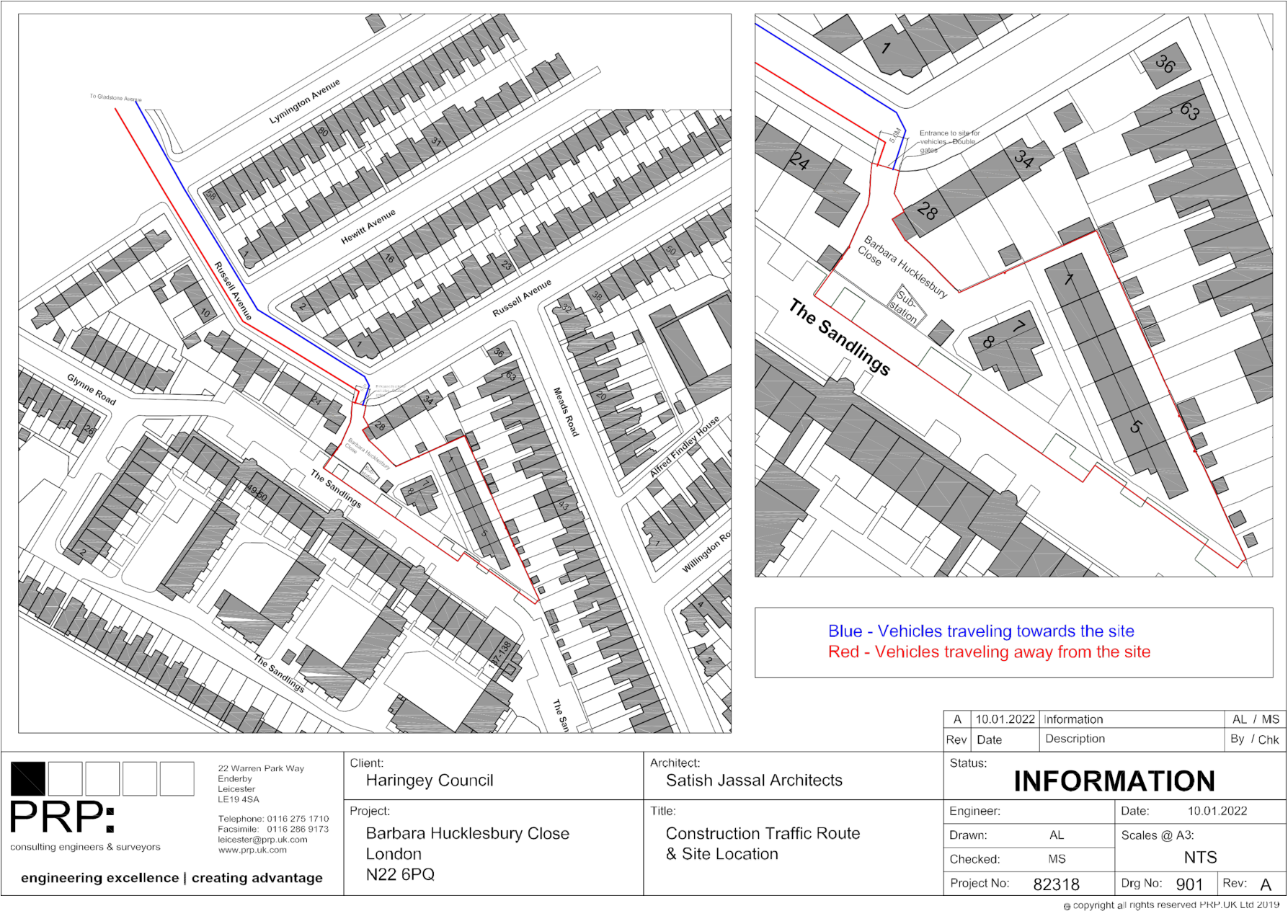

Appendix B - Site Setup / Compound and Logistics Plan
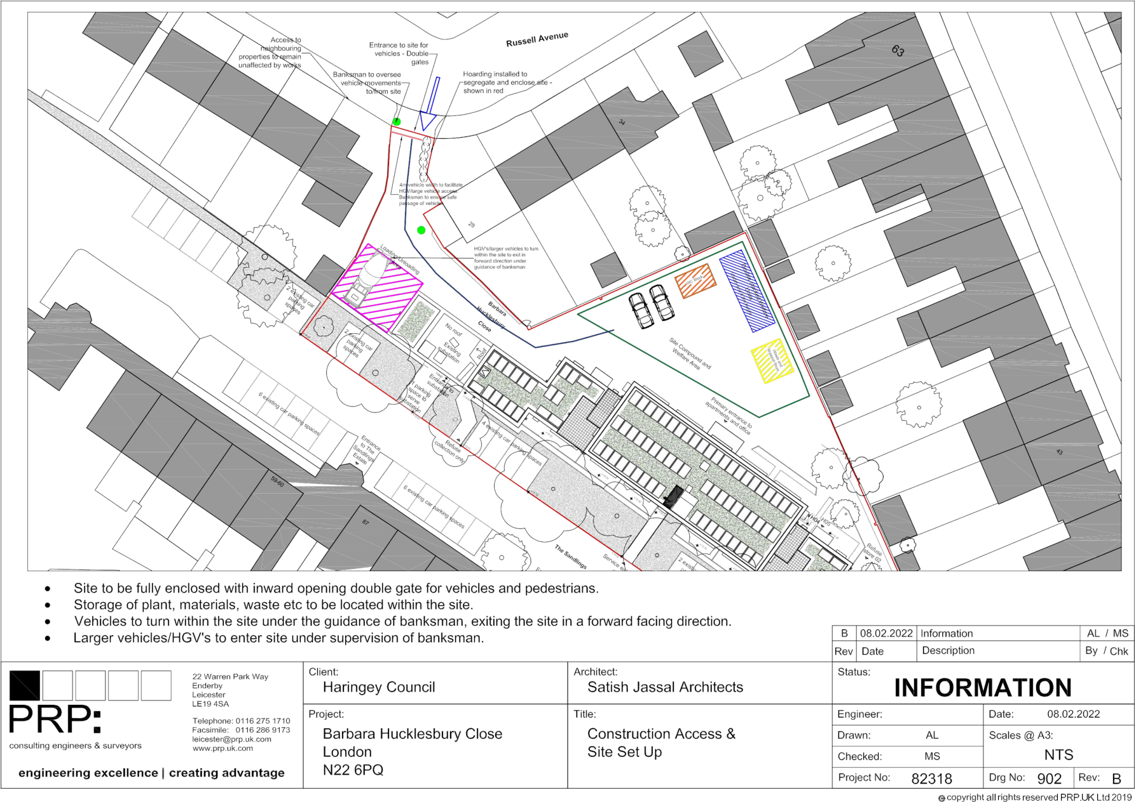

Appendix C - Sensitive Receptors Plan
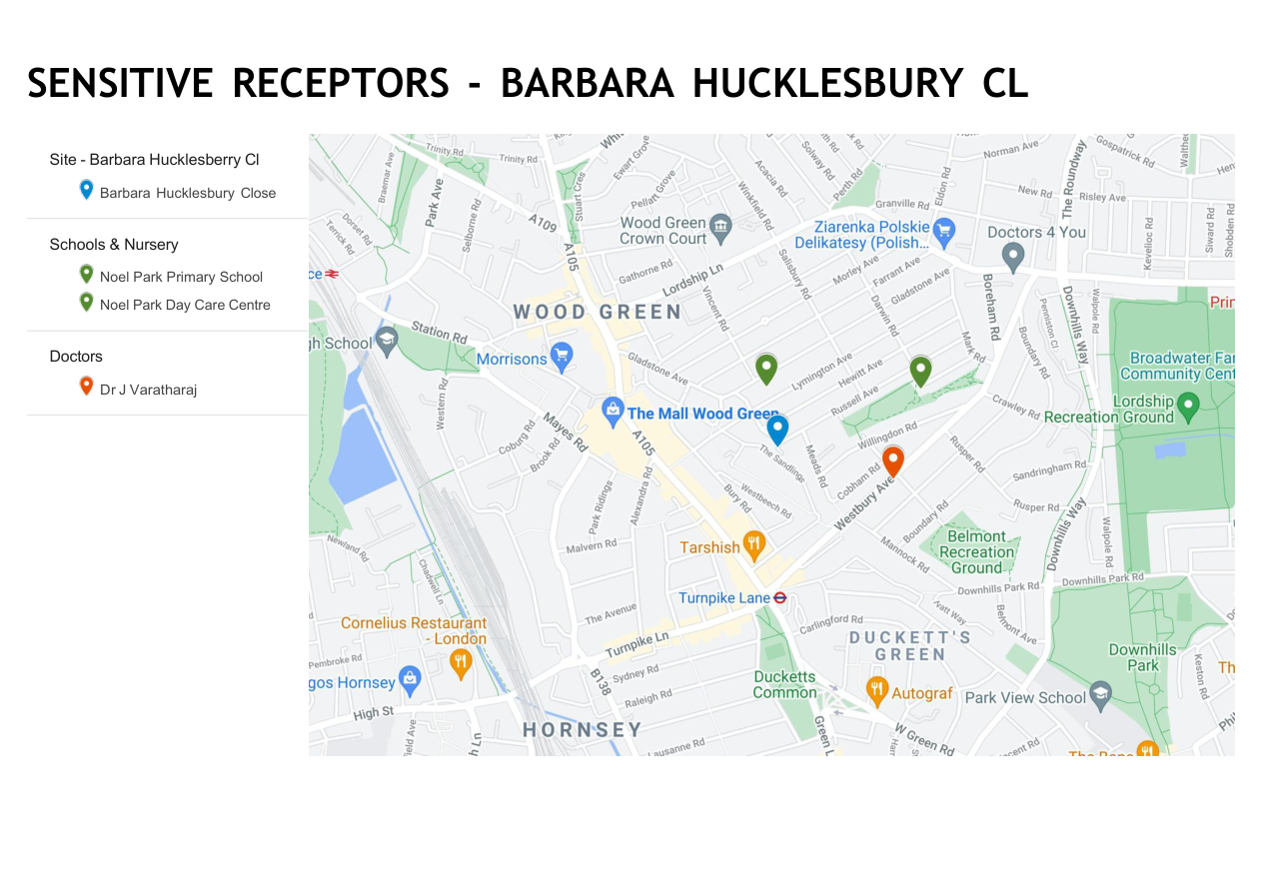

Appendix D - Landscape / External Interface Plan
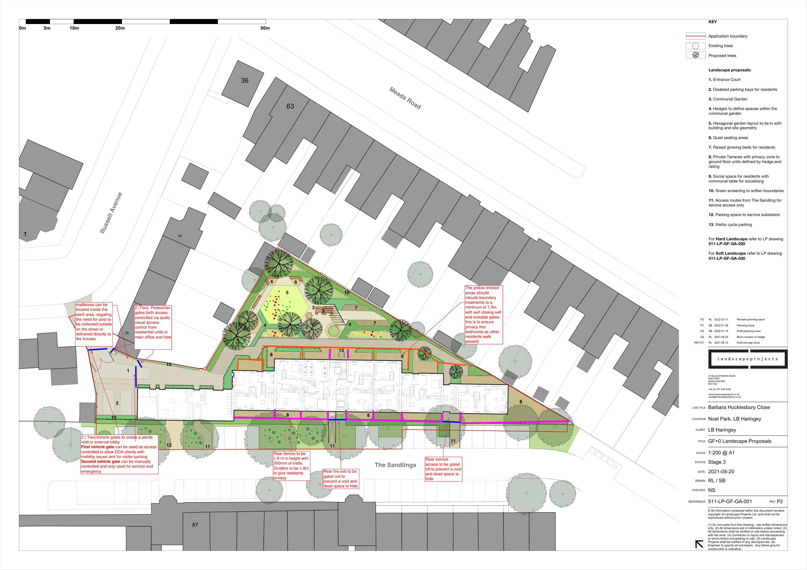

Appendix E - Proposed Ground Floor / Site Interface Plan
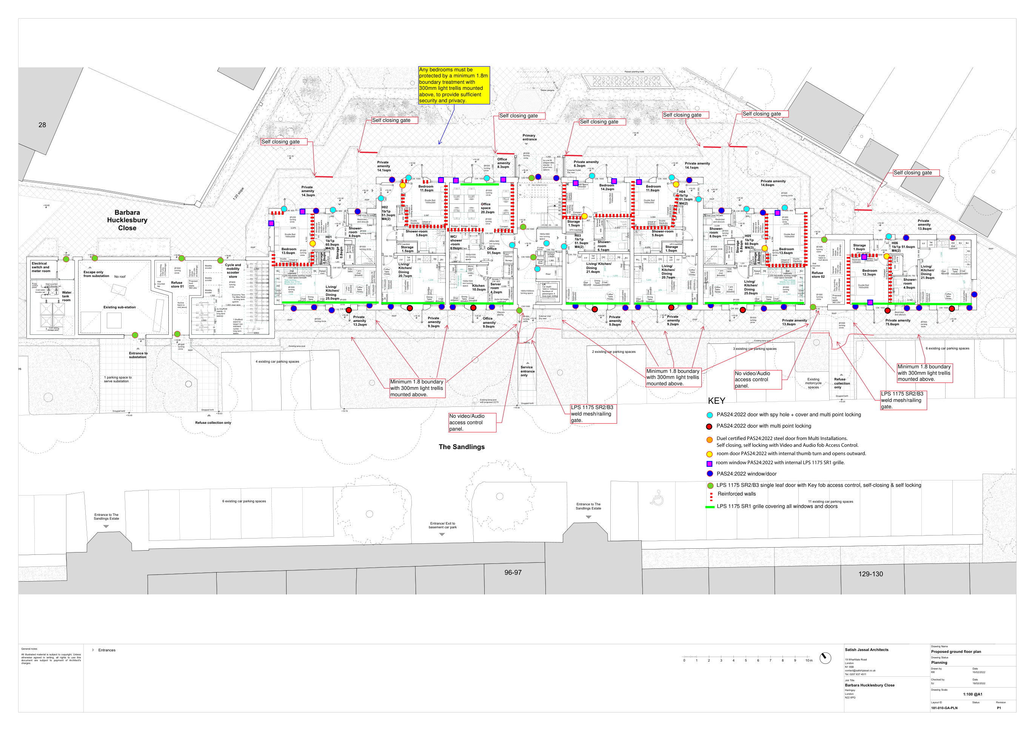

Appendix F - Vehicle Movement Summary Sheet 1
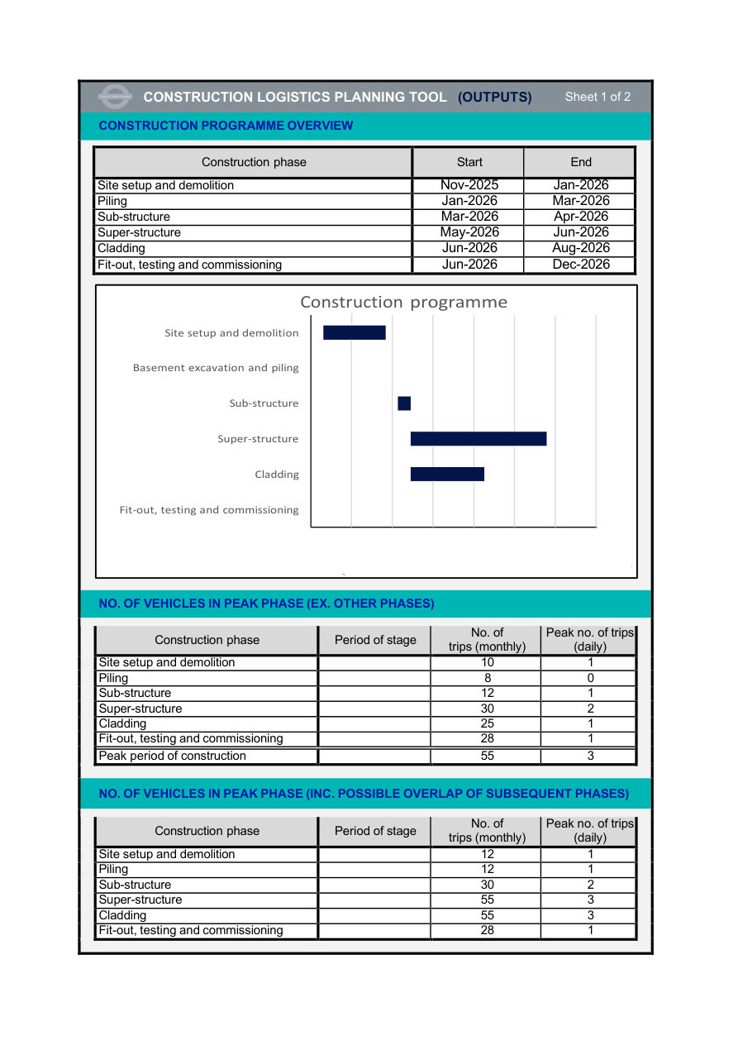

Appendix G - Vehicle Movement Summary Sheet 2
