Construction Method Statement
Supported Living Development, N22
Planning Application Reference: HGY/2022/0859
Prepared by Aspire Commercial Contractors Ltd
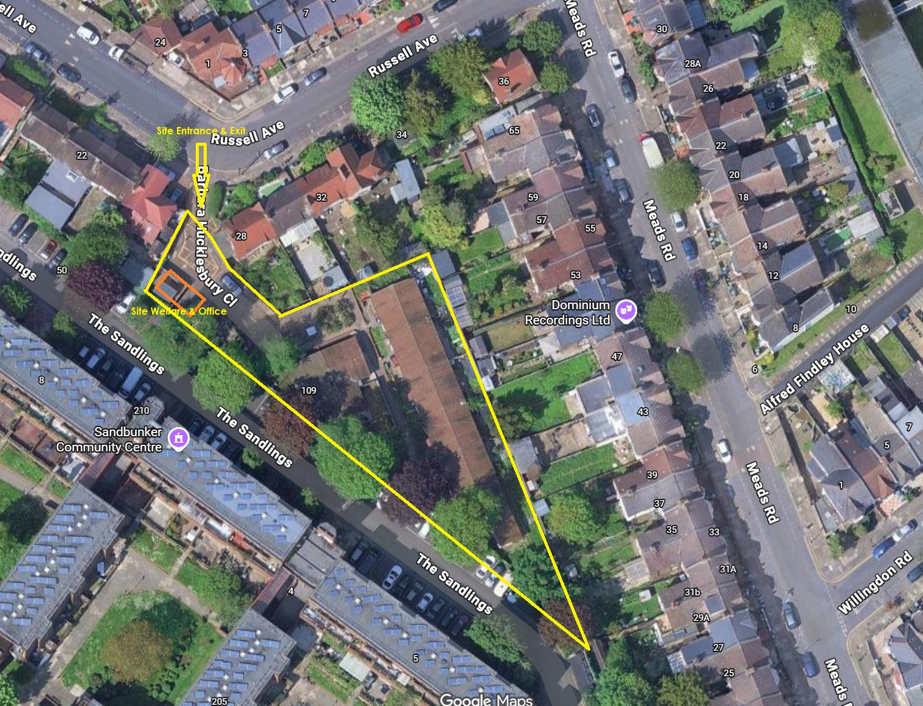

Document Control
Revision | Date | Status | Prepared By | Review / Action
P01 | 27 May 2026 | First draft for review | Aspire Commercial Contractors Ltd | Issued to Silver DCC for review and comment

1. Project Details
Item | Details
Project Name | Supported Living Development, N22
Site Address | N22 6PQ, accessed via Russell Avenue, Haringey
Planning Application Reference | HGY/2022/0859
Client / Developer | London Borough of Haringey
Principal Contractor | Aspire Commercial Contractors Ltd
Principal Designer | Simply CDM / TBC by current project appointment status
Site Manager | Matt Bradley
Resident Liaison Officer | TBC
Environmental Lead | TBC
Out-of-Hours Emergency Contact | TBC
Current Programme Dates | TBC
Demolition Status | TBC - refer to separate DEMP and demolition contractor RAMS once confirmed
No. 7 Occupation Status | Need update from Haringey
Utility Status | TBC

This Construction Method Statement has been prepared to describe the proposed construction methodology for the Supported Living Development, N22.
The document is based on the pre-construction information, design risk assessments, landscape risk information, draft construction logistics information, programme information, health and safety response and planning drawings provided to Aspire Commercial Contractors Ltd. It is to be reviewed and updated following confirmation of programme dates, demolition status, utilities, No. 7 occupation/access position, temporary works proposals and final subcontractor RAMS.

2. Purpose and Scope of this Method Statement
The purpose of this CMS is to set out the anticipated construction sequence and the controls that will be applied to undertake the works in a safe, planned and coordinated manner. It is intended to demonstrate that the construction stage has been considered in relation to the constraints of the site, neighbouring properties, substation access, logistics, environmental risk, quality control and resident liaison.
- Confirm the overall sequence of works from site establishment through to handover.
- Describe how construction works will be coordinated within a constrained residential setting.
- Set out how materials, plant, workforce access and temporary works will be managed.
- Identify key interfaces with the separate DEMP, CETMP/CLP, Construction Phase Plan, subcontractor RAMS and design information.
- Provide a structured first draft for review by Silver DCC and Haringey before final issue.

3. Description of the Works
The project comprises the construction of a part one, two and three-storey supported living development to provide 14 one-bedroom supported living homes, support office accommodation, communal garden space, wheelchair-accessible parking, cycle and mobility scooter storage, refuse and recycling stores, associated hard and soft landscaping and external service areas.
The scheme is located within a predominantly residential area and is accessed from Russell Avenue. The site arrangement is constrained by a single principal access point, neighbouring residential properties, The Sandlings interface, an existing substation and limited space for material storage. These constraints directly inform the construction sequence and logistics controls set out in this document.

4. Related Documents and Interfaces
This CMS should be read alongside, and not in substitution for, the project-specific documents below. Where final subcontractor RAMS or consultant information provides more detailed task-specific controls, those documents will take precedence for the relevant trade activity.
Document / Information | Purpose / Interface
Demolition Environmental Management Plan | Controls for demolition stage environmental risk, waste, dust, noise, vibration and hazardous materials.
Construction Environmental and Logistics Management Plan / CLP | Controls for vehicle routes, deliveries, resident liaison, environmental controls and logistics.
Construction Phase Plan | Principal Contractor health and safety management document under CDM 2015.
Subcontractor RAMS | Task-specific working methods for piling, steelwork, CLT installation, scaffolding, M&E, roofing, glazing, landscaping and other packages.
Temporary Works Designs and Permits | Design, checking and approval of any temporary works, excavations, propping, lifting points, hoarding support and working platforms.
Design Drawings and Specifications | Architectural, structural, M&E and landscape design information against which construction works will be delivered.
Inspection and Test Plans | Quality hold points, inspection records, benchmark approvals, testing and commissioning evidence.

5. Site Constraints and Construction Considerations
The construction methodology is driven by the physical and operational constraints of the site. These are not background issues; they are the main factors that will determine how the project must be built.
Constraint | Construction Response
Single access from Russell Avenue | Deliveries will be pre-booked, vehicle movements controlled by the Site Manager or banksman and reversing onto the public highway avoided.
Constrained residential setting | Works will be sequenced to minimise disruption, keep noisy and high-impact works within agreed hours and maintain active communication with neighbours.
Substation close to entrance/interface area | Access to the substation will remain unobstructed. No storage, parking, lifting, oversailing or temporary obstruction will be permitted in the agreed access zone.
No. 7 occupation/access status | Need update from Haringey. Until confirmed, construction arrangements will assume access must be protected and no works may block or prevent lawful access.
Limited storage capacity | Just-in-time deliveries, phased ordering and controlled laydown areas will be used. Bulk storage on site will be avoided where practicable.
Neighbouring pedestrian/resident interfaces | Hoarding, controlled gates, warning signage and segregated pedestrian arrangements will be used where required.
Service and utility uncertainty | Utility status is TBC. No intrusive works will proceed until surveys, isolations and permit-to-dig arrangements are confirmed.
Ground and contamination risk | Groundworks will proceed under controlled excavation procedures with stop-work protocols for unexpected contamination or suspicious materials.

6. Overall Construction Sequence
The final programme dates are TBC. The intended construction sequence is set out below as a logical methodology sequence. Activities may overlap where safe and appropriate once design, procurement, temporary works and site logistics allow.
Phase | Main Activities | Key Controls / Outputs
1. Pre-start and mobilisation | Confirm appointments, review PCI, planning conditions, utilities, surveys, temporary works requirements, RAMS and CPP. | Pre-start meeting, site-specific CPP, permits, inductions, welfare plan, emergency arrangements and logistics briefing.
2. Site establishment | Install hoarding, access gates, welfare, temporary services, signage, storage zones, fire points and pedestrian/vehicle segregation. | Secure site, controlled access, defined laydown areas, substation access protection and resident liaison notices.
3. Demolition/enabling interface | Demolition status TBC. Where demolition remains outstanding, works will follow the separate DEMP and demolition contractor RAMS. | Site made safe for construction, arisings removed, services isolated, ground handed over for construction.
4. Groundworks and substructure | Survey setting out, service investigations, excavation, drainage, foundations, ground beams/slabs and DPC/DPM works. | Permit-to-dig, CAT and Genny scans, excavation protection, spoil management, concrete delivery controls and inspections.
5. Superstructure | Erection of structural frame, CLT/steel elements where applicable, floors, walls, roof structure and stability elements. | Temporary works checks, lifting plans, exclusion zones, sequencing to maintain stability and inspection of connections.
6. Scaffold/access and envelope | Scaffold/access systems, external walls, insulation, windows, doors, weatherproofing and roof works. | Scaffold design/inspection, fall prevention, edge protection, material loading controls and progressive weathering-in.
7. Internal works and M&E | First fix M&E, partitions, linings, fire stopping, bathrooms, kitchens, joinery, second fix, decorations and floor finishes. | Trade coordination, fire stopping inspection, sample/benchmark approvals, protection of finished works and ITP records.
8. External works and landscaping | Hard landscaping, drainage interfaces, paving, cycle/refuse areas, garden structures, planting, fencing and gates. | Tree/root protection, pedestrian interface controls, seasonal planting, material handling and protection of completed surfaces.
9. Testing, commissioning and handover | Commissioning, certification, snagging, cleaning, O&M manuals, health and safety file information and client demonstrations. | Commissioning evidence, as-builts, certificates, defect closure, handover packs and final inspections.

7. Site Establishment Methodology

7.1 Access, Hoarding and Security
The site will be secured before construction works commence. Hoarding and controlled gates will be installed to define the construction boundary, prevent unauthorised access and separate construction activities from neighbouring residents and pedestrians. Access will be controlled through the Russell Avenue entrance. The entrance will be managed to prevent vehicle waiting on the public highway where practicable.
- Install perimeter hoarding/fencing to the agreed site boundary and maintain it in good condition.
- Provide lockable access gates with directional and warning signage.
- Maintain a signing-in process for operatives, visitors and delivery drivers.
- Display emergency contacts, site rules and complaint contact information at the site entrance.
- Ensure the site is secured when unattended and that out-of-hours contact details are displayed once confirmed.

7.2 Welfare, Site Office and Storage
Welfare and office provision will be established in accordance with CDM 2015 and sized to suit the workforce. Welfare is expected to include toilets, washing facilities, drying area, canteen/mess facilities, office space and first aid provision. Final welfare location is to be confirmed on the site setup drawing before construction starts.
- Materials will be stored within the site boundary only.
- Storage zones will be kept clear of the substation access route and any protected pedestrian/resident access routes.
- High-value materials will be stored securely and delivered on a phased basis.
- Hazardous substances will be stored in a dedicated controlled area with COSHH information available.
- Waste and material storage areas will be maintained to prevent trip hazards, fire loading and obstruction of access routes.

7.3 Temporary Services
Temporary power, water and lighting arrangements will be confirmed prior to mobilisation. No connection, alteration or use of existing services will be undertaken unless authorised and controlled through the permit system. Temporary supplies will be installed and maintained by competent persons.

8. Construction Logistics and Material Distribution
Construction logistics are to be controlled through the project CLP. This CMS summarises the construction-specific method for receiving, unloading and distributing materials around the site.

8.1 Delivery Management
- All deliveries will be pre-booked with the Site Manager or nominated logistics lead.
- Deliveries will avoid peak local traffic periods where practicable and will be coordinated with the approved CLP delivery windows.
- Drivers will be issued with the agreed route to site and will not be permitted to wait on Russell Avenue without authorisation.
- Banksmen will control vehicle movements where vehicles enter, exit, turn or unload within the site.
- Deliveries will be refused or rescheduled if they arrive outside the agreed slot and cannot be safely accommodated.

8.2 Unloading and Internal Distribution
Materials will be unloaded within the site boundary using suitable plant, manual handling controls or mechanical aids appropriate to the package. The Site Manager will ensure that unloading zones remain segregated from pedestrian routes and that material distribution does not block emergency access, substation access or escape routes.
- Large or heavy items will be subject to task-specific lifting plans and RAMS.
- Palletised materials will be positioned in designated laydown areas and moved to workfaces as required.
- Internal distribution will be phased to avoid overloading floors, corridors or access routes.
- Finished surfaces will be protected before follow-on trades or material movements pass through completed areas.
- Manual handling will be assessed by package and mechanical aids used where reasonably practicable.

8.3 Swept Path and Vehicle Tracking Basis
Vehicle access and turning will be based on the swept path information already included within the project logistics information. The principle to be maintained is that construction vehicles will enter from Russell Avenue, load or unload within the site and turn within the site before exiting forward gear where practicable. The swept path analysis is to be appended to the final issue and checked against the proposed site setup, hoarding line, storage zones and substation access requirements.
- The largest regular vehicle type will be confirmed before final issue.
- Where vehicle tracking indicates restricted clearance, banksman control will be mandatory.
- No storage, skips or welfare units will be positioned within the tracked turning envelope unless the logistics plan is revised.
- Vehicle tracking will be reviewed before high-impact deliveries such as steel, CLT, scaffold, plant, concrete or large M&E items.
- Any abnormal or non-standard delivery will require a separate delivery plan and Site Manager approval.

9. Construction Methodology by Work Package

9.1 Pre-Construction Coordination and Setting Out
Before works commence, Aspire will review the latest construction information, planning conditions, services records, survey information, design drawings and residual risk registers. A setting-out strategy will be agreed and relevant control points established. Any discrepancies between existing conditions and the design information will be reported to the design team before affected works proceed.
- Confirm latest revision drawings and specifications are issued for construction.
- Review residual design risks with the Principal Designer and design team.
- Confirm planning condition requirements relevant to construction sequencing.
- Complete pre-start condition survey of relevant boundaries, roads, kerbs and nearby interfaces where required.
- Confirm temporary works requirements before excavation, lifting, scaffolding or structural installation.

9.2 Demolition and Enabling Interface
Demolition is to be controlled under the separate DEMP and demolition contractor RAMS. The construction phase will not proceed into affected areas until the Site Manager is satisfied that the area has been made safe, waste has been removed, services have been isolated or protected and any required handover records have been provided.
- Confirm demolition status and handover boundary before construction works commence.
- Confirm any remaining slab, foundation, service or contamination risks before groundworks.
- Protect substation access and any retained structures or boundaries during enabling works.
- Complete clearance inspections and record any residual hazards that remain from demolition.
- Update the CPP and CMS where demolition handover conditions alter the planned construction sequence.

9.3 Groundworks, Drainage and Substructure
Groundworks will commence following survey confirmation, utility checks and permit-to-dig approval. The methodology will be developed by the appointed groundworks contractor and reviewed by Aspire before the works begin. The sequence will typically include site clearance to formation, setting out, service investigations, excavation, drainage, foundations and ground floor construction.
- Undertake service scans and trial holes where required before excavation.
- Use permit-to-dig controls for all intrusive works.
- Provide edge protection, barriers and signage around open excavations.
- Keep excavated material away from edges and manage spoil to avoid obstruction of site routes.
- Control concrete deliveries through pre-booked slots and washout arrangements.
- Inspect formation, reinforcement, shuttering, drainage and concrete works in accordance with ITPs.
- Stop works and escalate if suspected contamination, asbestos, UXO or unexpected services are encountered.

9.4 Superstructure
The superstructure phase is expected to include a structural frame and CLT/steel elements where applicable. Final sequencing will be determined by the structural engineer, temporary works designer and specialist subcontractors. The works will be planned to maintain stability at all stages and to ensure safe access, lifting zones and exclusion areas are in place before installation activities commence.
- Review structural sequence, temporary works and lifting requirements before installation.
- Use competent installers and appointed persons for lifting operations.
- Establish exclusion zones below and around lifting and installation activities.
- Confirm bearing surfaces, holding down bolts, connection details and tolerances before installation.
- Do not load incomplete structures beyond design or temporary works limits.
- Record inspections of key structural connections and hold points before follow-on trades proceed.

9.5 Scaffolding and Temporary Access
Scaffold and temporary access systems will be designed, erected, altered and inspected by competent persons. Scaffold requirements will be coordinated with elevation works, roof works, window installation, external wall construction and public/resident protection needs.
- Scaffold design to be provided where required by TG20 or project-specific conditions.
- Scaffold to be inspected before first use, after alteration and at statutory intervals.
- Loading bays to be clearly identified and loaded within permitted limits only.
- Edge protection and fall prevention to be maintained throughout high-level works.
- Scaffold ties, protection fans or sheeting to be coordinated with facade and boundary conditions where required.

9.6 Building Envelope, Roof and Weatherproofing
Envelope and roof works will be sequenced to achieve weather tightness as early as reasonably practicable and to protect internal works. Works may include external walls, insulation, windows, doors, roof build-up, rainwater goods and associated detailing.
- Confirm approved specifications, fire performance and interface details before installation.
- Install windows, doors and weatherproofing progressively to reduce water ingress risk.
- Protect openings, unfinished roof areas and penetrations during works.
- Coordinate high-level works with scaffold, edge protection and lifting plans.
- Carry out inspections and photographic records before covering key details.

9.7 Internal Works and Fit-Out
Internal works will be coordinated through phased trade sequencing to avoid congestion, rework and damage to completed areas. The sequence will typically include internal partitions, M&E first fix, plasterboard/linings, fire stopping, bathrooms, kitchens, joinery, second fix M&E, floor finishes, decorations and final fixtures.
- Trade sequencing will be reviewed at weekly coordination meetings.
- Fire stopping inspections will be undertaken before closing up and records retained.
- Samples or benchmarks will be agreed for key finishes before wider installation.
- Completed works will be protected before following trades enter the area.
- Defects will be recorded progressively rather than left until final handover.
- M4 accessibility requirements and clearances shown on the design drawings will be protected during fit-out.

9.8 Mechanical, Electrical and Plumbing Works
M&E works will be coordinated with the architectural and structural design. Service routes, risers, plant areas, meter/switch rooms, water storage and roof plant interfaces will be reviewed before first fix. The M&E contractor will provide detailed RAMS, commissioning plans and test records.
- Confirm builder’s work openings, risers and plant access routes before installation.
- Isolate, lock off and permit any works associated with live or existing services.
- Coordinate M&E with fire stopping strategy and access requirements for maintenance.
- Pressure testing, electrical testing and commissioning will be recorded and included within handover documentation.
- Plant replacement and maintenance access information will be captured for the Health and Safety File.

9.9 External Works and Landscaping
External works will generally follow completion of main structural and envelope works where site access permits. The works include hard landscaping, paving, refuse/cycle areas, boundary treatments, garden features, raised planting beds, soft landscaping and planting. Tree/root protection and retained boundary interfaces will be managed in accordance with the landscape information and specialist requirements.
- Confirm levels, drainage falls, sub-bases and surface specifications before installation.
- Protect retained trees and root protection areas where relevant.
- Maintain service/substation access during external works.
- Control dust during cutting and use wet cutting or suppression methods where practicable.
- Sequence planting to suit appropriate seasonal conditions where possible.
- Protect completed paving, planted areas and external finishes during final works.

10. Temporary Works and Lifting Operations
Temporary works will be identified, designed, checked and controlled in accordance with Aspire procedures and the requirements of the Temporary Works Coordinator. No temporary works will be installed, loaded, altered or removed without appropriate review and authorisation.
Temporary Works / Lift Activity | Control Requirement
Excavations and trenching | Permit-to-dig, service checks, edge protection, battering/support where required and inspection before entry.
Hoarding and gates | Installed to suit site boundary, wind loading and public protection requirements; inspected and maintained.
Scaffold and access systems | Designed and inspected by competent contractor; loading limits and handover certificates maintained.
Structural frame/CLT/steel installation | Sequenced with structural and temporary works input to maintain stability at all stages.
Lifting operations | Lift plans, competent operators, slinger/signaller, exclusion zones and appointed person involvement where required.
Loading bays and material laydown | Capacity and loading limits confirmed; no unauthorised loading of incomplete structures.

11. Health, Safety and Environmental Controls
Health, safety and environmental controls will be managed through the Construction Phase Plan, site inductions, RAMS, permits, inspections and ongoing supervision. Environmental controls that relate specifically to logistics and site-wide impacts are addressed in the CETMP/CLP. Demolition-specific controls are addressed in the standalone DEMP.
Control Area | Construction Method Requirement
Inductions and briefings | All operatives and visitors to receive site induction. Task briefings and toolbox talks to be delivered before relevant activities.
Permits | Permits to be used for hot works, excavations, roof works, work at height, lifting, confined spaces, electrical works and any other high-risk activity.
Dust control | Wet cutting, on-tool extraction, damping down, covered skips and housekeeping during dust-producing works.
Noise control | Use well-maintained plant, avoid unnecessary idling, plan noisy activities and notify residents where disruptive works are planned.
Vibration control | Monitor high-impact activities where required and select methods that reduce unnecessary vibration.
Fire prevention | Fire risk assessment, hot works controls, fire points, temporary escape routes, emergency plan and housekeeping to control fire load.
Public/resident protection | Maintain hoarding, signage, controlled access, segregated routes and liaison procedures.
Contamination/unknown materials | Stop work, isolate area, inform Site Manager and obtain specialist advice before disturbance or removal.
Manual handling | Use mechanical aids, team lifts and package-specific manual handling assessments.
Work at height | Use scaffold, MEWPs, edge protection or other collective protection before relying on harness systems.

12. Quality Assurance and Inspection
Aspire will manage quality through approved drawings, specifications, ITPs, site inspections, subcontractor check sheets, photographic records and progressive snagging. The aim is to identify and close issues during the works rather than relying on end-stage inspection only.
- Current drawing register to be maintained and outdated drawings removed from use.
- Inspection and test plans to be agreed for key packages before works commence.
- Hold points to be set for foundations, structure, fire stopping, waterproofing, M&E testing, envelope details and handover-critical elements.
- Benchmark areas or sample panels to be agreed where appropriate before wider installation.
- Defects and snags to be logged, allocated and closed with evidence.
- Handover documentation to be compiled progressively rather than at the end of the project.

13. Community, Resident and Stakeholder Liaison
The site is within a residential setting and the construction works will require proactive communication. The Resident Liaison Officer is TBC. Until confirmed, the Site Manager will be responsible for coordinating resident communications and escalation of complaints.
- Display contact details and key information at the site entrance.
- Provide advance notice of disruptive works where practicable.
- Record complaints, investigate promptly and issue corrective actions where required.
- Coordinate access requirements with Haringey, Silver DCC and relevant residents where required.
- Keep substation access arrangements under review and escalate any risk of obstruction immediately.

14. Emergency Arrangements
Emergency arrangements will be confirmed in the Construction Phase Plan and displayed on site. The out-of-hours emergency contact is TBC. Emergency access must be maintained through the site entrance and internal routes must remain clear of unnecessary storage or obstruction.
Emergency Scenario | Initial Response
Fire | Raise alarm, evacuate to assembly point, call emergency services, isolate works if safe and account for personnel.
Serious injury | Stop works, make area safe, call first aider/emergency services and preserve scene where required.
Utility strike | Stop works, evacuate if required, isolate if safe, contact utility provider and emergency services where necessary.
Pollution/spill | Stop source if safe, deploy spill kit, protect drains, notify Site Manager and escalate as required.
Structural instability | Stop works, evacuate affected area, establish exclusion zone and seek engineer/temporary works advice.
Discovery of suspect material/UXO | Stop works, isolate area, prevent disturbance and obtain specialist advice.

15. Items Requiring Confirmation Before Final Issue
Item | Current Position | Required Action
Current programme dates | TBC | Confirm current start, completion and key phase dates with project team.
Demolition status | TBC | Confirm whether demolition is complete, partly complete or still to be undertaken.
No. 7 occupation/access status | Need update from Haringey | Confirm occupation status, access rights and any restrictions before finalising logistics.
Utility status | TBC | Confirm isolation, disconnection, diversion and temporary service arrangements.
Environmental monitoring | Need update from Haringey | Confirm whether formal noise, dust or vibration monitoring is required by condition or council request.
Resident Liaison Officer | TBC | Confirm named person and contact details.
Environmental Lead | TBC | Confirm named person and responsibility scope.
Out-of-hours emergency contact | TBC | Confirm number and display location before mobilisation.
Swept path analysis | Draft logistics information available | Append final swept path drawing and confirm vehicle types, turning envelope and exclusion zones.
Temporary works register | TBC | Confirm temporary works coordinator and initial temporary works schedule.
Final subcontractor RAMS | TBC by package | Obtain and review before each trade package commences.

16. Appendices
The following drawings and visual information are included for review context. Source drawing title blocks may retain their original consultant naming because they are embedded drawings and not editable Word text.
Appendix A - Construction traffic route plan / access context
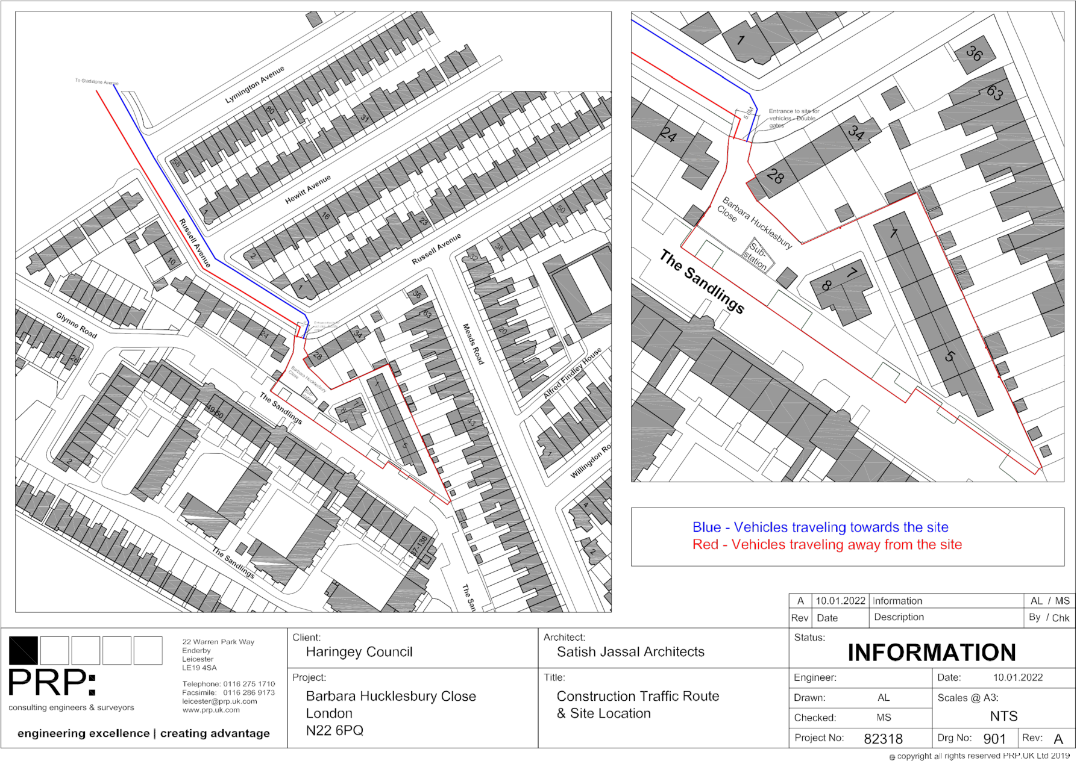

Appendix B - Site setup / logistics arrangement drawing
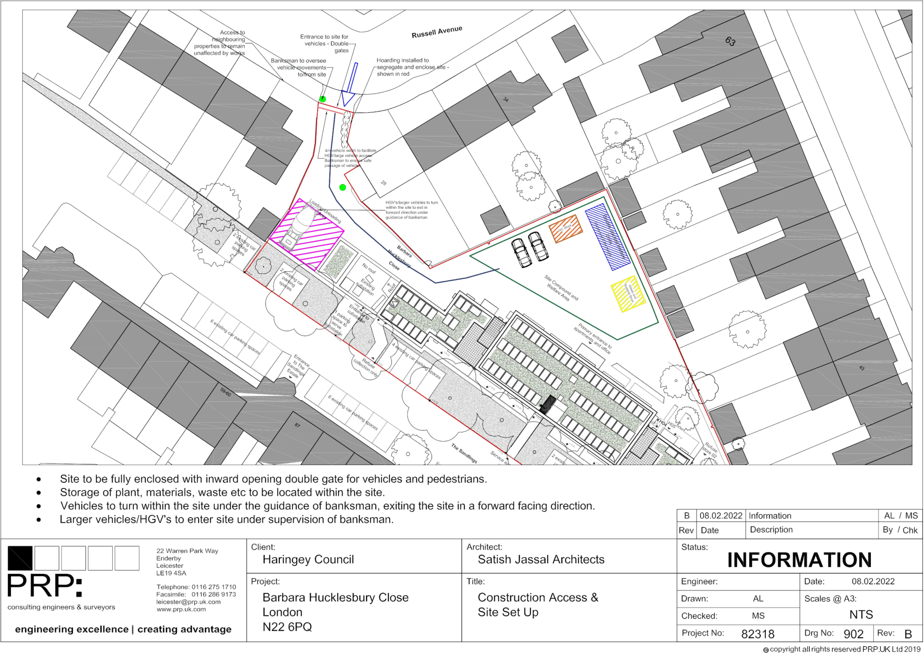

Appendix C - Sensitive receptors location plan
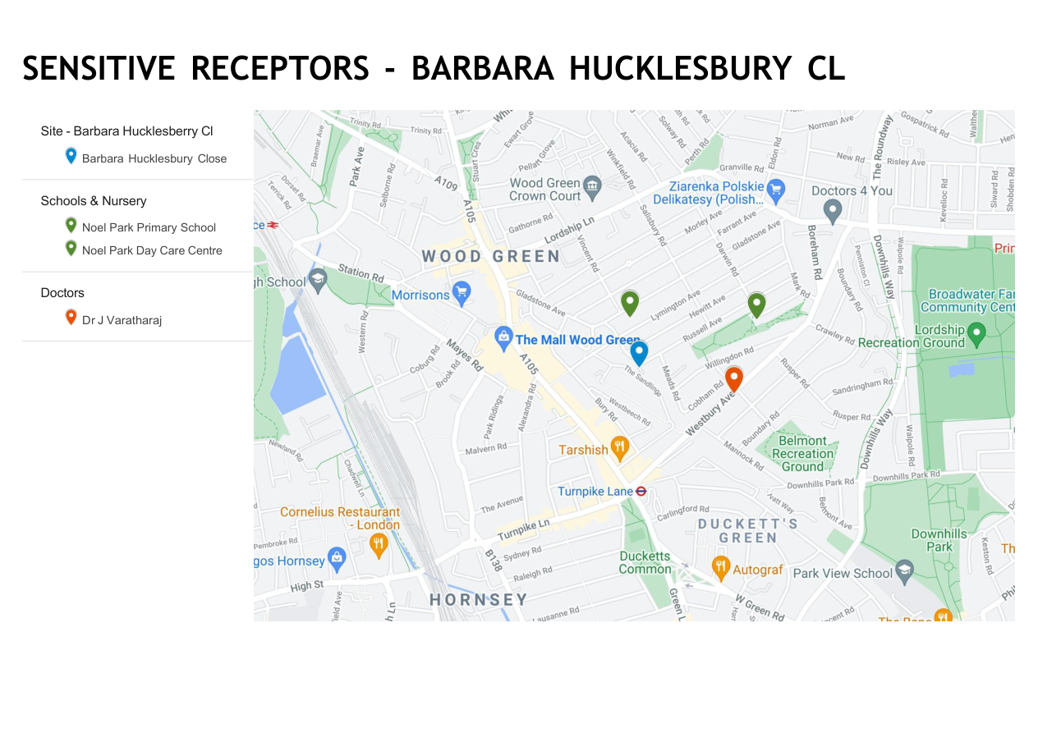

Appendix D - Ground floor / site interface plan
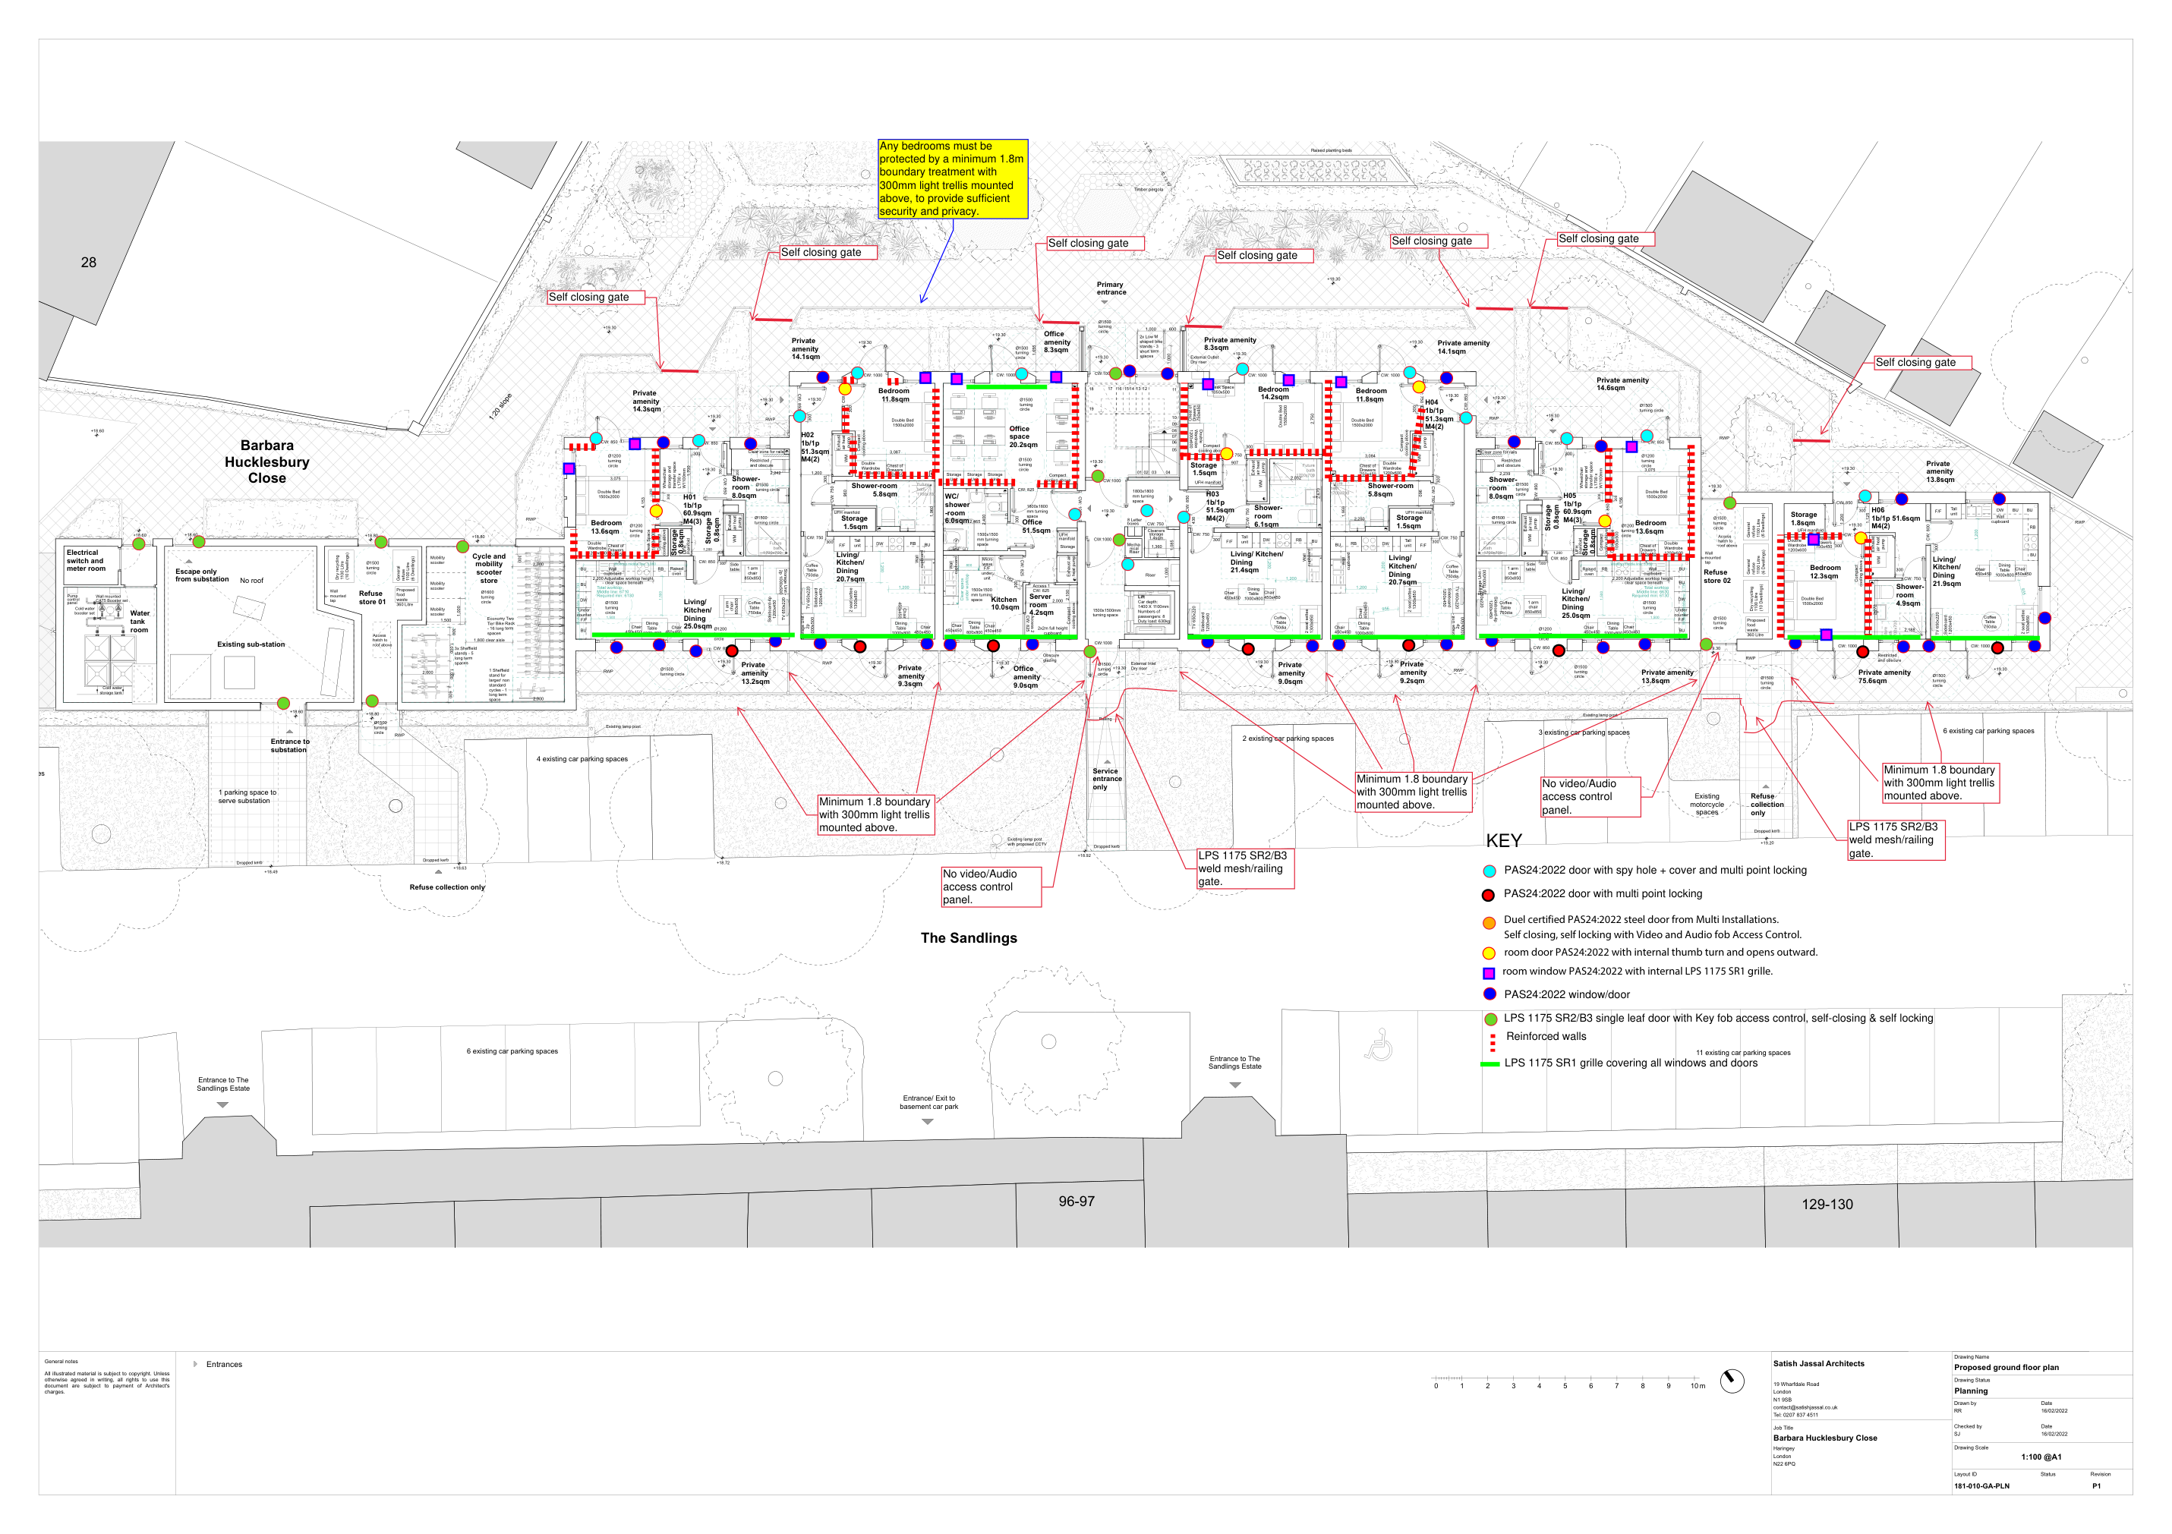

Appendix E - Landscape and external works proposal plan
