

North London Reinforcement Project
Requirement 7 - Highway Accesses & Requirement 9 - Construction Traffic Management Plan
Stage 4a: London Borough of Haringey

National Grid
Unit 6
The Grange Business Park
Wick Road
Hewish
Somerset
BS24 6RR

June 2026

Document Control
Document Properties
Organisation |  | National Grid
Author |  | Various
Approved by
Title |  | North London Reinforcement Project  Requirement 7 - Highway Accesses & Requirement 9 - Construction Traffic Management Plan  Stage 4a: London Borough of Haringey
Document Reference |  | 1
Version History
Date | Version |  | Status | Description/Changes
02/02/2026 | P01 |  | Draft for Internal Comment | Issued to MES/NG for review
13/5/2026 | P02 |  | Draft for NGET review
22/5/2026 | 0.5 |  | Draft for consultation
1/6/26 | 1 |  | For submission

Table of Contents

1 Introduction 5
1.1 This Document 5
1.2 Requirements Summary 5
1.3 Overview of the Project 6
1.4 Stage overview 7
1.5 Consultation 8
2 Site Access 10
2.1 Overview. 10
2.2 Proposed Works 12
3 Means of Managing Routes on the local highway network 14
3.1 Vehicle Routeing 14
3.2 Traffic Generation 15
3.3 Temporary Traffic Management (Highway works) 16
3.4 Speed Limit 16
3.5 Driver Information 16
3.6 Emergency Access 17
3.7 Road Debris 17
4 Means of Managing non-motorised user Routes with construction traffic 17
4.1 Footway closures and diversion 17
4.2 Footpath closures and diversions 17
5 Scheduling and Timing 18
5.1 Construction Schedule 18
5.2 Operational Times 18
6 Condition Survey 18
6.1 Extent of Survey and Methodology 18
6.2 Survey Results 18
7 Highway Maintenance 20
7.1 Damage Caused by Construction Traffic 20
8 Construction Laydown Areas 20

Introduction

This Document
    - This document comprises the Access Strategy and Construction Traffic Management Plan (CTMP) for the authorised development comprising the Stage 4a overhead line works, within the London Borough of Haringey (LBH), that form part of the North London Reinforcement Project (‘the Project’) as required by Schedule 2, Requirements 7 & 9 of The National Grid (North London Reinforcement) Development Consent Order 2014 (‘the DCO’). The works within LBH are defined as Stage 4a within the revised DCO Stage Plan agreed with the Authority.
    - There are no OHL works associated with Stage 4a. The works in this stage are solely for the establishment of the access and associated track that leads to the proposed new tower location (Tower VC1R). Access is via Watermead Way.
    - This document has been submitted for approval to LBH as the relevant Planning Authority for the Project to discharge Requirements 7 & 9 for works forming Stage 4a within this Authority area.

Requirements Summary
    - Requirement 7 of the DCO states as follows:
1) No stage of the authorised development shall commence until for that stage written details of the siting, design and layout of any new permanent or temporary means of access to a highway to be used by vehicular traﬃc, or any alteration to an existing means of access to a highway used by vehicular traﬃc, has, after consultation with the relevant highway authority, been submitted to and approved by the relevant planning authority.
2) The highway accesses must be constructed in accordance with the approved details unless otherwise agreed with the relevant planning authority.
3) No stage of the authorised development shall commence until for that stage, a written access management scheme for the arrangements for the use and maintenance of highway accesses during construction of that stage has been submitted to and approved by the relevant highway authority.
4) The access management scheme must be carried out in accordance with the approved details unless otherwise agreed with the relevant highway authority
    - Requirement 9 of the DCO states as follows:
(1) No stage of the authorised development shall commence until a construction traﬃc management plan for that stage has been submitted to and approved by the relevant highway authority. The construction traﬃc management plan for that stage shall include:
a) construction vehicle routing plans;
b) site access plans;
c) means of managing shared use routes, including pedestrian and cycling safety measures where applicable;
d) proposals for the scheduling and timing of movements of delivery vehicles;
e) proposals for assessing the existing condition of aﬀected highways;
f) proposals for the making good of any incidental damage to highways by construction traﬃc associated with
that stage of the authorised development including street furniture, structures, drainage features, highway
verge and carriageway surfaces; and
g) construction laydown area details aﬀecting highways.
(2) Each construction traﬃc management plan shall be implemented as approved unless otherwise agreed with the relevant highway authority.
    - In addition to the Requirements set out above, verified DCO document: Appendix A9 - Table of Environmental Measures also identifies other measures to be applied as part of Requirement 7 and Requirement 9.
    - There is a site-specific measure related to Stage 4a as part of Requirement 7 Highway Accesses which is:
- Temporary redesign of the A1055 Watermead Way/Marigold Road signalised junction including the provision of dedicated cyclists/ pedestrian crossings.
    - Measures relevant to Requirement 9 (CTMP) are identified as general DCO measures that relate to Traffic and Transport. These measures are:
- Temporary construction signage;
- Traffic routeing strategy; and
- Access security personnel.
    - There are also additional measures relevant to Requirement 9 (CTMP) within other environmental disciplines as they have a traffic related element. The additional measures that are specific to Stage 4a within the Haringey area and the associated environmental subject area are as follows:
- Using designated access routes to/from the sites for construction vehicles. Access to winching compounds and pylons using existing tracks, roads, and hardstanding to minimise vegetation clearance (Landscape/Townscape).
- Specify access routes for tracking vehicles. (Land and Water Quality).
Note: From discussions within National Grid, it is inferred that, in the context of the last bullet point above, the word ‘tracking’ is a typo in the DCO, and this refers to the use of ‘tracked’ vehicles such as excavators, not swept path analysis. No tracked vehicles will be used for works in Stage 4a.

Overview of the Project
    - The DCO was made by the Secretary of State for Energy and Climate Change for the Project on 16 April 2014 and came into force on 7 May 2014. The DCO provides powers to National Grid to carry out the Project, which comprises of the replacement of the existing 275kV overhead line with a 400kV overhead line from Waltham Cross substation in Epping Forest, through Enfield, and then to Tottenham substation in Haringey. The DCO also contains powers to carry out associated works to the substations at Waltham Cross, Brimsdown and Tottenham.
    - The Project falls within the administrative boundaries of, Epping Forest District Council, the London Borough of Enfield, the London Borough of Waltham Forest, and the London Borough of Haringey. The Project is also within the administrative boundaries of the Greater London Authority and Essex County Council though these are not relevant planning authorities in relation to the Project.
    - The Project includes the following elements:
- Existing 275kV route uprating to 400kV for 14km from the Waltham Cross substation to Tottenham substation. This would comprise of:
  - The existing 275kV conductor cables (wires) to be removed and replaced (i.e. reconductored) with 400kV wires. This would use the existing pylons.
- An extension to the Waltham Cross substation to provide a new 400kV Gas Insulated Switchgear (GIS) substation and associated overhead line entry modifications.
- The replacement of two 275/132 kV Super Grid Transformers (SGTs) at Brimsdown with two new 400/132kV SGTs, located both inside and partially outside the existing Brimsdown substation boundary, with underground cable connections between these new SGTs and the existing substation.
- Works to bypass Tottenham substation, including the construction of a new pylon (VC1R) and cable sealing end (CSE) compound south of the Tottenham substation, and the removal of the existing VC1 pylon.
- Associated works, for example, temporary access roads, highway works temporary construction compounds, scaffolds, work sites and ancillary works.

Stage overview
    - A written scheme of stages (required by Schedule 2, Requirement 3 of the DCO) was submitted to the following authorities:
- London Borough of Haringey
- Epping Forest District Council
    - London Borough of Enfield
- London Borough of Waltham Forest
    - The written scheme of stages sets out the works that form part of Stage 4a.
    - The proposed works in this stage of the Project are limited to:
    - Establishment of a new access track off Watermead Way. This involves installation of a temporary haul route between AC72 and the works area for Tower VC1R (shown on Sheet 10 of the Access/Rights of Way Plans) to accommodate construction vehicles for works to pylons VC1 and VC1R. The access will comprise of the following:
  - An extended dropped kerb to allow larger vehicles access.
  - Appropriate safety measures to guide pedestrians and cyclists to crossing facilities that will be introduced to allow them to safely cross the access.
  - The operation of the access will be incorporated into the existing Watermead Way / Marigold Road signal junction arrangement.
  - Beyond the access, a temporary track will be provided leading to the works area for Tower VC1R.
  - Access to the Lee Valley Regional Park (LVRP) will be closed to users with an alternative route provided to the south.
  - Maintenance and emergency vehicle access to LVRP will be maintained at all times.
    - Appropriate traffic management will be provided during the access establishment and whilst in operation.
    - Vegetation clearance: removal of plants and vegetation in the vicinity of Tottenham substation and relevant pylons to allow for the works within this stage.
    - The relevant DCO Work Plans and associated Access/Rights of Way Plans are Included as Appendix A.

Consultation
    - A number of consultation meetings have been undertaken with Highway officers from LBH and representatives from Lee Valley Regional Park Authority (LVRPA). The initial pre-app consultation occurred in October 2024 and a number of comments were provided at this time and are summarised below:
- For the access points AC71/AC72, it was highlighted that the proposals set out within the Transport Statement linked to the DCO describes the removal of the existing paved area and reinstatement of the access that was historically located at this point. It was discussed that this would be impractical, and it was proposed that the existing dropped kerb at this location is extended to allow vehicular access over the existing paved area.
- The pedestrian crossing on this arm of the junction will be provided as per the requirements set out in the DCO.
- LBH confirmed that it is happy with this approach as long as there is an assurance that the condition of the paving within the adopted highway will be returned to its original state once the work has been completed. This was confirmed.
- LVRPA also confirmed it is happy with this approach as long as their section of the access is also returned to its original state if damaged. This was confirmed.
- LBH confirmed the programme for fixtures taking place at Tottenham Hotspur Football Club stadium to facilitate a check for potential conflicts with the proposed works and traffic management on the wider highway network which is activated when events are taking place. It was agreed that consultation would continue throughout the works programme to ensure there is no conflict with events in the area.
    - Since the initial consultation and subsequent correspondence, a necessary design change has been made to the scheme. This has required amendments to the proposed access layout, specifically to ensure that the access design stays within the approved DCO boundary. A further consultation with Highway officers from LBH was undertaken on 19th November 2025 to outline these changes. From this consultation, a further comments were provided as below:
- LBH confirmed that it is satisfied with the approach to the revised layout but has requested that information is provided on existing buried utilities within the adopted highway section of the access to confirm that there is no impact on the infrastructure. in the section of paved area that will be crossed. To resolve this matter, service plans have been obtained and a Ground Penetrating Radar (GPR) survey has been commissioned to understand the exact location and depth. It was confirmed that this access was originally built to full standard carriageway construction (macadam surfaced) when it operated as an arm of the signalised junction with Watermead Way. It is only in recent years that the tarmac has been replaced by paving so buried utilities should benefit from highway standard depth and protection suitable for the proposed use.
    - Consultation has been undertaken with the London Borough of Haringey Highways Authority on 22 May 2026. Therefore, the formal consultation requirements for Requirements 7 and 9 have been met.

Site Access

Overview
    - Access (AC71/AC72) is to be improved to allow the construction of the haul road for Tower VC1R. It is located at the A1055 Watermead Way / Marigold Road traffic signal controlled junction. The location of the access is shown in Figure 1.
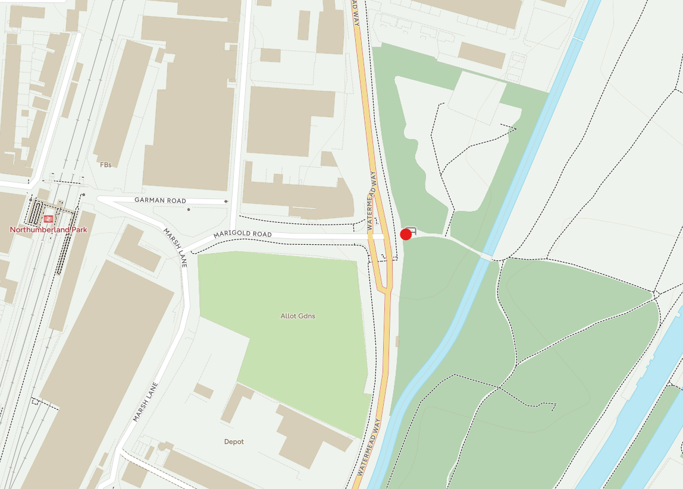
Figure 1 – Location of access AC71 from A1055 Watermead Way.
    - The junction is currently a three-armed signalised junction. Historically, it operated as a four-way signalised junction with the fourth arm providing vehicular access to the LVRP (which is AC71/AC72 within the approved DCO). At some time in the past (circa 2007) this arm was removed from the main operation of the signals and paved over to provide a continuous footway. The access to LVRP was gated and use restricted to pedestrians, cyclists and maintenance / emergency vehicles. As limited vehicular access has been retained through the gate, the signal head remains in place and is operational within the current signal staging for incidental traffic that may need to access to LVRP (see Photo 1).
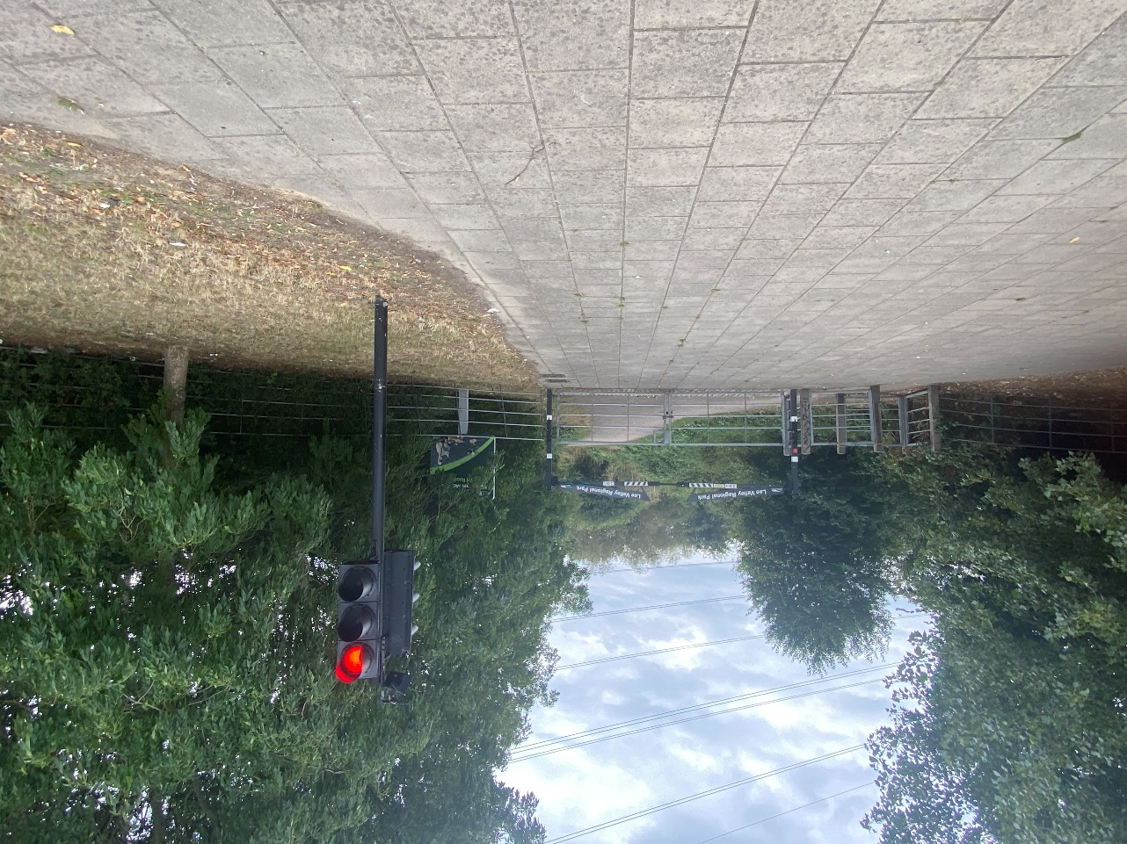Photo 1 – Existing signal head at LVRP access from Watermead Way / Marigold Road
    - Highway adoption records have been obtained from LBH and confirm that the paved area is within the adopted highway. The extent of adoption is shown in Figure 2. The figure also shows that a small triangular section of the LVRP path beyond the existing access gate is within the adopted highway however there is no obvious indication why this is the case.
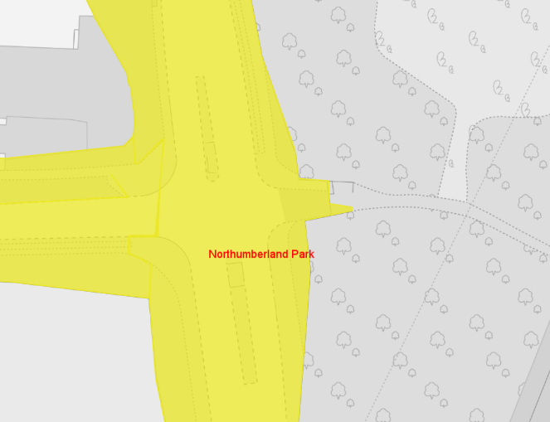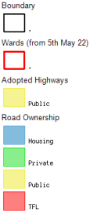
Figure 2 – Extent of adopted highway maintainable by LBH at site access (AC71)
    - The LVRP access point is also a Public Right of Way (PRoW) designated as Path 226-227 as highlighted yellow on the extract of the LBH PRoW map shown in Figure 3.
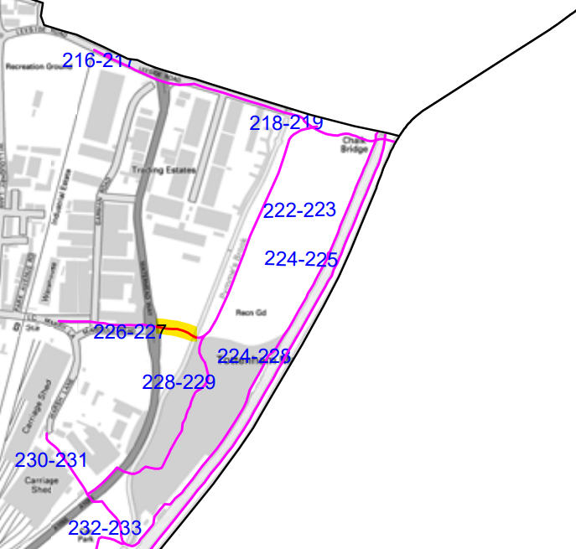 Figure 3 – PRoW at site access AC71/AC72 (source LBH): https://haringey.gov.uk/sites/default/files/2023-08/public_rights_of_way_map_-east_.pdf)

Proposed Works
    - In order to facilitate access for construction vehicles to the works area for Tower VC1R, works are required at AC71/AC72, and a temporary haul road will be installed between AC72 and the works area for Tower VC1R. AC72 is the point where the haul road deviates from the LVRP path.
    - The layout of the proposed improvements at AC71 and the haul road from AC72 is shown in the Fairhurst General Arrangement drawing 159177-AC72-1000, included within Appendix B.
    - Appendix B also comprises a Design Statement and the following detailed design drawings:
- 159177-AC72-1000 Rev C – General Arrangement
- 159177-AC72-1001 Rev B – White Lining and Signage
- 159177-AC72-1002 Rev B – Proposed Contours
- 159177-AC72-1003 Rev B – Existing Utilities
- 159177-AC72-1004 Rev B – Construction Details
- 159177-AC72-1005 Rev A – Road Longitudinal Sections
- 159177-AC72-1006 Rev A – Road Cross Sections
- 65213806-SWE-XX-XX-D-H-AC72-0005 to 0009 – Swept Path Analyses
- 65213806-SWE-XX-XX-D-H-AC72-0014 & 0015 – Swept Path Analyses
- 65213806-SWE-XX-XX-D-H-AC72-0004 – Initial Track construction phases.
    - The access measures to be implemented and shown in Appendix B are summarised as follows.
    - To facilitate access, the existing dropped kerb adjacent to the Watermead Way carriageway will be extended to accommodate the construction vehicles requiring access to the works area for Tower VC1R.
    - The existing paved area will remain in-situ with construction vehicles crossing over when they use the access as per the existing situation for LVRP maintenance vehicles. Utilities plans have been sourced, and a GPR survey has been undertaken to determine the location and depth of utilities within the adopted highway at this point. The survey results are included in Appendix C and show that services in the adopted highway area are of a suitable depth but do vary across the access, as such, to provide additional protection of the services trackway panels will be installed. The proposed trackway arrangement is included in Appendix B. It should be noted that the trackway layout includes panels that are required for site establishment. These will be removed once the haul route construction has commenced.
    - Appropriate road safety measures will be installed, including, warning signage and water filled barriers to guide pedestrians and cyclists to crossing facilities that will be introduced to allow them to safely cross the access.
    - To ensure that the access design stays within the DCO boundary, a secondary temporary traffic signal head (out-with the public highway) is required at the end of the track being installed within LVRPA land. In order for this extra signal to be incorporated into the signals operation, the whole junction will be under temporary signal control.
    - No changes to the existing signal staging and timing are required to incorporate this and the junction will continue to operate as at present as the existing signal head for vehicles egressing the LVRP access point runs on the same stage as Marigold Road. This will not change when the temporary signals are in place. The anticipated signal phases are shown in Figure 4.

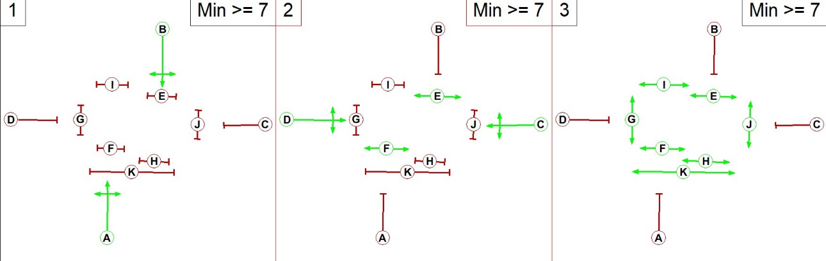
Figure 4 – Anticipated signal phasing for AC71.
    - The existing access into the LVRP will be closed to pedestrians and cyclists during the works period for safety reasons. Emergency and LVRPA maintenance vehicle access will be unaffected and will be maintained at all times. Pedestrians and cyclists will be temporarily diverted to the south via an alternative existing access point to LVRP. The access point to be closed to pedestrians and cyclists is designated as a PRoW; however, the DCO did not specify this and as such, to enable the temporary closure of the footpath a TTRO will be submitted so that the closure and diversion is in place before works on the access commence. Appropriate signage will be put in place directing pedestrians and cyclists along the diversion route. Further details are provided in Section 4.
    - Beyond the adopted highway, a new temporary haul road will be constructed through land owned and managed by LVRPA to the works area and the location of the new Tower VC1R. Works associated with the overhead lines form part of Stage 4b and will be set out in the Stage 4b CTMP.

Means of Managing Routes on the local highway network

Vehicle Routeing
    - The construction vehicles that will be used for the construction of the access will primarily travel along routes from the strategic highway network, namely the M25 and/or from the storage yard located on Towpath Road, Enfield (South Yard). It is envisaged that all local works traffic within LBH will originate from the South Yard.
    - The HGV routeing plan to the access point AC71/AC72 in Stage 4a is included as Appendix D in accordance with the DCO environmental Air Quality measure and is summarised in Table 1.

Tower Ref | Access Point |  | Vehicle Routeing
Tower Ref |  |  | From Strategic Road Network to Tower | Between Tower and South service yard
ZBC1R | AC71/AC72 | Watermead Way | M25 J25,  A10,  A1055 Bullmoor Lane,  A1055 Mollison Avenue,  A1055 Meridian Way,  A1055 Angel Edmonton Road,  A1055 Watermead Way | A1055 Watermead Way  A1055 Angel Edmonton Road  Conduit Lane  Montagu Road  A406 Angel Road  Harbet Road,  Hawley Road,  Towpath Road (south yard)
Table 1: Construction HGV Routeing for Stage 4a
    - The routes summarised above will be utilised by all HGV traffic and the majority of LGV traffic associated with the Stage 4a works within LBH. A small number of trips, such as those originating from more locally sourced suppliers, may utilise other roads within the local highway network.

Traffic Generation
    - The volume of traffic associated with the Stage 4a haul road establishment within LBH is not significant and will be temporary in nature. A traffic impact assessment (Transport Statement Part 2) was undertaken and approved as part of the DCO. This considered the construction traffic generated by the proposed development and concluded that it could be accommodated within the existing local highway network without detriment to highway safety, or capacity. Therefore, apart from the establishment of suitable access points to the works, the DCO carries no requirement for any additional off-site highway, or junction, improvements other that what is specified.
    - The total volume of construction traffic on roads within LBH associated with the access works for Stage 4a for the whole construction period of 4 weeks is 400 two-way trips (200 arrivals and 200 departures). The contractor (MGroup) has revisited these traffic predictions and confirm that they are consistent with the anticipated traffic generation for Stage 4a and will not exceed the total approved by the DCO.
    - Table 2 summarises the predicted construction traffic required to construct the haul road at AC71/AC72. As shown, the typical daily traffic flows at this access are minimal and unlikely to be detectable within the daily variation in flow on the local highway network.
Tower Ref | Access Point |  | Anticipated Traffic Volumes (two-way) per access point
Tower Ref |  |  | Total | Peak Week | Typical Day*
VC1R | AC71/AC72 | Watermead Way | 400 | 130 | 20
Table 2: Anticipated Construction Traffic Volumes for Stage 4a
    - It should be noted that construction vehicles numbers are for the construction of the haul road and all access works at AC71/AC72. Once this work is completed there will be other vehicles using this access that are associated with the works required on the overhead lines. The likely volumes of traffic needed for that stage of the works will be significantly less and will be provided in the Stage 4b CTMP.

Temporary Traffic Management (Highway works)
    - A temporary traffic management scheme is proposed at the A1055 Watermead Way/ Marigold Road junction as part of the construction works associated with access AC71/AC72. This includes the temporary closure of the inside lane of the southbound carriageway and the closure of the shared footway/cycleway at the LVRP entrance to allow the initial site establishment works to be completed. Pedestrians will be diverted around the footway closure via the existing controlled crossings at the junction.
    - No traffic management measures are proposed during the operational phase other than the crossing facilities described above.
    - The temporary traffic management plans for AC71/AC72 are included as Appendix E.
    - All construction traffic will access and egress the works area in forward gear. No reversing manoeuvres are required and will not be permitted except for the first initial establishment of the haul road track where vehicles will reverse on the area of footway that will be closed to the public as shown on Drawing 65213806-SWE-XX-XX-D-H-AC72-0004 – Initial Track construction phase, included in Appendix B.

Speed Limit
    - The Stage 4a access point is located on Watermead Way which is subject to a 40mph speed limit. No temporary speed limit changes are proposed on the local highway network during access construction, or operation.

Driver Information
    - All drivers working on the contract, (including all sub-contractors), will receive Traffic Information Packs prior to commencing operations. The Information Pack is a Contractor document which presents the project traffic management strategy. Its key aims are to minimise the interface, wherever possible, between public and site traffic, to reduce the number of deliveries where practicable, maintaining even traffic volumes and avoiding peaks by appropriately staging deliveries and controlling vehicular movements.
    - All drivers will also undergo an induction that describes and explains the details of the traffic management requirements and traffic routeing strategy, the importance of adhering to these and the implications if they are not followed.
    - Deliveries between the storage yards and site will be managed. As such, there will be no unexpected deliveries to the site. All external deliveries will be initially received at the off-site yards before being distributed to work areas on the scheme within the allotted delivery period.

Emergency Access
    - Access for emergency service vehicles on the public highway and within the LVRP will be maintained at all times. All accidents and incidents will be reported in line with the Contractor’s reporting procedures.

Road Debris
    - A local company will be engaged to clean roads where construction traffic may deposit material and other debris onto the carriageway. The timing and duration of road sweeping will be at the discretion of the engineer in charge of the works to ensure availability as and when needed; however, in the normal course of events it is anticipated that the sweeper will be utilised daily for four hours in the afternoon to remove any debris that may have accumulated during the shift. The resource will also be used at the Leeside Road access that forms a separate Stage of the scheme.
    - Outside of these times, the project team will check the local roads and access points on a regular basis for signs of mud, or other debris, which may have been brought onto the highway from the site as the road sweeping contactor will be on a retained basis and will be expected to react with minimum notice to any reported issues.

Means of Managing non-motorised user Routes with construction traffic

Footway closures and diversion
    - As stated in paragraph 3.2.1, the shared footway / cycleway at the access will be temporarily closed whilst the site access establishment is completed. Pedestrians and cyclists will be diverted around the footway closure via the existing controlled crossings at the Watermead Way / Marigold Road junction that will remain unaffected. This diversion route is shown on the TM plan included in Appendix E.

Footpath closures and diversions
    - Access into the LVRP via the existing path access route will also be temporarily suspended for safety reasons for the duration of the works (Stage 4a and Stage 4b works).
    - This access is designated as a Public Right of Way (PRoW) but is not included in the DCO as a path that is to be closed as part of the works. Therefore, a TTRO will be required to facilitate a temporary closure of the PRoW for the duration of the works. The diversion of the PRoW will be via an existing access into the LVRP further to the south on Watermead Way (opposite the Watermead Way Municipal Services Depot). This diversion route will be signed as shown in the Plan Included in Appendix F.

Scheduling and Timing

Construction Schedule
    - The construction works programme is expected to commence and be completed in Q4 2026..

Operational Times
    - Deliveries to the site will be limited to weekdays and will occur between the hours of 9am to 4pm. No deliveries to the site will be permitted at any other time.

Condition Survey

Extent of Survey and Methodology
    - Construction traffic movements for Stage 4a will occur over a short period of time whilst the haul road is constructed. Given the high level of background traffic flows on the A1055 Watermead Way, it is not considered possible to identify, or attribute, any possible changes in carriageway condition to the vehicle movements associated with the Stage 4a works except where the impact may be directly related to vehicles turning into or out of the access and on the paving within the LVRP access that will be overrun by construction vehicles.
    - As such, a visual condition survey has been undertaken to review and record the condition of the footway / cycleway in the vicinity of AC71/AC72.
    - The condition survey will be repeated on completion of the construction works and any existing defects which have deteriorated, or new defects which have appeared (attributable to the works), will be identified and any requirement for remedial action agreed with the LBH and LVRPA as appropriate.

Survey Results
    - The footpath / cycle path surface in the vicinity of access AC71/AC72 is in an overall good condition, with some minimal vegetation growth in places, as can be seen in Photo 2 and Photo 3.
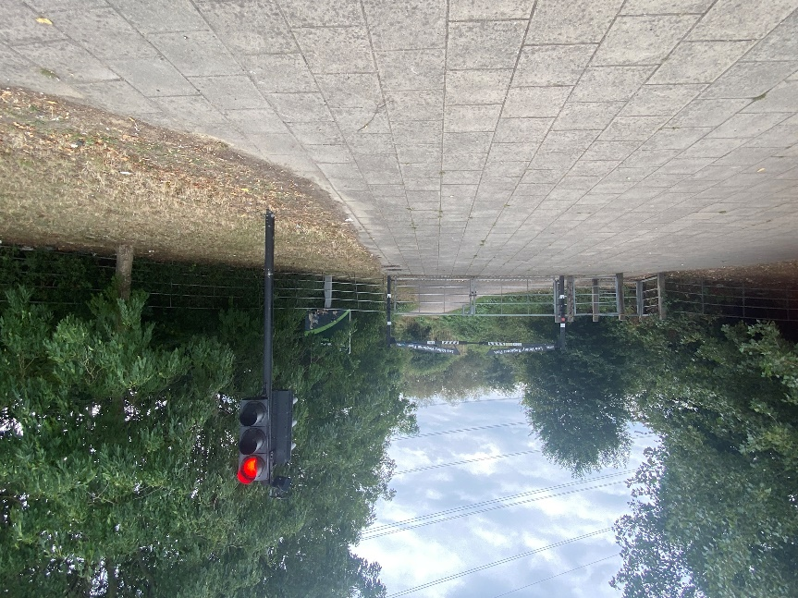
Photo 2 – Footpath/ cycle path area adjacent to access AC71/AC72
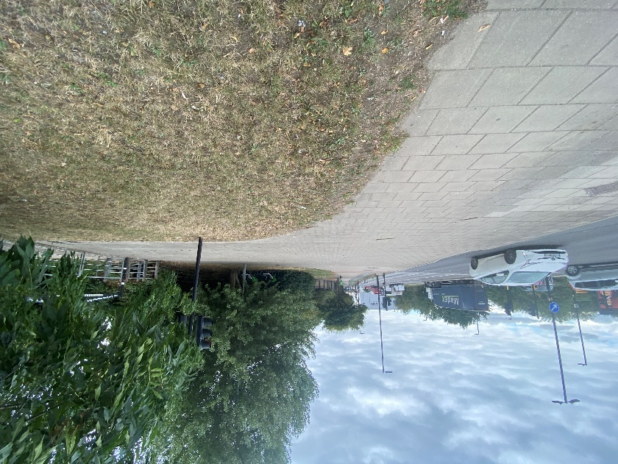
Photo 3 – Footpath/ cycle path area adjacent to access AC71/AC72
    - There is evidence of general surface wear along the LVRP access path, with some surface failure/ cracks in places, as shown in Photo 4.
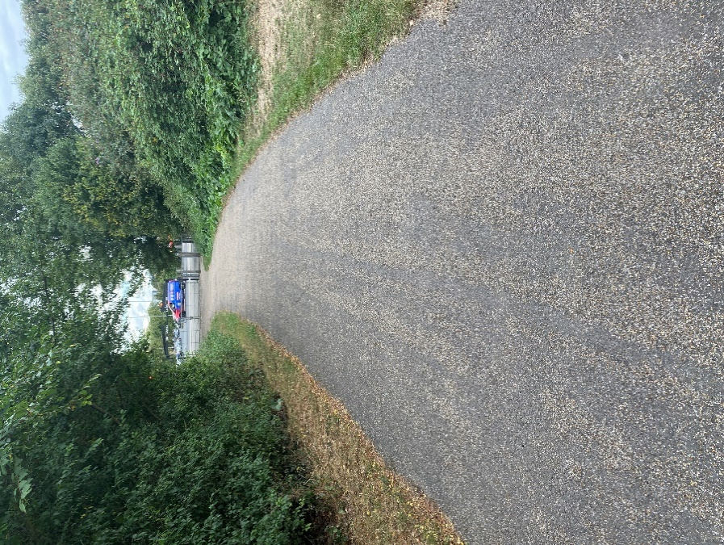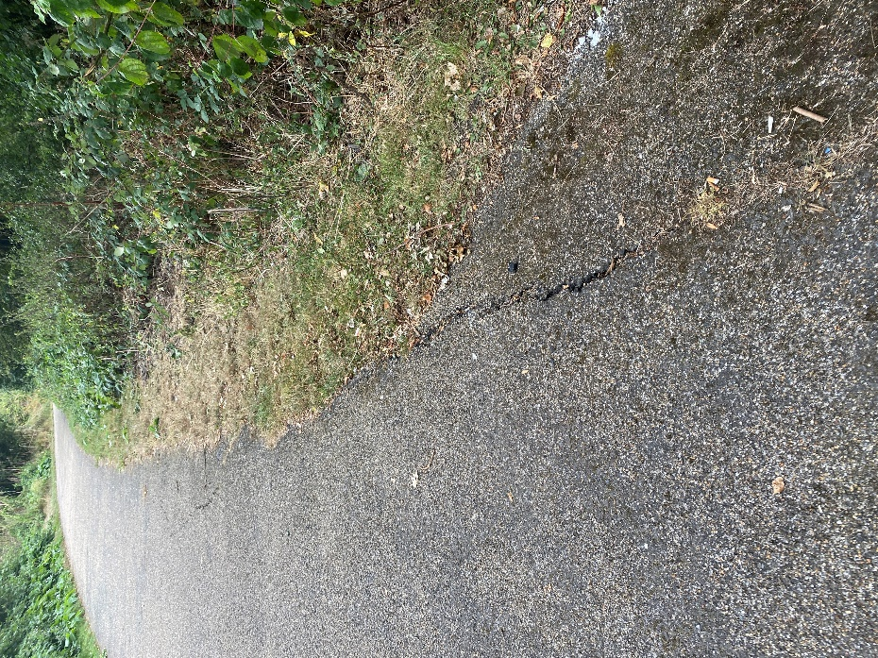
Photo 4 – LVRP access path

Highway Maintenance

Damage Caused by Construction Traffic
    - Any damage to the public highway identified following completion of the post-construction condition survey, or incidental damage identified in the interim, and which is shown to be as a result of construction traffic, will be reported to the Site Operation Team and subsequently to LBH Highways Maintenance team. Arrangements will be made for reparatory works to make good any damage that may cause immediate safety concerns for other road users. Alternatively, works may be planned for a future date once the construction works have been completed.
    - Similarly, any damage identified on the LVRP path impacted by the works will be reported to the Site Operation Team and will be repaired. The LVRPA will be informed of any works and access for pedestrians, cyclists, maintenance and emergency vehicles will be maintained.
    - Any deterioration which is not attributable to construction traffic will continue to be the responsibility of the LHA, or the LVRPA, as appropriate.

Construction Laydown Areas
    - There are no construction laydown areas which affect highways as part of this Stage of the works.

