

SITE PHOTOGRAPHS

Project Description – Single storey rear extension

Property Address – 21 Shanklin Road, N8 8TJ

REAR ELEVATION PHOTOGRAPHS

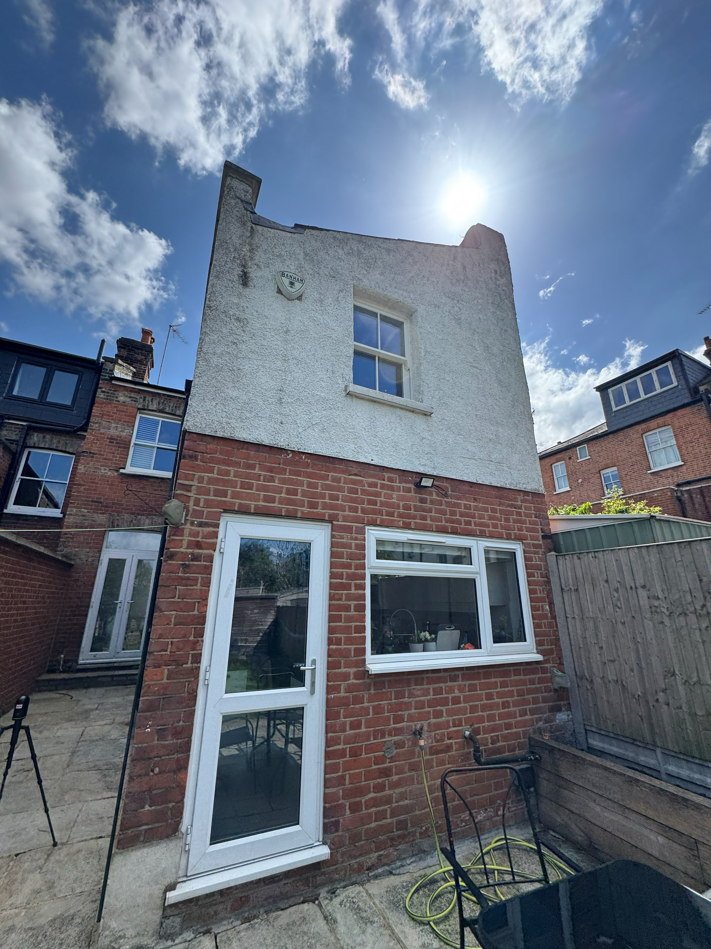

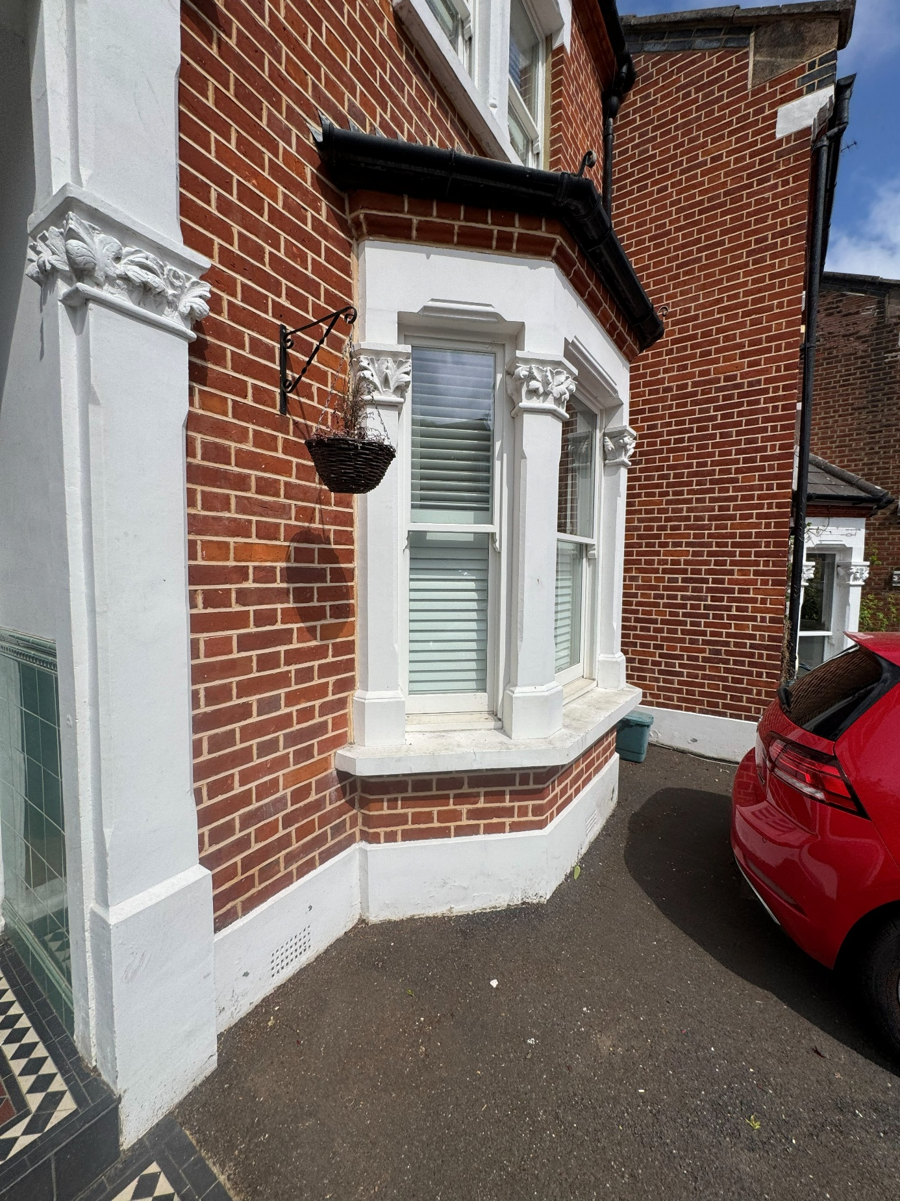
FRONT ELEVATION PHOTOGRAPHS



The Art of Building Ltd 45 Maplewell Road Woodhouse Eaves Leicestershire
LE12 8RG

www.taob.co.uk
T. 01509 891 105
E . info@taob.co.uk
VAT Registration No. 797787140
Reg. in England & Wales No. 4775259

