4 Albany Road
London
N4 4RJ
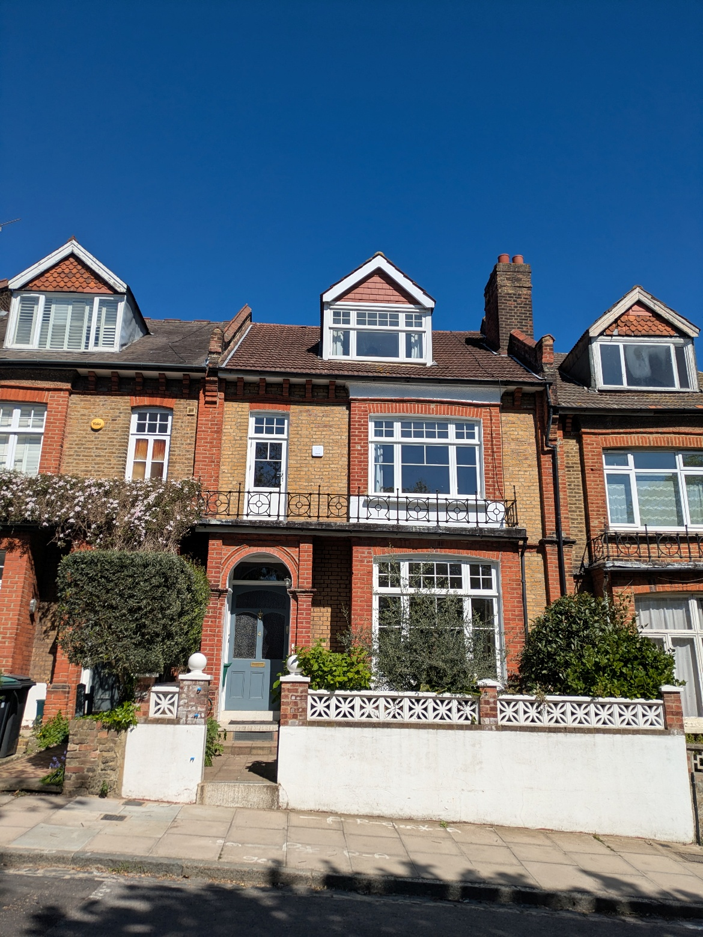
Air conditioning units proposed cannot be seen from the front.
The condenser units will be placed in the garden at the rear out of sight and will be positioned in acoustic enclosures in order to minimise any noise emitted.

The units proposed are :-
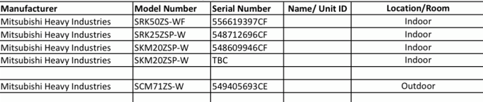

The noise mitigation
The condenser units will be positioning in the garden, not against any neighbouring property and will be placed inside acoustic enclosures.
An acoustic enclosure for an outdoor air conditioning unit is a specialized cover designed to reduce noise pollution—often by 15 dB(A) to 27 dB(A)—while maintaining necessary airflow. They typically feature high-density exterior barriers (like galvanized steel), interior sound-absorbing foam or fiberglass, and custom louvers or attenuators

Key Features and Benefits
- Noise Reduction: Substantially drops decibel levels, ensuring compliance with local planning and environmental noise regulations.
- Ventilation Control: Engineered baffles allow air intake and exhaust without causing the AC unit to overheat and underperform.
- Security & Weather Protection: Protects the condenser from unauthorized access, vandalism, and harsh weather conditions.


