

North London Reinforcement Project
Requirement 10: Stage 4a – Drainage Management Plan

National Grid
Unit 6
The Grange Business Park
Wick Road
Hewish
Somerset
BS24 6RR

August 2026

Document Control
Document Properties
Organisation |  | National Grid
Author |  | David Clark (Arthian)
Approved by |  | Hayder Pars (Arthian)
Title |  | North London Reinforcement Project  Requirement 10 – Stage 4a – Drainage Management Plan
Document Reference |  | 1
Version History
Date | Version |  | Status | Description/Changes
28/05/2026 | 1.0 |  | Initial Draft | Initial Draft
11/6/26 | 002 |  | Draft for consultation
24/7/26 | 003 |  | Draft for consultation | Incorporating statutory consultee comments
13/8/26 | 1 |  | Final for submission

Table of Contents

1 Introduction 5
1.1 This document 5
1.2 Overview of the Project 5
1.3 Stage 4a Overview 6
1.4 Consultation 6
2 Requirement context 7
2.2 References to this document within existing DCO documents 7
2.3 Associated Documents 8
3 Policy and guidance 9
3.1 Introduction 9
3.2 UK Legislation 9
3.3 Local Planning Policy 10
3.4 Climate Change 13
4 SITE DETAILS 15
4.1 Location 16
4.2 Existing Site Conditions 16
4.3 Topography 16
4.4 Hydrology 17
4.5 Geology 17
4.6 Hydrogeology 18
4.7 Local Drainage 18
4.8 Existing Surface Water Drainage 19
4.9 Existing Foul Drainage 19
5 Drainage manAGEMENT PLAN 20
5.1 Surface Water Drainage 20
5.2 Drainage Hierarchy 20
5.3 Preferred Method of Surface Water Discharge 20
5.4 Foul Water Drainage 21
6 PotentiAlly Polluting Materials and Construction METHODS 22
6.2 Silt-Laden Runoff 22
6.3 Watering and dewatering management measures 22
6.4 Measures to Reduce Sediment 22
6.5 Diffuse Pollution Contained in Urban Runoff 23
6.6 Measures to Reduce Hydrocarbons 23
6.7 Accumulation and Runoff from Roads 23
7 Consents and permits 24
8 Conclusions and recommendations 24
8.1 Conclusions 24
8.2 Recommendations 24
9 Appendices 26

Introduction

This document
    - This document has been prepared by Arthian Ltd for National Grid Electricity Transmission plc (‘National Grid’).
    - This document comprises a Drainage Management Plan for Stage 4a of the authorised development as part of the North London Reinforcement Project (‘the Project’) as required by Schedule 2, Requirement 10 of the National Grid (North London Reinforcement) Development Consent Order 2014 (‘the DCO’).
    - Requirement 10: Surface Water Drainage of the DCO is as follows:
“(1) No stage of the authorised development shall commence until for that stage, written details of the surface and foul water drainage system (including means of pollution control) have, after consultation with the sewerage and drainage authority, been submitted to and approved by the relevant planning authority.
(2) The surface and foul water drainage system must be constructed in general accordance with the details approved in accordance with requirement 10(1) unless otherwise agreed with the relevant planning authority.”

Overview of the Project
    - The DCO was made by the Secretary of State for Energy and Climate Change for the Project on 16 April 2014, and came into force on 7 May 2014. The DCO provides powers to National Grid to carry out the Project, which comprises of the replacement of the existing 275kV overhead line (OHL) with a 400kV OHL from Waltham Cross substation in Epping Forest, through Enfield, and then to Tottenham substation in Haringey. The DCO also contains powers to carry out associated works to the substations at Waltham Cross, Brimsdown and Tottenham.
    - The Project falls within the administrative boundaries of, Epping Forest District Council, Enfield Council, the London Borough of Waltham Forest, and the London Borough of Haringey. The Project is also within the administrative boundaries of the Greater London Authority and Essex County Council, though these are not relevant planning authorities in relation to the Project.
    - The Project includes the following elements:
- Existing 275kV route uprating to 400kV for 14km from the Waltham Cross substation to Tottenham substation. This would comprise of:
  - The existing 275kV conductor cables (wires) to be removed and replaced (i.e. reconductored) with 400kV wires. This would use the existing pylons.
- An extension to the Waltham Cross substation to provide a new 400kV Gas Insulated Switchgear (GIS) substation and associated OHL entry modifications.
- The replacement of two 275/132 kV Super Grid Transformers (SGTs) at Brimsdown with two new 400/132kV SGTs, located both inside and partially outside the existing Brimsdown substation boundary, with underground cable connections between these new SGTs and the existing substation.
    - Works to bypass Tottenham substation, including the construction of new pylon (VC1R), and the removal of the existing VC1 pylon, and conductions, insulators and fittings between VC1R and VC2, and connection between VC1 and the existing Tottenham substation.
- Associated works, for example, temporary access roads, highway works temporary construction compounds, scaffolds, work sites and ancillary works.

Stage 4a Overview
    - A written scheme of stages (required by schedule 2, Requirement 3 of the DCO) was submitted to:
- London Borough of Haringey
    - The written scheme of stages sets out the works that form part of Stage 4a.
    - Access: establishment of a new access track off Watermead Way (Work No. 13). The existing construction compound at Tottenham Substation will be used to facilitate the construction of the new access track.
    - Vegetation clearance: removal of plants and vegetation in the vicinity of Tottenham substation and relevant pylons to allow for the works within this stage.
    - Plans showing the Stage 4a (Sub-area) works are provided in Appendix A.

Consultation
    - Prior to the formal submission of this document for the discharge of Requirement 10, a pre-application consultation is to be completed with a draft version of the document provided to the relevant planning authorities for comment.
    - Consultation was undertaken with the Haringey LLFA on 12/6/26. Their comments were incorporated into this version of the reporting.

Requirement context
    - The Stage 4a works do not include the installation of any significant (>50m²) areas of permanent hardstanding. Therefore, Section 5 of this DMP references only the temporary impermeable surfaces required to facilitate the construction phase.
    - This is limited to the establishment of a new access track off Watermead Way.
    - The Stage 4a works are located within Flood Zone 2 of the Environment Agency Flood Map for Planning. Therefore, a site-specific Flood Risk Assessment is included in Appendix B and assesses flood risk to the proposed development site from all sources.

References to this document within existing DCO documents
    - This document is referenced within Schedule 2, Requirement 10 of the Development Consent Order submitted to the Secretary of State for Energy and Climate Change for the Project on 16 April 2014. The document is further referred to within Environmental Measures document (updated July 2014).
    - Measures to be included within this document are contained within existing DCO documents, which have been certified by the DCO.
    - The Construction Environmental Management Plan (CEMP) sets out measures relating to Flood Risk and Drainage (Section 4.7 of the CEMP). Mitigation measures included in the CEMP on this matter are summarised as follows:
- Install temporary surface water controls including silt fences and sediment traps at discharge points, and swales or shallow bunds to divert clean runoff away from work areas.
- Drainage inspections will be carried out weekly and after heavy rainfall events, with remedial works undertaken immediately if defects are found.
- Minor shallow grading or temporary grips to direct clean runoff away from work areas;
- Use of gravel or crushed stone working surfaces to encourage infiltration and reduce soil compaction;
- Straw-bale barriers or silt-fencing to intercept and filter runoff before it reaches the River Lee corridor;
- Drip trays, spill kits and designated refuelling zones for plant and vehicles (refuelling and fuel storage will be located at least 10 m away from any watercourse and on impermeable bunded areas); and
- No discharge of untreated water will be permitted into the nearby watercourses; temporary settlement through vegetated ground or straw-bale filtration if clean water must be discharged.
During flood alerts issued by the Environment Agency:
- Cease works in flood-prone areas.
- Remove plant, equipment, and materials to higher ground.
- Follow the site-specific Flood Response Plan.
- All staff will be briefed on flood evacuation routes and emergency procedures.

Associated Documents
    - Documents submitted as part of the DCO that are to be read alongside this DMP include:
- Construction Environmental Management Plan; and
- Flood Risk Assessment.

Policy and guidance

Introduction
    - The aim of this section of the report is to discuss the main aspects of the local and national planning policies that are relevant to any proposed development on the site and relevant guidance and legislation.

UK Legislation

Building Regulations (2010) Part H of Schedule 1 (‘Building Regulations Part H’)
    - Building Regulations Part H, provide guidance in terms of foul drainage, wastewater treatment systems and cesspools, rainwater drainage, building over sewers, separate systems for surface water and foul waste disposal.
    - In relation to flood risk, Buildings Regulations Part H sets out a hierarchy of where surface water should discharge. This hierarchy should be followed where practicable and is listed below.
    - Infrastructure protocol states that a designer should consider the following in order of preference before finalising a surface water design statement for the development:
      - Discharge to SuDS devices, e.g. an adequate soakaway or some other infiltration system;
      - Discharge to a watercourse or where this is not reasonably practicable, and
      - Discharge to a public sewer network.

National Planning Policy
    - The National Policy Statements (NPSs) that are relevant to the Scheme are:
      - Overarching National Policy Statement for Energy (EN-1) (November 2023)
      - National Policy Statement for Renewable Energy Infrastructure (EN-3) (November 2023)
      - National Policy Statement for Electricity Networks Infrastructure (EN-5) (November 2023)
    - The NPSs listed above came into effect on 17 January 2024. These NPSs set out the Government’s energy policy for the delivery of nationally significant energy infrastructure, the need for new energy infrastructure, and guidance for the determination of an application for a Development Consent Order (DCO).

National Planning Policy Framework
    - The National Planning Policy Framework (NPPF) (February 2025) sets out the Government’s planning policies for England and how these are expected to be applied. The National Planning Practice Guidance (NPPG) documents are published and updated to support the NPPF. The flood risk and coastal change PPG was published in 2014 and most recently updated in August 2022.
    - The NPPF sets out the tests needed to ensure people and properties are protected from flooding. The ‘sequential test’ (Paragraph: 023 Reference ID: 7-023-20220825) is applied to all developments to direct developments to the areas at lowest risk of flooding in preference to those in areas at higher risk. If the sequential test shows that there are no suitable development sites in areas of lower flood risk, then the exception test is applied (Paragraph: 031 Reference ID: 7-031-20220825). The exception test must demonstrate that the development has wider benefits that outweigh flood risk, that the development will be safe for its lifetime and will not increase flood risk elsewhere. The NPSs also require application of the sequential and exception tests in a manner consistent with the NPPF.
    - The NPPF also ensures that climate change is considered in the long term for flood risk, coastal change, water supply and changes to biodiversity and landscape. Therefore, new developments should be planned to avoid increasing vulnerability arising from the impacts of climate change.
    - The NPPF states that a site-specific Flood Risk Assessment (FRA) is required for the following scenarios:
      - All proposals involving sites of 1 hectare or greater in Flood Zone 1;
      - All development in Flood Zones 2 and 3;
      - All proposals involving land within Flood Zone 1, which has been identified by the EA as having critical drainage problems;
      - All proposals involving land within Flood Zone 1 identified in a strategic flood assessment as being at increased flood risk in future; and
      - All proposals involving land within Flood Zone 1 that may be subject to other sources of flooding, where its development would introduce a more vulnerable use.

Local Planning Policy
    - Haringey’s Local Plan – Strategic Policies 2013 – 2026 (adopted March 2013) contains the following policy relating to flood risk:

SP5 Water Management and Flooding
    - The Council will require all development in Haringey to be water efficient during construction and operation and to reduce all forms of flood risk. All development shall:
- Improve the water environment, water quality and drainage systems;
- Minimise water use and illustrate how development would contribute to general and flash flooding;
- Take account of flood risk vulnerability classification as set out in paragraph 100 of the NPPF and will apply the NPPF Sequential Test and Exception Test;
- Implement measures to prevent (or mitigate as last resort) local surface water and downstream flooding;
- Implement Sustainable Drainage Systems from strategic to individual site level to improve water attenuation, quality and amenity;
- Restore and enhance the Blue Ribbon Network including Pymmes Brook, Moselle Brook, the River Lee and its tributaries, deculverting wherever feasible, to improve water quality and amenity of these waterways and to help reduce food risk (in line with London River Action Plan); and
- Require higher resilience and levels of flood protection for critical infrastructure to ensure the protection of essential services such as water and power.
    - The water environment is a valuable recreational, educational and leisure resource for the residents of Haringey. From the large reservoirs of the Lee Valley to small ponds in parks and gardens, it is a resource that needs to be protected. Developments should ensure measures are incorporated to protect and improve water quality for surface and groundwaters, particularly in areas of land contamination. An increase in residential and commercial developments in the growth areas of Haringey Heartlands and Tottenham Hale will increase demand for water and abstraction from rivers. Too much water taken from rivers can cause problems for wildlife and increase the risk of pollution, as there is less water available to dilute pollutants.
River Lee
    - The River Lee downstream of Tottenham Lock has poor chemical and biological water quality. This is partly due to the confluence of the River Lee and Pymmes Brook at Tottenham Lock. Pymmes Brook has historically poor chemical water quality and Haringey is working closely with other boroughs to improve this. The River Lee and River Lee Navigation’s use of water storage bodies and its associated open space is a key location in aiding food risk management. The River Lee and the large reservoirs of the Lee Valley is a resource to be protected and enhanced and Haringey are working closely with the Lee Valley Park Authority to continue to improve the area in terms of flooding and sustainable development. Haringey is also working closely with neighbouring boroughs and strategic authorities regarding the Water Framework Directive targets for the Thames River Basement Management Plan, in particular the physical modification of water bodies, abstraction and diffusion of pollution from urban sources.
Water Demand
    - The combination of climate change predicted growth in population and increased water usage will exacerbate demand for water. Therefore, along with the increase in the intensity of rainfall, and the increased amount of hard surfaces in our environment, there is a greater pressure on the drainage systems. Haringey requires that new developments should aim to decrease the demand for water as much as possible. Haringey will require the incorporation of water saving measures and equipment in all new development in order to meet the London Plan water consumption targets of 105l/p/d.
Flood Risk
    - Implications of anticipated change in climate in the UK increased frequency in extreme weather conditions and the possibility of flash floods are being considered carefully. The borough contains areas of flood risk in proximity to Pymmes Brook on Pinkham Way, the Moselle Brook and the River Lee. In Haringey, risk areas include parts of the Lee Valley and South Tottenham (as identified in the Strategic Flood Risk Assessment) and areas identified by the Environment Agency mapped data showing areas susceptible to flooding. According to the Environment Agency, approximately 9% of land in Haringey has one in 100-year probability of flooding from rivers. About 8,000 properties are at risk of flooding although the defences such as the River Lee flood relief channel reduce the risk of this happening.
    - In developing this document, the Council has worked on a Strategic Flood Risk Assessment for the borough and consulted with the Environment Agency on measures which are necessary to reduce flood risk in the area and suitable mitigation where risk is identified. The best form of flood mitigation is to encourage development in areas of lower flood risk. Where a risk of flooding is identified, a Sequential Test will be required, as set out in paragraph 100 of the NPPF. The Council will prepare Area Action Plans for Tottenham Hale and Northumberland Park. This more detailed work will be informed by the Level 2 Strategic Flood Risk Assessments and will identify development sites and the quantum and type of development needed. Masterplanning exercises and development briefs will ensure that flood risk is considered at an early stage, at an appropriate scale and in close consultation with the Environment Agency. Sequential Tests will be conducted to ensure proposals are in accordance with the NPPF, and flood risk assessments for individual development proposals will need to demonstrate that development is safe.
    - The Flood and Water Management Act 2010 brings responsibilities to Local Authorities for more comprehensive management of flood risk for people, homes and businesses. Haringey forms part of the Drain London Forum, a partnership including London boroughs, the Environment Agency and the Mayor of London, which is formed to ensure the requirements from the Flood and Water Management Act 2010 are met in producing a Surface Water Management Plan (SWMP). The development of SWMPs include a Preliminary Flood Risk Assessment for Haringey, and for the other sub-regional boroughs to investigate and address flood risk problems.
    - Increased flood risk due to anticipated changes in the climate also requires the Council to consider measures for adapting to climate change and focus on minimising the flood risk in the area. Hard and soft landscaping associated with new development must take account of sustainable land management practices and managing the risk of flooding by applying Sustainable Urban Drainage Systems (SUDS) in order to improve water attenuation, quality and amenity. The provision of green features, including green roofs, provides opportunities to reduce runoff rates and enhance biodiversity, and are fully encouraged in both new development and retrofitting in older buildings.
    - In addition, the Development Management Policies and Site Allocations Document set out borough-wide standards and guidance for managing flood risk through development, including those relating to:
- The need to address non-fluvial sources of flooding; ▪ The use and design of water recycling;
- Requirements for site-specific Flood Risk Assessments;
- The use and design of water attenuation (in line with the drainage hierarchy set out in the London Plan);
- The use and design of SUDS;
- The design and layout of developments, including setting built developments back from rivers, watercourses and flood defences; and
- Requirements for implementation of flood resilient and resistant building techniques.

Climate Change
    - The EA ‘Flood Risk Assessments: Climate Change Allowances’ Guidance states that ‘Essential Infrastructure’ developments should utilise the Upper End allowance. The EA’s Online Peak River Flow Map indicates that within the London Management Catchment, the Central Allowance equates to 10% for the 2020s epoch, 7% for the 2050s epoch and 17% for the 2080s epoch, whilst the Upper End Allowance equates to 26% for the 2020s, 30% for the 2050s and 54% for the 2080s.
    - This DMP has been authored in accordance with the following legislation:
- Department for Environment, Food, and Rural Affairs Non-Statutory Technical Standards for Sustainable Drainage Systems (2015);
- Construction Industry Research and Information Association (CIRIA) SuDS Manual C753 (2015);
- CIRIA Report C532 Control of Water Pollution from Construction Sites (2001);
- CIRIA Report C648 Control of Water Pollution from Linear Construction Project – Technical Guidance (2006);
- CIRIA Report C649 Control of Water Pollution from Linear Construction Projects: Site Guide (2006);
- CIRIA Report C609 SuDS – Hydraulic, Structural and Water Quality Advice (2004);
- Water Framework Directive (2006/60/EC);
- Flood and Water Management Act (2010);
- Land Drainage Act (1994);
- Surface Water Management Action Plan (2018);
- Environment Agency’s Regulatory Position Statement on Temporary Dewatering from Excavations to Surface Water (2018);
- Epping Forest District Local Plan 2011-2033 Part One (2011); and
- Haringey SuDS Design and Evaluation Guide (2018).
    - The CIRIA SuDS Manual includes the Drainage Hierarchy which states that surface water will be disposed of in the following order of preference:
- Harvesting for re-use;
- Infiltration into the ground;
- Discharge to a surface water body;
- Discharge to a piped surface water network; and
- Discharge to a piped combined network.

SITE DETAILS
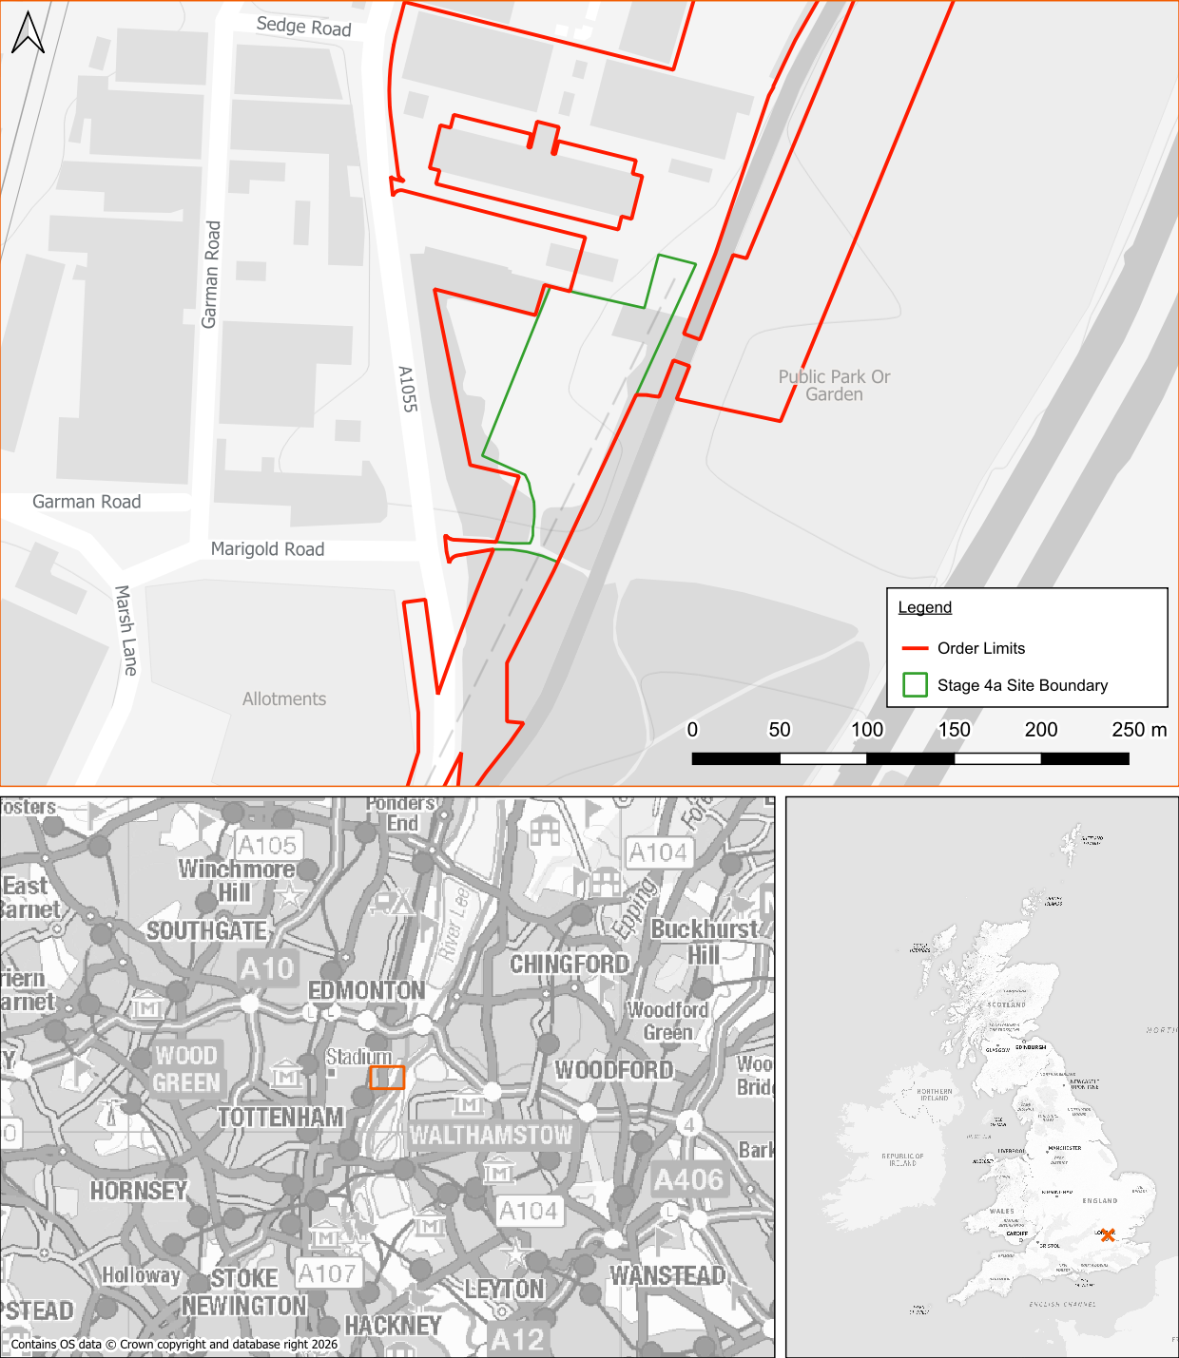
Figure 1: Stage 4a Work Area

Location
    - The Stage 4a work area is located at North London, N17 OQJ, within the London Borough of Haringey at NGR TQ 35345 91319. The site is located approximately 350m east of Northumberland Park Railway Station.

Existing Site Conditions
    - Online mapping (including Google Maps / Google Streetview imagery, accessed 25/05/26) shows that the Stage 4a work areas comprise the existing Tottenham Marsh Electricity Transformer Station, industrial units and greenfield land. The Main River, Pymmes Brook, is located along the eastern boundary of the site and joins the River Lee 1.4km downstream.

Topography
    - A topographical survey has been undertaken and is included in Appendix C. The topographical survey shows the site is relatively flat. In the area east of Watermead Way, ground levels range from 11.20m Above Ordnance Datum (AOD) in the north to 9.56m AOD in the south. In the area proposed for VC2, to the west of Watermead Way, ground levels range between 8.41m AOD and 8.90m AOD.
    - Topographic levels to m AOD have also been derived from a 1 m resolution Environment Agency (EA) composite ‘Light Detecting and Ranging’ (LiDAR) Digital Terrain Model (DTM). A review of LiDAR ground elevation data shows that the working area included in Stage 4a range from approximately 8m to 11m AOD and concurs with the topographical survey.

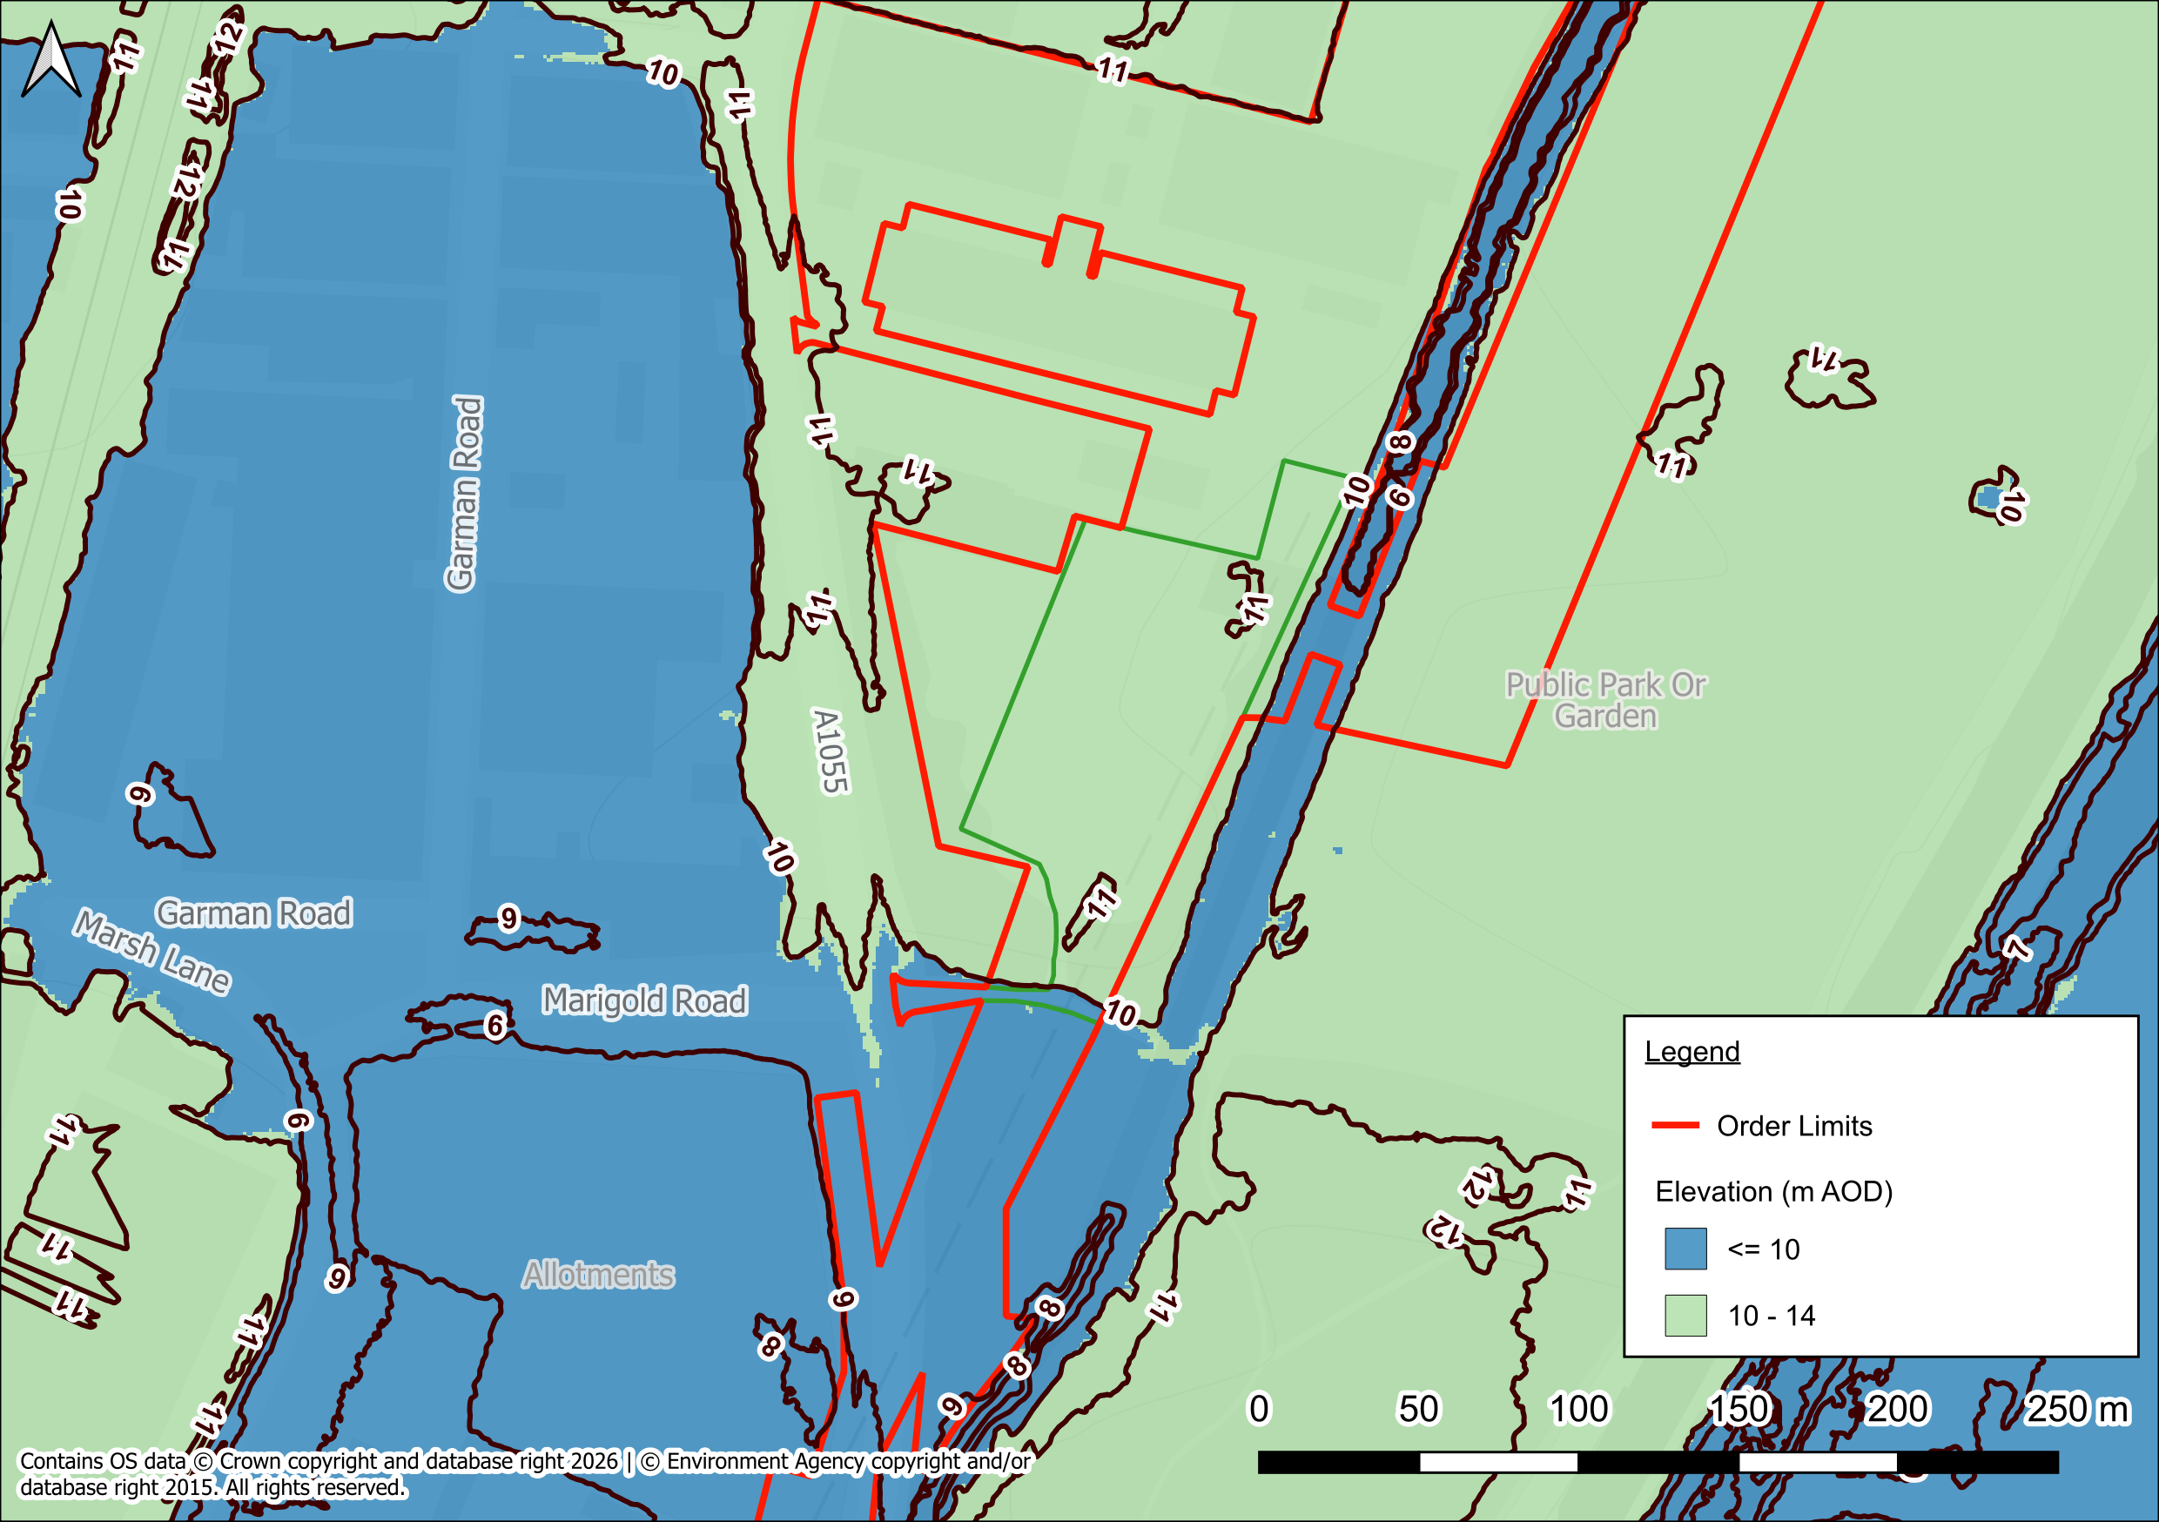
Figure 2: LiDAR Plan

Hydrology
    - The Pymmes Brook (Main River), a tributary of the River Lee, flows adjacent to the eastern boundary and joins the River Lee approximately 1.4km downstream.
    - Other watercourses in the area include the River Lee Navigation Channel, Banbury Reservoir and Lockwood Reservoir which are located approximately 200m east of the Stage 4a proposed works.
    - Main Rivers are within the jurisdiction of the EA.

Geology
    - Reference to the British Geological Survey (BGS) online mapping (1:50,000 scale) indicates that the site is underlain by superficial deposits of Alluvium generally comprising of clay, silt, sand and gravel (Figure 3). The superficial deposits are identified as being underlain London Clay Formation generally comprising of clay, silt and sand.

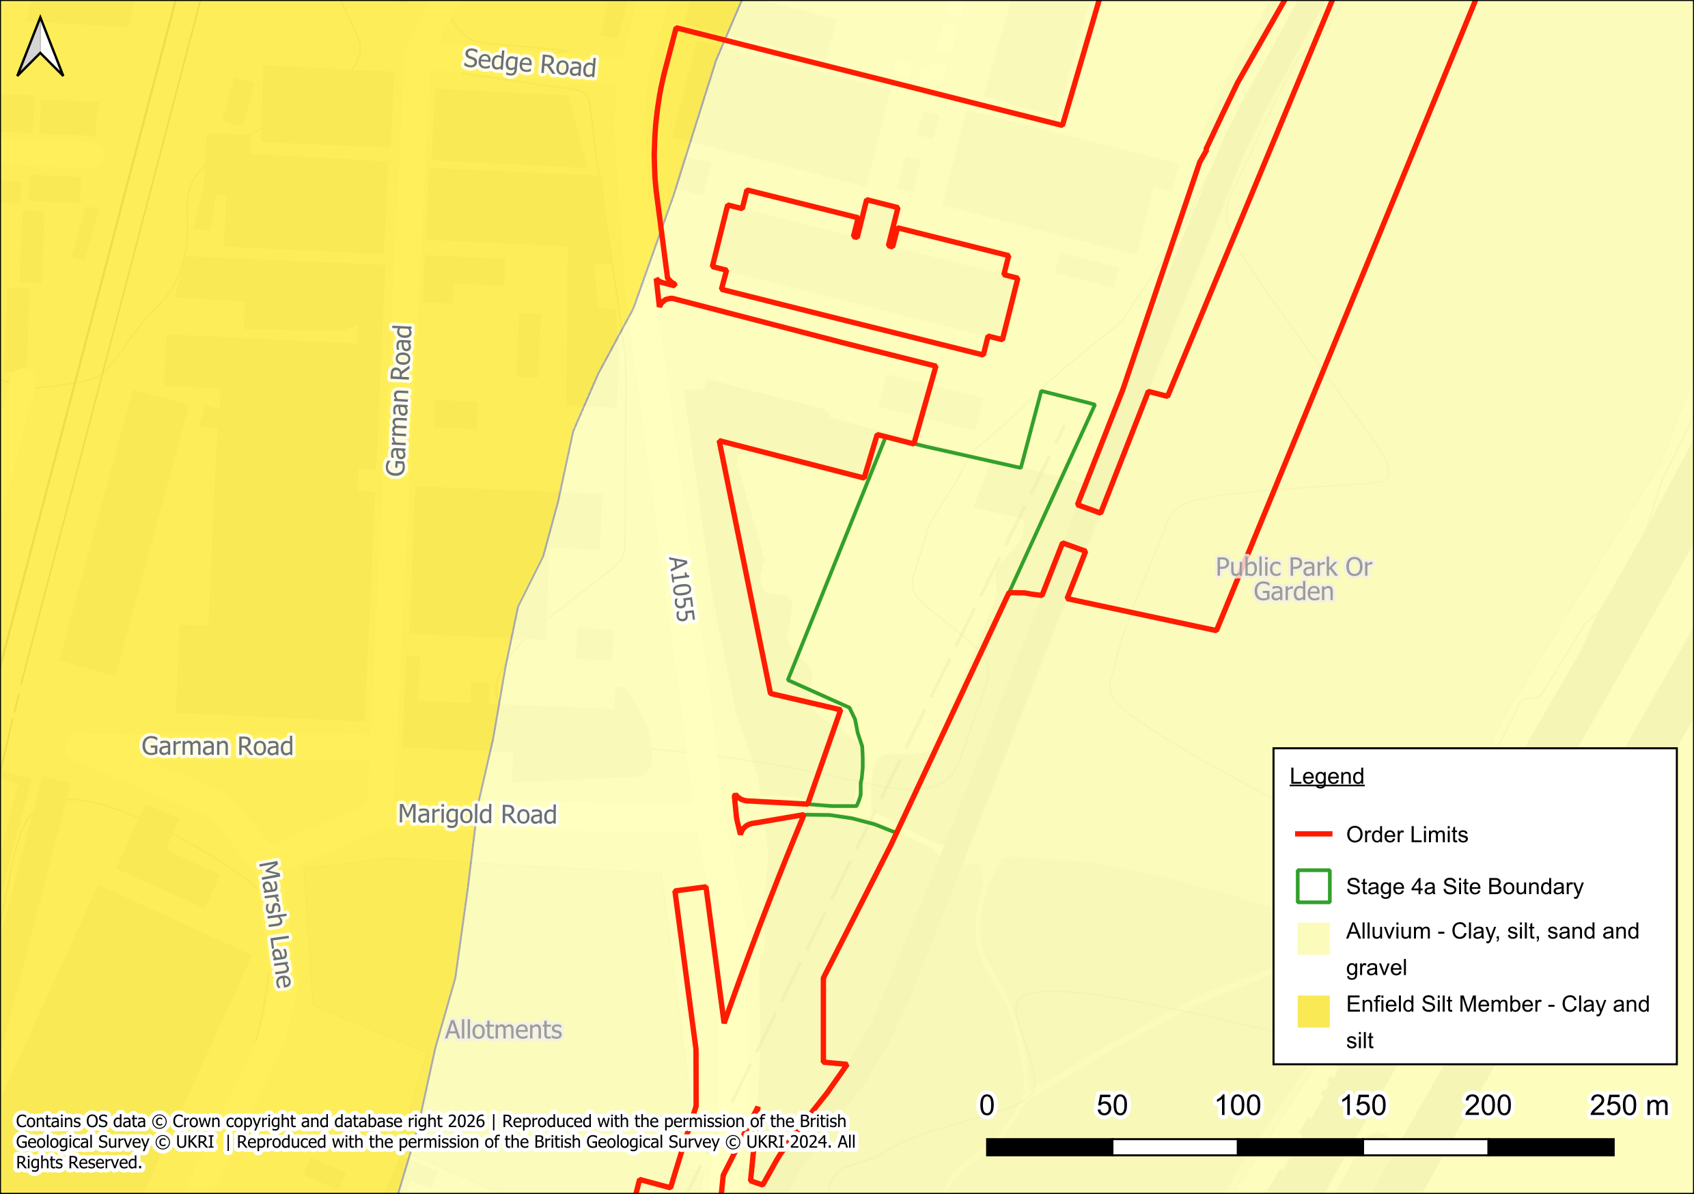
Figure 3: Superficial Deposits

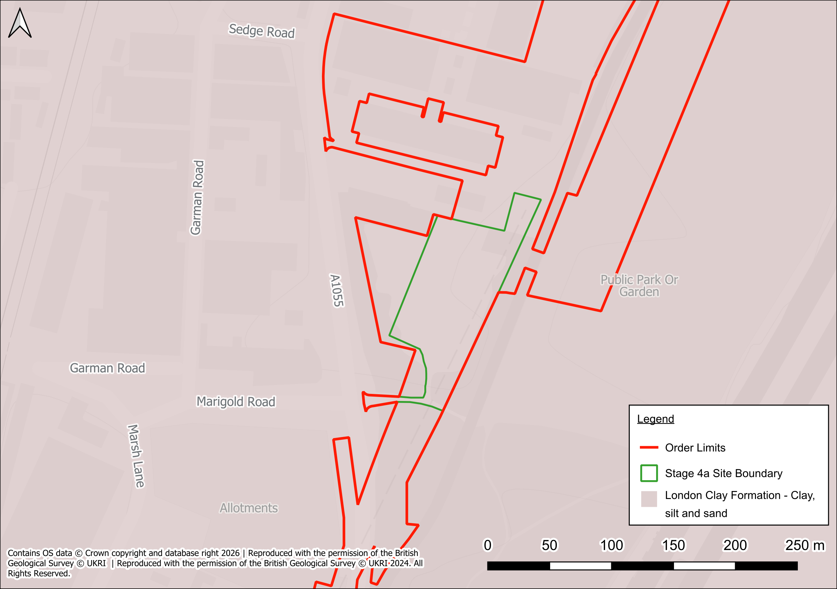
Figure 4: Bedrock Deposits
    - The geological mapping is available at a scale of 1:50,000 and as such may not be accurate on a site specific basis.
    - Site specific ground investigation undertaken WorleyParsons in 2013 found varying compositions of Made Ground, with an average thickness of 1.78m. The deepest Made Ground deposit was recorded to be approximately 6.0m, located at the proposed location of VC1.

Hydrogeology
    - According to the EA’s Aquifer Designation data, obtained from MAGIC Map’s online mapping [accessed 25/05/2026], the superficial and underlying deposits is classified as a Secondary A Aquifer.
    - The EA’s ‘Source Protection Zones’ data, obtained from MAGIC Map’s online mapping [accessed 25/05/2026] indicates that the site is located within a Zone 2 – Outer Protection Zone.

Local Drainage
    - Thames Water Asset Plans are included in Appendix D. The asset plans show there is a surface water sewer flowing south within the eastern footway of Watermead Way until the proposed works access where it then flows east and outfalls into the Pymmes Brook at headwall reference 201B. The invert and cover levels of this sewer run are not shown on the Thames Water asset plans.
    - There is also a surface water sewer transecting the Stage 4a works in the north. The sewer outfalls into the Pymmes Brook at headwall reference 3101, with a recorded cover level of 10.52m AOD and an invert level of 6.91m AOD. The upstream inspection chamber is located within Watermead Way (reference 1101) however, its invert and cover levels are not shown on the Thames Water asset plans.

Existing Surface Water Drainage
    - The Order Limits included within Stage 4a comprise a mix of undeveloped land with no formal positive surface-water drainage system, and the existing development, Tottenham Marsh Electricity Transformer Station. Other exceptions include existing transmission tower bases, and associated access routes where limited engineered drainage may already exist.
    - The majority of the area east of Watermead Way is publicly accessible land forming the Lee Valley Country Park. Surfacing comprises scrub, brambles and rough grass with informal pathways. There is an existing asphalt access into the Lee Valley County Park in the south, with a double gully located at the access’s junction with Watermead Way suggesting it is positively drained. The double gully is expected to outfall into the Thames Water Surface Water Sewer. There is an existing fenced National Grid compound located in the north, which is expected to comprise of hardstanding. It is unknown whether the hardstanding is positively drained.
    - As the area proposed for Stage 4a is sited on London Clay with significant depths of Made Ground, infiltration potential is considered limited. Therefore, based upon the currently available information, the existing surface water regime for the is considered to drain via overland flow to the Pymmes Brook.

Existing Foul Drainage
    - There is no evidence of a current positive foul connection within the area proposed for Stage 4a works.

Drainage manAGEMENT PLAN

Surface Water Drainage
    - A surface water drainage strategy is required to manage the increase in surface water runoff and prevent an increase in flood risk elsewhere. Works for Stage 4a include the establishment of a new access track off Watermead Way.
    - This DMC references only the temporary impermeable surfaces required to facilitate the construction phase. This is limited to the establishment of a new access track off Watermead Way.

Drainage Hierarchy
    - The recommended surface-water drainage hierarchy, as set out in NPS EN-1 (Paragraph 5.8.15) and the National Planning Practice Guidance: Flood Risk and Coastal Change (Paragraph 056, Reference ID 7-056-20220825), is to:
- Discharge to the ground via infiltration (preferred);
- Discharge to a watercourse where infiltration is not feasible;
- Discharge to a surface-water sewer if neither of the above are practicable; and
- Discharge to a combined sewer only as a last resort.

Preferred Method of Surface Water Discharge
    - It is considered that considering the temporary nature of the proposals, draining to ground is feasible as per the existing scenario, and therefore discharge to soakaways, watercourses or the public sewer systems will not be required for the majority of the site. The vast majority of the Project will comprise natural ground cover post-construction, with limited areas of hardstanding associated with the existing concrete bases serving the transmission towers.
    - Because the works are temporary, small in area and do not introduce new permanent impermeable surfaces, the existing drainage regime will be maintained. Rainfall will continue to infiltrate and drain naturally across the surface with no change to local runoff pathways or volumes. Any short-term runoff during heavy rainfall will be managed using the passive construction controls defined in the Construction Environmental Management Plan (CEMP, Requirement 13).
    - As a result of the construction of the temporary trackways, some rainfall will be intercepted by the surface of the trackways before draining to the natural ground. Intercepted rainfall will drip into the ground along the perimeter of the temporary trackways.
    - Where rainwater drips onto the ground surrounding the trackways, the energy of the flow from the surface of the trackways is likely to be greater than that of the rainfall (especially where rainwater collects along perimeter of the trackways), which could result in the erosion of ground without appropriate mitigation. The erosion of the ground could then result in the formation of rivulets (albeit minor, considering the temporary nature of the trackways) which could increase the speed of runoff throughout the sites).
    - In order to mitigate against the potential erosion, temporary measures will be implemented to ensure there is no increase in surface water runoff as a result of the trackways. Temporary passive measures, such as gravel working platforms, shallow grips and straw-bale check barriers, may be installed during the works to manage local runoff and prevent sediment or pollutants reaching adjacent watercourses. The CEMP accompanying the DCO application describes these measures during the construction phase. All temporary drainage measures will be implemented through the Construction Environmental Management Plan (Requirement 13) and maintained until reinstatement.
    - In addition, the construction phase has the potential to result in compaction of soils through repeated use of the temporary trackways and movement of vehicles and heavy plant, thereby reducing the soil’s ability to accept surface water runoff. It is recommended that the movement of large vehicles is limited where possible to proposed access tracks in order to reduce the potential for soil compaction to occur, in addition to fitting vehicles with low pressure tyres to further reduce the impact on the underlying soil. It is also recommended that existing access tracks are retained where practicable, that construction traffic is restricted to designated routes, and that soil handling and reinstatement protocols are implemented to minimise compaction and maintain permeability.
    - The aforementioned techniques will discourage soil erosion within the Order Limits whilst maintaining the existing overland flowpaths.
    - For the contributing area of the site (0.78 ha), a drainage ditch to intercept and attenuate any additional flow is proposed. Surface water runoff will discharge to Pymme’s Brook via a pumped or temporary gravity outfall at a discharge rate of 1.1l/s. Runoff up to the 1 in 10-year event will be attenuated on site via the drainage ditch.
    - The LLFA have requested that runoff up to the 1 in 100-year event is attenuated on site prior to discharge to Pymme’s Brook. However, given the very short duration of the temporary works for Stage 4a (approximately 8 days), the 1 in 10-year event is considered more appropriate. The likelihood of either a 1 in 10 year or 1 in 100-year event occurring during an 8-day period is very low. Therefore, it is considered that the 1 in 10-year event design is appropriate for managing surface water runoff, subject to agreement from the LLFA.
    - The crushed hardcore and tracking panel should be graded with a nominal fall to encourage any runoff to discharge to the adjoining track side drainage ditches.
    - Runoff from temporary access will be allowed to discharge to adjacent vegetated areas as diffuse flow, maintaining existing drainage pathways. Where necessary, shallow grips, low bunds or straw-bale check barriers will be installed adjacent to track margins to intercept and slow runoff.
    - Upon completion, the site will be reinstated to its pre-construction condition, restoring the natural drainage regime. The temporary working areas will be restored once construction equipment and materials are removed.

Foul Water Drainage
    - There is no requirement for foul drainage within Stage 4a.

PotentiAlly Polluting Materials and Construction METHODS
    - This section describes the measures for managing water quality risks arising from construction activities and potentially polluting materials. These controls are embedded through the Construction Environmental Management Plan (Requirement 13) and are proportionate to the temporary nature of the works.
    - Where required, temporary drainage infrastructure will be installed in advance of construction works. A robust inspection and maintenance regime will be implemented through the CEMP and maintained for the duration of construction. Records of inspections will be retained for audit under Requirement 10.

Silt-Laden Runoff
    - Construction activities such as earthworks, temporary grading and movement of heavy plant may generate silt-laden runoff if not appropriately managed. If unmanaged, sediment mobilisation can result in the discharge of silty water to surface watercourses or infiltration to groundwater, potentially degrading water quality and harming aquatic ecology. Runoff may also contain pollutants such as oil, fuel or concrete washings, increasing the risk of contamination. The control measures listed below are designed to prevent silt or sediment entering surface water or groundwater receptors.

Watering and dewatering management measures
    - Management measures will be used to prevent water from entering excavations (e.g. for pylon foundations and piling works). The proposed management measures include covering excavations where possible during periods of high rainfall, bunding around excavations to prevent water flowing into the excavations, pumping to relocate any water which has the potential to flow into the excavations, and closed end channels and grips to discourage the flow of surface water into the excavations. If water needs to be emptied from excavations and it contains silt, it will not be allowed to pass directly through the surface water drainage system or outfall untreated into a watercourse or waterbody.
    - Contaminated water will be discharged through either oil or sediment filtration systems to the drainage system or pumped into a suitable container and then removed for disposal off-site.
    - Where there remains the potential for this silty water to runoff into nearby surface water features, additional control measures as outlined in Section 6 will be implemented.

Measures to Reduce Sediment
    - Management measures to reduce sediment runoff and deposition into surface water bodies include:
  - Install silt fencing and, where appropriate, temporary swales;
  - Control of water at source, and manage runoff from stockpiles through shaping and compaction of material;
  - Provision of designated washout and refuelling zones;
  - Geotextiles used to shield stockpiles, as and when needed;
  - Stockpiles to not be stored within 10m of a surface water feature, waterbody or watercourse;
  - Stockpiles in-situ for extended lengths of time, will be vegetated to reduce erosion and subsequent runoff; and
  - Prior to soil stripping, where required, pre-construction drainage will be installed as per specifications provided by the specialist drainage contractor.
    - All measures will be inspected weekly and following significant rainfall events to confirm effectiveness. These measures are secured through the CEMP.

Diffuse Pollution Contained in Urban Runoff
    - Runoff from the temporary trackways may contain low concentrations of hydrocarbons, heavy metals, nutrients, debris and silt. These pollutants may be transported to nearby watercourses (such as the Pymmes Brook or River Lee) via surface water runoff or infiltrate to ground, potentially affecting surface water and groundwater quality.

Measures to Reduce Hydrocarbons
    - To reduce the accumulation of hydrocarbons in surface water and potential impacts, the following mitigation measures include:
- Use of oil water separators;
- Use of spill kits (including oil absorbent granules and absorbent pads);
- Refuelling mats, bunded storage tanks and waste bunds to be readily available on site;
- Drip trays and/or absorbent plant nappies to be placed under stationary and/or parked plant; and
- Potential pollutants to not be stored within 10m of a surface water feature, waterbody or watercourse.

Accumulation and Runoff from Roads
    - All access roads will be kept free of runoff, mud and other deposits. Any deposits on access roads will be cleared by the contractor, as and when required. Further information will be provided within the CEMP submitted as part of the discharge of Requirement 13 of the DCO.

Consents and permits
    - The Pymmes Brook is an EA Main River. Any works within 8m of the top of bank of the Pymmes Brook will therefore require a Flood Risk Activity Permit (FRAP).
    - Based on the current design, no activities within Stage 4a are expected to occur within 8m of a regulated Main River channel. Accordingly, a Flood Risk Activity Permit (FRAP) is not anticipated to be required. This position will be confirmed through ongoing consultation with the Environment Agency as detailed designs are finalised.

ENVIRONMENTAL MEASURES
    - The following environmental measures relevant to Requirement 10 – Surface Water Drainage, have been incorporated in this report.
    - Agreement over detailed site drainage plan with the Environment Agency.
    - The EA confirmed via email on 12.06.26 that requirement 10 is not requested and they do not need to be consulted on drainage matters.
    - A water pollution risk-management system will be developed and deployed prior to the works to identity and control water pollution risks and maintain the quality of rivers, streams and waterbodies in the Lee catchment.
    - Section 5 and 6 of this report highlight the mitigation measures proposed to control water pollution risks and maintain the quality of rivers, streams and waterbodies in the Lee catchment.

Conclusions and recommendations

Conclusions
    - Given the temporary nature of the works proposed, it is considered that temporary drainage features throughout the work areas, alongside suitable mitigation measures, should sufficiently address any increased risk to surface water drainage for the duration of the Project.

Recommendations
- Maintain construction-stage surface water and pollution prevention controls in accordance with the CEMP;
- Inspect and maintain all temporary measures throughout the works and remove them on completion;
- Reinstate the ground to existing levels and vegetation to restore natural infiltrations;
- Monitor weather forecasts daily and suspend ground-disturbing works during or immediately before periods of heavy rainfall; and
- Retain records of inspections, weather monitoring and reinstatement as evidence of Requirement 10 compliance.

Appendices

Appendix A – Site Plan

Appendix B – Flood Risk Assessment

Appendix C – Thames Asset Plan

Appendix D – Topographical Survey

https://haringey.gov.uk/sites/default/files/2024-01/final_haringey_local_plan_2017_online.pdf

