

North London Reinforcement Project
Requirement 10 – Surface Water Drainage
Stage 4a Flood Risk Assessment

National Grid
Unit 6
The Grange Business Park
Wick Road
Hewish
Somerset
BS24 6RR

July 2026

Document Control
Document Properties
Organisation |  | National Grid
Author |  | David Clark (Arthian)
Approved by |  | Joshua Rigby (Arthian)  Hayder Pars (Arthian)
Title |  | North London Reinforcement Project  Requirement 10 – Surface Water Drainage  Stage 4a Flood Risk Assessment
Document Reference |  | 1
Version History
Date | Version |  | Status | Description/Changes
29/05/2026 | 001 |  | Initial Draft | Initial Draft
11/6/26 | 002 |  | Draft for consultation
30/7/26 | 1 |  | Final for submission

Table of Contents

1 Reference of Terms 5
2 introduction 8
2.1 Acknowledgement 8
2.2 Project Understanding 8
2.3 Structure of this Report 8
2.4 Sources of Information 8
2.5 Project Limitations 9
3 site details 10
3.2 Location 10
3.3 Existing Site Conditions 11
3.4 Topography 11
3.5 Hydrology 11
3.6 Geology 12
3.7 Hydrogeology 13
3.8 Local Drainage 13
4 relevant planning policy and guidance 14
4.1 Introduction 14
4.2 Assessment of Flood Risk 14
4.3 National Planning Policy Framework 14
4.4 Exception Test 15
4.5 Vulnerability Classification 15
4.6 Local Policy 15
4.7 Climate Change 18
5 ASSESSMENT OF FLOOD RISK 19
5.1 Tidal Flood Risk 19
5.2 Fluvial Flood Risk 19
5.3 Surface Water Flood Risk 20
5.4 Groundwater Flood Risk 21
5.5 Sewer Flooding 21
5.6 Reservoir and Canal Flooding 21
5.7 Residual Flood Risks 22
5.8 Summary of Flood Risk and Mitigation 22
6 Flood Risk during the construction phase 23
7 Sequential and exception test 23
7.1 Sequential Test 23
7.2 Exception Test 23
8 Conclusions and recommendations 24
8.1 Conclusions 24

Reference of Terms

Annual Exceedance Probability (AEP)
The AEP is the chance or probability of a natural hazard event (usually a rainfall or flooding event) occurring annually and is usually expressed as a percentage.

Aquifers
- Principal Aquifers are layers of rock or drift deposits that have high intergranular and/or fracture permeability - meaning they usually provide a high level of water storage. They may support water supply and/or river base flow on a strategic scale.
- Secondary A Aquifers are ‘permeable layers capable of supporting water supplies at a local rather than strategic scale, and in some cases forming an important source of base flow to rivers. These are generally aquifers formerly classified as minor aquifers’.
- Secondary B Aquifers are ‘predominantly lower permeability layers which may store and yield limited amounts of groundwater due to localised features such as fissures, thin permeable horizons and weathering. These are generally the water-bearing parts of the former non-aquifers’.
- Secondary Undifferentiated Aquifers are assigned in ‘cases where it has not been possible to attribute either category A or B to a rock type. In most cases, this means that the layer in question has previously been designated as both minor and non-aquifer in different locations due to the variable characteristics of the rock type’.
- Unproductive Strata are ‘rock layers or drift deposits with low permeability that have negligible significance for water supply or river base flow’.

Canal Failure
Canal failure can occur due to high-intensity rainfall or structural failure and can be dangerous due to the rapid release of large volumes of water. It is typically limited to raised canal reaches and can result in a rapid peak in flow followed by a gradual reduction.

Climate Change (CC)
A change in global or regional climate patterns. For flood risk, CC are assessed in terms of allowances which are predictions of anticipated change for peak river flow, peak rainfall intensity, sea level rise and offshore wind speed and extreme wave height. CC scenario data exists across different epochs (time periods) to determine the needs for climate resilience measures. CC data is requested as part of an EAPD request. If a separate ESG Flood Risk and CC Assessment is needed, additional CC data will be required.

Environment Agency (EA) and EA Product Data (EAPD)
The EA is the lead organisation for providing flood and coastal risk management and warnings of flooding from Main Rivers and on the coast. For sites within or in close elevational proximity to Flood Zone 2 or Flood Zone 3, EAPD is ordered to obtain more detailed flood risk data such as flood depths, breach and overtopping mapping and fluvial/tidal risks associated with CC.

Fluvial Flooding
Fluvial flooding typically occurs when a river’s capacity is exceeded, and the excess water overtops the riverbanks. It can also occur when the watercourse has a high level downstream, perhaps due to structures or blockage, thus limiting conveyance. This creates a backup of water which can overtop the banks. Typical flooding issues occur when the natural floodplain has been urbanised and the river has been confined. EA mapping defines three zones of different flood risk, the third of which is subdivided into two categories:
- Zone 1 “Low probability of flooding” – This zone comprises land assessed as having a less than 1 in 1,000 annual probability of river or sea flooding (<0.1%);
- Zone 2 “Medium probability of flooding” – This zone comprises land assessed as having between a 1 in 100 and 1 in 1,000 annual probability of river flooding (1% – 0.1%), or between a 1 in 200 and 1 in 1,000 annual probability of sea flooding (0.5% – 0.1%) in any year;
- Zone 3a “High probability of flooding” – This zone comprises land assessed as having a 1 in 100 or greater annual probability of river flooding (>1%), or a 1 in 200 or greater annual probability of flooding from the sea (>0.5%) in any year; and
- Zone 3b “Functional floodplain” – A sub-part of Zone 3, this zone comprises land where water has to flow or be stored in times of flood. This zone is not normally included within the national Flood Map for Planning and is calculated where necessary using detailed hydraulic modelling.

Groundwater Flooding
Groundwater flooding is caused by the emergence of water from beneath the ground at either point or diffuse locations when the natural level of the water table rises above ground level. This can result in deep and long-lasting flooding of low-lying or below-ground infrastructure such as underpasses and basements. Groundwater flooding can cause significant damage to property, especially in urban areas, and can pose further risks to the environment and ground stability.

Sewer Flooding
Flooding from sewers primarily occurs when flow entering a system exceeds available capacity or if the network capacity has been reduced through blockage or collapse. In the case of surface water sewers that discharge to watercourses, the same effect can be caused as a result of high-water levels in the receiving watercourse. As a result, water can begin to surcharge the sewer network, emerging at ground level through gullies and manholes and potentially causing flooding to highways and properties. If this occurs flooding can represent a significant hazard to human health due to the potential for contaminants in flood water.

Source Protection Zones
Source Protection Zones (SPZs) are areas of land through which water infiltrates into a groundwater borehole, well or spring that is used for public drinking water supply. These zones show the risk of contamination from potential pollution. SPZ’s have been created as public facing boundaries where discrete groundwater bodies within SPZ’s have been dissolved on zone number where common boundaries and overlaps have been removed. SPZs are defined around large and public potable groundwater abstraction sites. The purpose of SPZs is to provide additional protection to safeguard drinking water quality through constraining the proximity of an activity that may impact upon a drinking water abstraction.
- Zone 1 (Inner Protection Zone) is defined by a travel time of 50-days or less from any point within the zone at, or below, the water table. Additionally, the zone has as a minimum a 50-metre radius.
- Zone 2: (Outer Protection Zone) - This zone is defined by the 400-day travel time from a point below the water table. Additionally, this zone has a minimum radius of 250 or 500 metres, depending on the size of the abstraction.
- Zone 3: (Total catchment) - This zone is defined as the total area needed to support the abstraction or discharge from the protected groundwater source. A further Zone 4, or ‘Zone of Special Interest’ was previously defined for some groundwater sources.

Surface Water Runoff
Surface water runoff is defined as water flowing over the ground that has not yet entered a drainage channel or similar. It usually occurs because of an intense period of rainfall which exceeds the infiltration capacity of the ground. Typically, runoff occurs on sloping land or where the ground surface is relatively impermeable. The ground can be impermeable either naturally due to the soil type or geology, or due to development which places impervious material over the ground surface (e.g. paving and roads).

Tidal Flooding
Tidal flooding is caused by high tides coinciding with a low-pressure storm system which raises sea and tidal water levels, overwhelming coastal and river defences. This may be made worse by gale-force winds blowing the raised body of water up tidal river basins some distance from the coast, due to floodwater being forced up the tidal reaches of rivers and estuaries. Such flooding may become more frequent in future years due to rising sea levels.

Reservoirs Failure
Reservoir failure can be a particularly dangerous form of flooding as it results in the sudden release of large volumes of water that can travel at high velocity, causing deep and widespread flooding. The likelihood of this occurring is low as large reservoirs are managed in accordance with the Reservoirs Act 1975. The EA’s online reservoir inundation map illustrates the maximum flood extents that could occur in the event of a reservoir.

introduction

Acknowledgement
    - This report has been prepared for the sole and exclusive use of National Grid in accordance with the scope of work presented and issued by Arthian. This report is based on information and data collected by Arthian. Should any of the information be incorrect, incomplete, or subject to change, Arthian may wish to revise the report accordingly.
    - Arthian have been instructed to provide a Flood Risk Assessment (FRA) to support works for Stage 4a of the Development Consent Order (DCO) application.

Project Understanding
    - The Stage 4a work area is shown to be located wholly within Flood Zone 2, therefore the application requires a Flood Risk Assessment to support the DCO application.
    - The aim of this report is to assess the potential flood risk to the work areas within the site, the impact of the proposed development on flood risk elsewhere, and the proposed measures which could be incorporated to mitigate the identified risk (if required). This report has been prepared in accordance with the guidance contained in the National Planning Policy Framework (NPPF) revised in February 2025, and the National Planning Practice Guidance (NPPG) Flood Risk and Coastal Change.
    - This report takes into account the following national and local policies:
  - National Planning Policy Framework (NPPF) (2025);
  - National Planning Practice Guidance (NPPG) (2022);
  - CIRIA Guidance: The SuDS Manual (C753) (2017);
  - London Borough of Haringey Local Development and Planning Policies.

Structure of this Report
    - The FRA describes the site details of each of the work areas within the site.
    - The FRA describe the flood risk assessments of the main sources of flood risk at the work areas included in Stage 4a. The flood risk of the temporary works associated with the works are also included in these sections.

Sources of Information
    - The following sources of information have been reviewed and assessed for the purpose of this FRA:
- EA online flood maps;
- British Geological Society (BGS) Interactive Map;
- MAGIC Interactive Map;
- Haringey Council Strategic Flood Risk Assessment (2015 SFRA) ;
- London Borough of Haringey Level 1 Strategic Flood Risk Assessment (2022 SFRA); and
- London Borough of Haringey Local Flood Risk Management Strategy (2025 LFRM).

Project Limitations
    - The wider Arthian limitations are contained within Appendix A.

site details
    - The aim of this section of the report is to outline key environmental information associated with the baseline environment.
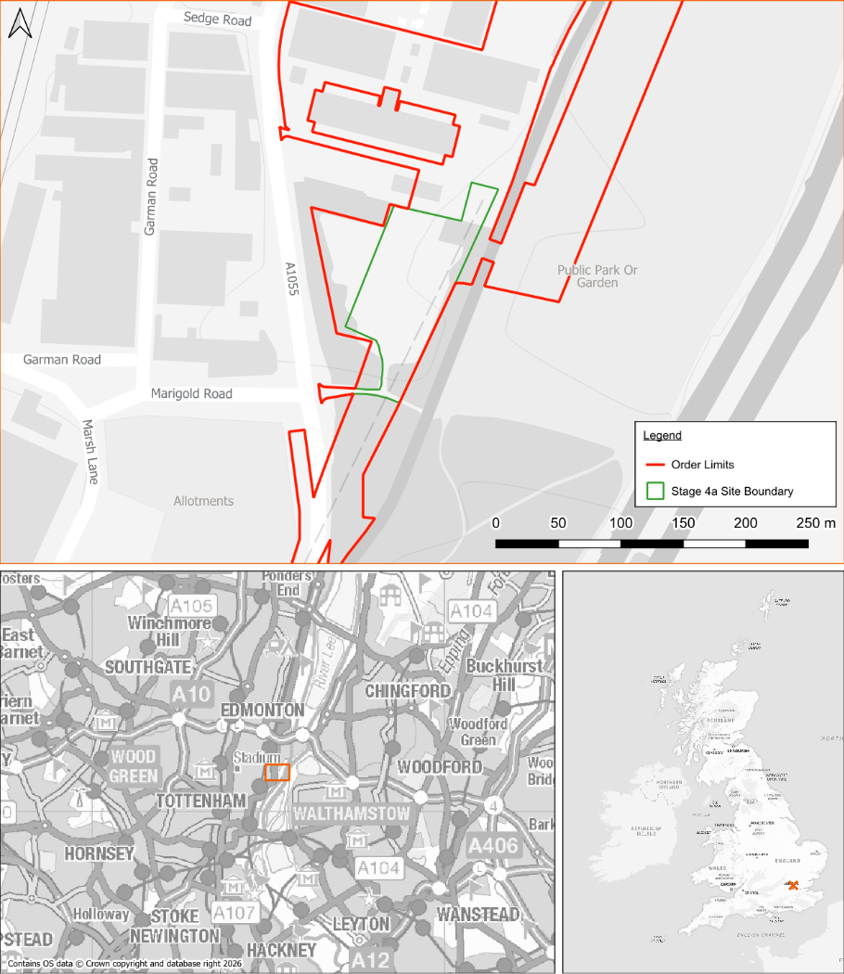
Figure 1: Stage 4a Work Area

Location
    - The Stage 4a work area is located at North London, N17 OQJ at NGR TQ 35345 91319. The site is located approximately 350m east of Northumberland Park Railway Station.

Existing Site Conditions
    - Online mapping (including Google Maps / Google Streetview imagery, accessed 25/05/26) shows that the Stage 4a work areas comprise the existing Tottenham Marsh Electricity Transformer Station, industrial units and greenfield land. The Main River, Pymmes Brook, is located along the eastern boundary of the site and joins the River Lee 1.4km downstream.

Topography
    - A topographical survey has been undertaken and is included in Appendix B. The topographical survey shows the site is relatively flat. In the area east of Watermead Way, ground levels range from 11.20m Above Ordnance Datum (AOD) in the north to 9.56m AOD in the south. In the area proposed for VC2, to the west of Watermead Way, ground levels range between 8.41m AOD and 8.90m AOD.
    - Topographic levels to m AOD have also been derived from a 1 m resolution Environment Agency (EA) composite ‘Light Detecting and Ranging’ (LiDAR) Digital Terrain Model (DTM). A review of LiDAR ground elevation data shows that the working area included in Stage 4a range from approximately 8m to 11m AOD and concurs with the topographical survey.

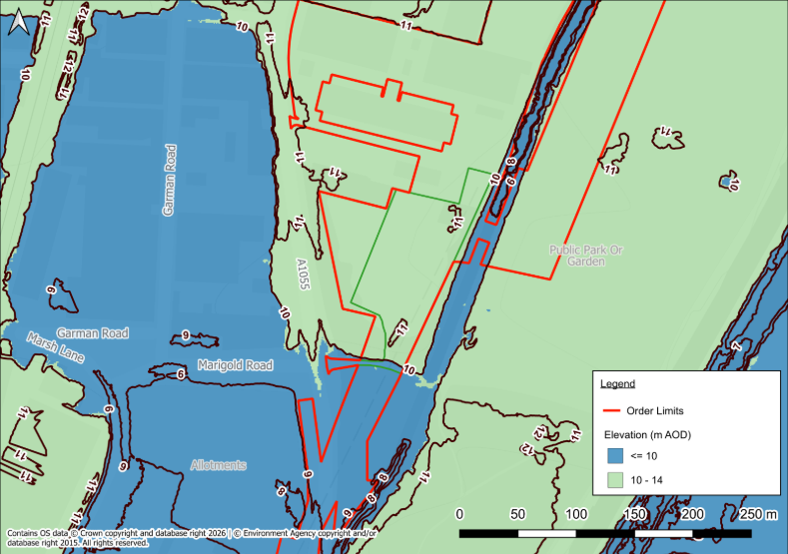
Figure 2: LiDAR Plan

Hydrology
    - The Pymmes Brook (Main River), a tributary of the River Lee, flows adjacent to the eastern boundary and joins the River Lee approximately 1.4km downstream.
    - Other watercourses in the area include the River Lee Navigation Channel, River Lee Navigation Channel, Banbury Reservoir and Lockwood Reservoir which are located approximately 200m east of the Stage 4a proposed works.
    - Main Rivers are within the jurisdiction of the EA.

Geology
    - Reference to the British Geological Survey (BGS) online mapping (1:50,000 scale) indicates that the site is underlain by superficial deposits of Alluvium generally comprising of clay, silt, sand and gravel (Figure 3). The superficial deposits are identified as being underlain London Clay Formation generally comprising of clay, silt and sand.

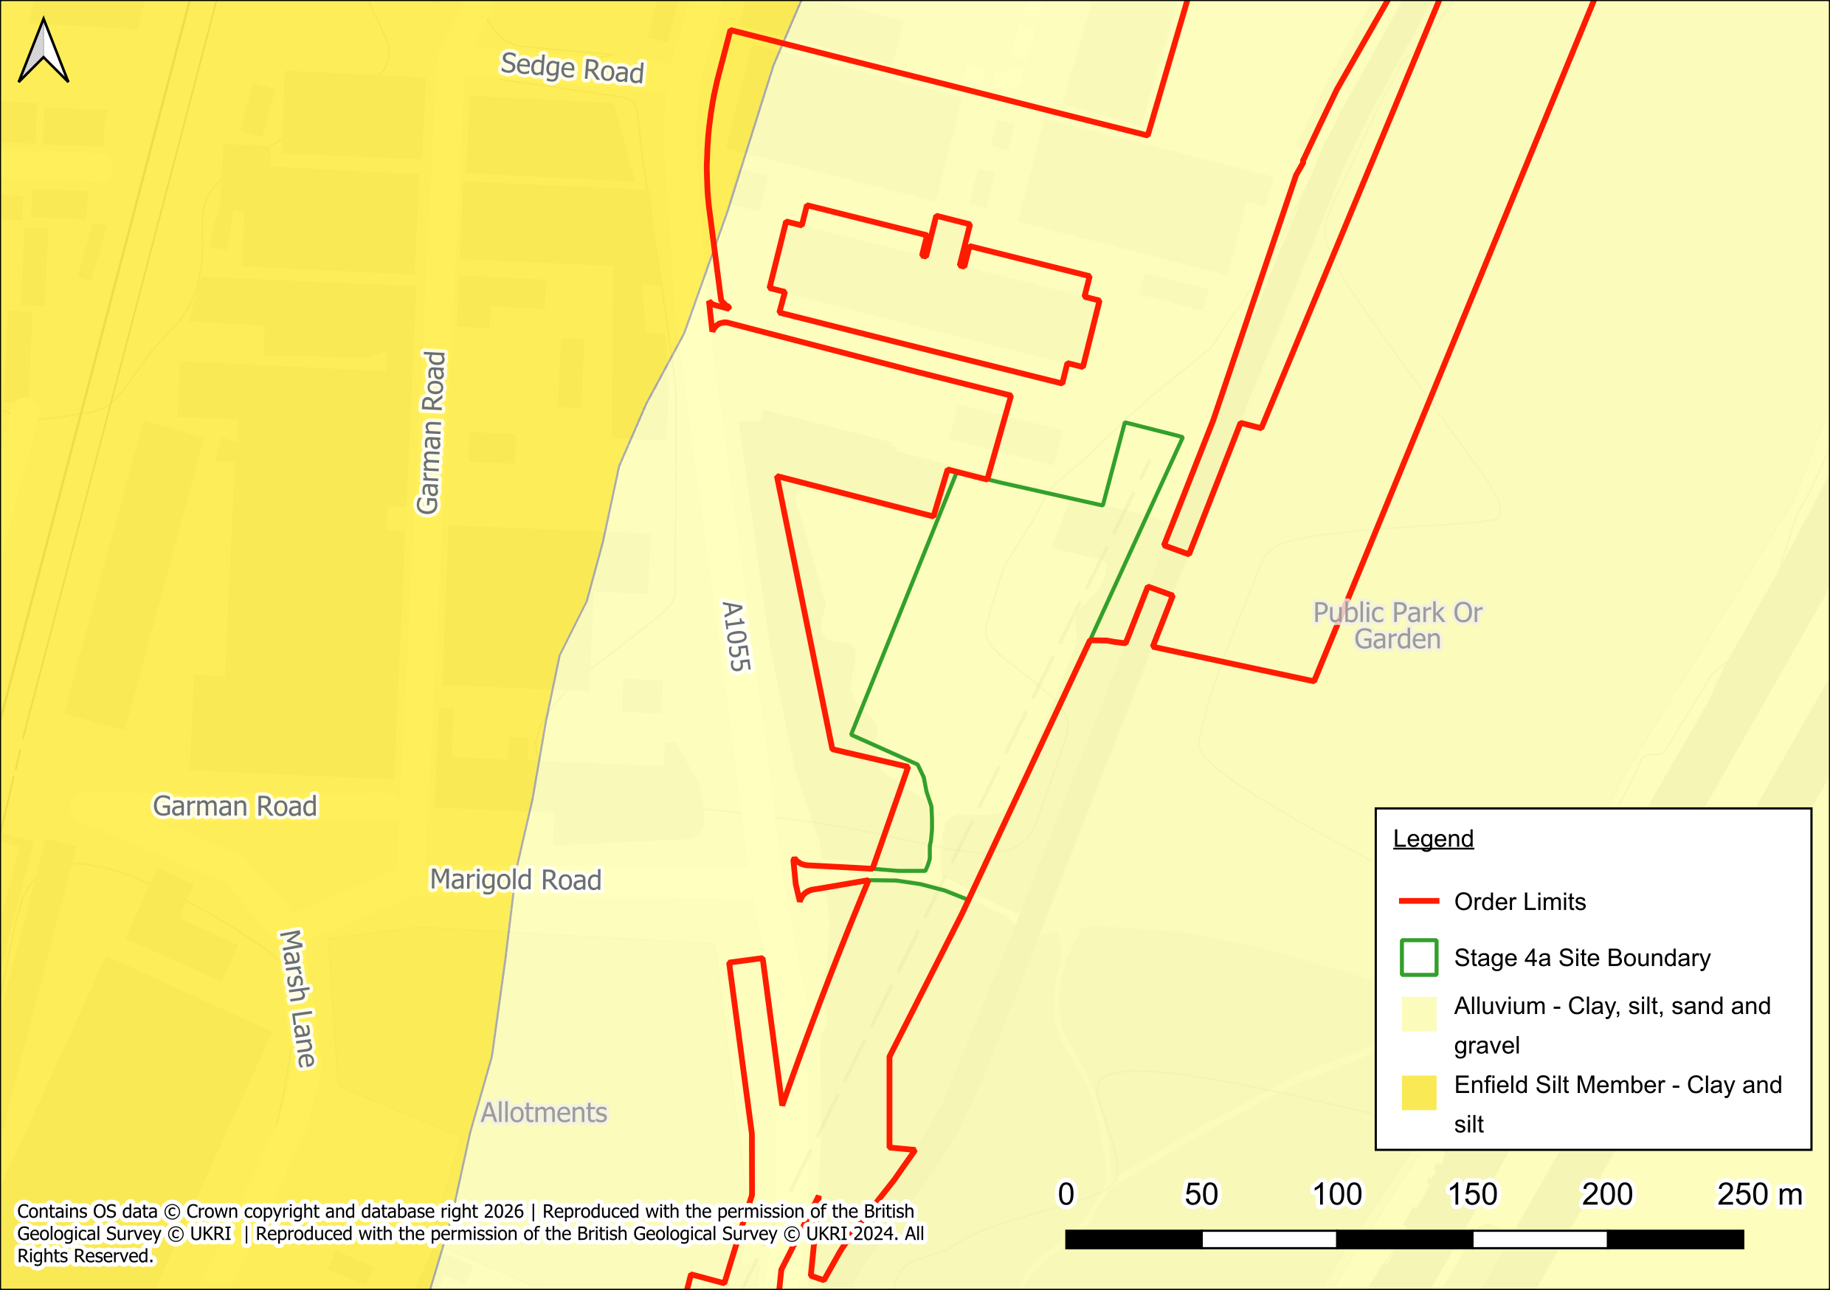
Figure 3: Superficial Deposits

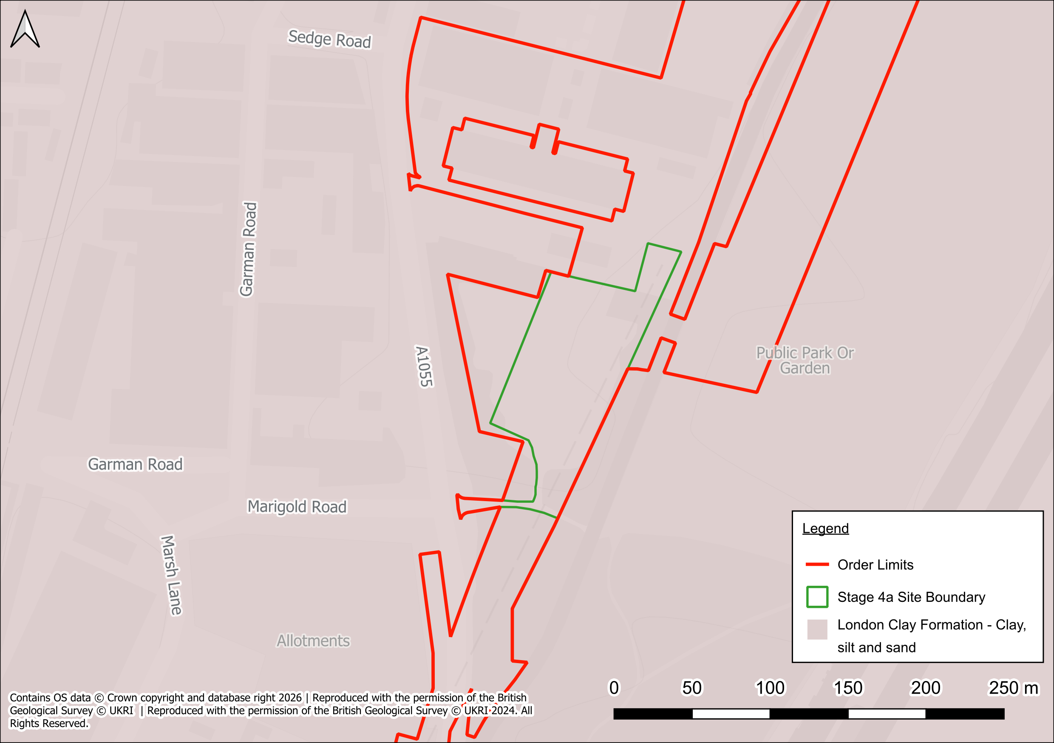
Figure 4: Bedrock Deposits
    - The geological mapping is available at a scale of 1:50,000 and as such may not be accurate on a site specific basis.

Hydrogeology
    - According to the EA’s Aquifer Designation data, obtained from MAGIC Map’s online mapping [accessed 25/05/2026], the superficial and underlying deposits is classified as a Secondary A Aquifer.
    - The EA’s ‘Source Protection Zones’ data, obtained from MAGIC Map’s online mapping [accessed 25/05/2026] indicates that the site is located within a Zone 2 – Outer Protection Zone.

Local Drainage
    - Thames Water Asset Plans are included in Appendix C. The asset plans show there is a surface water sewer flowing south within the eastern footway of Watermead Way until the proposed works access where it then flows east and outfalls into the Pymmes Brook at headwall reference 201B. The invert and cover levels of this sewer run are not shown on the Thames Water asset plans.
    - There is also a surface water sewer transecting the proposed Stage 4a works in the north. The sewer outfalls into the Pymmes Brook at headwall reference 3101, with a recorded cover level of 10.52m AOD and an invert level of 6.91m AOD. The upstream inspection chamber is located within Watermead Way (reference 1101) however, its invert and cover levels are not shown on the Thames Water asset plans.

relevant planning policy and guidance

Introduction
    - The aim of this section of the report is to discuss the main aspects of the local and national planning policies that are relevant to any proposed development on the site and relevant guidance and legislation.

Assessment of Flood Risk
    - The flood risk from fluvial (Main Rivers) and coastal flooding is assessed through the use of the EA Flood Maps (flood risk from rivers or the sea). This map defines three zones of different flood risk, the third of which is subdivided into two categories:
- Zone 1 “Low probability of flooding” – This zone comprises land assessed as having a less than 1 in 1,000 annual probability of river or sea flooding (<0.1%);
- Zone 2 “Medium probability of flooding” – This zone comprises land assessed as having between a 1 in 100 and 1 in 1,000 annual probability of river flooding (1% – 0.1%), or between a 1 in 200 and 1 in 1,000 annual probability of sea flooding (0.5% – 0.1%) in any year;
- Zone 3a “High probability of flooding” – This zone comprises land assessed as having a 1 in 100 or greater annual probability of river flooding (>1%), or a 1 in 200 or greater annual probability of flooding from the sea (>0.5%) in any year; and
- Zone 3b “Functional floodplain” – A sub-part of Zone 3, this zone comprises land where water has to flow or be stored in times of flood. This zone is not normally included within the national Flood Map for Planning and is calculated where necessary using detailed hydraulic modelling.

National Planning Policy Framework
    - Flood risk in England is normally considered through the planning process in the NPPF (2025), produced by Ministry of Housing, Communities & Local Government.
    - A Flood Risk Assessment is required when the following criteria (one or more) is met:
- The site is greater than one hectare in size;
    - All proposals for new development (including minor development and change of use) in Flood Zones 2 and 3;
    - Or in an area within Flood Zone 1 which has critical drainage problems (as notified to the local planning authority by the EA);
    - Land identified in a Strategic Flood Risk Assessment (SFRA) as being at increased flood risk in the future; and
    - Where proposed development or a change of use to a more vulnerable class may be subject to other sources of flooding.
    - A key part of the NPPF is that a proposed development must first pass a “Sequential Test” to demonstrate that the overall development proposal is appropriate in terms of flood risk. It ensures that a sequential approach is followed to guide new development to areas with the lowest probability of flooding.

Exception Test
    - The Exception Test determines whether the benefits of the proposed development will outweigh the potential flood risk.

Vulnerability Classification
    - In accordance with Annex 3 of the NPPG: Flood Risk and Coastal Change, the development is considered to be ‘Essential Infrastructure’ which is defined as ‘essential utility infrastructure which has to be located in a flood risk area for operational reasons, including infrastructure for electricity supply including generation, storage and distribution systems; including electricity generating power stations, grid and primary substations storage; and water treatment works that need to remain operational in times of flood’.
    - Table 2 of the NPPG states that ‘Essential Infrastructure’ development is considered appropriate within Flood Zone 2 (see below).
Table 1: Flood Risk Vulnerability Classification (from Table 2 of the online Planning Practice Guidance)
Flood Zones  Example | Flood Risk Vulnerability Classification
Flood Zones  Example | Essential Infrastructure | Highly Vulnerable | More Vulnerable | Less Vulnerable | Water- Compatible
Zone 1 | ✓ | ✓ | ✓ | ✓ | ✓
Zone 2 | ✓ | Exception Test Required | ✓ | ✓ | ✓
Zone 3a | Exception Test Required | ✗ | Exception Test Required | ✓ | ✓
Zone 3b | Exception Test Required | ✗ | ✗ | ✗ | ✓

✓ development is permitted

✗ development is not permitted

Local Policy
    - Haringey’s Local Plan – Strategic Policies 2013 – 2026 (adopted March 2013) contains the following policy relating to flood risk:

SP5 Water Management and Flooding
    - The Council will require all development in Haringey to be water efficient during construction and operation and to reduce all forms of flood risk. All development shall:
- Improve the water environment, water quality and drainage systems;
- Minimise water use and illustrate how development would contribute to general and flash flooding;
- Take account of flood risk vulnerability classification as set out in paragraph 100 of the NPPF and will apply the NPPF Sequential Test and Exception Test;
- Implement measures to prevent (or mitigate as last resort) local surface water and downstream flooding;
- Implement Sustainable Drainage Systems from strategic to individual site level to improve water attenuation, quality and amenity;
- Restore and enhance the Blue Ribbon Network including Pymmes Brook, Moselle Brook, the River Lee and its tributaries, deculverting wherever feasible, to improve water quality and amenity of these waterways and to help reduce food risk (in line with London River Action Plan); and
- Require higher resilience and levels of flood protection for critical infrastructure to ensure the protection of essential services such as water and power.
    - The water environment is a valuable recreational, educational and leisure resource for the residents of Haringey. From the large reservoirs of the Lee Valley to small ponds in parks and gardens, it is a resource that needs to be protected. Developments should ensure measures are incorporated to protect and improve water quality for surface and groundwaters, particularly in areas of land contamination. An increase in residential and commercial developments in the growth areas of Haringey Heartlands and Tottenham Hale will increase demand for water and abstraction from rivers. Too much water taken from rivers can cause problems for wildlife and increase the risk of pollution, as there is less water available to dilute pollutants.
River Lee
    - The River Lee downstream of Tottenham Lock has poor chemical and biological water quality. This is partly due to the confuence of the River Lee and Pymmes Brook at Tottenham Lock. Pymmes Brook has historically poor chemical water quality and Haringey is working closely with other boroughs to improve this. The River Lee and River Lee Navigation’s use of water storage bodies and its associated open space, is a key location in aiding food risk management. The River Lee and the large reservoirs of the Lee Valley is a resource to be protected and enhanced and Haringey are working closely with the Lee Valley Park Authority to continue to improve the area in terms of flooding and sustainable development. Haringey is also working closely with neighbouring boroughs and strategic authorities regarding the Water Framework Directive targets for the Thames River Basin Management Plan, in particular the physical modifcation of water bodies, abstraction and diffusion of pollution from urban sources.
Water Demand
    - The combination of climate change, predicted growth in population and increased water usage will exacerbate demand for water. Therefore, along with the increase in the intensity of rainfall, and the increased amount of hard surfaces in our environment, there is a greater pressure on the drainage systems. Haringey requires that new developments should aim to decrease the demand for water as much as possible. Haringey will require the incorporation of water saving measures and equipment in all new development in order to meet the London Plan water consumption targets of 105l/p/d.
Flood Risk
    - Implications of anticipated change in climate in the UK increased frequency in extreme weather conditions and the possibility of flash floods are being considered carefully. The borough contains areas of flood risk in proximity to Pymmes Brook on Pinkham Way, the Moselle Brook and the River Lee. In Haringey, risk areas include parts of the Lee Valley and South Tottenham (as identified in the Strategic Flood Risk Assessment) and areas identified by the Environment Agency mapped data showing areas susceptible to flooding. According to the Environment Agency, approximately 9% of land in Haringey has one in 100 year probability of flooding from rivers. About 8,000 properties are at risk of flooding although the defences such as the River Lee flood relief channel reduce the risk of this happening.
    - In developing this document the Council has worked on a Strategic Flood Risk Assessment for the borough and consulted with the Environment Agency on measures which are necessary to reduce flood risk in the area and suitable mitigation where risk is identified. The best form of flood mitigation is to encourage development in areas of lower flood risk. Where a risk of flooding is identified, a Sequential Test will be required, as set out in paragraph 100 of the NPPF. The Council will prepare Area Action Plans for Tottenham Hale and Northumberland Park. This more detailed work will be informed by the Level 2 Strategic Flood Risk Assessments and will identify development sites and the quantum and type of development needed. Masterplanning exercises and development briefs will ensure that flood risk is considered at an early stage, at an appropriate scale and in close consultation with the Environment Agency. Sequential Tests will be conducted to ensure proposals are in accordance with the NPPF, and flood risk assessments for individual development proposals will need to demonstrate that development is safe.
    - The Flood and Water Management Act 2010 brings responsibilities to Local Authorities for more comprehensive management of flood risk for people, homes and businesses. Haringey forms part of the Drain London Forum, a partnership including London boroughs, the Environment Agency and the Mayor of London, which is formed to ensure the requirements from the Flood and Water Management Act 2010 are met in producing a Surface Water Management Plan (SWMP). The development of SWMPs include a Preliminary Flood Risk Assessment for Haringey, and for the other sub-regional boroughs to investigate and address flood risk problems.
    - Increased flood risk due to anticipated changes in the climate also requires the Council to consider measures for adapting to climate change and focus on minimising the flood risk in the area. Hard and soft landscaping associated with new development must take account of sustainable land management practices and managing the risk of flooding by applying Sustainable Urban Drainage Systems (SUDS) in order to improve water attenuation, quality and amenity. The provision of green features, including green roofs, provides opportunities to reduce runoff rates and enhance biodiversity, and are fully encouraged in both new development and retrofitting in older buildings.
    - In addition, the Development Management Policies and Site Allocations Document set out borough-wide standards and guidance for managing flood risk through development, including those relating to:
- The need to address non-fluvial sources of flooding; ▪ The use and design of water recycling;
- Requirements for site-specific Flood Risk Assessments;
- The use and design of water attenuation (in line with the drainage hierarchy set out in the London Plan);
- The use and design of SUDS;
- The design and layout of developments, including setting built developments back from rivers, watercourses and flood defences; and
- Requirements for implementation of flood resilient and resistant building techniques.

Climate Change
    - The EA ‘Flood Risk Assessments: Climate Change Allowances’ Guidance states that ‘Essential Infrastructure’ developments should utilise the Upper End allowance. The EA’s Online Peak River Flow Map indicates that within the London Management Catchment, the Central Allowance equates to 10% for the 2020s epoch, 7% for the 2050s epoch and 17% for the 2080s epoch, whilst the Upper End Allowance equates to 26% for the 2020s, 30% for the 2050s and 54% for the 2080s.
    - Given the location of the Stage 4a work area is in Flood Zone 2, Product Data has been requested by the EA. We are awaiting response.

ASSESSMENT OF FLOOD RISK

Tidal Flood Risk
    - The site is situated at a minimum of approximately 8.41m AOD and is significantly above sea level. Therefore, it is considered that the site has Negligible risk from tidal flooding.

Fluvial Flood Risk
    - The site is situated within Flood Zone 2 (0.1 - 1% AEP) associated with the Pymmes Brook, River Lee Navigation Channel and River Lee as shown on EA mapping (Figure 5), indicating potential exposure to fluvial flooding during extreme events.
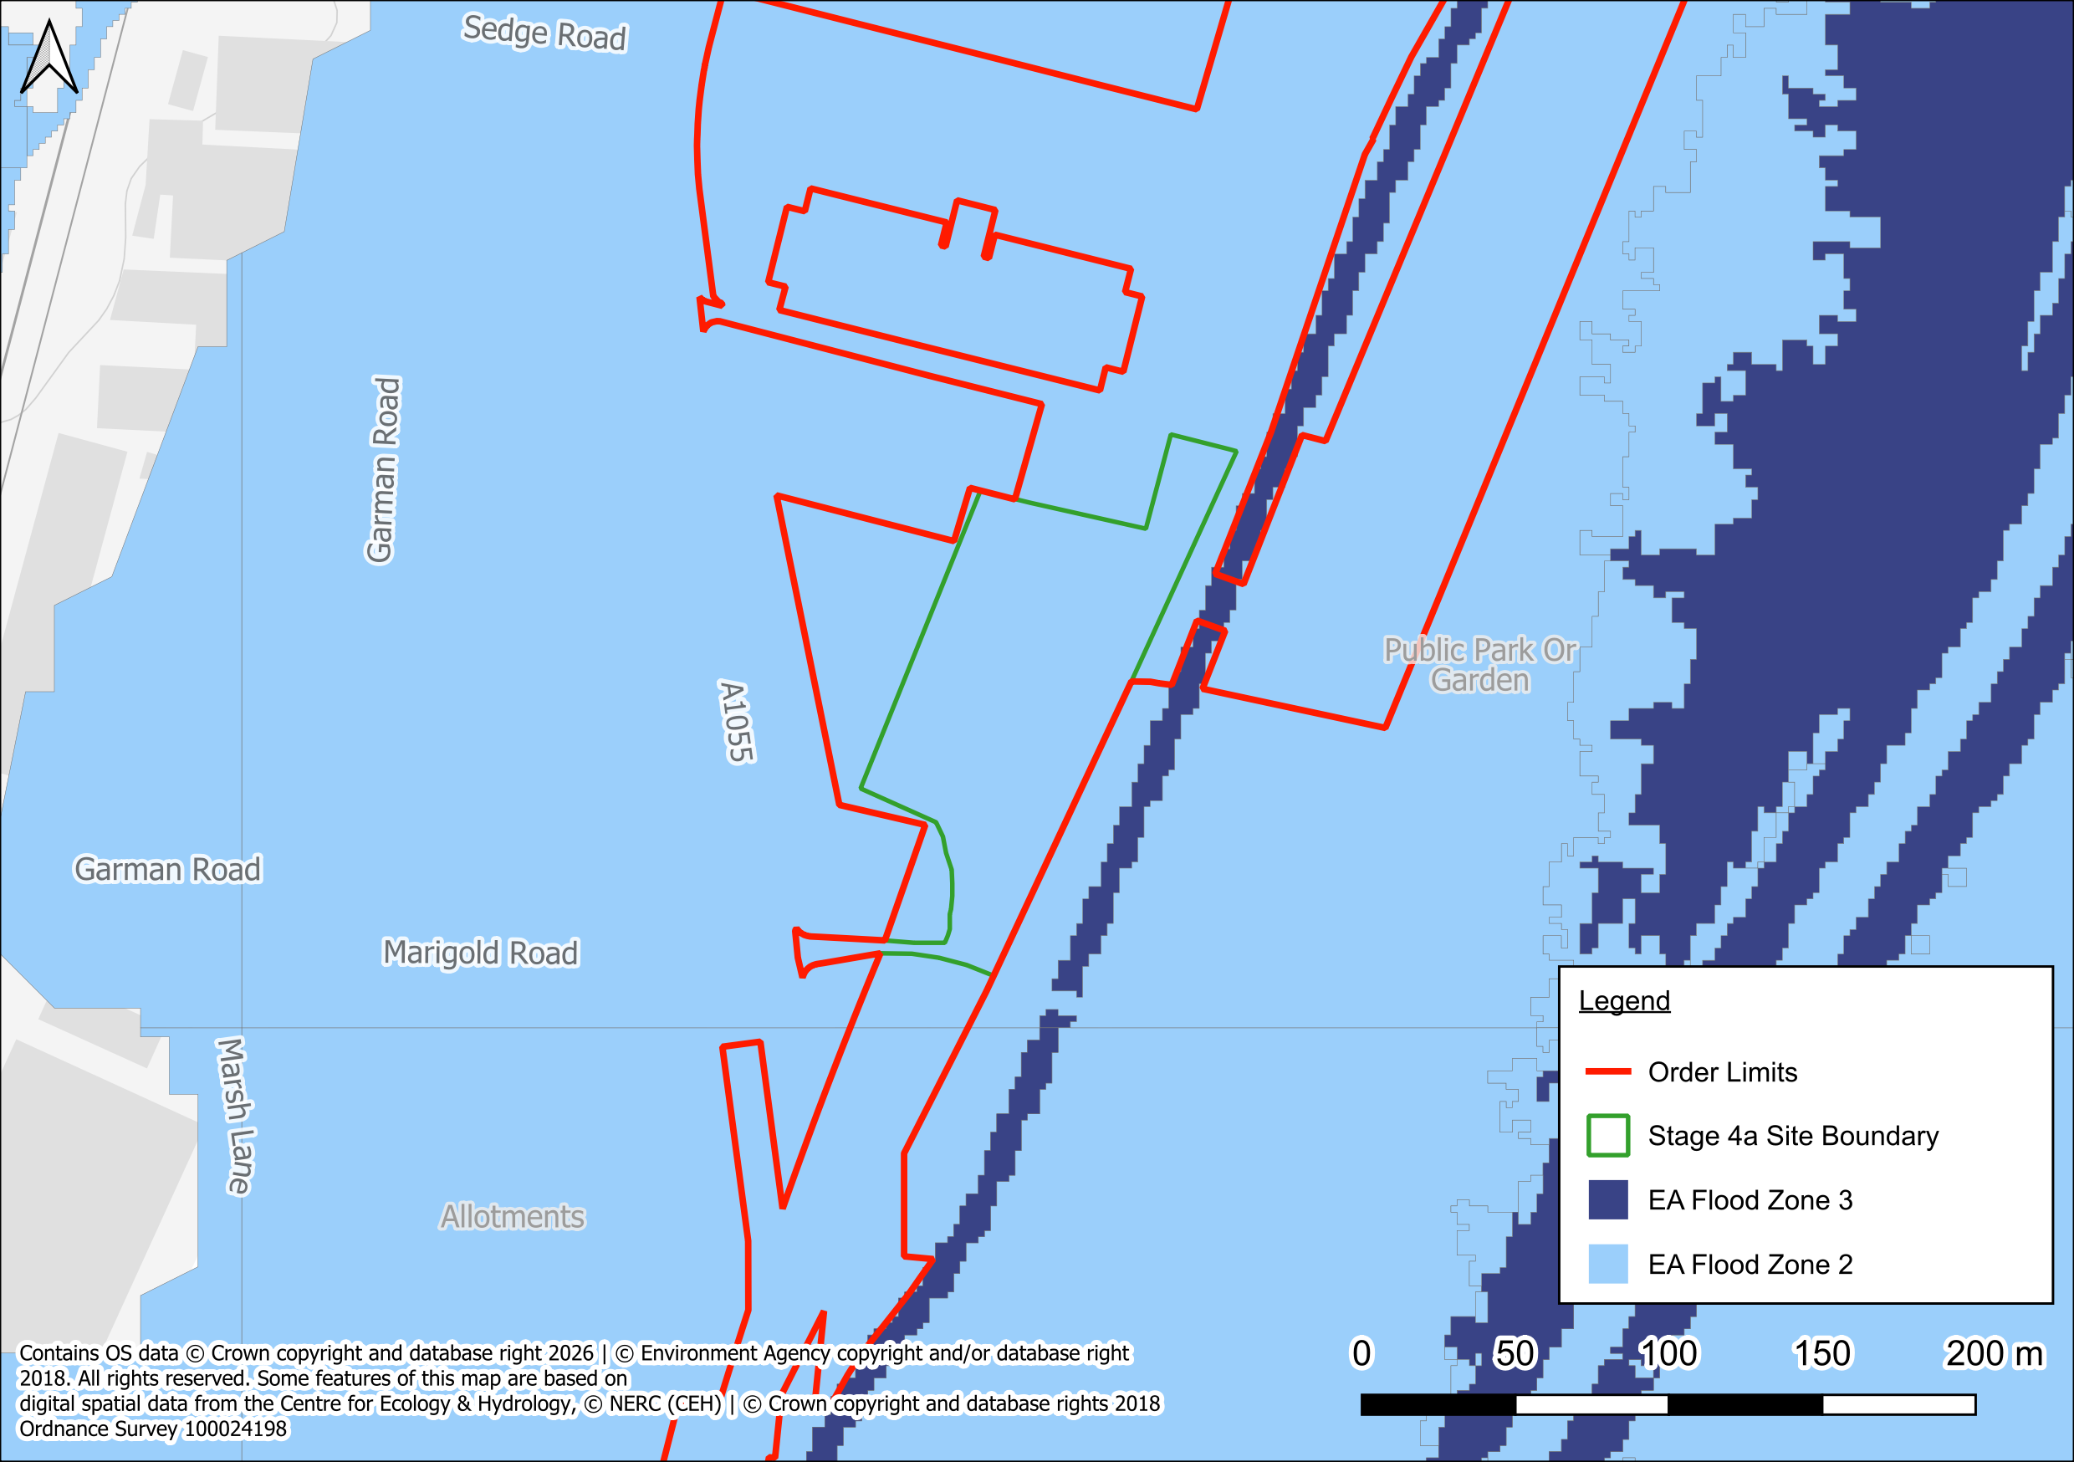
Figure 5: EA’s Flood Map for Planning
    - The nearest watercourse is the Pymmes Brook along the eastern boundary of the site. There is also the River Lee Navigation Channel situated approximately 250m east of the site.
    - The EA ‘Historical/ Recorded Outlines Flood Map’ indicates that the site has previously experienced flooding occurring in March 1947 due to channel capacity exceedance (no raised defences).
    - There is no site-specific information within third party reports relating to fluvial flood risk.
    - Given the site’s location within Flood Zone 2, Environment Agency Product Data has been requested and is currently awaited.
    - Summary
    - Given the nature of the development, the site is therefore considered to be at Low to Moderate risk of fluvial flooding. This risk rating will be refined following receipt and review of EA product data, which is expected to provide further clarification of site-specific risk.

Surface Water Flood Risk
    - The EA ‘Flood Risk from Surface Water’ Map (Figure 6) indicates that the site is predominately at Very Low risk (<0.1% AEP) of surface water flooding. However, there are isolated areas at Low to High risk (0.1% to ≥3.3% AEP) of surface water flooding to the southwest of the site and the access track off Watermead Way. These areas are likely associated with topographic depressions.
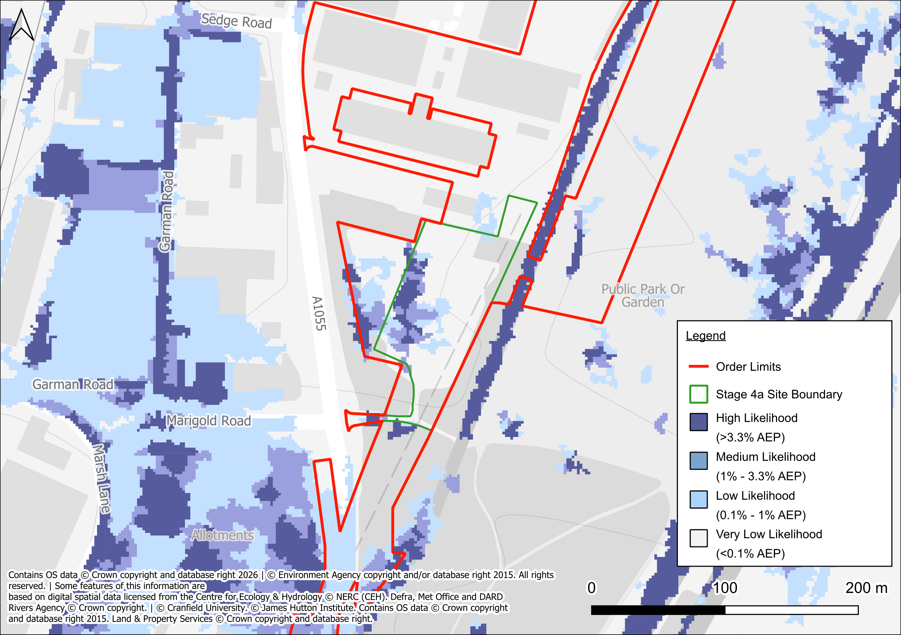
Figure 6: EA’s Long-Term Flood Risk Map (Flood Risk from Surface Water)

    - Depths across the site remaining below 300mm during all flood risk scenarios, with flow velocities remaining under 0.25m/s. This is considered passable by people and vehicles. Therefore, access and egress to the site via the access track off Watermead Way is achievable.
    - There are no distinct flow routes in the area which would direct any potential surface water flooding towards the site.
    - There is no site specific information within third party reports relating to surface water flood risk.
    - It can therefore be concluded that the site is at Low risk of surface water flooding.

Groundwater Flood Risk
    - The underlying geology comprises comprise Alluvium deposits which is underlain by London Clay Formation. These units typically have mixed permeability characteristics with the Alluvium generally having high permeability and London Clay Formation having low permeability.
    - Additionally, Soilscapes data identify loamy and clayey floodplain soils with naturally high groundwater.
    - A review of third party resources did not find any records of groundwater flooding at or near to the site. Additionally, EA Long Term Flood Risk Map states groundwater is not a known risk in this area.
    - It can therefore be concluded that the risk of groundwater flooding is Low. However, it should be noted that shallow groundwater may be present seasonally but poses no constraint given the short-term temporary nature of the works.

Sewer Flooding
    - Sewer flood risk is typically hard to predict as it depends on a range of factors including sewer capacity, condition, and the frequency of extreme rainfall events.
    - As discussed in section 4.8, according to Thames Water utility asset plans, there is a public surface water sewer present within the Stage 4a work area. The asset plans show there is a surface water sewer flowing south within the eastern footway of Watermead Way until the proposed works access where it then flows east and outfalls into the Pymmes Brook at headwall reference 201B.
    - There is no site specific information within third party reports relating to sewer flood risk.
    - Due to the presence of the surface water sewer within the area proposed for Stage 4a works, the risk of flooding from this source is considered to be Low to Moderate.
    - To mitigate this risk, all Thames Water easements associated with the infrastructure will be accorded with to prevent damage to the system. Where it is not possible to accord with the easements, sewer diversions will be implemented subject to approval from Thames Water.

Reservoir and Canal Flooding
    - The River Lea Navigation Canal is a controlled waterway hydraulically connected to the River Lea. Flooding from the canal is considered a residual risk managed through existing lock and weir systems.
    - The EA ‘Flood Risk from Reservoirs’ map shows that the work area is at risk of flooding from reservoirs during a ‘wet day’ scenario (when there is also flooding from rivers). It can be concluded that this is due to the presence of several rivers and waterbodies in close proximity to the work area.
    - The EA state that reservoir flooding is extremely unlikely to happen. All large reservoirs must be inspected and supervised by reservoir panel engineers. As the enforcement authority for the Reservoirs Act 1975 in England, the EA ensure that reservoirs are inspected regularly, and essential safety work is carried out.
    - It can therefore be concluded that there is a Negligible to Low risk of flooding from artificial sources.

Residual Flood Risks
    - A residual risk is an exceedance event, such as the greater than 1 in 1000 year (<0.1% AEP) flood event that would overtop the Pymmes Brook and River Lee, and potentially impact the site. As the probability of a 1 in 1000 year flood event occurring is <0.1% in any given year, the probability is low and, therefore, no further mitigation beyond what is proposed is required.
    - In the event of the defences failing or an exceedance event occurring, the residual risk to people working within the site can be managed through the implementation of an appropriate site management plan, which recognises the residual risks and details what action is to be taken by staff in the event of a flood to put occupants in a place of safety.

Summary of Flood Risk and Mitigation
    - It can be concluded that the site is at Low to Moderate fluvial flood risk and lies within an area covered by the Environment Agency’s Flood Warning Areas. However, the short duration of works, limited footprint, and reinstatement approach ensure that there will be no increase in flood risk on site or elsewhere, in accordance with Requirement 10 of the DCO.
    - All other sources of flooding are considered to present a Low risk to the site based on available data.
    - The following mitigation measures are recommended as good practice, given the site is located within Flood Zone 2:
- Site Management and Site teams register with the Environment Agency’s Floodline service (Tel: 0345 988 1188); and
- Implement the Flood Response Plan contained within the CEMP (Requirement 13).

Table 3: Summary of Risk and Mitigation
Source of Flooding |  | Summary of Risk | Mitigation
Tidal Flood Risk |  | Negligible | Negligible
Fluvial Flood Risk |  | Low to Moderate* | Low
Surface Water Flood Risk |  | Low | Low
Groundwater Flood Risk |  | Low | Low
Artificial Sources of Flood Risk | Sewer Flooding | Low to Moderate | Low
Artificial Sources of Flood Risk | Reservoir and Canal Flooding | Negligible | Negligible
* To be confirmed upon the receipt of EA Product data.

Flood Risk during the construction phase
    - The greatest risk posed during construction is the laying of temporary trackways / minor temporary ground works to facilitate safe access to the working areas. Following heavy rainfall, there may be a risk of runoff entering any open trenches and acting as a drainage path, or runoff pooling / making new flow routes alongside the new trackway when areas of previously rural land are being temporarily used as access.
    - To avoid this, impermeable barriers should be placed inside any trenches, with measures implemented to support the walls to maintain stability if areas are flooded due to run-off. High-capacity pumps should be made available during construction to allow for the draining of any flooded excavations. A discharge point for extracted water would need to be agreed with the EA, with water discharged following appropriate treatment methods to avoid contaminants.
    - It is also important to ensure safety of any personnel on-site during the construction phase, details of this are secured in the Stage 4a Construction Environmental Management Plan (CEMP, Requirement 13).

Sequential and exception test

Sequential Test
    - The work areas within the site are located wholly within Flood Zone 2. When considering the need for application of the Sequential Test, the chance of flooding needs to be weighed against the benefits of allowing development to occur in Flood Zone 2.

Exception Test
    - In accordance with Annex 3 of the NPPG: Flood Risk and Coastal Change, the development is considered to be ‘Essential Infrastructure’. Table 2 of the NPPG: Flood Risk and Coastal Change, states that ‘Essential Infrastructure’ development is considered appropriate within Flood Zones 1 and 2.
    - The NPPF advises that ‘Essential Infrastructure’ development can be considered appropriate in Flood Zone 2, following satisfactory application of the Exception Test.
    - The Exception Test aims to ensure that more vulnerable property types are not allocated to areas at high risk of flooding. For the Exception Test to be passed it must be demonstrated that:
      - the development would provide wider sustainability benefits to the community that outweigh flood risk, and
      - the development will be safe for its lifetime taking account of the vulnerability of its users, without increasing flood risk elsewhere, and, where possible, will reduce flood risk overall.
    - With reference to the points above, the work area that make up the site are within Flood Zone 2. Upgrades to the transmission towers are necessary to facilitate the increased flow of power into London, and therefore the development provides benefits that outweigh flood risk in these locations.

Conclusions and recommendations

Conclusions
    - Overall, the Flood Risk Assessment identifies that the works areas within Stage 4a are located within Flood Zone 2 on the Environment Agency’s Flood Map for Planning (Rivers and Sea). These areas are therefore associated with a Low to Moderate risk of fluvial flooding and are situated within areas covered by the Environment Agency’s Flood Warning Areas.
    - However, given the short duration of the works, the limited spatial footprint of the activities, and the proposed reinstatement of all affected areas upon completion, the works will not result in any increase in flood risk on site or elsewhere. This position is subject to the implementation of the recommendations set out below and ensures compliance with Requirement 10 of the DCO.

Appendix A- Limitations

This report contains recommendations from Arthian, which are based on the information listed in the report and reflect the professional opinions of an experienced Environmental Consultant. Arthian obtained, reviewed, and evaluated information from the Client and others to prepare this report. The conclusions, opinions, and recommendations presented in this report are based on this information. However, Arthian does not guarantee the accuracy of the information provided and will not be held responsible for any opinions or conclusions reached based on information that is later proven to be inaccurate.
This report was prepared exclusively for the Client and for the specific purpose for which Arthian was instructed. It is not intended for use by anyone other than the Client without Arthian’s written consent. Any unauthorized use of this report is at the sole risk of the user. Anyone using or relying on this report, other than the Client, agrees to indemnify and hold harmless Arthian from any claims, losses, or damages arising from the performance of the work by the Consultant.

Appendix B – Topographical Survey

Appendix C – Thames Asset Plan

https://www.bgs.ac.uk/map-viewers/geoindex-onshore/
https://magic.defra.gov.uk/
https://haringey.gov.uk/sites/default/files/sfra_document_high_res_red_0.pdf
https://haringey.gov.uk/sites/default/files/2025-11/strategic-flood-risk-assessment-sfra-level-1-report-2022.pdf
https://haringey.gov.uk/sites/default/files/2025-05/202505-haringey-lfrms-final.pdf
https://haringey.gov.uk/sites/default/files/2024-01/final_haringey_local_plan_2017_online.pdf

