
___________________________________________________________________

Planning Design and Heritage Statement
Proposed bicycle store and front garden landscaping
3 Claremont Road London N6 5DA
Applicants | Sorrel Brookes and Paul Lowenberg
Local planning authority | London Borough of Haringey
Designation | Highgate Conservation Area and Highgate Neighbourhood Area
Application type | Householder planning permission
Prepared by | Black Robin Garden Design
Date | September 2026

Purpose of this statement
This statement explains the design and heritage considerations supporting the proposed cycle store and associated front garden planting. It concludes that the modest, screened structure would conserve the character and appearance of the Highgate Conservation Area while providing secure, practical storage for three bicycles. The landscape works would also replace a significant area of tarmac with a small tree and layered planting.
7 Wordsworth Walk, London, NW11 6AU
Company No: 12104547
M: 0779 320 0973
E: robyn@blackrobingardendesign.co.uk
W: blackrobingardendesign.co.uk

Application Summary
Planning permission is sought for a freestanding metal bicycle store in the front garden of 3 Claremont Road, positioned behind the retained brick boundary wall and a new U-shaped hedge. The works also include the removal of approximately 5.5m² of tarmac beneath the bay window and its replacement with a small tree underplanted with bulbs, ornamental grasses and perennials.
The proposal has been deliberately designed around the Council's concern that front garden cycle storage should be discreet. The store is low, dark in colour and enclosed by planting that is higher than its maximum roof level. It would remain subordinate to the house, preserve the existing boundary wall and avoid any effect on neighbouring amenity.

Cycle store | Trimetals Protect-a-Cycle storage for three bicycles
Store dimensions | 1,960 mm wide x approximately 890 mm deep x 1,330 mm to 1,130 mm high
Roof form | Sloping roof with the highest point at the rear
Material and finish | PVC-coated galvanised steel in anthracite
Front hedge length | Approximately 3,670 mm behind the existing brick wall
Hedge enclosure depth | Approximately 1,750 mm, as shown on the proposed front garden layout
Hedge height | Approximately 1,580 mm, responding to the site's approximate 5.6-degree slope
Hardstanding removed | Approximately 5.5m² of tarmac beneath the bay window

Site and Surroundings
No. 3 is a three-storey dwelling on Claremont Road. Its principal elevation has white render, red-brick detailing and a prominent ground-floor bay beneath a gabled upper storey. The house is set behind a low brick boundary wall, with a separate pedestrian path to the front door and a driveway.
The property lies within the Highgate Conservation Area and the Highgate Neighbourhood Area. It is not a listed building. The significance of this part of the conservation area is found in the coherent domestic scale of the houses, their architectural detailing and the green setting created by front gardens, hedges, trees and traditional boundary walls. The Highgate Conservation Area Character Appraisal identifies Claremont Road as part of this established residential townscape and treats its buildings as positive contributors.
The current street photograph shows mature hedging within the adjoining front gardens at Nos. 1 and 5. The retained wall and proposed hedge at No. 3 would therefore reinforce an existing characteristic of the immediate street rather than introduce an unfamiliar boundary treatment.
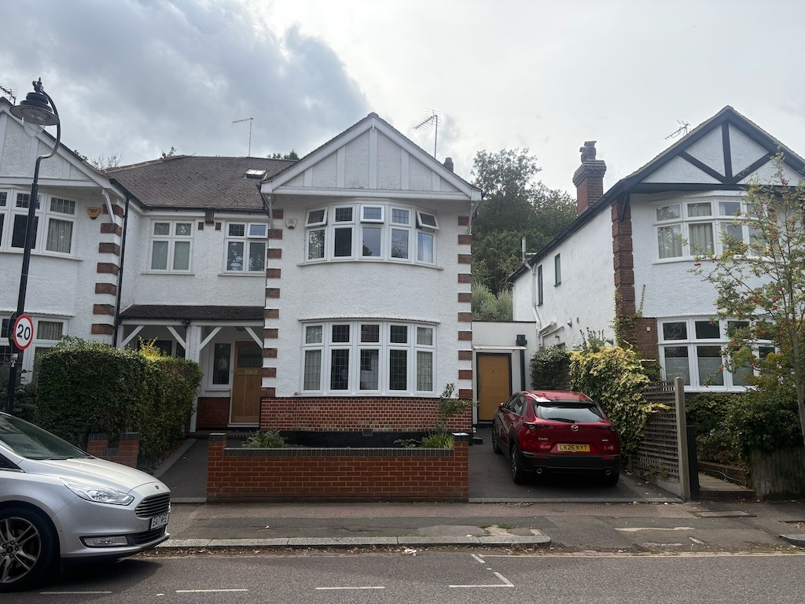
Figure 1 Existing street view showing No. 3 between Nos. 1 and 5 Claremont Road

The Proposed Development
The bicycle store would occupy the front garden between the driveway and the path to the front door. It would sit behind the existing 3,670 mm-long brick boundary wall, within a U-shaped hedge enclosure approximately 1,750 mm deep, as shown on the proposed layout drawing. This arrangement screens the store from direct and oblique views while preserving clear routes along both sides.
The site falls at approximately 5.6 degrees. A hedge maintained at about 1,580 mm is therefore required to provide consistent screening across the slope. The store's maximum height is 1,330 mm and its roof falls to about 1,130 mm. The hedge would remain above the store roof when viewed from Claremont Road.
The anthracite finish reduces contrast with planting and shadow. The store's simple form and modest footprint avoid competition with the house. Its opening mechanism and all day-to-day use would remain within the property, without projecting over the public footway or obstructing either access route.

Proposed Layout and Dimensions
The proposed front garden layout drawing records the overall frontage and garden depth together with the position and principal dimensions of the bicycle store, hedge enclosure and new planting bed. It also shows the retained driveway and front-door path.
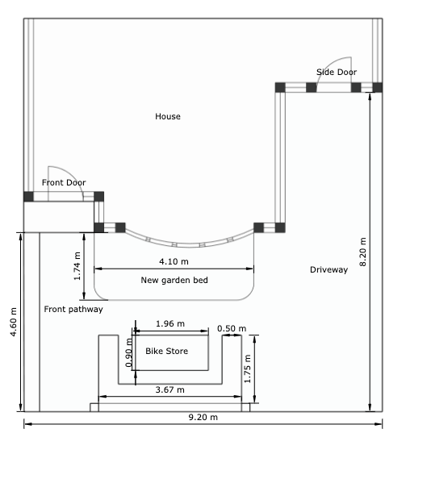
Figure 2 Proposed front garden layout and dimensions

Landscape Enhancement
The proposal is part of a wider improvement to the front garden. Approximately 5.5m² of tarmac beneath the bay window would be removed. The new bed would contain a small tree with bulbs, grasses and perennials, providing a softer foreground to the bay and a more characteristic garden setting for the house.
The planting would reduce the visual dominance of hardstanding, introduce seasonal interest and increase the amount and variety of vegetation at the frontage. The hedge performs a practical screening function while contributing to the planted character of the street.

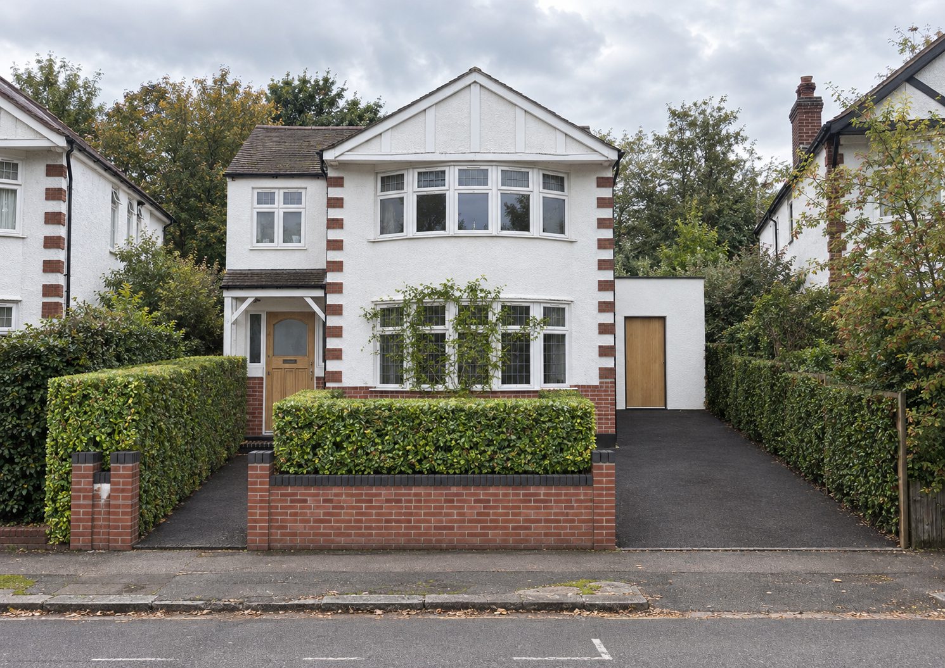
Figure 3 Proposed street view Illustrative visualisation with the measured drawings remaining definitive

Heritage Significance and Effect
Section 72 of the Planning Listed Buildings and Conservation Areas Act 1990 requires special attention to be paid to preserving or enhancing the character or appearance of a conservation area. National Planning Policy Framework policies HE4, HE5, HE6 and HE9 require a proportionate assessment of significance and support proposals that conserve the elements making a positive contribution to a conservation area.

Significance
No. 3 contributes to the conservation area through its period domestic form, gabled composition, bay windows, rendered elevations with brick detailing and its relationship with the neighbouring houses and front gardens. The low brick wall planted frontages and separation between pedestrian and vehicle access also contribute to the street's established character.

Effect of the Cycle Store
The proposal does not remove or alter the house, its architectural detailing or the existing brick boundary wall. The store would be read, where visible at all, as a small ancillary garden structure. Its scale is substantially below that of the boundary planting and the principal building.
Views from the road would be filtered by the retained wall and dense hedge. Oblique views from the driveway and entrance path would remain limited by the hedge returns. The dark anthracite finish and shallow roof profile further reduce prominence. On this basis, the store would not interrupt the rhythm of the street or compete with the host building.
The removal of tarmac and introduction of a tree and layered planting would improve the foreground of the house. Taken as a whole, the proposal would conserve the significance of the conservation area and provide a modest enhancement to the site's garden setting.
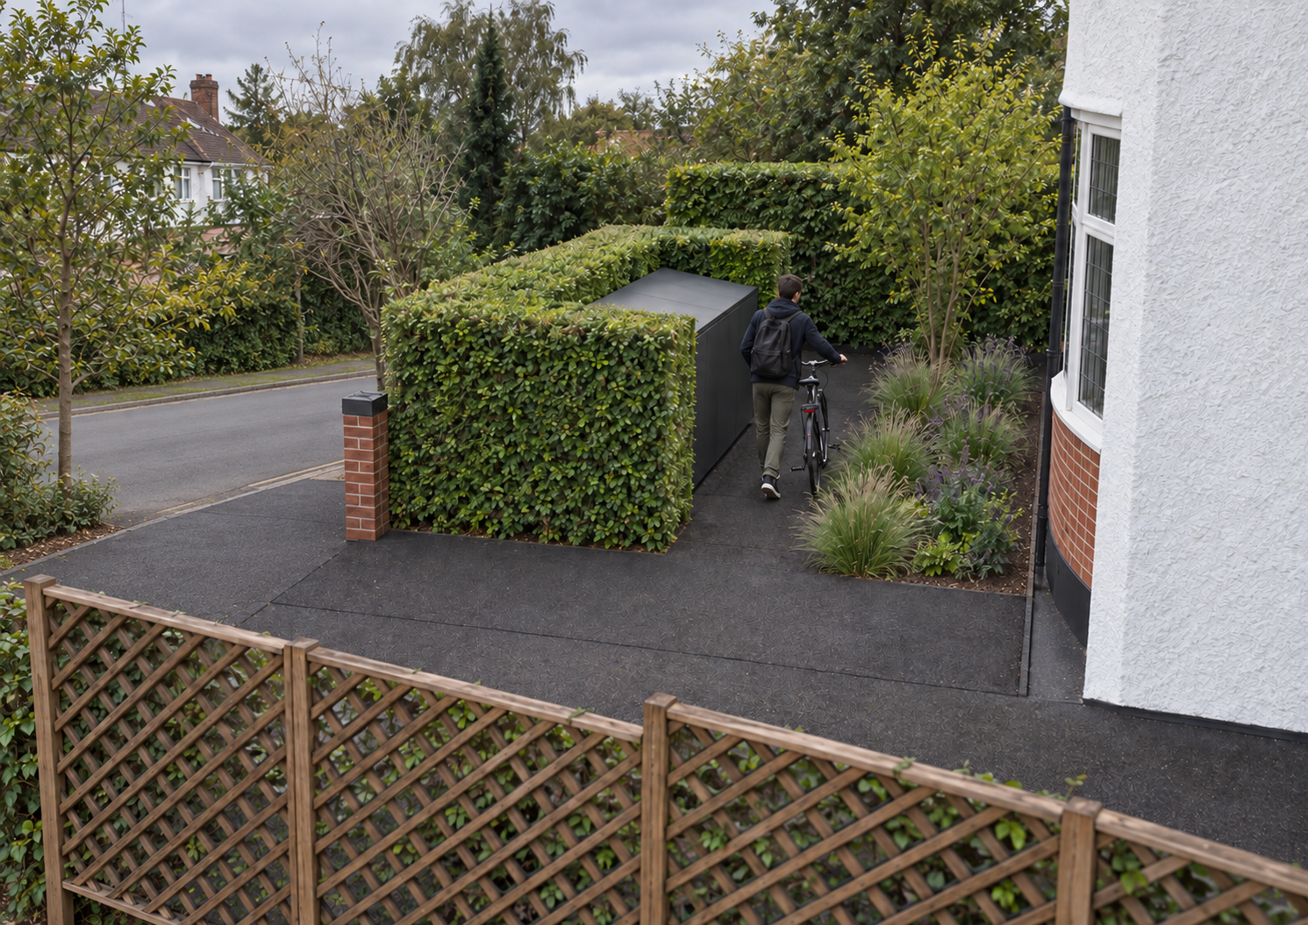
Figure 4 Proposed view from the driveway Illustrative visualisation showing access around the hedge

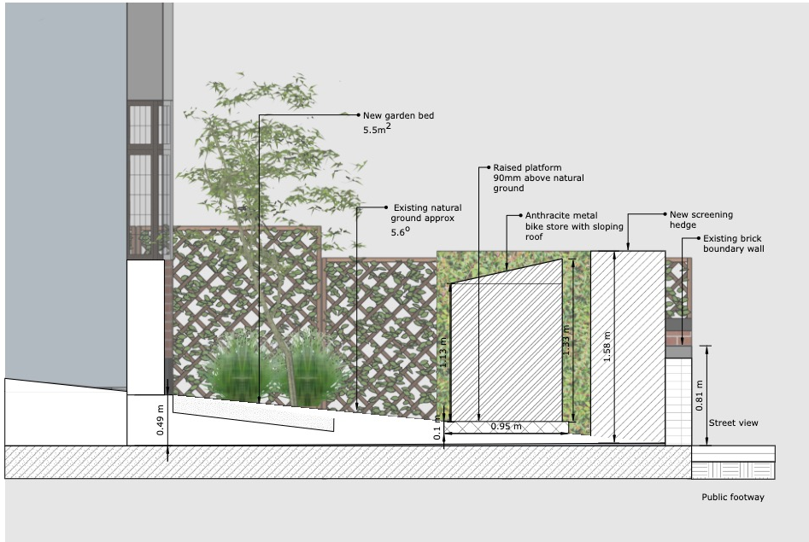
Figure 5 Proposed elevation view from front path looking cross the front garden to the driveway

Planning Policy Assessment

Haringey Policy DM35 Cycle Storage in Front Gardens
Policy DM35 supports front garden cycle storage where it is of high-quality design and is not visually intrusive.
- Size and scale The store has a compact footprint and a maximum height of 1,330 mm. It remains clearly subordinate to the house and below the proposed hedge.
- Location The store uses the central front-garden area between the established access routes, behind the retained wall, without narrowing or obstructing the driveway or front-door path.
- Screening The U-shaped hedge screens frontal and oblique views. Its 1,580 mm height responds to the slope and remains above the roof of the store.
- Materials Anthracite PVC-coated galvanised steel has a muted, durable finish that recedes visually behind planting. Haringey accepted the same product and finish at No. 19.
- Amenity The low structure would not cause overlooking, loss of privacy, loss of light, noise or an overbearing effect for neighbouring occupiers.

Design and Heritage Policies
Haringey Policies DM1 and DM12 require high-quality, site-specific design that responds positively to local character. Policy DM9 and Strategic Policy SP12 seek to conserve and enhance the historic environment. Strategic Policy SP11 requires design that respects local context and historic significance. The proposal responds to these policies through its modest scale, dark finish, retention of the boundary wall and integrated planting.
Policy DH2 of the Highgate Neighbourhood Plan expects development to preserve or enhance Highgate's conservation areas. Policy DH10 supports the retention of garden land and mature landscape features. The proposal retains the front garden's function, adds a substantial new hedge and converts approximately 5.5m² of hardstanding to soft landscape.
London Plan Policy HC1 requires development affecting heritage assets to conserve their significance, while Policy D3 promotes a design-led response to local context. The scheme meets these objectives because the store is visually recessive and the associated landscape works improve the setting of the house.

Current National Planning Policy
The August 2026 National Planning Policy Framework is a material consideration from the date of publication. Its historic-environment policies require applicants to explain significance and the likely effect of development proportionately. The assessment above finds no harm to the significance of the Highgate Conservation Area. The scheme retains the features that contribute positively and strengthens the planted character of the frontage.

Comparable Approval at 19 Claremont Road
Haringey granted householder planning permission under reference HGY/2023/0250 for a bicycle storage box in the front garden of 19 Claremont Road. The officer's report records the same Trimetals Protect-a-Cycle store, with dimensions of 1.96 m by 0.89 m by 1.33 m, constructed from anthracite PVC-coated galvanised steel.
The officer concluded that the location, scale, height and bulk were acceptable because the front boundary wall and hedge would mostly screen the store. The anthracite material was also considered non-intrusive. The officer found no harm to the host dwelling, the Highgate Conservation Area or neighbouring amenity and recommended approval with conditions.
Matter | No 19 approved scheme | No 3 proposed scheme
Location | Front garden on Claremont Road within the Highgate Conservation Area | Front garden on the same road and within the same conservation area
Store | Trimetals Protect-a-Cycle metal shed | The same Trimetals three-cycle storage model
Dimensions | 1.96 m long, 0.89 m wide and 1.33 m high | 1.96 m long, approximately 0.89 m wide and 1.33 m to 1.13 m high
Finish | Anthracite PVC-coated galvanised steel | Anthracite PVC-coated galvanised steel
Screening | Mostly screened by the front boundary wall and hedge | Behind the retained brick wall and enclosed by a new U-shaped hedge maintained at approximately 1.58 m
Landscape | Existing boundary screening formed part of the acceptability assessment | About 5.5m of tarmac removed and replaced by a small tree with bulbs, grasses and perennials
Weight to be given to the comparison
The No. 19 decision does not bind the Council because every application must be determined on its own facts. It is nevertheless a closely comparable decision on the same road, within the same conservation area, involving the same product, dimensions and finish. The screening and landscape measures at No. 3 address the precise reasons why the officer found the No. 19 scheme acceptable. The additional removal of tarmac and new planting provides further site-specific benefits.

Response to the Earlier Conservation Comments
The Highgate Conservation Area Advisory Committee objected to the No. 19 application because it considered that insufficient detail had been supplied, sought greater attention to sustainability and biodiversity, and wanted clearer design guidance for stores in small front gardens. This application responds directly to those concerns through measured dimensions, street and driveway visualisations, a clearly defined screening strategy and a substantial increase in soft landscape.

Neighbouring Amenity Access and Safety
The proposal is a low, non-habitable structure with no windows, lighting or independent activity. Its position within the front garden would not create overlooking, reduce privacy or affect daylight and outlook at Nos. 1 or 5. Bicycle movements are ordinary domestic activity and would not generate material noise or disturbance.
The driveway and pedestrian path remain open and legible. The bicycle store is reached wholly within the property. The door would operate within the garden enclosure and would not overhang the public highway. Secure storage close to the street makes routine cycle use practical without leaving bicycles against the house, wall or railings.

Landscape Establishment and Maintenance
The hedge will be planted to form the U-shaped enclosure shown on the submitted drawings and maintained at approximately 1,580 mm so that it continues to screen the store. Any failed plants will be replaced so the enclosure remains continuous. The tree and underplanting beneath the bay window will be managed as a permanent planted bed.
If the Council considers it necessary, the applicants will accept a proportionate condition securing the anthracite finish and the implementation and maintenance of the screening hedge and associated planting.

Planning Balance and Conclusion
The proposed store meets the practical need for secure storage of three bicycles in a location that is convenient to use. Its compact scale, anthracite finish and position behind the existing wall and new hedge prevent it from becoming a prominent feature in the street.
The design conserves the architectural contribution of No. 3 and the character and appearance of the Highgate Conservation Area. The associated removal of approximately 8m² of tarmac, new tree and layered planting improve the garden setting and strengthen the green character visible along Claremont Road.
Haringey's approval of the same store at No. 19 provides a close and relevant comparison. The additional screening and landscape enhancement proposed at No. 3 give the Council a sound basis to reach the same conclusion. Planning permission should therefore be granted, subject to any proportionate conditions considered necessary.

Information to Accompany the Application
This statement should be read alongside the following application material:
- Completed householder application form and ownership certificate
- Site location plan and proposed block plan
- Existing and proposed plans, elevations and sections, including levels – Figure 5
- Proposed front garden layout and dimensions drawing showing the overall frontage, bicycle store, hedge enclosure, access routes and new garden bed – Figure 3 and 4
- Trimetals Protect-a-Cycle manufacturer information and anthracite finish
- Current site photograph and proposed visualisations – Figure 1
- Haringey officer's report for application HGY/2023/0250 at 19 Claremont Road

Policy and Evidence References
National Planning Policy Framework, August 2026, particularly policies HE4, HE5, HE6 and HE9. https://www.gov.uk/guidance/national-planning-policy-framework
The London Plan 2021, particularly policies D3 and HC1. https://www.london.gov.uk/programmes-strategies/planning/london-plan
Haringey Local Plan Development Management DPD, adopted July 2017, particularly policies DM1, DM9, DM12, DM34 and DM35. https://www.haringey.gov.uk/planning-and-building-control/planning/planning-policy/local-plan
Haringey Local Plan Strategic Policies, consolidated with alterations 2017, particularly policies SP11 and SP12. https://www.haringey.gov.uk/planning-and-building-control/planning/planning-policy/local-plan
Highgate Neighbourhood Plan, adopted September 2017, particularly policies DH2 and DH10. https://www.camden.gov.uk/highgate-neighbourhood-forum
Highgate Conservation Area Character Appraisal and Management Plan. https://www.haringey.gov.uk/planning-and-building-control/planning/planning-policy/design-and-conservation/conservation-areas
Haringey officer's report for HGY/2023/0250, 19 Claremont Road, proposed bicycle storage box in the front garden.

