
Construction
Phase Plan

Brunel Walk
Contents
1 Record of Site Documentation Amendments/Revisions 3
2 Foreword 4
3 Introduction 5
4 Project Directory 6
5 Description of the Project 8
6 Communication and Management of the Work 11
7 Information, Instruction and Training 22
8 Welfare Arrangements 24
9 Emergency Arrangements 26
10 Arrangements for Controlling High Risk Activities 30
11 Health and Safety File 40
Appendix A. Site Rules 41
Appendix B. Evidence Error! Bookmark not defined.

Record of Site Documentation Amendments/Revisions
Revision number | Reviewed/issued By | Date of amendment/  revision | Section No. amended/  revised | Amendment details
00 | Tom Bartram | 29.01.2024 |  | Document issued for the construction phase
01 | Tom Barker | 20.02.2024 | DEMP Submittance

Foreword
Selsdon Building has prepared this document based on the Construction (Design and Management) Regulations 2015 [CDM 2015] and guidance document L153 - Managing Health and Safety in Construction. It should be read in association with the pre-construction information produced by the Principal Designer.
This construction phase plan has been developed specifically to address the safety, health and environmental requirements for this contract.
If all of the information relating to the project is not available to develop the plan fully before construction works commence, amendments to the plan will be implemented within the appropriate section and subsequently recorded within the Index of Amendments contained in Section 1.

Introduction
Selsdon Building is committed to ensuring the health, safety and welfare of their employees, Contractors, the public and any other person affected by their activities. This plan will be developed and maintained as the project progresses with the input of the project management team and all Contractors.

Preparation and Review of the Construction Phase Plan
The construction phase plan will be prepared prior to the commencement of the project, in conjunction with information received from the Client and the Principal Designer in the form of the pre-construction information and client brief.
Once prepared, the construction phase plan must be issued to the Client and Principal Designer in accordance with CDM 2015.
Throughout the duration of the project, the project management team, assisted by their Contractors, will review the plan at regular intervals, not to exceed one working month. These reviews will consider significant changes to the project, such as, but not restricted to:
- Planning restrictions;
- Specific phased completions;
- Changes to personnel appointments and responsibilities;
- Updates to emergency arrangements;
- Traffic management;
- Environmental aspects and impacts.

Project Health and Safety Objectives and Goals
It is the intention of Selsdon Building to provide a safe working environment and ensure that health and safety is given due regard on this contract. To achieve this, the co-operation of all Contractors is essential, together with good planning and a risk based approach to identify and mitigate risk.
Along with any client objectives issued, the following objectives are in place for the project:
- Ensure an injury free environment without harm or accident to persons or the environment;
- To remove occupational health hazards;
- To protect the public;
- To be considerate to neighbours of the project.

Project Directory
Role | Contact Name | Contact Details
Client | Haringey Council. | Alexandra House  10 Station Road, Wood Green, N22 7TR  P:  E: TBC
Architect | Howard Fairbairn MHK | Lambourn House  Redlands  Coulsdon  Surrey  CR5 2HT  P: 020 8665 5252  E: Sue.Kent@hfmhk.com
Principal Designer | Michael Lordan  ML Associates Ltd | Suite A, Corinthian House,  17 Lansdowne Road,  Croydon,  Surrey. CR0 2BX  P: 0203 375 3460  E: Michaellordan@ml-assoc.co.uk
Principal Contractor | Selsdon Building Contractors  Tom Barker | Twin Bridges Business Park,  Unit 10, 232 Selsdon Road,  South Croydon, CR2 6PL  P: 07876801355  E: Tom.Barker@selsdonpm.co.uk
Site Manager | Name: Tom Barker  Selsdon Building Contractors | Brunel Walk,  London  N15 5HQ  P: TBC  E: TBC
CDM Advisor | Tom Bartram  Havio | Christopher Wren Yard  Freedman House  117 High Street  Croydon CR0 1QG  P: 0333 577 0248  E: tomb@havio.com
Clients Agent | Andrew Bamberger  Calfordseaden | St John's House  1A Knoll Rise,  Orpington,  Kent, BR6 0JX  P: 01689 888222  E: abamberger@calfordseaden.com

Enforcing Authorities
Health and Safety
The Health and Safety Executive | Tel: 0845 345 0055
The Health and Safety Executive | Email: N/A

Local Authority
Haringey Council. | Tel: 020 8489 1000
Haringey Council. | Email: N/A

Environmental
Environment Agency | Tel: 0800 80 70 60
Environment Agency | Email: N/A

Description of the Project

General Description of the Project
The project consists of the construction of 45 new dwellings, in blocks of 3 to 4 stories.

Project Dates
Date of site possession | 29 January 2024
Enabling work duration (weeks) | 8 Weeks
Contract duration (weeks) | 95 weeks from Commencement of piling
Contraction completion date | November 2025

Hours of Work
Days | Times of work
Monday – Friday | 08.00 – 18.00
Saturday | 08.00 – 13.00
Sunday | N/A

Planning and Other Restrictions Applicable to the Site
All works must be planned to minimise the impact and disruption to existing clients, tenants, neighbours and the public (including road users).
The following existing services and restrictions are in place:
Service | Comment
Gas | N/A
Water | Live 300mm SW drain will require diverting prior to construction
Electrics | N/A
Telecommunications | There is a live virgin media box on site which will be diverted prior to works commencing.
Other pipelines | N/A

Site Fencing and Security
Selsdon Building will ensure the site perimeter is adequately secured using the existing perimeter security. 24-hour security will be located at the entrance to the site.
Access gates to the site will be kept closed, except when in use. Notices will be posted advising employees, visitors and site operatives of the PPE requirements on site.
The site boundary will be secured with a timber hoarding to the perimeter of the scheme, please refer to the site logistic plan contented within this document. The perimeter is highlighted in a red line on the logistic plan.
The hoarding will be regularly inspected and maintained during the life cycle of the scheme.
A wire mesh gate will be installed to the entrance of the scheme that will provide viability of vehicles entering the scheme. The site gate will be controlled at all times to ensure that vehicles enter the scheme in a timely manner.
- No Acoustic Hoarding will be required

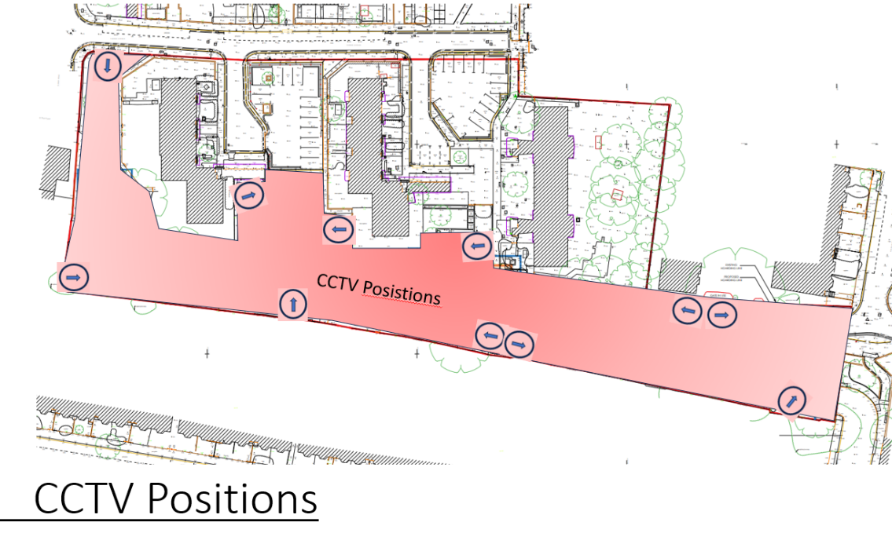
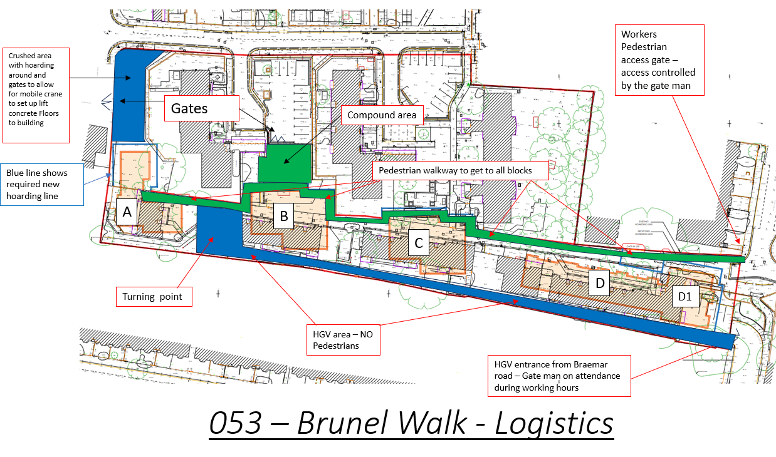

Site Access Arrangements
Segregated vehicle and pedestrian access to site will be via Braemar Road for HGV access and Brunel walk or Turner avenue for Pedestrian access.
Pedestrian and vehicle access route.
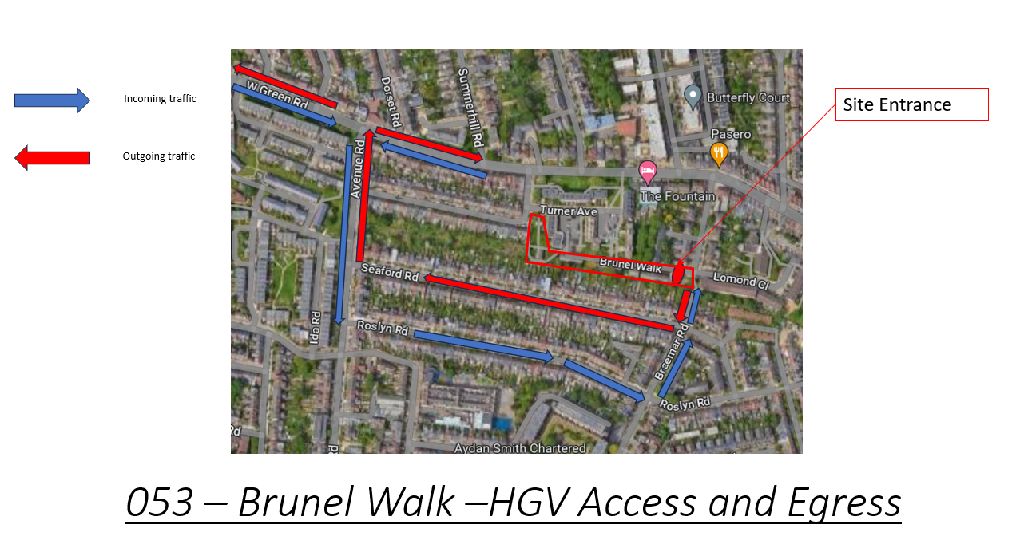

Loading and unloading of plant and Materials
All loading and unloading of plant and materials will be done within the confides of the site boundary. Suppliers will be encourage to use lorries with moffit forklifts to unload materials. In the event that a vehicle with a moffit is unavailable, materials will be unloaded by a forklift contained within the site boundary.

Deliveries
All deliveries will have to have a booked in time slot to avoid any build up or congestion being formed causing disruption to the heavily congested Seven sisters and St Annes Road. All Subcontractors to book in deliveries with the approval of site management. This will be monitored by using a white board system so everyone is aware on site what is coming in and when, please see example below.

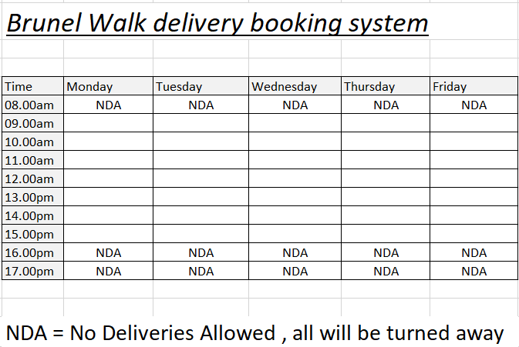

Material storage
All plant and materials will be retained within the confines of the site boundary and moved by mechanical means when required within the boundary of the scheme. Please refer to the site logistic plan to review the storage locations on the scheme.

Mud Management
During wet periods or when dirty works are in progress that produce excessive mud, a jet wash will be position at the site gates to clean the wheels of all vehicles prior to the vehicles entering the public highway.

Dust Management
During the demolition phase on site, dust suspension will be used to reduce the dust imagination this will be carried out using water hoses to dampen down the building. During dry periods whilst the main construction works are in progress in the event that excessive dust is being created a dampening down process will be operated.

- AQDMP - Report has been created, Please see Appendix 3
- UXO - Report has been Completed, Please see Appendix 2

Demolition Phase
All demolition of old structures, down to ground floor slab has been completed on the project prior to Selsdon Building Contractors taking position of the site.
Selsdon Building Contractors will need to remove the ground floor slabs, crush and retain on site to be used as a temporary haul road.
All parking and management of vehicles will be controlled by the demolition contractor and will be carried out within the confines of the site boundary.
All loading and unloading will be controlled within the confines of the site boundary.

NRMM - None Road Mobil Machinery
Please see Planning discharge notes attached on Appendix 1 attached
An inventory and plant registration / log books will be on site at all times.
Selsdon will be using is an 18m telehandler from JCB (540-180 Hi Viz Telehandler),
Demolition will have a 13 Tonne excavator and Dumper
Pilers will have a Piling Rig and trailer Jet wash.

Temp Drainage and surface water run off management
All existing Gully’s to have filter bags installed to stop any contamination entering the drainage system.
Diesel bowser to be double walled sealed tank to catch any spills with a plastic lined sand pit where the operative will stand when filling the plant up.
A 360 ltr spill kit will be provided to stay with the diesel bower to contain and clean up if diesel was to leak onto the floor
Foul water will be collected from a septic tank on site weekly until a foul connection is made to the existing manhole at the site entrance.

Waste Management
All waste will be removed from site via a skip company ( yet to be appointed ) they will segregate the waste at the relevant depot and provide waste tickets to SBC
We have allowed for 1 skip a week for the site.
Plaster board will have its own segregated skip.
Construction Method statement
Enabling works
- Install hoarding and gate to secure the site from access and egress by general public for safety.
- Install TBS meters to we have electric and water on site, fixing all cables and water against the perimeter fence line or brick party wall at a safe height
- Install site accommodation in the form of container style cabins stacked 2 high by use of a hi ab truck on a hard standing area.
Construction

- Reduce dig - To reduce the ground down by machinery to a level designed for the ground beam to be formed after the piles

- Install Pile Matt - Reversing lorries in with crush with use of a banks man and a 360 machine levelling out the crush and
compressing with a roller machine

- Drill and pour piles - A piling rig will drill down and pour concrete into the hole drilled with use of concrete machines
reversing into the site with use of a banksman
- Form Ring Beam - after breaking down piles, digging trenches from pile to pile, forming steel cages that sit in the trench and shuttered around.

- Sub Brickwork and drainage - Build on top of the ring beams with concrete block and install drain pipes from the correct locations
top the outside of the buildings

- Install ground floor - Lifting concrete T beams supported at each end by ring beams and infilled with concrete blocks

- Super structure brickwork, Pre cast floors and roofs - start building the main super structure in a standard cavity wall with face brick
on the outside and block on the inside
- Install internal walls - Formed by metal stud and sheeted with 12.5mm Gyproc plaster board and pattress’s installed
- 1st fix - Consists of installing all wiring and plumbing into the property void areas like ceilings and walls before we close up
- Close up - The property will get its final layer of board on the open side of the walls and ceilings

- Tape and joint - this is to fill all the joints between boards and screw holes, once dry it is then sanded ready for a mist coat of paint

- Tile - Ceramic tile all wet areas - around baths and kitchen splash backs

- 2nd fix - At this stage, the Plumber, electrician and carpenter will install all the face fitting items to the finished walls, ie plugs, switches,
skirtings, architraves radiators etc
- Decorate - To apply paint to all walls and wood work internally to the specification required
- Final - To fit all fixtures and fittings to the flat, ie door handles, taps, shower screens etc
- Commission - Test and commission all electric in the buildings by a qualified tester and get the NICC Cert for handover
- Remove hoarding and replace with temporary - Take down all timber hoardings and remove all site cabins and TBS

- Install hard landscaping - To fit all block paving, edgings to the development

- Install soft landscaping - Fitting all turf and planting trees to the scheme

- Complete and handover

Communication and Management
of the Work
Selsdon Building accepts one of its main duties is to ensure that essential health, safety and environment information is disseminated to employees and Contractors (including self-employed and labour only supply Contractors).

Management
Responsibilities of the various members of the project team, whether site or office based, are described in Selsdon Building’s health and safety policy.
The following arrangements and procedures will be used in the managing of issues on site at several stages throughout the contract;
- Prior to commencement on site, a pre-commencement planning workshop is held to review the information available for inclusion within the construction phase plan. The project management team, applicable to the contract, and an Havio Consultant will attend this meeting.
- It is deemed within the tender enquiry documents that all subcontractors/suppliers must carry out their work in line with legislative requirements, as well as Selsdon Building’s health and safety requirements.
- At the time of tender, subcontractors/suppliers are made aware that project specific documentation is available, in particular the pre-construction information, client brief, the construction phase plan and contract documentation, together with any other relevant health and safety information.
- A pre-start meeting is recommended to be held with each subcontractor, prior to commencement on site, to review and develop the health, safety and environmental information that is required.
- All operatives and visitors who visit site will receive an induction from the operational management team who will explain, complete and give a copy of the site rules to all persons before commencing or visiting site for the first time. All personnel will be expected to complete a personnel safety induction record.
- Regular meetings will be held to review health and safety matters, past and future, and deal with corrective and preventative action.

Management Responsibilities
On this project, the following persons are responsible and have scope of authority for the tasks noted below:
Name | Scope of Authority
Tom Barker | General Site Management
Tom Barker | Skip Tickets, Time Sheets, Delivery Tickets, Work Inspection Sheets, Quality Plan, Company Forms etc
Tom Barker | General Document Control
Tom Barker | Weekly H&S Inspections
Tom Barker | Temporary Works
Tom Barker | Scaffold Inspections
Tom Barker | Hot Works Permits
Tom Barker | Fire Risk Assessment
Tom Barker | Site Inductions
Tom Barker | Contractor Risk Assessment and  Method Statement Evaluations
Tom Barker | Monthly Contractor Meetings
Havio | H&S Inspections

Monitoring and Review of Health and Safety Performance
Selsdon Building will undertake the following monitoring system:
- Daily checks by the Site Manager with regards to general health and safety standards;
- Weekly site health, safety and environment inspections by the Site Manager;
- Monthly health, safety and environment inspections (independent);
- Weekly
- health, safety and environment meetings;
- Contractor supervisors will undertake daily checks of the work areas under their control;
- The statutory weekly inspections will be undertaken and either recorded in the registers located in the Site Managers office, or, if the Contractor is recording their own inspection, in their Contractor management pack.
With regards to the visits undertaken by Havio, a formal written report is submitted to the Directors, Contracts Manager and Site Manager, as appropriate for their information. If the advisor is concerned about any aspect of the work, the Contracts Manager or Directors shall be contacted and concerns expressed, so the necessary actions can be rectified without delay.

Consultation with the Client and Designers
Selsdon Building will liaise with the Client and Designers as required, according to the work in progress and the difficulties experienced. This item will be a standard agenda item at the progress meeting, and so the need for further input or liaison with Client or Designers, will be reviewed either weekly or monthly, depending on the speed of construction and the frequency of the progress meetings.

Consultation with Employees – Health and Safety Meetings
Selsdon Building will ensure the establishment of regular health and safety meetings. The Site Manager will be in daily contact with site operations, by way of continual work on site and so it is thought, there will be ample opportunity for any persons to raise an item of concern with the Site Manager.
If a Contractor or employee has any concerns relating to health and safety, they should bring it to the attention of any member of Selsdon Building’s project team without delay.

Exchange of Health and Safety Information
The Site Manager will be the “on-site” point of contact for all significant information flow between the Client, CDM Advisor, Designers and Contractors.

Exchange of Health and Safety Information between Selsdon Building and Contractors
This plan will be updated as the project progresses. Information from the Client, Principal Designer and Designers should be available in conjunction with this plan.
Details of site specific hazards will be outlined to Contractors at the tender stage, in particular the hazards relating to the particular package being tendered by the Contractor, together with any special precautions or control measures Selsdon Building feels should be applied. Contractors should evaluate this information when planning their work and should clearly state the control measures they will apply in their method statements and risk assessments.
Selsdon Building will co-ordinate the activities of Contractors on site and if any Contractor has a health and safety question or there is a co-ordination problem with other Contractors this should be referred to Selsdon Building as soon as possible. If a Contractor becomes aware of a hazard that has not been foreseen, he should bring this to the attention of the Site Manager and discuss precautions that can be adopted to minimise any risk.

Controlling Design Changes
If a problem arises which questions or may require a change or review of the existing design, Selsdon Building will ensure this is formally raised with the Designers, and in addition, ensure the CDM Advisor is also advised. Any changes in design will be evaluated by Selsdon Building Contractors’ project management team. All relevant parties will be advised of design changes with revised drawings and/or information being issued.

Selection of Contractors
Selsdon Building will ensure only Contractors who can demonstrate the necessary organisational skills, knowledge, training and experience will be selected to work with the company. Contractors are to be signed up to the appropriate CITB CSCS and/or CPCS scheme; only approved Contractors will be used.
For the purposes of CDM 2015, a Contractor is a company or individual who is providing a package of work, including plant and materials to Selsdon Building. For companies supplying labour only, such as bricklayers, painters etc. these people will be classed as employees and will be controlled by the Site Manager.

Control of Contractors
The Site Manager is responsible for ensuring adequate coordination and control of all Contractors; this will be achieved by ensuring all essential health, safety and environment information is given to the Contractors.
Contractors are expected to comply with current legal requirements, good working practices, and the site rules detailed in this plan, which will be brought to the attention of employees, visitors and Contractors working on the site.

General Duties of Contractors
All Contractors and their employees are expected to assist Selsdon Building in implementing this plan by:
- Informing the Site Manager of any significant risks that have not been foreseen so that the appropriate precautions can be put into place;
- Ensuring their employees have received information, instruction and training as is necessary to ensure their health and safety;
- Providing the appropriate personal protective equipment;
- Providing well maintained plant, tools and equipment;
- Ensuring employees follow the site rules and any relevant method statements.;
- Check own competence of operatives.;
- Cooperate with other and co-ordinate work to ensure the health and safety of construction workers and others who may be affected by the work;
- Report obvious risks to the Site Manager. Selsdon Building will also have a visiting Safety Consultant (Havio) - site personnel will also be able to voice their feelings with regards to health and safety to the Safety Advisor.

Production and Approval of Risk Assessments
and Method Statements
Contractors must undertake risk assessments for work under their control. If, as a result of this assessment, the task or work is considered to be high risk, (i.e. it has potential to cause death, major injury, or seriously damage someone’s health), then a specific method statement must be produced for this work.
All method statements must be approved by Selsdon Building before the work commences. Method statements should be site specific and submitted a minimum of 5 working days in advance of the planned commencement of the work. This allows sufficient time for the Site Manager to assess the method statement and consider what impact this will have on other Contractors and site activities and plan accordingly.
Contractor supervision will be responsible for briefing their own operatives on the relevant risk assessment and/or method statement along with any other associated documents.

Permit to Work
Permits to work will be issued in accordance with the permit to work procedure for the following work practices:
- Permit to demolish;
- Permit to load/strike (temporary work);
- Hot works;
- Permit to work in electrical intake rooms;
- Electrical permit to work;
- Confined space;
- Stepladder permits.
The Site Manager will be in overall control of the permit system. Permits are issued for one day or one shift, whichever is the shorter. All permits are to be returned on expiry or completion of works, and relevant sections completed by the Site Manager.

Information, Instruction and Training

Information and Instruction
The following information shall be prominently displayed on the site notice board:
- A copy of the F10 notification, once received from the Client;
- Health and Safety Law Poster;
- A copy of the signed company health and safety policy statement;
- A copy of Selsdon Building insurance verification;
- Emergency contact details;
- Route to hospital;
- Emergency procedures, including fire action notice and identity of persons in charge will be displayed.

Induction Training
All personnel who work on site must receive an induction from the Selsdon Building management team before they commence work. All Contractors will be expected to meet the requirements of the CSCS Recognised Card Scheme and be in possession of the relevant card.
Contractors are responsible for maintaining their operative training records on site. A comprehensive training matrix is to be maintained and available upon request.
Visitors to site will be given a shorter induction, which will cover any health and safety issues they need to be aware of. All visitors to site must be accompanied by their respective sponsor.
Relevant parts of the construction phase plan and Selsdon Building risk assessment and method statements will be made known. A record will be kept of all training carried out.
Contractors are expected to carry out their own induction talks covering their own risk assessment and method statements.

Site Rules
The site rules are detailed in Appendix 1. A copy of the rules will be given and explained to site personnel, before they commence work, or to visitors on arrival on site.

Non-English-Speaking Contractors
Selsdon Building endeavours to be an equal opportunities employer and accepts that more and more non-English speaking Contractors are entering the construction industry. There is an increasing problem with communication on site, with people not being able to understand spoken or written English language or have low literacy levels. The following communication strategies will be adopted on site, as required:
- Ensure adequate time for consulting with employees/ Contractors where language and/or literacy may be an issue, so they can absorb the information and respond as required;
- Where difficulty lies, employees/Contractors should be encouraged to express their views in their preferred language by using interpreters;
- Ask a work colleague to interpret and identify them as the ‘team leader’, so that should any emergency evacuation take place, to ensure the individual escapes in good time and not be left behind. It may be necessary for these employees to receive some training if they are asked to undertake this role;
- Consider getting information translated, where possible, and check that this has been done clearly and accurately by testing it with native speakers;
- The use of pictorial information and internationally understood pictorial signs, where appropriate;
- Where information has to be in English, use clear and simple materials, and allow more time;
- If committees and representatives are in place, they should reflect the workforce they represent;
- Be aware of cultural differences and take these into account when consulting employees – there may be some employees who do not feel able to speak up about health and safety matters.

Toolbox Talks
Toolbox talks are to be conducted and recorded on a weekly basis. All operatives are expected to attend a weekly toolbox talk. Contractors who hold their own toolbox talks shall ensure records are submitted to the Site Manager.

Welfare Arrangements

Welfare Facilities
Adequate and suitable toilets, washing facilities, rest rooms and changing rooms will be provided at the earliest possible time. Refer to the table below for the facilities to be provided on this project and the location of these. Contractors are expected to use these facilities in a sensible way.

Site Provisions
Facility | Location
Toilets
  Toilets shall be provided within green zone identified below. These shall be well ventilated, lit, kept in a clean and orderly condition and contain a supply of clean hot and cold, or warm water, soap and towels.
Canteen | A canteen will be provided in the green zone identified below. The canteen will have an adequate supply of drinking water and suitable cups, a kettle and a refrigerator and microwave for the preparation of meals. The canteen will also have a suitable rest area with tables and seating with back support sufficient for the amount of people on site.
Changing room | Changing rooms shall be provided in the green zone identified below. The changing rooms shall contain seating and allow operatives to securely store clothing and personal effects.
Drying room | Drying room will be located within the changing rooms.
Site office | Site office and meetings rooms shall be established on site.
Smoking area | A smoking area will be established on site and will contain a metal sand bucket and fire extinguisher.
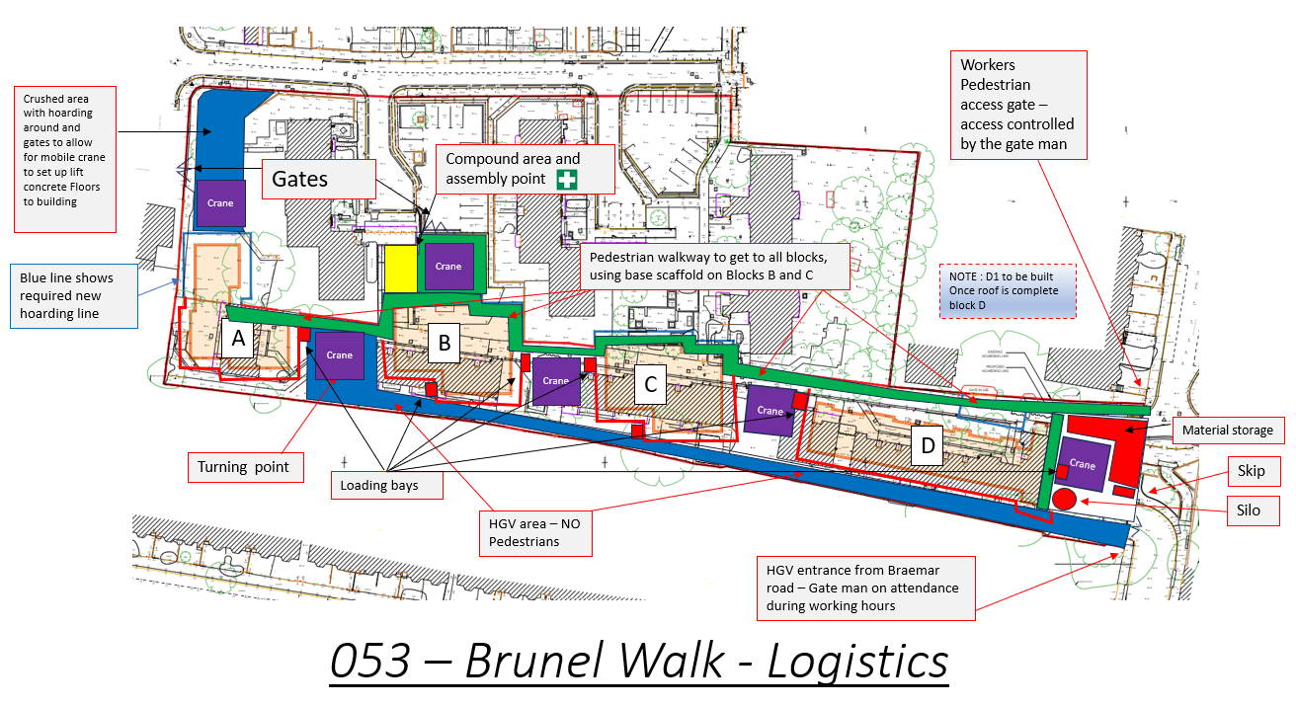

Emergency Arrangements

Details of Emergency Services
In the event of a major injury, fire or other dangerous occurrence, the Emergency Services shall be contacted by telephone (999 or other number dependant on location). The incident will be immediately reported to the site office, where the Site Manager shall assess further actions required. Details of local site-specific emergency contacts can be found below:

Emergency Services:
Local Addresses and contact numbers are for information; always dial 999 in an emergency.

Hospital (Accident and Emergency)
Address: Sterling Way, London, N18 1QX
Tel: 020 8887 2000
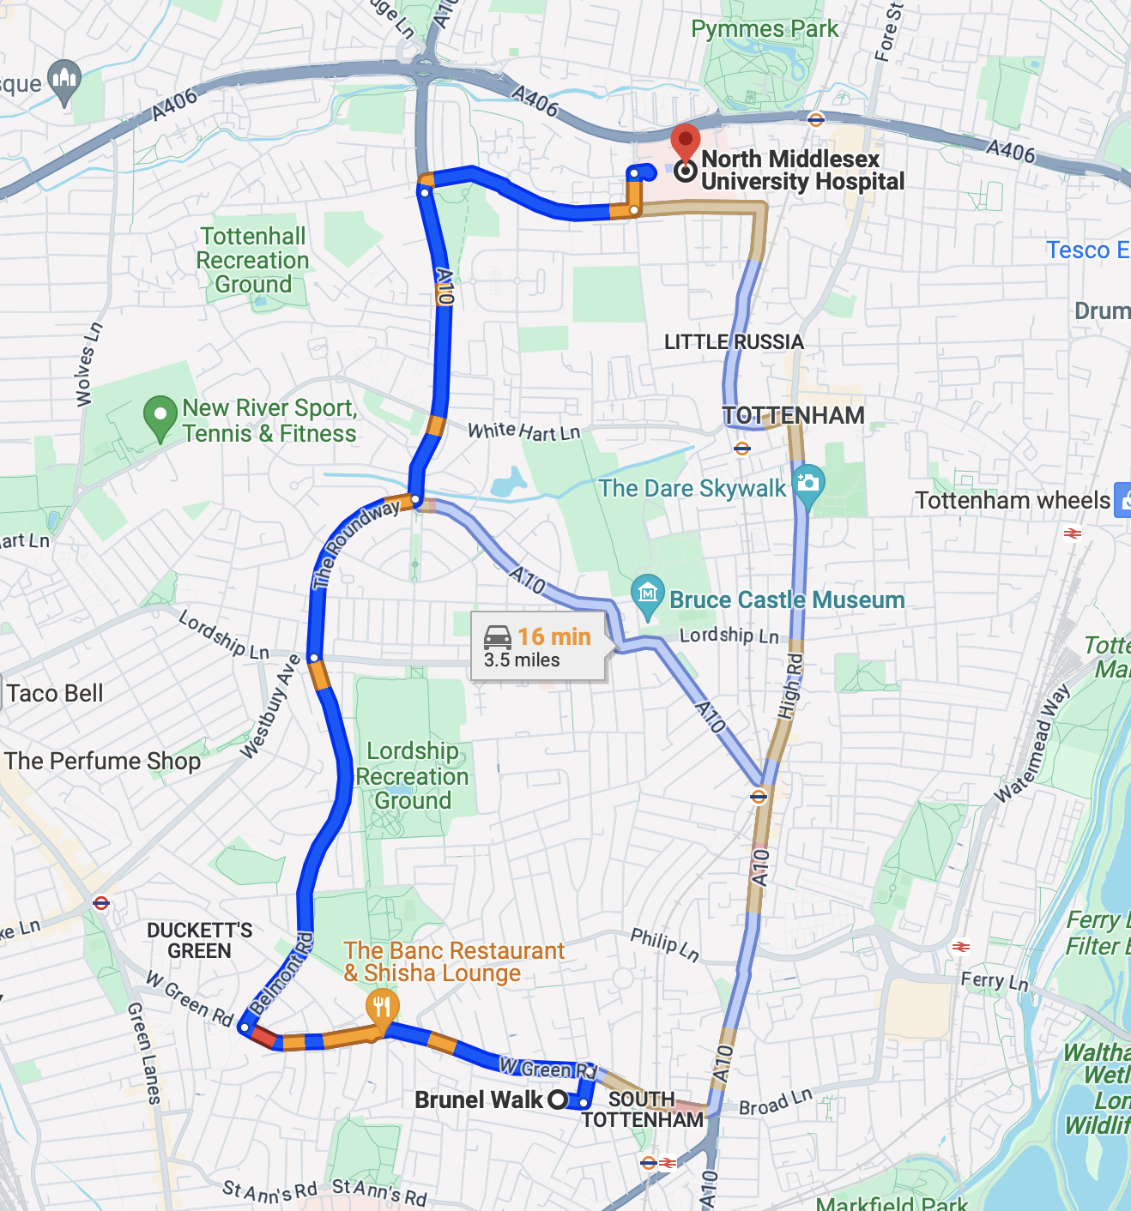

Nearest Fire Station (Full-Time):
Address: Tottenham Fire Station. 49 St. Loys Rd, London N17 6UE

First Aid
Each site will have a suitably trained First Aider who will be in possession of a current first aid certificate to manage first aid. In the absence of a company First Aider, a qualified person employed by a subcontractor will be appointed to provide cover.
First aid facilities will be kept on site for minor injuries, as well as for the purpose of preserving life and minimising the consequences of injury and illness, until help from a medical practitioner or nurse can be obtained. The minimum provision will be a suitably stocked first aid container. The Site Manager will be responsible for restocking the first aid box.
Notices to show the location of equipment, facilities and personnel will be displayed in a prominent position on site.
All injuries, however minor, will be entered in the site accident book.

Accident, Incident and Near Miss Reporting
All accidents and incidents, including that to the environment, near misses or damage to property belonging to Selsdon Building or others, shall be reported to the Site Manager. The Site Manager shall notify all relevant persons, as soon as is practicable, following the event. The Site Manager shall introduce, where appropriate, immediate corrective actions to avoid recurrence of the incident.
All incidents shall be entered into the accident book with details of medical or first aid treatment sought, where required.
In instances where a major incident has occurred, the services of Selsdon Building’s external safety consultants should be sought to assist in the accident investigation. Incident investigations shall be completed within a reasonable time frame.
All RIDDOR categorised reportable accidents, incidents and dangerous occurrences are to be reported within the required timeframes, as stipulated by the HSE.

General Fire Precautions
In accordance with the Regulatory Reform (Fire Safety) Order 2005 a fire risk assessment will be carried out to identify adequate control measures to minimise the risk of fire on the project. This will be reviewed at regular intervals, not exceeding one working month.

Site Fire Plan
In the event of a fire, the Emergency Services shall be contacted by telephone (999 or other number dependant on location). The incident will be immediately reported to the site office, where the Site Manager shall assess further actions required. Details of local site-specific emergency contacts can be found below:
 | Detail
Fire Safety Coordinator | Site Manager
Access arrangements | Access for emergency services will be by the site entrance on Brunel Walk.
Fire Points /  Fire Fighting Equipment | Local fire points will be established at access/egress points and within the building when construction commences. These will include a means to raise the alarm, water and CO2 fire extinguishers and fire action notice.
Fire Alarm | Suitable means of raising alarms will be located at fire points. Alarm type will be battery operated push call points.
Emergency Evacuation Routes | Emergency access routes will be via the site entrance on Brunel Walk.
Temporary Accommodation | Site welfare facilities will be located on site.
Assembly Point | The assembly point will be the small car park on Braemar Road pictured below.

Proposed assembly point location

Arrangements for Controlling
High Risk Activities

High Risk Safety Hazards Specific to this Project
Hazard | Harm that could be caused | Control measures
 | Not knowing the dangers of confined spaces has led to the deaths of many workers. Persons at risk, including those working in confined spaces but also those who try to rescue them, but who are not properly equipped to carry out the task safely.  Air in the confined space is made unbreathable either by harmful gases and fumes or by lack of oxygen. There is not enough natural ventilation to keep the air fit to breathe. In some cases, the gases may be flammable, so there may also be a fire or explosion risk.  Working space may be restricted, bringing workers into close contact with other hazards such as moving machinery, electricity or steam vents and pipes. The entrance to confined spaces, e.g. a manhole, may make escape or rescue in an emergency, more difficult. | Any working in a confined space on the project will be done so under a strict confined space permit to work – this will be issued by Selsdon Building.  The permit to work and task specific risk assessment and method statement will detail the specific control measures required to control the risks to an acceptable level.
 | There is a risk of drowning where people work beside or above water, or have to pass near or across it, on their way to or from their workplace.  The most immediate danger following a fall into water is drowning. Causes or contributory factors include shock of sudden immersion in cold water, weight of waterlogged clothing, incapacity following injury caused by striking an object during the fall or while in the water, fatigue or hypothermia where rescue is not immediate. | Any working beside or above water on the project will be done so under a strict permit to work – this will be issued by Selsdon Building.  The permit to work and task specific risk assessment and method statement will detail the specific control measures required to control the risks to an acceptable level.
 | During demolition and dismantling, workers are injured in falls from edges and through openings and fragile surfaces.  Workers and passers-by can be injured by the premature and uncontrolled collapse of structures or parts of structures and by flying debris. | Selsdon Building will work with an approved demolition Contractor to ensure that all demolition and dismantling works are completed safely and with minimal impact upon our neighbours and the surrounding community.  Only trained and competent operatives will carry out demolition work. Structures will be safely supported as the demolition continues.  Selsdon Building will ensure that noise, dust and vibration levels resulting from demolition and dismantling works will be reduced, so far as reasonably practicable.
 | Electricity can kill or severely injure people and cause damage to property.  The main hazards of working with electricity are electric shock and burns from contact with live parts, injury from exposure to arcing, fire from faulty electrical equipment or installations, explosion caused by unsuitable electrical apparatus or static electricity igniting flammable vapours or dusts. | All services location reports will be communicated to the relevant Contractors at pre-start and before works are due to take place on site.  Temporary electric supply will be completed by a competent electrical Contractor in line with BS7671 and re-certificated every 3 months.  Electric cabling will be protected against damage from construction activity in the vicinity.  Electrical distribution boards will be held in a protected box/hoarding which is locked when not in use. Signage stating, “Danger high voltage electricity”, or similar, shall be erected.  All portable appliances on site must be PA tested by a competent person every 3 months and records maintained.  Temporary lighting on site must be stored away from combustible materials and, where possible, be strip lights to avoid issues with festoon lights breaking constantly.  110V or lower only to be used on the operational areas of the site.
 | Falling materials and collapses can affect workers and the general public.  Hazards can include people being struck by material falling from loads being lifted and material that rolls or is kicked off work platforms. Persons may also be struck or buried by falling materials when excavations, buildings or structures collapse. | Loads will be adequately secured during storage or movement.  Good housekeeping will be maintained when working at height with tools and materials kept away from the edge of platforms or roofs. Brick guards and/or netting will be installed on scaffolding.  All scaffolding and work at height access equipment will have secure physical barriers at the edge of the elevated area.
 | Many solids, liquids and gases can catch fire and burn. It only takes a source of ignition, which may be a small flame or an electrical spark, together with air. Any outbreak of fire threatens the health and safety of those on site. | Selsdon Building will develop a fire risk assessment which will be reviewed regularly on the project.  Adequate resources are to be made available as determined by emergency planning.
 | Almost all construction work involves some form of excavation (for foundations, drains, sewers etc.). Working in excavations is an extremely dangerous operation.  Hazards include collapse of the sides of the excavation, materials falling onto the people working in the excavation, people and vehicles falling into the excavation, the undermining of nearby structures causing their collapse into the excavation, damage to underground services during excavation work causing electrocution, explosion, gas escape or flooding or ingress of water causing flooding. | All service drawings will be checked prior to any breaking ground. Hand dig practices will be followed in the vicinity of live services.  All excavations, where necessary, will be battered or stepped to prevent collapse. Where not possible, shoring will be installed to a design prepared by a competent person. All shoring will be checked prior to shift and after any factors, which may affect its integrity.  Safe means of access will be put in place (scaffold steps, footed and tied ladder etc) for access and egress from excavations.  All plant to be operated by trained and competent personnel. Where working close to services, buildings, boundaries and/or persons, a banksman will be utilised.
 | Construction workers can suffer fatal consequences or be seriously harmed during the movement of goods and lifting operations.  Hazards associated with moving goods include, crushing due to impact of moving objects or loads falling from vehicles, or plant because they are not slinged properly, or the wrong type of slings were used, moving vehicles or collapsing structures, cranes overturning, material falling from hoists and slinging failures. | Any mechanical lifting on site is to be completed under a specific lifting plan.  All operatives involved in lifting must be suitably trained and competent.  All lifting equipment/accessories in use by Selsdon Building or Contractors will be subject to pre-use inspections by operators and formal weekly inspections by the Site Manager or Contractor supervision, as necessary. These are to be recorded.  All lifting equipment must have full thorough examination certificates at the necessary intervals (6-12 months).  No lifting will be carried out over persons.  Lifting plant will be segregated, as far as is possible, with physical barriers
 | Workers are at risk of being fatally or seriously injured on construction sites by moving vehicles or by vehicles overturning. Construction plant can be heavy. It often operates on ground which is muddy and uneven, and where driver visibility is poor.  Effective traffic management systems are essential to avoid workers being put at risk of being hit by slewing or reversing plant or injured by overturning vehicles and plant. | Traffic management plan is to be developed and followed at all times.  Vehicles will be banked on and off site.  Site speed limits to be adhered to.  Site roads and adjacent roads to the site will be maintained in good order.
 | Something as simple as a slip or trip is the single largest cause of injuries on construction sites, leading to more than 100 major injuries being reported each year.  Main causes of this type of accident are having to walk over uneven ground, tripping over building materials or waste, tripping over trailing cables, slipping caused by wet surfaces or poor ground conditions or trips caused by small changes in level. | Access and egress routes and general ground conditions will be maintained in good order. Areas which are not safe must be barriered to prevent access.  Selsdon Building will ensue that pedestrian walkways and traffic routes are free from slip, trip and falls hazards, this will require constant vigilance.  Operatives will be encouraged to clear up any debris that they find on site.
 | Falls are the largest cause of accidental death in the construction industry. They account for 50% of all fatalities. There is no distinction between low and high falls.  The main risks associated with work at height are the worker falling from height or objects falling from height onto someone below. People may fall because access to and from the workplace is not adequate, or the workplace itself is not safe. | All work at height completed by Contractors is to be separately risk assessed and subject to a specific method statement.  Selsdon Building will work with Contractors to ensure the hierarchy of control is adopted for all work at height activities:  - Where possible avoid work at height;  - Where it cannot be avoided, prevent falls using an existing place of work that is already safe or use the right type of equipment;  - Minimise the distance and consequence of a fall, by using the right type of equipment where the risk cannot be eliminated.
 | Members of the public are fatally and seriously injured each year from construction works.  Accidents often happen when people are walking near a building being built, refurbished or demolished, or walking near work in the street. | Selsdon Building will ensure that all access points to the site are fully secured at all times to prevent unauthorised access – this will be a mixture of utilising the existing walls to the site and where necessary installing close boarded hoarding or fencing.  Selsdon Building will engage with the community regularly to make them aware of the project and to allow any concerns to be raised.

High Risk Health Hazards Specific to this project
Hazard | Harm that could be caused | Control measures
 | Asbestos-related diseases kill more people than any other single work-related cause. All types of asbestos can be dangerous if disturbed. The danger arises when asbestos fibres become airborne. They form a very fine dust which is often invisible.  Breathing asbestos dust can cause serious damage to the lungs and respiratory diseases such as asbestosis and cancer. | Selsdon Building will not start any works until a full Refurbishment and Demolition Survey has been completed – this will identify areas where asbestos is present and allow for a removal strategy to be developed.  All demolition operatives on site are to have received asbestos awareness training.  For any areas of known ACM’s (where relevant), these are all to be clearly labelled and all site users informed at induction to not disrupt these areas at any time.
 | People may be exposed to hazardous substances, either because they handle or use them directly (e.g. exposure to cements and solvents can cause skin problems such as dermatitis), or because the work itself results in the creation of a hazardous substances (e.g. scabbing concrete generates silica dust).  Harm could be caused by breathing in fumes, vapours and dust, direct contact with the skin and swallowing or eating contaminated material. | Selsdon Building will work with Contractors to control work in line with the hierarchy of control to eliminate or reduce exposure to substances hazardous to health.  All Contractors will be expected to provide COSHH assessments for any substances that are hazardous to health.  Any dangerous substances on site are to be subject to a DSEAR Risk Assessment.  Selsdon Building will work with Contractors to ensure all storage of substances is adequately controlled.  PPE is to be used as a last resort for protection (not the first line of defence).  If face masks are required to control exposure to harmful dusts/fumes these must be face fit tested to the operative.
 | Manual handling relates to the moving of items either by lifting, lowering, carrying, pushing or pulling and cause musculoskeletal disorders, e.g. by lifting heavy and awkward loads causing back and other injuries.  Some injuries can result from a single lift, but more commonly long-term injury develops as a result of repeated minor injury due to repetitive lifting. | Site operatives to have received formal manual handling training.  Operatives on site to be instructed not to complete any lifting which is beyond their physical capabilities.  Where possible Contractors are to utilise mechanical lifting to reduce the need to carry out any heavy lifting.  Loads are to be landed as close to the point of use as possible.
 | When individuals are exposed to high levels of noise in the workplace, they can suffer from various adverse health effects. These health effects can be caused by a single exposure to a very loud noise or by exposure to raised levels of noise over a prolonged period of time.  Exposure to noise can result in hearing impairment, noise induced hearing loss, tinnitus and/or mental stress. | Selsdon Building will work with Contractors to attempt to reduce noise levels to as low as reasonably practicable. This could include procuring tools which create less noise, altering processes, installing acoustic screens etc.  Stocks of hearing protection are on site for use by visitors.  All Contractors are required to risk assess their activities and reduce noise exposure to operatives to as low as reasonably practicable. Hearing protection is to be used as a last resort.  Any areas where noise exposure is above the maximum exposure limit of 87dBA will be segregated into a noise exclusion zone, this will require noise monitoring to adequately detail.  Where noise levels are expected to be excessive, we will communicate this to neighbouring properties, building users, or anyone else relevant. Noisy times will be advised.
 | Repeated exposure to high levels of vibration is known to cause injury to workers in the form of hand-arm vibration. This can come from use of hand-held power tools (such as grinders or road breakers), hand-guided equipment (such as pedestrian controlled floor saws) or by holding materials being worked by hand-fed machines (such as pedestal grinders or forge hammers).  Regular and frequent exposure to hand-arm vibration can lead to two forms of permanent ill health – hand-arm vibration syndrome (HAVS) and carpal tunnel syndrome. | Selsdon Building will work with Contractors to ensure that that hand arm vibration levels are limited to the daily action value of 2.5 M/S and never above the daily exposure limit value of 5.0 M/S.  Contractors are required to risk assess their activities which includes where hand arm vibration is a hazard.  Where necessary Selsdon Building will complete vibration monitoring to ensure levels are maintained to reasonable levels.

High Risk Environmental Hazards Specific to this project
Hazard | Harm that could be caused | Control measures
 | Air pollution can result in harm to the natural environment and have adverse effects on human health.  Air quality impacts from construction include increased dust particulates in the atmosphere caused by grading, filling, removals, and other construction activities.  Air borne bacteria and mould spores can also be released by heating, ventilation, air conditioning (HVAC) construction or maintenance errors, e.g. legionella pneumophila can spread through airborne water droplets which can cause the potentially lethal Legionnaire’s disease). | Selsdon Building will ensure that levels of air pollution are minimised so far as is reasonably practicable. This will mean that during demolition or groundworks activities the working areas will be dampened down to suppress dust levels.  During construction activities Selsdon Building will work with Contractors to ensure that dust creating processes and tools are fitted with extraction devices to reduce dust levels which are released into the air.
 | Chemical spills can have adverse impacts on people, wildlife and the environment. Impacts from construction include fumes, emissions and spills from chemicals applied during construction (e.g. finishers, sealants, adhesives, solvents etc.) or accidental release of oils or fuels (e.g. release from mobile fuel tanks or fluid discharge from large equipment). | All fuel, oil and chemicals will be stored in containers specifically manufactured for the purpose, and/or bunded/double skinned to prevent contamination in the event of spillage, damage.  The contents of storage containers shall be clearly marked, to prevent accidental cross contamination.  A licensed waste disposal Contractor or the original supplier shall remove leaking or empty containers from site.  All valves and nozzles shall be protected from vandalism and unauthorised use by means of a padlock. Where this is not possible, tanks/bowsers shall be stored in secure compound areas.  All refuelling is to be undertaken in a safe, appropriately designated area.
 | Contamination can result in harm to the natural environment. This may be caused by the disturbance of identified or unidentified pre-existing contamination during site preparation or excavation works (e.g. residual lead or petroleum contamination from fuels or the inadvertent transport and subsequent disposal of unknown contaminated soils. | Ground contamination survey has been completed and is available in the preconstruction information.  Selsdon Building will ensure that all plant and vehicles which work on the site and then enter the public highway are subject to a fully comprehensive wheel and body wash to prevent the public highway becoming muddy / dirty.
 | Large projects usually entail extensive land disturbance involving the removal of vegetation and reshaping of topography.  Such activities make the soil vulnerable to erosion. This has further impact such as pollution of waterways, deterioration of water quality, landslides and slope failure. | Arboriculture report and ecological appraisal has been completed - all control measures to be considered and implemented, where necessary.
 | Impacts resulting from construction dust, noise and vibration are generally limited to areas adjacent to the project.  This can result in adverse nuisance to neighbouring persons and communities. | Impacts from dust, noise and vibration will be reduced, as far as reasonably practicable, in line with the identified controls in the applicable sections.
 | Improper disposal of waste materials or excessive generation of waste streams into landfill (e.g. not reducing or reusing materials, where possible) can cause environmental harm. 32% of landfill waste comes from the construction and demolition of buildings.  Typical construction waste products include insulation and asbestos materials, concrete, bricks, tile and ceramics, wood, glass and plastic, metallic waste, soil, gypsum, cement, paints and varnishes and adhesives and sealants. | Where possible earthworks arising on the project will be reused on the site – where this is not possible the waste will be removed by a licensed Contractor who will provide a report to Selsdon Building on how the waste has been dealt with at their processing plant.  Waste shall be stored appropriately on site depending on type and classification.  Waste storage shall be kept to a minimum and in suitable containers or locations for disposal. Whenever possible segregation shall be implemented to allow for recycling.  Where hazardous waste is identified, it shall only be segregated, stored and removed following approved methods from the Environment Agency.
 | Changes in water quality may affect its aesthetic value or even prevent some uses of the water. During construction, the potential for soil erosion and risk to water quality is greatest when removal of vegetation for initial clearing and grading activities exposes soil and makes it susceptible to erosion.  The impacts and risks are greatest during the rainy season where extensive land clearing can increase sediment load into the rivers from erosion of the exposed soil. | Water pollution considered in ecological appraisal - all control measures to be considered and implemented where necessary.

Health and Safety File
Developing the health and safety file will be a continuous process throughout the project. Upon completion of a project, where more than one Contractor is involved, it is required under CDM 2015 that a health and safety file is prepared by the Principal Designer.
The Principal Designer will be updated by the Site Manager of any information that may be necessary for the compilation of the health and safety file, including as built drawings, operating and maintenance manuals and plans compiled during the construction process. Regular liaison with the Principal Designer will ensure that any relevant information is passed on.
The format for the health and safety file will be agreed with the Client and Principal Designer prior to the construction phase of the project.

Information will include:
- A brief description of the work carried out;
- Residual hazards and how they have been dealt with (for example surveys or other information concerning asbestos, contaminated land, water bearing strata, buried services);
- Key structural principles incorporated in the design of the structure (e.g. Bracing, sources of substantial stored energy – including pre- or post-tensioned members) and safe working loads for floors and roofs, particularly where these may preclude placing scaffolding or heavy machinery there;
- Any hazards associated with the materials used (for example hazardous substances, lead paint, special coatings which should not be burnt off);
- Information regarding the removal or dismantling of installed plant and equipment (for example lifting arrangements);
- Health and safety information about equipment provided for cleaning or maintaining the structure;
- The nature, location and markings of significant services, including fire-fighting services;
- Information and as-built drawings of the structure, its plant and equipment (e.g. the means of safe access to and from service voids, fire doors and compartmentation.
- Site Rules
All persons must abide by the site rules as follows. Failure to do so may result in disciplinary action.

 | Attend a site induction  All personnel on site must attend an induction and receive and understand a copy of the site rules.
 | Sign in and out  All personnel must report to the site office and sign in/out before entering/leaving.
 | Wear mandatory PPE  All personnel on site must wear the minimum mandatory PPE – steel caps, high visibility vest and hardhat.
 | Do not use abusive language  The use of abusive language or making excessive noise is prohibited on site.
 | Be trained and competent for the task  Personnel must be suitably trained, competent for the task  they are undertaking and hold relevant certification.
 | Do not interfere with scaffolding or equipment  Unauthorised interference by personnel  is strictly forbidden.
 | Do not use defective equipment  Any defects to vehicles, plant, machinery or equipment must not be used and communicated to the Site Manager.
 | Use a banksman when reversing  All reversing vehicles and plant must be  supervised by a banksman.
 | Ensure permit is in place for required activities  All personnel must ensure a permit is obtained prior to  undertaking permit required activities i.e. hot works.
 | Store fuels and chemicals appropriately  Fuels and chemicals are to be bunded holding 110% of  their volume and drip trays provided for generators.
 | Refuel within a designated area  Refuelling must only be carried out within  designated areas. A designated area shall be established for this site and only used for this purpose. The location of which will be advised to all site users at induction.
 | Operate tools at 110-volt or lower  Portable electric tools and equipment shall only operate at 110-volt power or lower.
 | Dispose of rubbish in identified skips  Dispose and segregate waste into appropriate bins/skips. Discarded waste will not be tolerated.
 | Clear up after yourself  You are responsible for leaving the site and welfare facilities clean and tidy at all times
 | No smoking or vaping is permitted on site  Smoking, vaping and use of any e-cigarettes is only allowed in authorised areas as indicated by signage.
 | Understand emergency evacuation procedures  Ensure you understand the emergency procedures in place including location of exits and fire assembly point.
 | Keep fire exits clear at all times  Fire exits and access/egress routes must be kept clear of vehicles and materials at all times.
 | Know the first aid arrangements  Your First Aider is Tom Barker.  The first aid box is located at the site office.
 | Report accidents or near misses to the site office  All accidents and incidents must be reported to the Site Manager. All injuries will be recorded in the accident book.
 | Work in a safe manner  All personnel must work in safe manner and not endanger  themselves or other persons by their actions.
 | Observe site working hours  Monday to Friday 08:00 to 18:00  Saturday 08:00 to 13:00 (as required)  Sunday No working

Appendix 1
NRMM - Details of plant and machinery to be used during demolition/construction works;
Appendix 2
Details of an Unexploded Ordnance Survey; -
Appendix 3
AQDMP report
Appendix 4
Build Programme
Appendix 5
Community engagements
Appendix 6
Construction Logistics Plan
Appendix 7
Waste management Report
Appendix 8
Site Drainage drawings

www.havio.com

