Construction and Logistics Plan
Brunel Walk



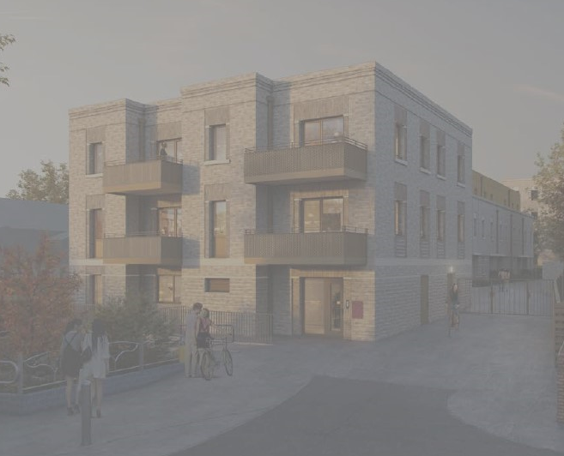


Adding Value to our communities

Introduction
Applicant :
Selsdon Building Contractors,
Unit 10, Twin Bridges Business Park,
232 Selsdon Road,
CR2 6PL

Key issues of the development are precise delivery planning due to the constraints of the site and continues perimeter inspections to ensure that were possible the traffic flow is not restricted. To prevent the risk of debris entering the public highway during the construction phase of the scheme, the external perimeter will be encase in debris netting.
Programme for the site found in appendix 1

Overview of Development
The proposed development site is located at Brunel Wal, N15, within the London Borough of Haringey.

Currently on the site, all original building have been demolished and all services disconnected.

The proposal is for the redevelopment of an existing estate in N15 is to construct 4 new blocks of apartments in traditional build with Pre cast floors.
The apartments will be now higher than 4 floors except for Blocks D1 and D2 which will be 3
Floors.

This will be Phase 1 of a 3 Phase project. Each Phase will require its own Construction Logistics Plan.

Phase 1 Construction duration is 74 weeks – programme attached in Appendix 1

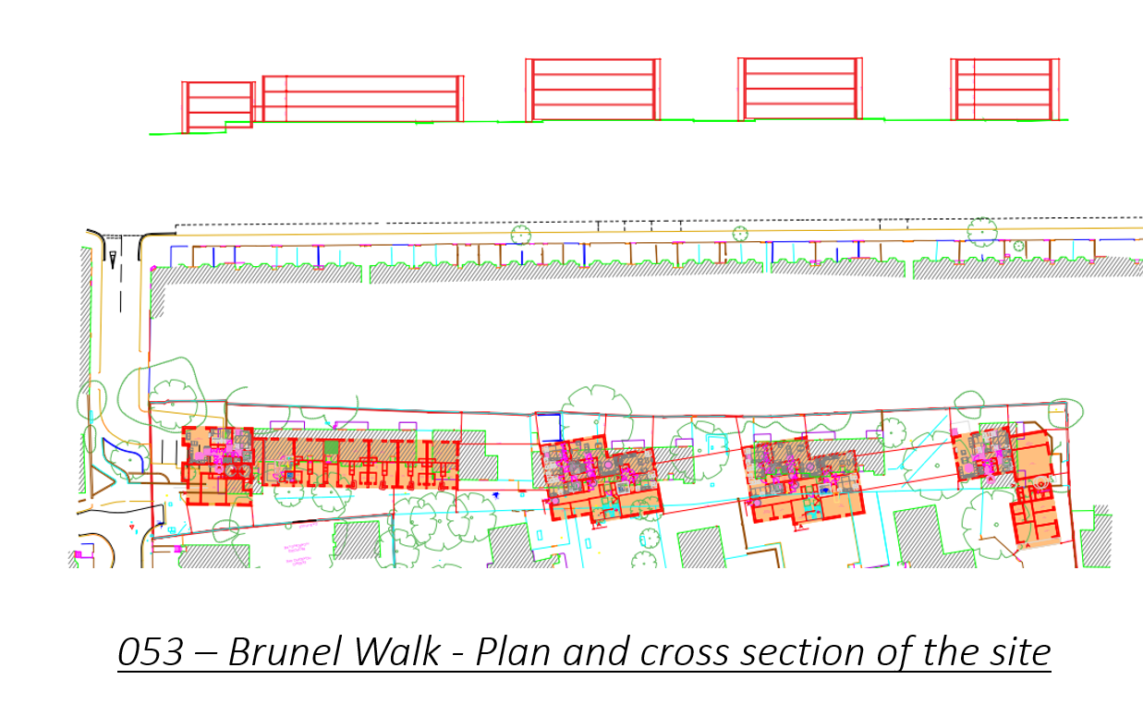

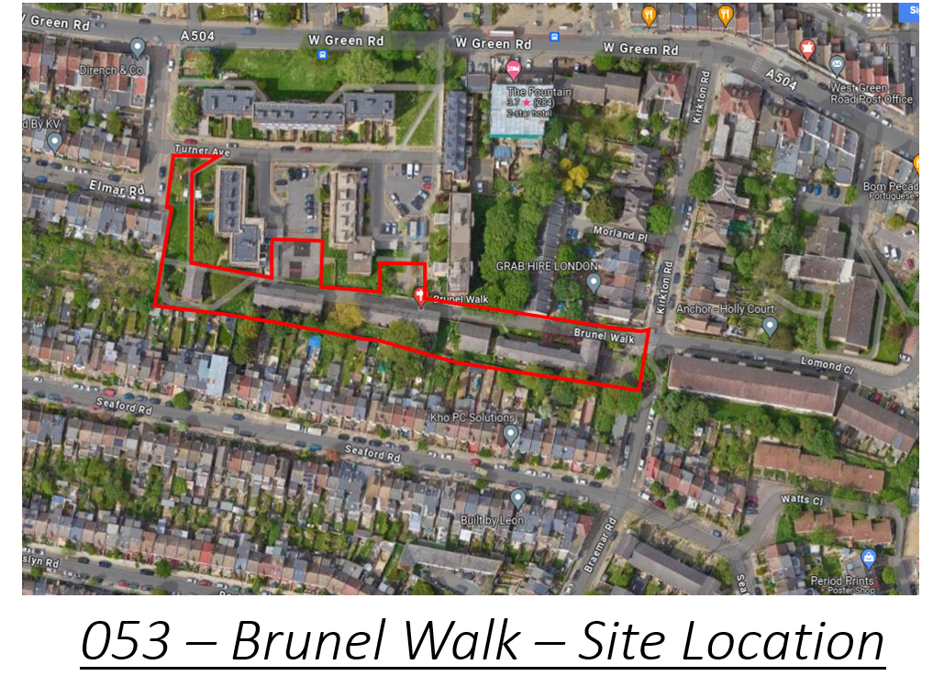

Kerswell Close and St. Ann’s Road and provision of 25
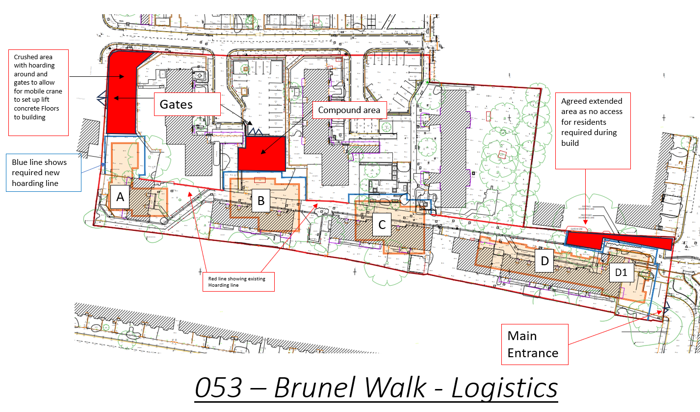

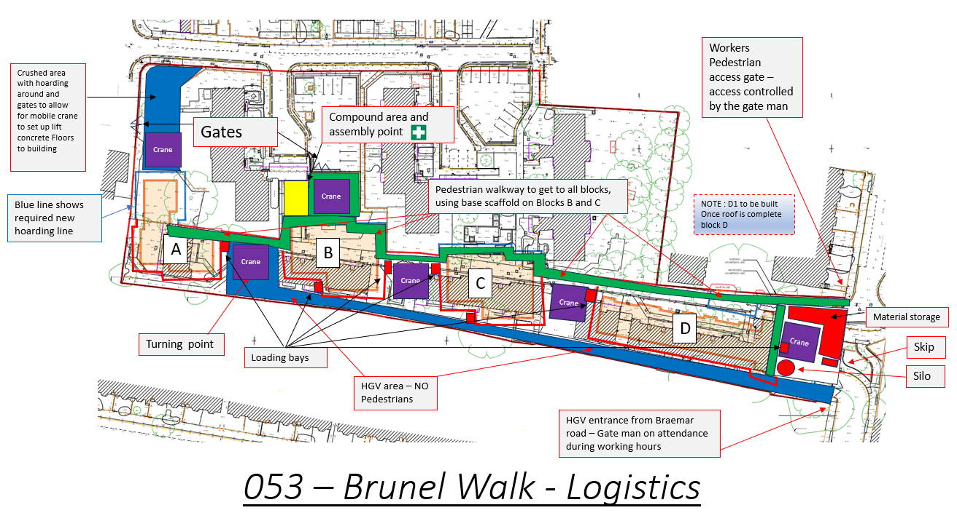
Possible trip Generation

Over the duration of the scheme, there will be an average of 1 skip exchange a week and approx. 2 material deliveries per day. This will decrease during the lift cycle of the scheme.
Routing and Delivery Scheduling
An application has been submitted to Haringey Council for the temporary closure of parking bays on Braemar road ( between Seaford road and Brunel walk) to allow for our vehicles to be able to access site.
All deliveries will arrive to the scheme via Avenue Road onto Roslyn Road Onto Braemar road as per the Access and Egress plan as started on this CLP.
This will be managed through a booking system to minimise traffic and congestion caused during the construction of the scheme. Ridged lorries at 8m would be the preferred method of delivery due to the local area and congestion, this will be requested in all orders and subcontract orders due to limited access to the site.
All deliveries will arrive to site via a booking system that will be in place from the outset of the scheme. The suppliers will be notified that all delivery drivers will need to contact the site management team to be given a time slot for their arrival to the scheme. This will be managed on a daily/weekly basis by the site management team. They will be banked into the site if necessary, by a qualified banksman.
Failure for any HGV to notify the site team 10 minutes before arrival, the delivery company will be asked to carry onto the next delivery and not wait on or near by site. They will have to be booked in accordingly. SBC will not keep any HGV waiting on the public highway.
All HGV’s leaving the site will have to turn right onto Braemar road then right onto Seaford road then right onto Avenue Road, at which point they can turn left or right onto the A504 , as per the Access and Egress drawing attached, not disturbing the flow of traffic.
There is no holding points for delivery vehicles due to the nature of the area, therefore all deliveries drivers will be instructed to contact the site management team ten minutes before arriving to the scheme to ensure that space has been allocated for the delivery. The delivery system will be included within all material and sub-contractor packages.
The above booking system will prevent the requirement of introducing a permit to enter scheme for the project.

Due to the location of the project and the nature of the system that will be in place for deliveries no adjustment to the local roadwork network will be required during the construction of the new proposed development.

A dilapidation survey as been completed by SBC on the 8th January 2024 and a copy has been submitted to Haringey Council.
Please see Appendix 3

Number on construction vehicles on site will be 1 x 12m Forklift, which will be registered on the NRMM once on site.

All deliveries will be restricted to arrive on the project between the 9am and 3pm were possible. In the event that deliveries need to arrive on the project outside the perimeter hours this needs to be arranged at 48 hours prior to the event. The main exception to the delivery hours will be the requirement for concrete lorries to arrive on the project, however this will be mainly during the onset of the scheme and the requirement will reduce during the life cycle of the project.
Concession to these specific deliveries maybe required to allow the project to operate at a functional level without causing delays to the daily operations that will occur and also prevent excavations from being exposed for long time periods.
All deliveries will be required to call forward 10 minutes prior to arrival on site to ensure site is ready to accept any delivery and competent operatives can meet vehicles at the site entrance to ensure smooth transition on to site premises avoiding disruption to the public highway. This will include a booking in system so site Operatives are aware if the slop is booked by another on white board in the office, example below,

Brunel Walk delivery booking system
Time | Monday | Tuesday | Wednesday | Thursday | Friday
08.00am | NDA | NDA | NDA | NDA | NDA
09.00am
10.00am
11.00am
12.00am
13.00pm
14.00pm
15.00pm
16.00pm | NDA | NDA | NDA | NDA | NDA
17.00pm | NDA | NDA | NDA | NDA | NDA
NDA = No Deliveries Allowed , all will be turned away
A copy of the site traffic and delivery plan will be provided with each, and every order placed.

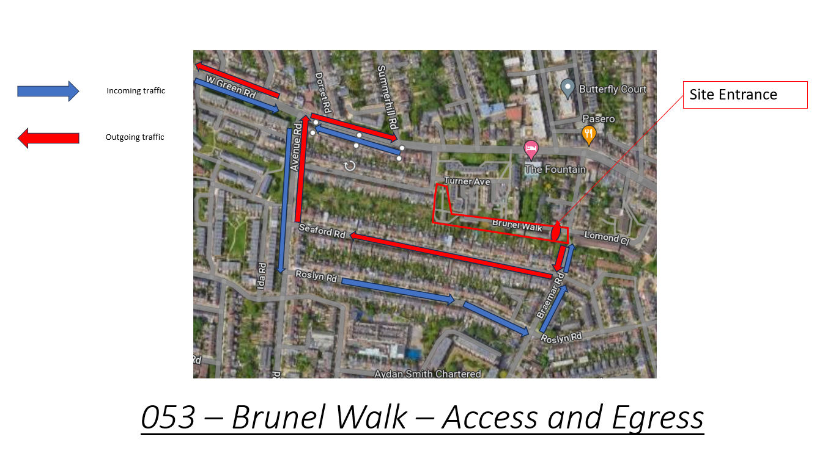

Swept Path Analysis

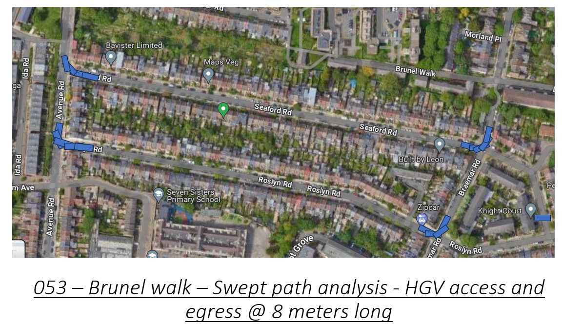

Site Access and car parking arrangements
Personnel access to the site shall be via the main entrance located next to the residents car park of Turner Avenue, where all contractors will sign in with site management. In addition to this, I have allocated a pedestrian gate at Brunel Walk which will be locked at all times and manned by the gate man, who will be in radio contact with the site team to inform them There will be no parking available on the project for contractors, visitors or site management.

On-street parking is limited within the local area and contractors discouraged from parking in a manner that causes distress to residents. All operatives/visitors will be encouraged to use public transport where possible.

There are no adjoining neighboring developments within the surroundings of the project were it will be possible to share parking or use for temporary parking for lorries or alike.

The Principal Contractor shall ensure that vehicular access routes remain accessible to others (particularly the Emergency Services and any other users) during the project. Furthermore, the Principal Contractor shall ensure that appropriate measures are undertaken to protect and secure the public from all construction activities.
NRMM - None Road Mobil Machine

An inventory and plant registration / log books will be maintained within the project offices at all times recording plant used on site to ensure that all plant complies to the NRMM.
Selsdon Building Contractors will require the use of a 18m telehandler from JCB (540-180 Hi Viz Telehandler) during the external works construction.

Please see below, NRMM registration of Brunel Walk

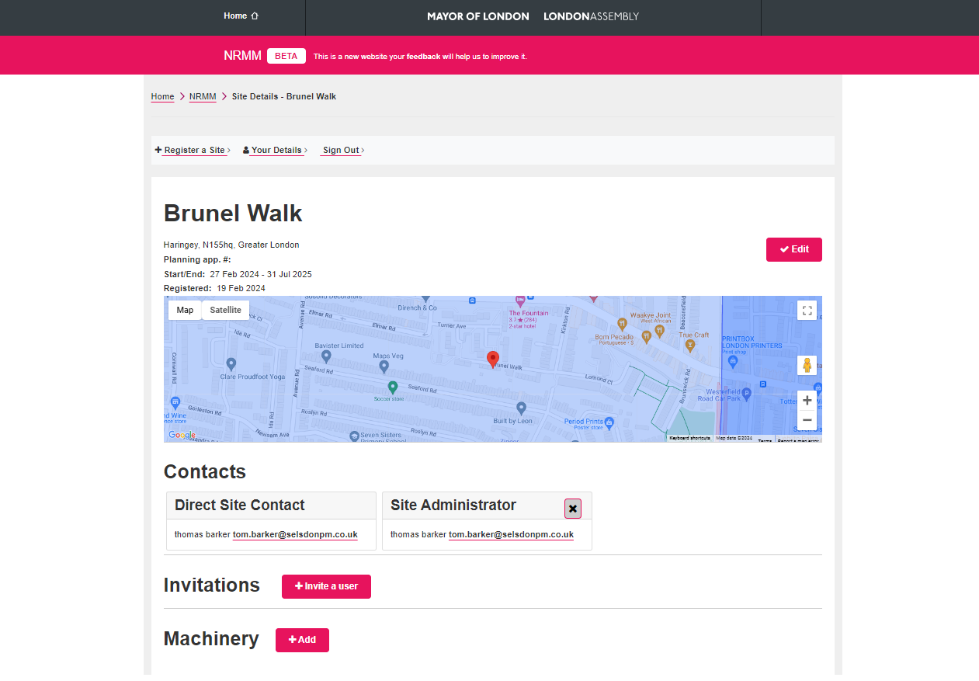

During the demolition phase the demolition contractor will have a 13 Tonne excavator and Dumper on the scheme to assist with the demolishment of the existing Foundations. Subcontractor not appointed as yet.
During the piling phase of the scheme the piling contractor will required the use of a piling rig to form the piles and the scheme will be cleaned with a jet wash that will be contained on a trailer.

Pollution

- Burning of materials on the project shall not be permitted,
Emphasis will be placed on using methods that do not cause unnecessary emissions (e.g. dust smoke).

- Dust pollution will be minimized during demolition of the existing buildings foundations by the complete screening if practicable, a dust suppression system will be in operation during the required works. This will be controlled by the use of a watering system, dampening down the existing building to prevent the risk of dust being exposed to the atmosphere.

- The suppression system will be operated where necessary to minimize dust transfer into neighboring premises.

- Stockpiles of earth shall be damped down or otherwise suitably treated to prevent the emission of dust from the project. Stockpiles will be planned and sited to minimize the potential for dust generation. The handling of spoil will be kept to a minimum and when materials are deposited onto a stockpile it will be from the minimum possible height.

- Selsdon Building Contractors will ensure that the area around the project, including the public highway, is regularly and adequately swept to prevent any accumulation of dust and dirt.

- Where possible, skips and removal vehicles will be properly sheeted when leaving the project. Watering of rubble chutes shall be undertaken where necessary to prevent dust emissions.

- Selsdon Building Contractors will take all necessary precautions to prevent smoke emissions or fumes from plant or stored fuel oils. In particular, measures will be taken to ensure that all plant is well maintained and not left running for long periods when not in use.

Fuel spillage

Diesel bowser to be double walled sealed tank to catch any spills with a plastic lined sand pit where the operative will stand when filling the plant up.

A 360 ltr spill kit will be provided to stay with the diesel bower to contain and clean up if diesel was to leak onto the floor

AQDMP
A Report is in the process of being formed by Aval Consulting Group for Brunel Walk on Behalf of Selsdon Building Contractors.

Draft for attached in Appendix 2

Agreed Routes to / from Plot
All site personnel will follow fenced walkways, keeping segregated to All HGV and plant movement on the project.
Crossover points will be formed in areas were crossing of roads is required. These will be formed of barriered gates with signage to advise to take care whilst crossing.
Crossing points will be clearly marked on the floors and this will be maintained during the construction phase.

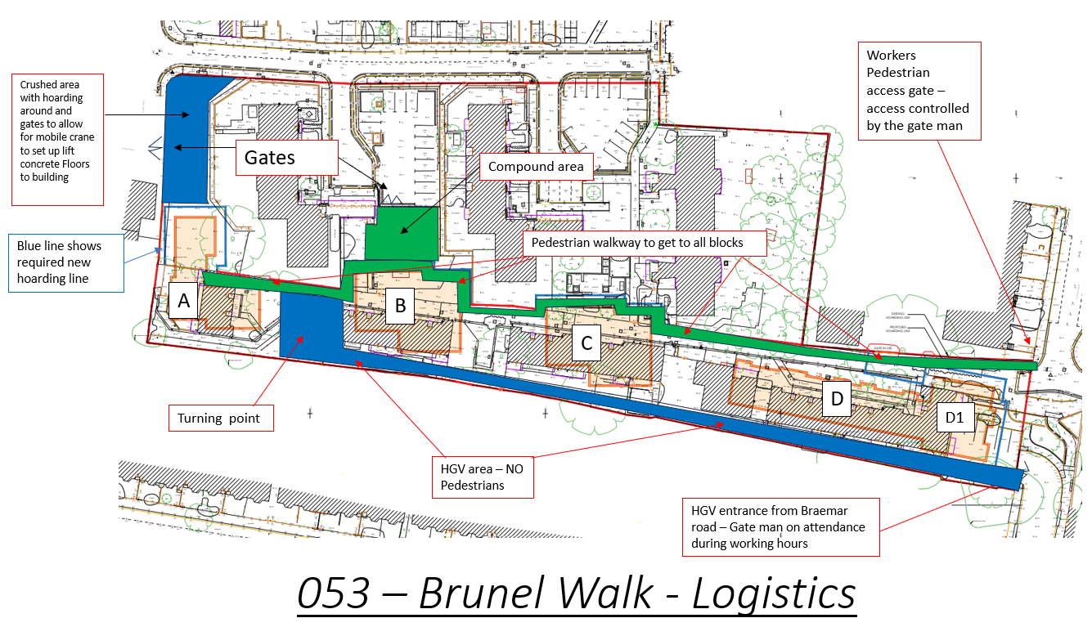

Travel Plans for staff / Personnel
Personnel access to the site shall be via the main entrance located on Kerswell Close where all contractors will sign in with site management. There will be no parking available on site for contractors or visitors, on-street parking is limited and contractors discouraged from parking in a manner that causes distress to residents are encouraged to use public transport where possible.
We have no adjoining neighboring developments that we can share parking or use for temp lorry parking
The Principal Contractor shall ensure that vehicular access routes remain accessible to others (particularly the Emergency Services and any other users) during the project. Furthermore, the Principal Contractor shall ensure that appropriate measures are undertaken to protect and secure the public from all construction activities.

Considerate Contractors Scheme

To Be Provided once site has started.

