27 ROOKFIELD AVENUE
LONDON
N10 3TS

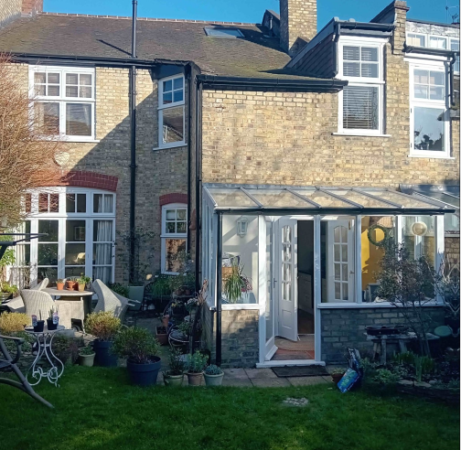

Design and Access Statement/Heritage Assessment
for a replacement conservatory to the rear of the property.
Written by Mrs B Ratcliffe – Anglian Home Improvements
March 2024

Summary
This application seeks permission for a replacement conservatory to the rear of the property. The new conservatory uses appropriate materials and architectural language, ensuring a low key, modestly sized conservatory, which accords with local and national policy and guidance. It both enhances the building’s appearance and contribution to the Rookfield Conservation Area, while preserving its residential amenity.
Setting
No 27 Rookfield Avenue located within the Rookfield Estate. The Rookfield Estate is a low-density housing development built around the garden suburb principles consisting largely of terraced houses of the Arts & Crafts style with communal open spaces, grass verges, hedges, and many mature trees. The property is not listed however it is located within the Rookfield Conservation Area (designated in 1976). The National Planning Framework (NPPF) categorises conservation areas as ‘designated heritage assets.’ Heritage Assets are an irreplaceable national resource and in determining applications, ‘local planning authorities should require an applicant to describe the significance of any heritage assets affected’. The level of detail should be proportionate to the assets’ importance ... ‘sufficient to understand the potential impact of the proposal on their significance’ and use ‘appropriate expertise where necessary’. The quality of the area was protected by an Article 4 Direction in 1978. The aim is to prevent the erosion of a high standard of design by means of a closer control of minor developments. It is not intended to stifle change, merely to direct and channel alterations into taking the most sympathetic form. The properties within the Rookfield Estate have a general uniform aesthetic in the Arts and Crafts style that manifests itself in the richly detailed facades within a material palette of red brick, coloured renders, and white timber windows. The estate is laid out against steep changes in level that are common throughout the Muswell Hill. The grass verges and green spaces visually hold the estate together. Whilst the frontage on Rookfield Avenue has overall a uniform aesthetic, the rear is less formal and typified by plain brickwork with rear extensions, dormer windows and utilitarian elements such as rain and waste pipes. Such variety of additions contributes to the conservation area’s vernacular character.

Fig.1 – Frontages on Rookfield Avenue
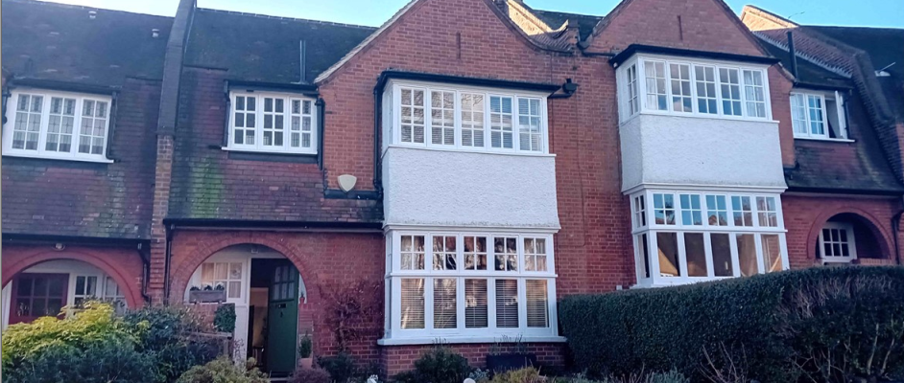

Fig.2 – Rear of Rookfield Avenue
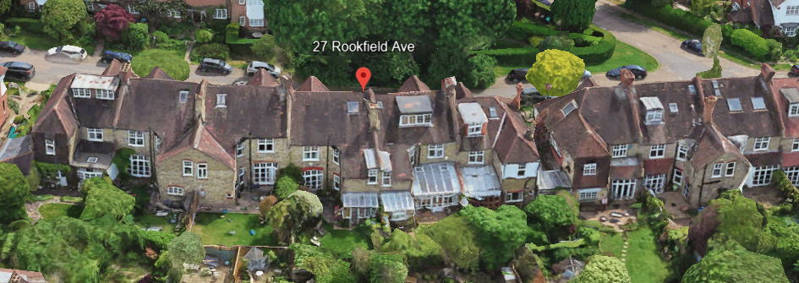#

Fig.3 – Rear of 27 Rookfield Avenue
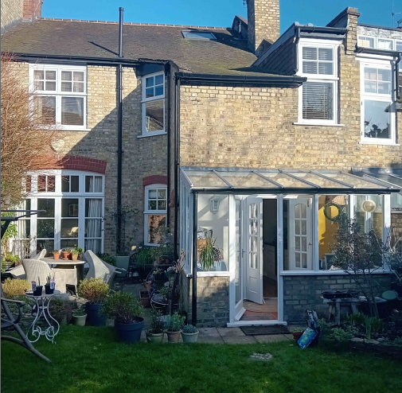
Planning History
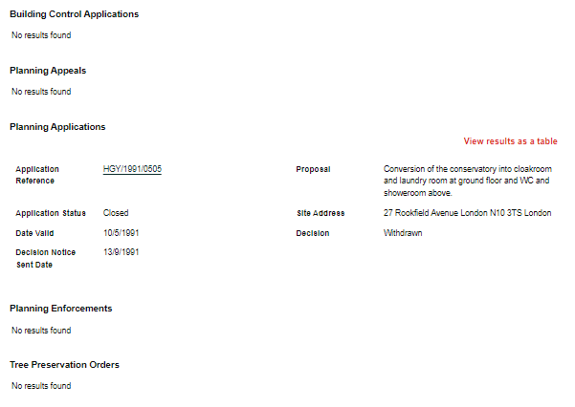
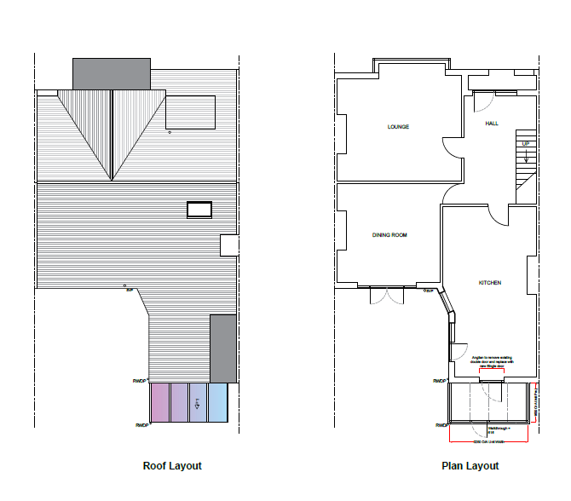

Proposal Outline: Anglian Home Improvements have been contracted to erect a replacement conservatory to the rear of the above property. Our client has chosen a conservatory to meet their personal requirements whilst being considerate to neighbouring properties and council guidelines.

Design Principles: Our client has chosen a white PVCu framed conservatory. The small design of this predominantly glass structure ensures that all aspects of the garden area can be enjoyed all year round without resulting in an overbearing effect on the property whilst providing additional living space.

Due consideration has been given to the overall look and size of the property to give the most aesthetically pleasing look and giving consideration to privacy without being overbearing.

All external materials used will to match the existing property.

Access: No Changes to Access.

Landscaping: Our proposal will not require the alteration of the rear garden in any form, we will not be required to remove or cut back any hedges or trees on the site. Our proposal will not affect the amenities of the site or the surrounding area.

