Our ref: HGY/2024/0216
Contact: Sarah Madondo

Date: 26/02/2024
Town and Country Act 1990 (As amended)
Location: | Florentia Clothing Village, Vale Road, Tottenham, London, N4 1TD
Proposal: | Non-Material Amendment to the wording of condition 13a(Energy Strategy) attached to planning reference HGY/2022/0044 to read as per covering letter.
Approved wording for condition 13a: | The development hereby approved shall be constructed in accordance with the Energy Statement,(dated 18 March 2022, Issue 3) and energy Note (dated October 2022), prepared by DWA, delivering a minimum 106% improvement on carbon emissions over 2013 Building Regulations Part L, with SAP10 emission factors, high fabric efficiencies, temporary communal heating solution with measures in place to allow for a future connection to the Decentralised Energy Network and a minimum 285.6 kWp solar photovoltaic (PV) array.  (a) Prior to above ground construction, details of the Energy Strategy shall be submitted to and approved by the Local Planning Authority. This must include:  - Confirmation of how this development will meet the zero-carbon policy requirement in line with the Energy Hierarchy;  - Confirmation of the necessary fabric efficiencies to achieve a minimum 21% reduction in SAP10 carbon factors, including details to reduce thermal bridging, with the aim of increasing the specified u-values;  - Details of the specification, efficiency, layout and capacity of temporary gas boiler plant and thermal store;  - Details of the solar PV, demonstrating the roof area has been maximised, with the following details: a roof plan; the number, angle, orientation, type, and efficiency level of the PVs; how overheating of the panels will be minimised; their peak output (kWp);  - A metering strategy.  The development shall be carried out strictly in accordance with the details so approved prior to first operation and shall be maintained and retained for the lifetime of the development. The solar PV array shall be installed with monitoring equipment prior to completion and shall be maintained at least annually thereafter.

Carbon Management Response 26/02/2024

Documents submitted:
- NMA cover letter, prepared by DP9 (dated 25th January 2024)

Response
The applicants are requesting to amend the carbon factor and reduce the solar photovoltaic array capacity in this NMA application.

The applicant has made several attempts to water down the sustainability and energy reduction benefits of this development. The timeline in this is important, and our objection to this has been recorded under the discharge of condition reference HGY/2023/2867 for Condition 13a.

A timeline of events is relevant here:
- The Energy Strategy (ES) submitted with the application, dated 9 December 2021, with SAP2012 carbon factors was proposing a 265.6 kWp solar PV array.
  - SAP2012 were supported at the time following the recommendation by the GLA
- Carbon Management comments dated 21/06/2022 stated that SAP2012 carbon factors could no longer be used, following advice by the GLA for schemes connecting to a future DEN. Based on the ES dated 18th March 2022, the scheme achieved a 89% reduction with SAP10 carbon factors. The solar PV capacity was reduced from 265 kWp to 240 kWp. This reduction in PV was not supported.
- The application received resolution to grant permission by the Planning Sub-Committee on 4th July 2022.
- The applicant then submitted an Energy Note (dated 13th October 2022) that sought to worsen the proposed fabric efficiencies (u-values). As a compromise, the applicant proposed to increase the solar PV array again. The changes have been screenshotted below.

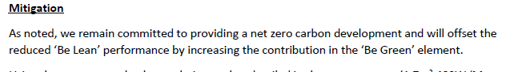

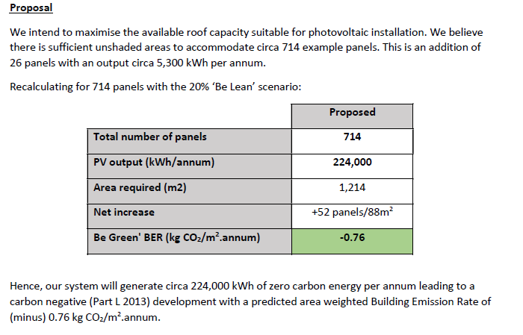

- This would result in a solar PV capacity of 285.6 kWp (714 x 400W). As a result of these changes, the CM response dated 8th March 2023 recommended that the planning conditions were revised to reflect this proposal by the applicant. The revised proposals would also result in a net positive development (in regulated energy terms). See below the screenshot of the revised condition wording. The decision notice was subsequently based on this.

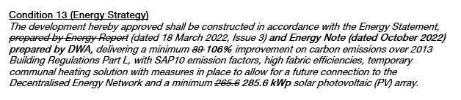

- The applicant is now trying to further water down their proposals in two ways, in addition to already watering down their proposals with worse fabric efficiencies. This is concerning and not acceptable.
  - They are proposing to reduce their PV array from 285.6 kWp to 271 kWp. This means they are no longer fully compensating for the reduced fabric efficiencies.
  - They are proposing to use different carbon factors. The SAP2012 carbon factors set an electricity grid factor of 519 grams of CO2/kWh, and were set over 12 years ago. The interim SAP10 carbon factors were adopted by the GLA (using Part L 2013) to recognise the decarbonisation of the grid before Part L 2021 was adopted with more up-to-date carbon factors. This assumed a factor of 233 grams of CO2/kWh. The revised SAP10 carbon factor was accepted by the applicant. Moving back in time with wildly out-of-date carbon factors would not recognise the reality of this scheme being built now and what the carbon footprint might be. It is also not consistent with other approvals. The applicant may be trying to use SAP2012 carbon factors to justify a lower solar PV capacity to reach net zero carbon. It is therefore artificially improving the performance of this scheme, without delivering the actual savings needed.
- The information submitted as part of the condition (ref. HGY/2023/2867) has not been found acceptable by the Carbon Management Team. Responses have clearly set out reasons also included above.

Lastly, their covering letter is quoting incorrect figures that do not reflect submitted and approved documentation as part of the planning permission. They are misquoting that the October 2022 Energy Note proposed a PV capacity of 275.2 kWp which is not correct, this should state 285.6 kWp.

Conclusion

We strongly object to this proposal, we do not support the watering down of this scheme. The NMA application should not be approved.

