The application Ref HGY/2020/2762
Appeal Ref: APP/Y5420/W/21/3279945

The plot of land before number 1 Wroxham Gardens, Alexandra Palace, London, N11 2AY
(Also known as the land to the rear of 10-12 Bidwell Gardens)

- Introduction
- Analysis of building and context
- Design Proposal
- The Design & Relevant Policies
- Tree Report & Landscaping
- Recent Planning History

1.0 Introduction

Earlier this year we bought the plot known as the rear land of 10 & 12 Bidwell Garden, N11 with planning permission for a 2-bedroom house with a flat roof and a large dug-out patio garden. We wish to revise the design, addressing some of the shared concerns and objections from the neighbours, making the house work better as a family dwelling and ensuring that the various policies are met.

2.0 Analysis of building and context

The land is not in a conservation area and has been left neglected for the last two decades.
The plot has a sloping topography, mainly sloping downwards from north/east to south/west and is surrounded by residential brick houses built in the 1930s with pitched gable ends and bay windows.
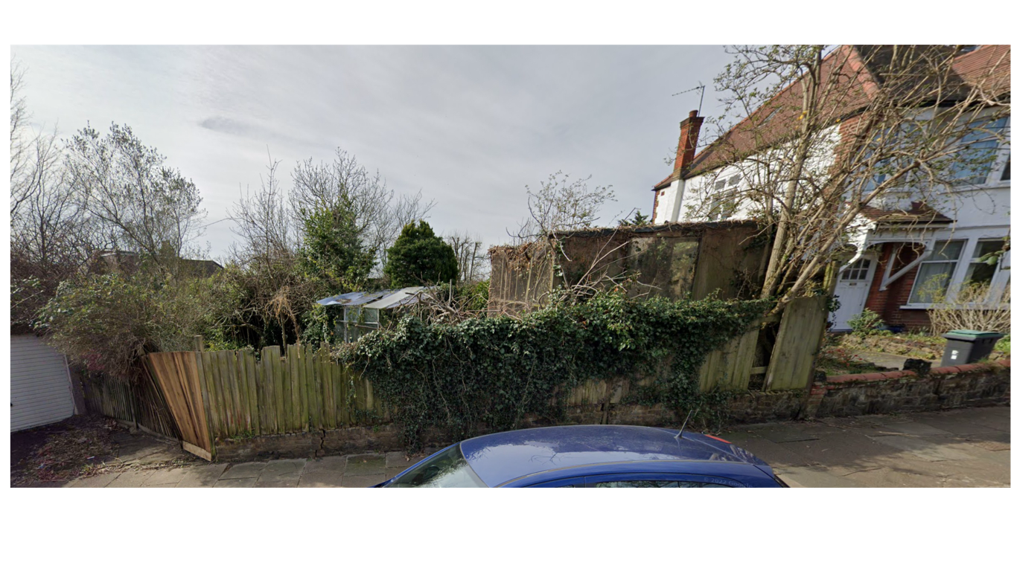
The house would replace two unsightly structures on site; an overgrown and dilapidated greenhouse, and a large, derelict aviary that was on the plots highest point, right next to the street, much taller than the fence and clearly visible from the street.
3.0 Design Proposal

We asked Paul Archer Design to create a sympathetic design that works harmoniously with the surroundings and aligns more closely with the architectural ‘context’ of the area than the previous design, and at the same time adheres to various planning policies. Our main focus:
1. Having assessed the neighbouring properties and the overall streetscape, a pitched roof seems more appropriate and it also eliminates some concerns expressed by neighbours regarding the flat roof feeling out of place.

2. To amend the existing design to provide more space for us as a family, with a flexible internal design for changing needs.

3. Create a high performing house more in line with a fabric-first approach and energy-efficient principles. Replace the flat roof with a pitched roof to accommodate solar panels.

4. Reduce the size of the sunken patio in order to maximise the surrounding garden of the house. Keeping some of the existing trees and give space for a garden with flowers, berries and seeds for birds and bees, and generally promote greater biodiversity in the garden space, as well as manage and harvest rain water.

Paul Archer Design has designed a detached family dwelling with 3/4 bedrooms and 2 bathrooms.
A partial second floor, only at the north end of the property, taking advantage of the space under the eaves for an office/guest room, as we both work from home.

The topography will be dug down so the house would be more level with the street. The main front wall of the house is in line with no 1 Wroxham Garden, and the partial glass wall protruding outwards under the end gable gives a gentle ‘nod’ to the neighbouring 1930’s bay windows. We believe the glass front of the house creates a lighter and more elegant look, as well as for practical considerations such as bringing natural light up to the mezzanine and down into the darker part of the basement in line with low energy house principles.

- The Design and Relevant Policies:

National Planning Policy Framework (2021) (NPPF)
The London Plan (2021)
Haringey’s Local Plan Strategic Policies (2017) (Local Plan)
Development Management DPD (2017) (DM DPD)

This development already has planning permission in place and we are just looking to improve
on it. The principle of additional housing is supported by relevant planning policy from national
to local level.

The new design would maintain the L-shape form and its siting would be very similar to the previous scheme. Although slightly bigger, the increase in floor areas has been contained within the massing of the new design, with the addition of a mezzanine floor set into the pitched roof. The house would only be situated on approximately 34% of the plot, generously set back from all neighbouring boundaries, including the street. The proposal has a generous portion of garden around the house, and the scheme is sensitive to natural features of the site and includes design and architectural features sympathetic to the character of the area, adjacent buildings and the street-scene. (Policy DM7 of the Haringey Development Management DPD (2017) and Policies DM1 and DM2)

A 4-bedroom house with 168sqm in total has large enough bedrooms and storage to be well within the space standard. The light well allows for plenty of light to enter the bedrooms in the basement/lower ground floor level. All habitable rooms would benefit from natural daylight and an outlook into the garden. A large garden area would provide amenity space for all, with off street parking, bin area and cycling shed (Policy D5 and D6 of the London Plan (2021). The government’s 2015 ‘Technical housing standards – nationally described space standard’ (NDSS), London Plan Policy T1, Local Plan Policy SP7, SP6 and DPD Policy DM1, DM4 and DM18, paragraph 3.10.5 and 3.10.6 of the London Plan 2021)
In accordance with passive house design principles, large panes of glass facing South provide passive heat from the sun during the winter months. This principle has also been applied in reverse to the bedrooms, where a large overhang walkway provides shade and cooling during the summer months. A small obscured window on the north side and walk-on glass windows have been added to all bathrooms to avoid the use of artificial light during the day, again in line with an energy-efficient house. The pitched roof is designed for integrated solar panels, to easier achieve a high level of thermal performance, as well as allowing for the hot air to rise providing a better indoor climate. Compared to a flat roof, a pitched roof also has less surface exposed to the elements and therefore keeps a more comfortable temperature. The house would minimise greenhouse gasses by 86%. (Local Plan Policy SP4, DM DPD Policy DM21, London Plan Policy SI4)

With longevity in mind, the house has been given a flexible design from the outset to be able to adapt to changing needs and the level thresholds allow for wheel chair access. (The London Plan D6, 3.3.10)

The site is not within an area at risk from flooding as defined by the Environmental Agency. The site is situated within a Critical Drainage Area (CDA) and the plan is to retain some of the existing trees on site to collect rainwater for re-use during dry spells. In the lightwell large garden planters housing various plants and flowers will be lined with permeable geotextile and small trickle vents in order for the water to slowly work its way down the various layers before reaching the drainage, acting as a water reservoir, reducing surface water flows and flood risk. (Policy DM24 & DM26, DPD Policy DM1 and London Plan Policy G7)

- Recent Planning History

The site was granted permission on appeal 21st of February 2022 (APP/Y5420/W/21/3279945) for a detached 2- bedroom house with a flat green roof. The appeal was made by Elena, Christos and Androula Christou, following a refusal at planning sub-committee on the 7th of May 2021 (application HGY/2020/2762).

- Conclusion

We have spent a lot of time and money improving on the existing design to better complement the street landscape, improve the performance of the house and make sure both the house and garden work more harmoniously with the environment, at the same time maintaining privacy for us and our neighbours.

We chose Paul Archer Design to help us create our future home. Paul Archer Design are an architectural firm formed in 1999, specialising in bespoke architectural and interior design. Their focus is on high quality residential projects with a commitment to well considered contemporary design. The quality of their work in this sector is recognised in the widespread publication of completed projects as well as the number of design awards received.

