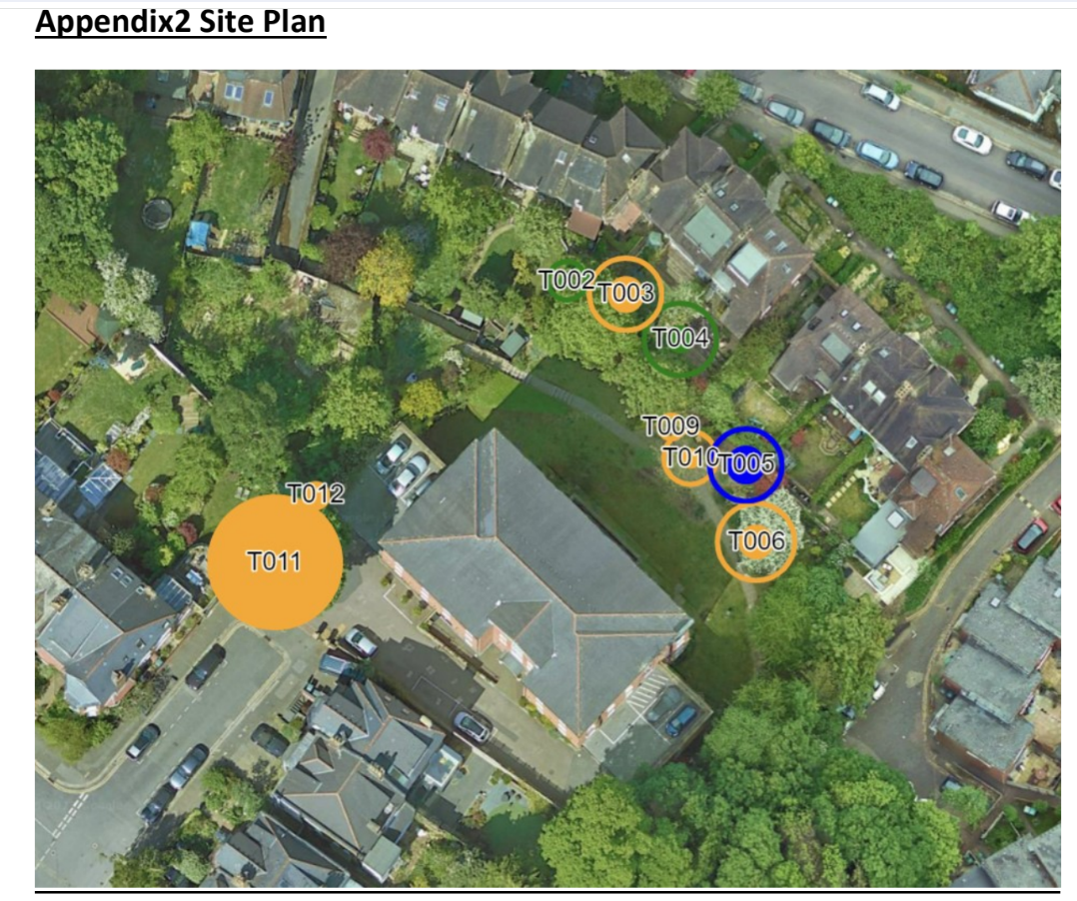
Neighbours encroachment
S
N

