Design Statement

Installation of Air Source HeatPump and solar panels, change of existing UPVC windows to timber sash at 111 Effingham Road, N8 0AE
This design statement is to support a planning application for the installation at 111 Effingham Road (N8 0AE) of an Air Source Heat Pump (ASHP) at the rear garden and solar panels on street facing roof slope as well as change of windows from UPVC to timber sash.
The proposed ASHP installation will remove the existing gas boiler that provides heating and hot water to the household, while solar panels will harness solar energy instead of relying solely on the electricity grid.
ASHP Unit location
We propose siting the ASHP along the boundary fence to 109 Effingham Road. The unit will be installed circa 7.4m away from the habitable window at 109 (6.4m is 1m away). It will be located adjacent to solid metal fence separating the gardens, which reduces noise levels as well as eliminates visual disruption.
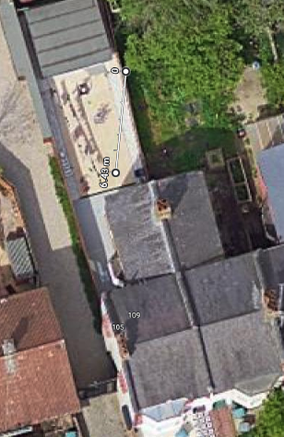

Noise levels
The ASHP hardware chosen is Vaillant aroTherm plus 5kW. Unit’s sound power level at various distances is specified in the screenshot below. At 5m distance, the sound pressure level is 32 dB (compared to sounds in a quiet rural area or someone nearby whispering).

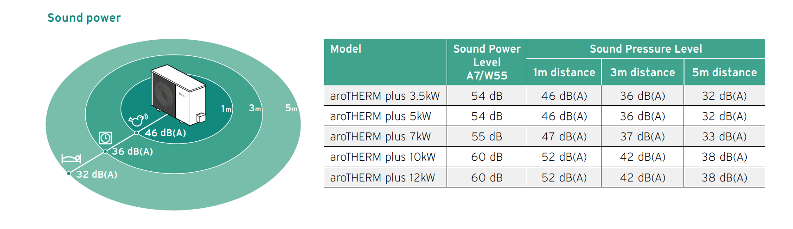

The installation supports the UK in achieving its climate targets
As a low carbon, low emission source of heating ASHP units are supported as a measure to reduce energy consumption/ reduce CO2 emissions, in turn addressing climate change and working towards Haringey’s objective to be zero carbon by 2041 as set out in Haringey’s Climate Change Action Plan (HCCAP) as well as meeting the requirements of policies SP4 and DM21.
It should be noted that typically 1 x ASHP unit can be erected in connection with a domestic premises under permitted development, without the need for planning permission, as per Part 14 of Schedule 2 of the Town and Country Planning (General Permitted Development) (England) Order 2015.
Based on the siting of the ASHP and the separation distances to neighboring properties, in specific habitable windows, the proposal will not harm amenity of neighboring occupiers, falling below the permitted noise level of 42dB associated with ASHPs (sound assessment result is 41dB).

Solar panels
In total 6 in-roof solar panels are proposed to be installed on the south (street) facing slope of the house. The installation of the solar panels would allow for a method of energy generation that would see another household contributing towards the council’s environmental goals.
The proposal is to install “in-roof” panels such that these visually integrate with the slate roof as much as possible, hence minimizing the effect on the external appearance of the building and the amenity of the area.
It should be noted that Solar PV installation in domestic premises falls under permitted development, if all conditions are met, without need for a planning permission.

Existing windows
Existing double-glazed windows in UPVC will be replaced with double-glazed timber sash windows in line with the original design in order to restore original character of the property.

