PLANNING APPLICATION FOR THE

INSTALLATION OF AIR SOURCE HEAT PUMP

45 Hillfield Park, London,
N10 3QU.

DESIGN and ACCESS STATEMENT to support application for

Planning Permision

The Property

The application site is an attractive mid – terrace 3 storey (at the rear) town-house, located in this linear street, close to the centre of Muswell Hill, North London.

Figure 1: Site Location Plan and aerial image of site:

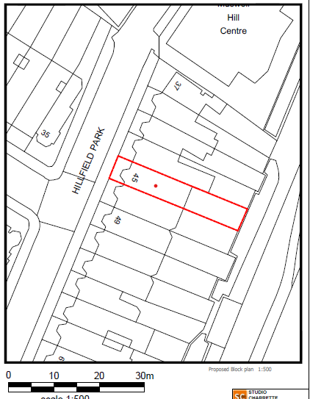

The Proposal

The proposal is to install a Vaillant 20kw aroTHERM plus heat pump with sound power as low as 54 db and a floating floor design to reduce noise and vibration. The pump would be located in the rear garden, alongside a raised terraced area, with the garden being approximately 1 metre lower, and the ASHP is located at garden level, so will be barely visible from outside the site:

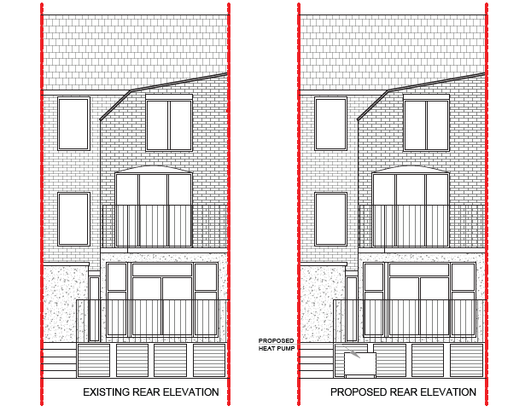

National Planning Policies

The following policy and guidance documents are recognised as primary considerations for the decision of the associated application at the site location:

National Planning Policy Framework (NPPF 2021)
National Planning Practice Guidance

Section 38(6) of the Planning and Compulsory Purchase Act (2004) requires that proposals should be determined in accordance with the development plan unless material considerations indicate otherwise. For the purpose of this application the relevant development plan policies are: -

The delivery of renewable energy plays an important part of the Council’s development strategy and forms part of the objectives that underpin the Local Plan.

Assessment

Paragraph 8 of the NPPF explains that achieving sustainable development means that the planning system has overarching objectives, which are interdependent and need to be pursued in mutually supportive ways (so that opportunities can be taken to secure net gains across each of the different objectives):

- an economic objective – to help build a strong, responsive and competitive economy, by ensuring that sufficient land of the right types is available in the right places and at the right time to support growth, innovation and improved productivity; and by identifying and coordinating the provision of infrastructure;

- a social objective – to support strong, vibrant and healthy communities, by ensuring that a sufficient number and range of homes can be provided to meet the needs of present and future generations; and by fostering well-designed, beautiful and safe places, with accessible services and open spaces that reflect current and future needs and support communities’ health, social and cultural well-being; and

- an environmental objective – to protect and enhance our natural, built and historic environment, including making effective use of land, improving biodiversity, using natural resources prudently, minimising waste and pollution, and mitigating and adapting to climate change, including moving to a low carbon economy.

The proposal is to install a heat pump at garden level within the rear garden, attached to the rear of a retaining wall. Supporting a decked terraced.

Paragraph 157 of the NPPF supports the transition to a low carbon future in a changing climate. It acknowledges that planning policies should contribute to the reduction in greenhouse gas emissions and support renewable and low carbon energy and associated infrastructure.

The NPPF also states that-

When determining planning applications for renewable and low carbon development, local planning authorities should:

- not require applicants to demonstrate the overall need for renewable or low carbon energy, and recognise that even small-scale projects provide a valuable contribution to significant cutting greenhouse gas emissions;
- approve the application if its impacts are (or can be made) acceptable.

Paragraph 164 of the NPPF supports this further and explains that when determining planning applications, local planning authorities should give significant weight to the need to support energy efficiency and low carbon heating improvements to existing buildings. The delivery of renewable energy plays an important part of the Council’s development strategy and forms part of the objectives that underpin the Local Plan.

The Council Local Plan includes specific policies to achieve that vision which includes an aim to reduce the Boroughs contribution to, and adapt to the effects of climate change.

This proposal would help to achieve a reduction in the broader carbon footprint and increase the production of energy via renewable and low carbon means. Policy in the plan encourages the development of renewable and low carbon energy generation.

The Air Source Heat Pump LOCATION:

The proposed ASHP would be located as shown above and consequently would not be visible from the public highway, it would be situated against the backdrop of the existing property.
As such, it is judged that the proposal would not detrimentally impact upon the character or appearance of the area or street scene. It would be utilitarian in design by nature, but its small size and discrete location would ensure that it would appear subordinate in scale and prevent it from appearing out of character with the existing dwelling or the surrounding area.
Access to the site is to be maintained as existing.
Broader Global Sustainable objectives:
Paragraph 163- 164 of the NPPF states:
When determining planning applications for renewable and low carbon development, local planning authorities should:
- not require applicants to demonstrate the overall need for renewable or low carbon energy, and recognise that even small-scale projects provide a valuable contribution to significant cutting greenhouse gas emissions;
- approve the application if its impacts are (or can be made) acceptable58. Once suitable areas for renewable and low carbon energy have been identified in plans, local planning authorities should expect subsequent applications for commercial scale projects outside these areas to demonstrate that the proposed location meets the criteria used in identifying suitable areas; and
- in the case of applications for the repowering and life-extension of existing renewable sites, give significant weight to the benefits of utilising an established site, and approve the proposal if its impacts are or can be made acceptable.
In determining planning applications, local planning authorities should give significant weight to the need to support energy efficiency and low carbon heating improvements to existing buildings, both domestic and non-domestic (including through installation of heat pumps and solar panels where these do not already benefit from permitted development rights).
Renewables made up 33% of electricity in 2018, which was up from 29.2% in 2017. However, fossil fuels still made up 79.4% of the overall energy supply while renewables still only accounted for 11% of the final consumption in 2018. This is according to the Digest of United Kingdom Energy Statistics (July 2019 Edition) also referred to as DUKES. The UK target is for that figure to be 20% by 2020 and although each year sets new records for renewables, it is considered that for the UK that the pace of change isn’t fast enough, currently sitting at 12% increase year on year between 2017 and 2018.

The EU statistical office Eurostat Statistics produced by the EU statistical office show that the share of renewable across Europe was up to 17.5% in 2017. This is an increase of 0.5% from 2016, and more than double the share in 2004. Eleven of the 28 countries in the EU have already exceeded the EU’s target to obtain 20% of energy in gross final consumption of energy from renewable sources.

It is aiming to increase this to 32% by 2030. Despite having more offshore wind power than any other nation, it is stated that the UK’s renewable transition has been slow. The Eurostat figures show that the UK is predicted to miss its target by 5% in 2020, as not enough is being done to transition the nation to renewables - while phasing out coal power has been relatively successful, natural gas still makes up the majority of the UK’s electricity demand with the exception to this being Scotland showing that renewables provided 74.6% of Scotland’s gross electricity consumption in 2018.

Therefore, the proposal amounts to Sustainable Development which accords with the prevailing policies of the Development Plan and NPPF. As highlighted the local plan will encourage development that will conserve and enhance green infrastructure, the proposal will not have any significant impact on the streetscape character or surrounding amenities.

The National Planning Policy Framework sets out how the local planning authority, in making a decision, looks at balancing the harm of a renewable energy scheme against the sustainability benefits of the proposal.

The proposal and location would respect the design, scale, materials, character, appearance and proportions of the existing buildings and area and would preserve the character and appearance of the surrounding area and wider street scene. The proposal amounts to Sustainable Development which accords with the prevailing policies of the Development Plan and NPPF. As highlighted from the supplied proposed plans, the proposal will not have any significant impact on streetscape character or surrounding amenities.

The size of the proposed air source heat pump should be viewed as acceptable and due to its location, is unlikely to impact on neighbouring properties in regard to a loss of daylight, sunlight or overdominance.

The technical specifications of the pump and manufacturers brochure is submitted with the application which contains technical information about the air source heat pump. The details should demonstrate in our view that the anticipated noise levels will be acceptable. The development is therefore acceptable in relation to the provisions of the National Planning Policy Framework, and sustainable Local Plan Policies.

Conclusion

Following a review of the proposal's applicable policy and material considerations, it is of our professional view that the development is in compliance with all applicable policies as previously illustrated.

The scheme would provide betterment for the occupiers of the building allowing a better standard of accommodation providing sources of renewable energy and reducing the climate change impacts.

As previously outlined, there is a significant level of International and Governmental policy that underpins planning policy in respect of developments for the production of heat from renewable sources. The proposed development is strongly supported by European Energy Policy on Renewables and National Planning Policy in the Government’s National Planning Policy Framework. The UK has signed up to the EU Renewable Energy Directive, which includes a UK target of 15% of energy (electricity, heat and transport) from renewable sources by 2020.

The need for the development is therefore paramount, with reference to the failing of the UK to meet the 2020 renewable energy targets. Collectively, all heat pumps can make a significant contribution to meeting these national targets and has the added benefit that it can be brought on-stream quickly, a characteristic that is not shared by its nuclear and fossil fuel counterparts.

Given the growing sustainability attributes of ASHP across the UK, it is assumed the Local Planning Authority will grant Planning Permission for the ASHP, however should any further information be required to assist in the council’s assessment of the proposal, please do not hesitate to contact us directly;

Colin Tebb, BA (Hons), BTp,
Senior Planning Consultant info@studiocharrette.co.uk www.studiocharrette.co.uk

