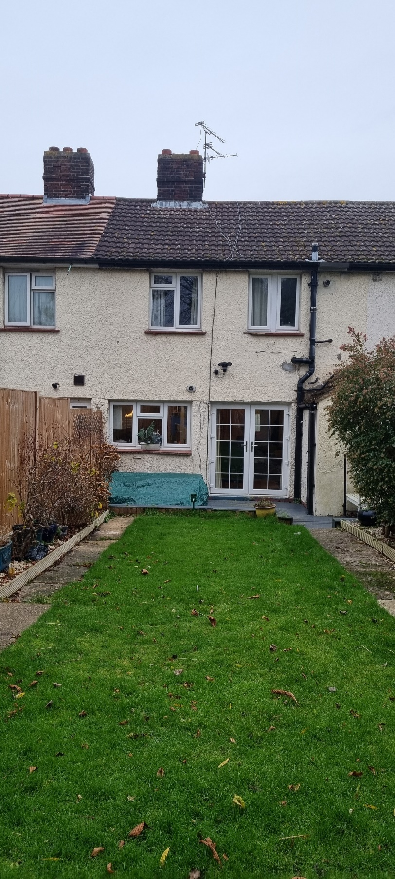
REAR VIEW NO 19 HILL ROAD
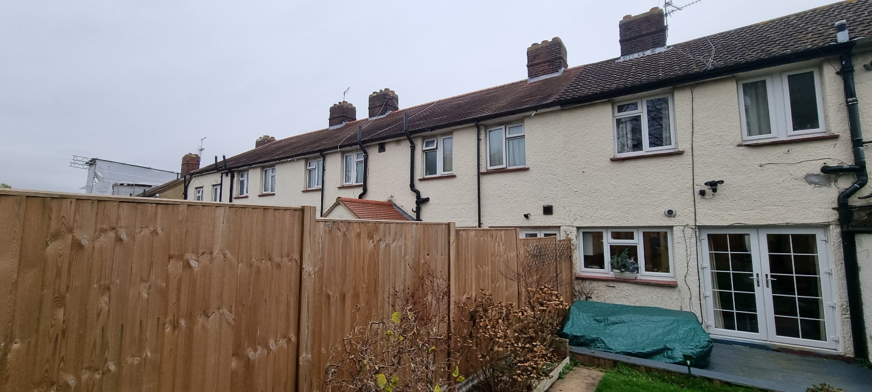

REAR VIEW LOOKING LEFT (NO 21)

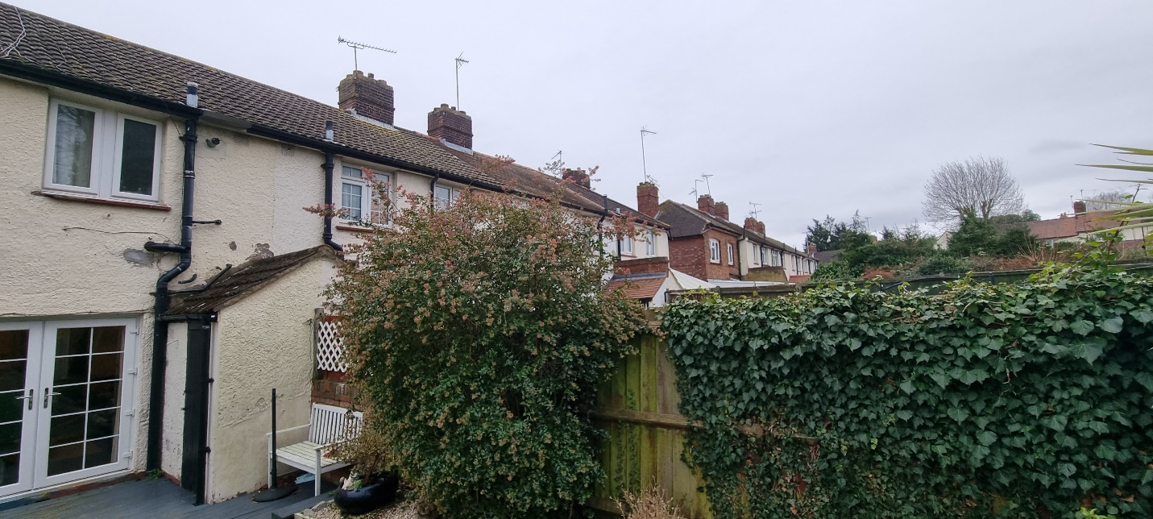

REAR VIEW LOOKING RIGHT (NO 17)

