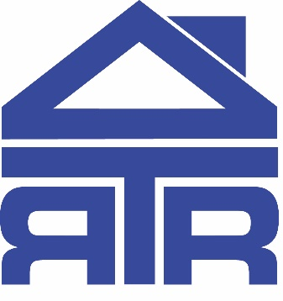

ROOFTOP ROOMS Ltd
342 Baker St, Enfield, EN1 3LH.
0208 367 0066 www. rooftoprooms.co.uk

PLANNING STATEMENT

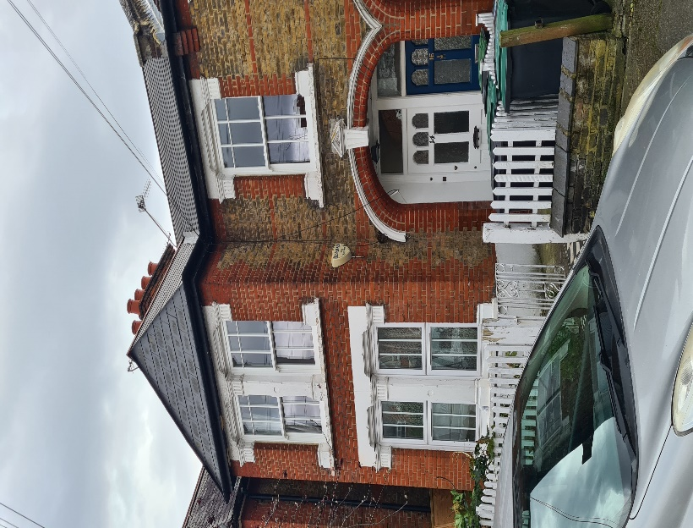
16 Southey Road, N15 5LH
Prepared by S. Ashen.
Date: April 2024

Introduction

The proposal will take the form of a L-shaped dormer extension over the existing roof. The proposed development will enable the homeowner to obtain much needed additional space to service the needs of a growing family. The subject property is a Victorian terraced property and with the exception of the introduction of two no. Velux windows to the front elevation of the property the visible street scene will remain unchanged. The property was subject of a previous planning application HGY/2022/2780 which was approved, this new application seeks to add the outrigger dormer.

Site Description

The property is a victorian mid terraced property divided into two flats, with the home owner occupying the top floor flat. The subject property is located at the far end of Southey Road, this end of the Road is a no through area the end of the Road is sided by properties in Greenfield Road, where L-shaped dormer conversions can be found in abundance as illustrated below in image 1 & 2.

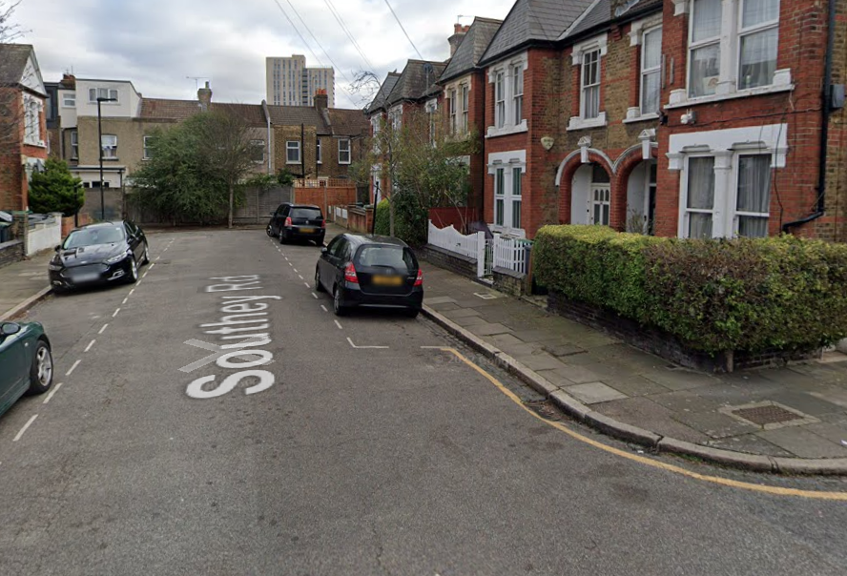

Image 1
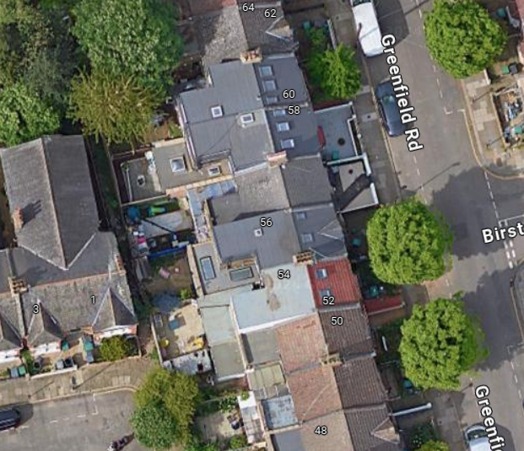
Image 2

Southey Road has an eclectic mix of properties as illustrated in image 3 Therefore this L-shaped conversion will not change the ambience of an already eclectic mix of differing architectural designs.

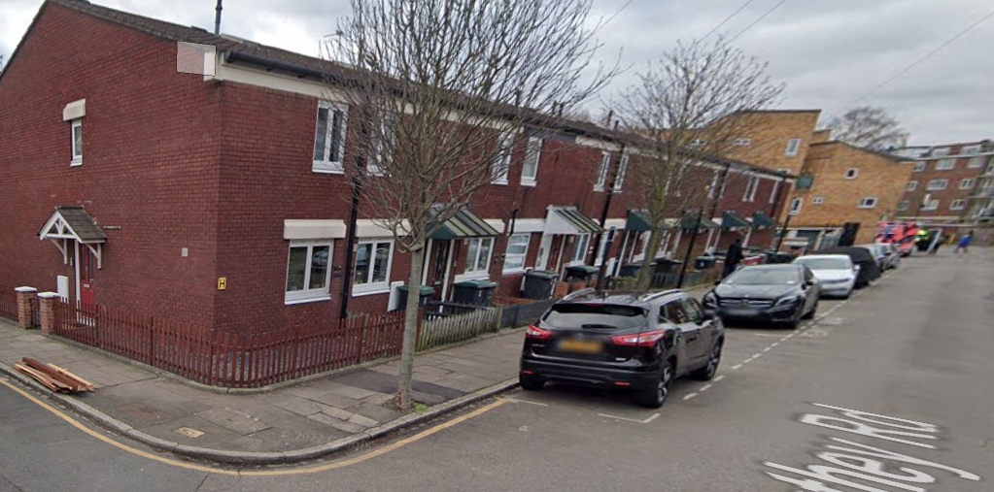

Image 3

Proposed Development

The proposal looks to extend the approved application HGY/2022/2780 with a second rear dormer over a section of the original outrigger, whilst still remaining subordinate to the original roof of the outrigger. The properties directly behind the subject property in Elizabeth Rd are unaffected in terms of privacy as these are side facing as illustrated in Image 4 and will not be any more impeded by the addition of the outrigger dormer than by the previously approved rear dormer.

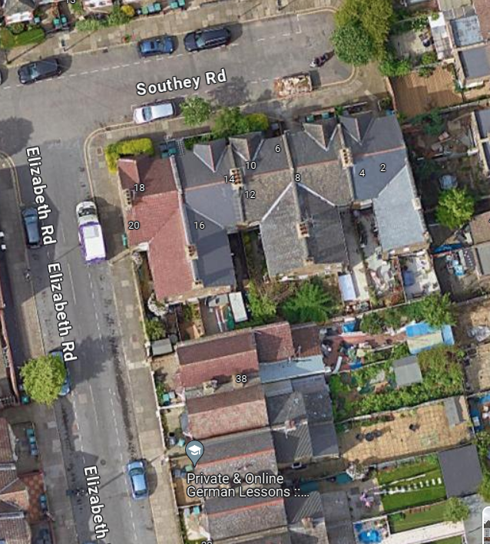

Image 4

Summary

The proposal should be considered acceptable for the following reasons: the proposed roof extension by size scale and design is in keeping with the guidelines provided on the Haringey Council London Borough planning portal and is in line with an abundance of L-shaped dormers that have been undertaken under permitted development rights. As such the proposal will not be detrimental to the character and appearance of the surrounding area. It will have no adverse impact on the visual amenities of neighbours or the street scene.

.

Contractor Commitment & Contact Details

As a conscientious contractor undertaking a significant number of home extensions, we are keen to work with the local authority in order to achieve a sympathetic conversion which meets both the requirements of the local authority but also provides our client with the much-needed space to improve the standard of family life.

Sam Ashen
sam@rooftoprooms.co.uk
Telephone 0208 367 0066

