Condition 55 – Landscaping – Responses received 25.09.24
HPL responses in blue:
On the landscaping a few more queries:
- Do we have full detailed of the play equipment?
Yes, please see attached and refer to the below:
- N15301-PLI-XX-ZZ-DR-L-60233 (Boardwalk access – Play Space)
- N15301-PLI-XX-ZZ-DR-L-60236 (Causeway – Play Space)
- N15301-PLI-XX-ZZ-DR-L-60237 (Climbing wall – Play Space)
- N15301-PLI-XX-ZZ-DR-L-60249 (Play Space - Detailed Plan)
- N15301-PLI-XX-ZZ-DR-L-60240 (Play Space – Detailed Sections)
- Could the cycle route to the SW link be denoted by lines on the roadway instead of being segregated?
We recommend to install inground signage and/or post-mounted cycle icons to highlight the through-route for cyclists. Lines would imply a segregated route, for which there is insufficient room, and would create confusion and conflict between cyclists and motorists parking.
- CCTV was requested by the SBD Officer in his report dated 01/09/2022 (see extract from his comments below). It has also been discussed with the Project Director David Wakeford at meetings with the Council’s ASB and Community Safety Team, in response to a number of crime/ASB incidents in this location.
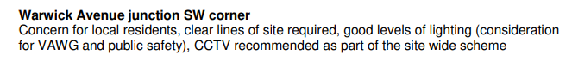
See attached updated CCTV layout, CCTV camera mounted on the lighting column.

Thank you for sharing the lighting plan. This pathway has been a topic of discussion with the Council’s ASB and Community Safety Team, as well as local police. Everyone agrees that a well-planned lighting and CCTV strategy is crucial for ensuring the route's safety.
According to CIBSE guidance for Pedestrian Areas and Cycle Paths, this area requires a higher peak illumination than 10 lux (as currently proposed) to provide clear visibility and enhance safety. Additionally, it's important to ensure a more even distribution of light with an acceptable contrast ratio. Currently, there is a significant contrast between illuminated areas (5-10 lux) and dark edges, making the edges feel unsafe. Using lighter-coloured paving would also increase the perception of brightness and make the space easier to visually understand.
Noted. Lighting design for the path through the SINC (Site of Importance for Nature Conservation) should address the real and perceived risks relating to darker areas at night, while minimizing the impact of the new route on sensitive ecology.
External lighting is currently being revised to show the 15 Lux levels required on this area.
The pedestrian route is already proposed as a (light) golden colour resin-bound aggregate. The cycle route through the SINC could be surfaced with a lighter, but still contrasting, paving material, potentially tying in with proposed cycleway surfacing in the adjacent Phase - material TBC. The vehicular circulation uses ‘bracken’ block pavers which are lighter-coloured than asphalt. There are slightly lighter tones in ‘natural’ or ‘buff’ if deemed necessary – see below for comparison:
1. Bracken (as currently proposed):
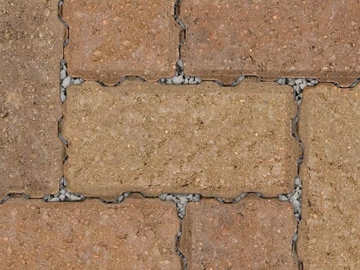

2. Natural:
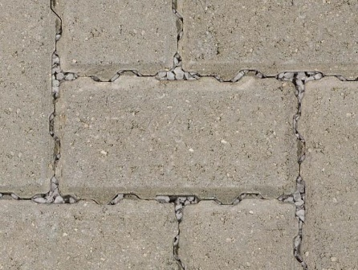

3. Buff:
