Planning Department
Planning, Regeneration & Economy
Level 6
River Park House
Wood Green
N22 8HQ

Dear Sir/Madam
The Hornsey Club, Tivoli Road, London, N8 8RG: Application for Temporary InstantPadel Courts
The Hornsey Club is pleased to enclose a full planning application seeking temporary planning permission for the following:
“Installation of four de-mountable InstantPadel courts on the site of the existing hardstanding tennis courts for a temporary period until 31st October, 2024.”
The application, which has been submitted via the Planning Portal comprises the following documents:
    - Completed application form and CIL Additional Information Form;
    - Application drawings;
      - Site Location Plan (drawing ref. 2403-P-106-001-00);
      - Proposed Site Plan (drawing ref. 2403-P-101-001-02);
      - Existing Site Plan (drawing ref. 2403-P-106-002-00);
      - Indicative Padel Court (drawing ref 2401-P-101-002-00; and
      - InstantPadel-Court-3D

Background and Proposals
The Hornsey Club is a long established, non-profit-making cricket club situated in its own freehold grounds in the heart of the Crouch End/Hornsey community.
The Club is located within the south eastern corner of the wider Crouch End playing fields and comprises a Club house, cricket pitch and nets. Part of the site wider site, also within the Club’s ownership, includes three underutilised tennis courts which are in a poor condition. This comprises the application site, which totals 0.18 ha.
The Club has recently been approached by a InstantPadel Tennis company regarding the installation of four no. double padel courts on a temporary basis. Padel is a form of tennis that is played on an enclosed court about the third of the size of a tennis court. The reduced court size and ability to play off the wall enables players with reduced mobility to participate as there is less court to cover. It is a fast-growing and inclusive sport.
The provision of these courts at the Club will increase the publicly accessible sports facilities in the immediate area, and provide a source of additional revenue for the Club which is currently solely reliant on member contributions and voluntary commitments.
Each proposed court is a flexible structure, with no permanent attachments to the ground, it can be easily moved and taken down within a matter of hours. Figure 1 below provides an indicative drawing, with dimensions, of a padel court. Each court will measure 23m (length) and 13m (width), in terms of its outer dimensions, supported by legs which protrude from the court by 1.32m. The court’s wall panels measure up to 3.5m in height and are made of polycarbonate glass. The tallest part of the structure is the lighting columns on each corner which measure up to 5.5m. The floor inside the courts is a portable plastic floor.
Figure 1 Indicative Drawing of Padel Court
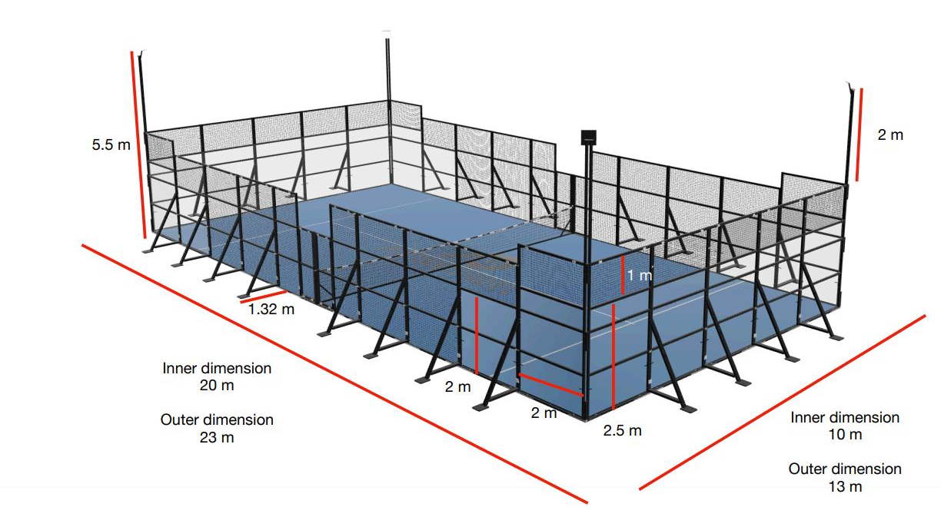
Source: Instantpadel

It is intended that the four padel courts will be located on the site for a temporary three month period, until the end of October 2024. After which they will be removed from the site.
Please note that this application has been submitted at the request of Haringey Council. Given the nature of the proposals and the fact that they are fully (and quickly) demountable and not fixed to the ground, there is a strong planning case to argue that these padel courts do not actually require planning permission.

Planning Policy Context
The Statutory Development Plan for LBH comprises:
    - The London Plan (2021);
    - The Local Plan: Strategic Policies (adopted 2013, alterations 2017);
    - The Local Plan: Development Management DPD (adopted 2017); and
    - The Local Plan: Site Allocations DPD (adopted 2017).
The National Planning Policy Framework (NPPF) (2023) is also a material consideration.

Planning Assessment

Principle of Development
The site’s existing use is as tennis courts which have been in existence for many years.
The NPPF recognises the importance of sports and recreation facilities as key mechanisms which can promote ‘healthy and safe communities’ (Chapter 8). The Framework states that that “planning policies and decisions should aim to achieve healthy, inclusive, and safe places which […] enable and support healthy lifestyles, especially where this would address identified local health and well-being needs” (Paragraph 96).
Paragraph 102 of the NPPF acknowledges that access to opportunities for sport and recreation can make an important contribution to the health and wellbeing of communities. Similarly, Policy S5 (‘Sports and Recreation Facilities’) of the London Plan encourages proposals that increase or enhance the provisions of sports and recreation facilities.
Haringey’s Strategic Policies SP14 (Health and Well-being), SP15 (Culture and Leisure), and SP16 (Community Facilities) all support the provision of sporting facilities. Specifically, SP15 states the aim of “the protection and enhancement of sporting and leisure facilities in areas of deficiency”. The principle of padel courts in this location therefore accords with the Statutory Development Plan.
As the site is designated Metropolitan Open Land (MOL), a key consideration for the application is whether the development would be inappropriate development in the MOL and the effect of the development on the openness of the MOL. London Plan Policy G3 Metropolitan Open Land confirms that MOL is afforded the same status and level of protection as Green Belt. The policy states that MOL should be protected from inappropriate development in accordance with national planning policy tests that apply to the Green Belt.
The NPPF classes development on the Green Belt (and therefore also on MOL) as inappropriate, with some exceptions. One such exception is given by Paragraph 154 (b) which states that the following would not be inappropriate: the provision of appropriate facilities for outdoor sport, outdoor recreation, cemeteries and burial grounds and allotments; as long as the facilities preserve the openness of the Green Belt and do not conflict with the purposes of including land within it.
It is clear that the proposed padel courts fall within this definition. In terms of preserving the openness of the MOL, given the proposed erection of the padel courts is for a temporary period of time, and they can be moved and deconstructed at any time, it is considered that the openness of the MOL would be maintained. Notwithstanding, the proposed padel courts are not materially different from the existing tennis courts and fencing on the site.
On this basis, we conclude that the proposed padel courts do not present any conflict with the purposes of the MOL. It is not inappropriate development, it maintains the openness of the site and accords with the intended functions of the MOL.

Design and Amenity
The proposed four padel courts are set within enclosures made from mesh and polycarbonate glass – not dissimilar to the existing fencing surrounding the tennis courts. The padel courts are of a high quality design and are clearly not materially different to the existing use of the site. We therefore consider the proposals to be acceptable in terms of design and amenity.

Biodiversity Net Gain
Due to the site comprising of existing tennis courts, the Biodiversity Net Gain de minimis exemption applies to the site i.e. there is no requirement to provide biodiversity net gain as part of this application. For clarity:
- the development does not impact on any onsite priority habitat;
- the existing tennis courts and hardstanding area at the subject site are classified as developed land: sealed surfaces which have a biodiversity value of zero under the statutory biodiversity metric; and
- there are no other onsite habitats.

Summary
On the basis of the above assessment, we consider the proposal for planning permission for the erection of four temporary padel courts to be acceptable in planning terms.
We trust you have sufficient information to validate and determine the application within the statutory timescales.
Yours faithfully,

The Hornsey Club

